**EduCloud – Cloud-Based Trainer & Student Learning Platform**

**Document Type:**

**Implementation & Execution Guide**

This document provides **step-by-step instructions** to deploy, configure, and validate the EduCloud platform infrastructure and services using **Linux and AWS**

**Technologies Used**

* AWS: VPC, EC2, ALB, Auto Scaling, S3, RDS, Lambda, CloudFront
* Linux: User & group management, security policies, services
* Frontend: HTML (static, CloudFront hosted)
* Automation: AWS Lambda, S3 triggers
* Database: Amazon RDS (MySQL / MariaDB)

**Project Objective:**

To design and implement a secure, scalable, and automated cloud learning platform that supports:

* Trainer material uploads
* Student assignment submissions
* Secure storage & notifications
* High availability and fault tolerance

**Document Scope:**

* Linux system configuration
* AWS infrastructure setup
* Networking & security design
* Automation workflows
* Frontend integration
* Verification & testing steps

**Prepared By:**

**Mohammed Nihal Makandar**

**US East (N. Virginia)**

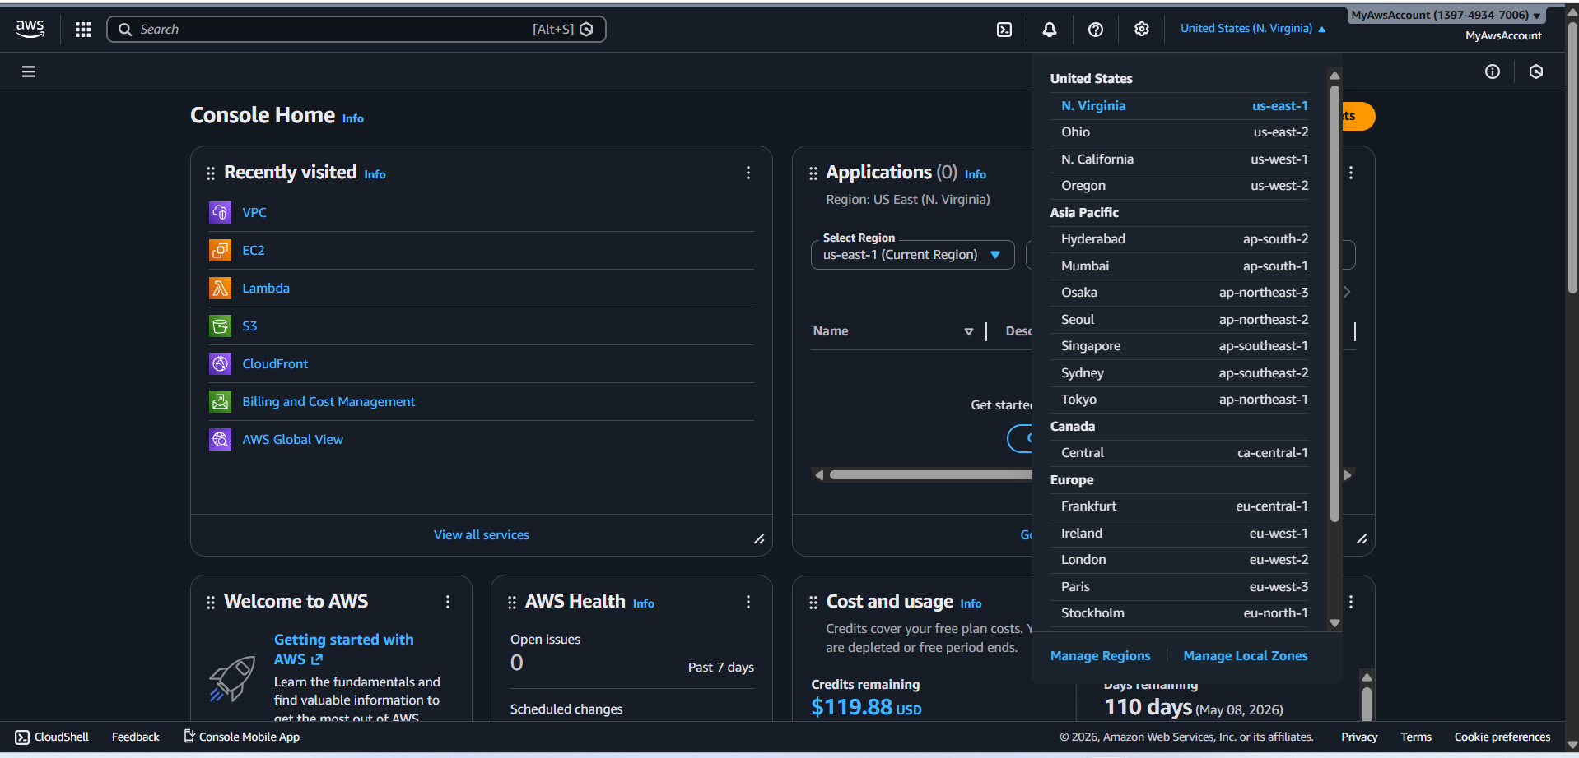

**VPC**

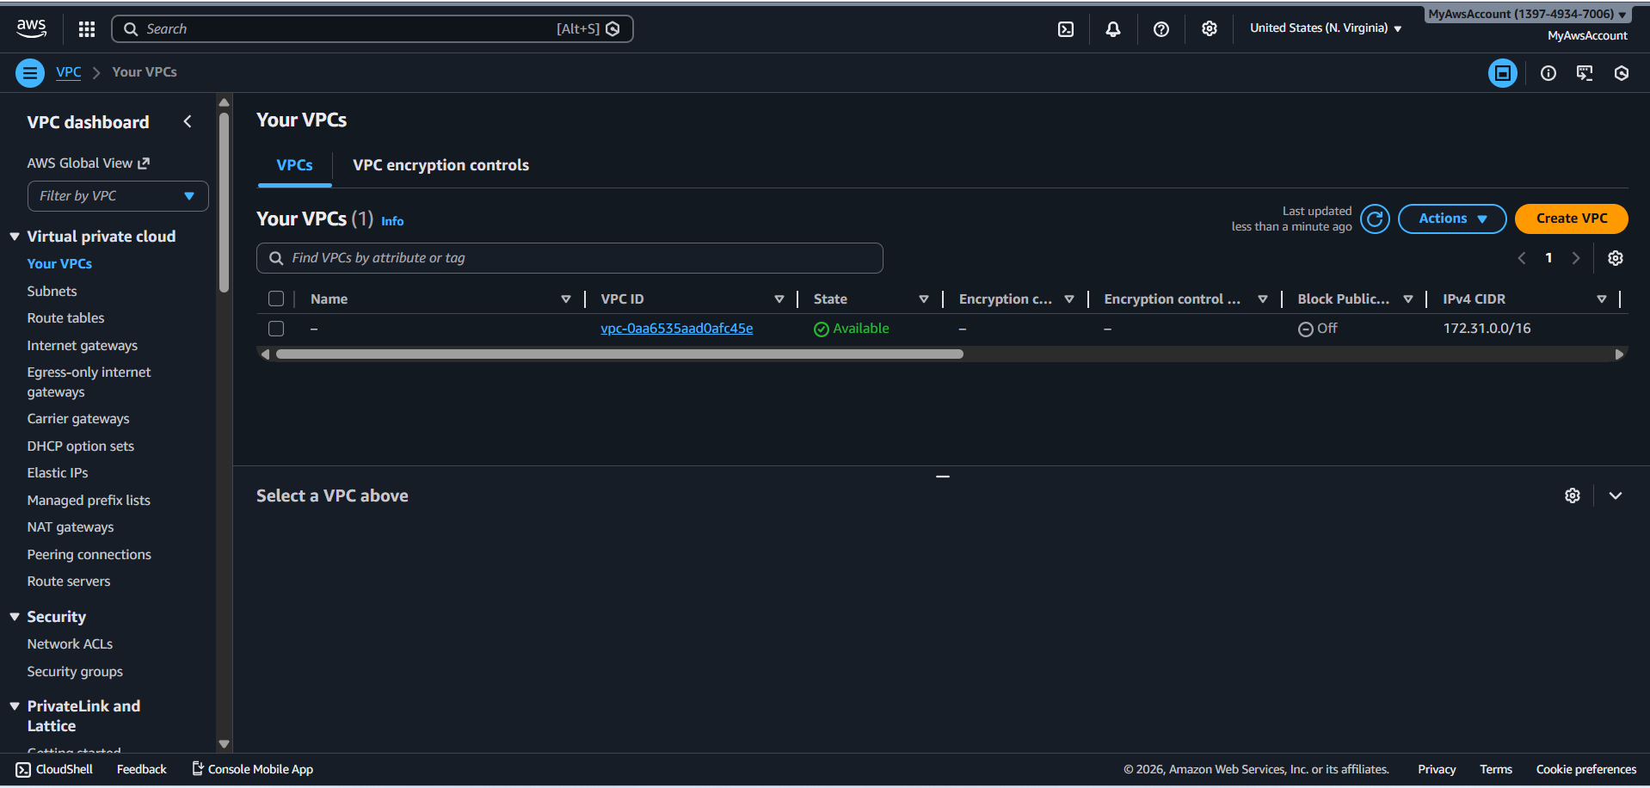

**Create VPC form filled out**

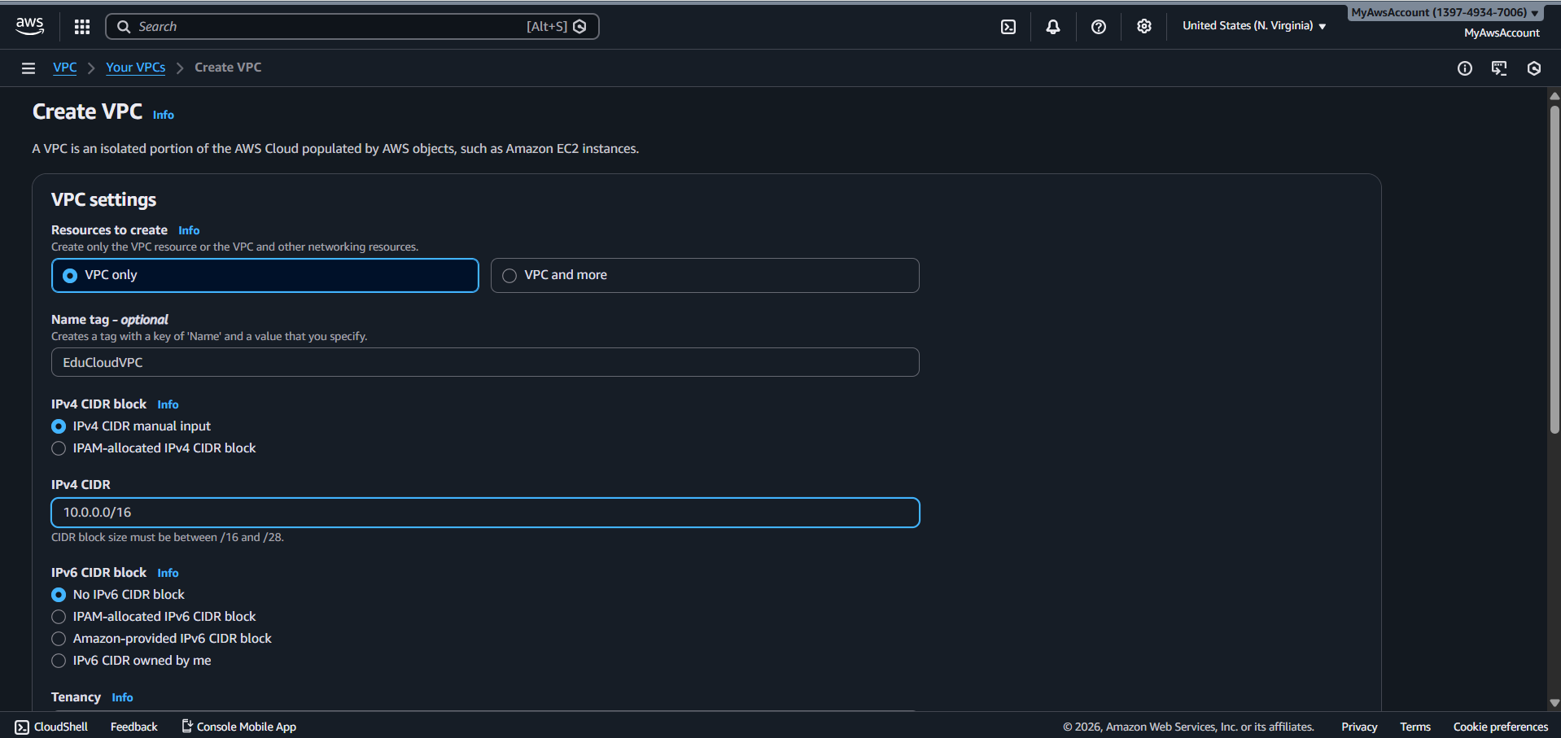

**Educloud VPC**

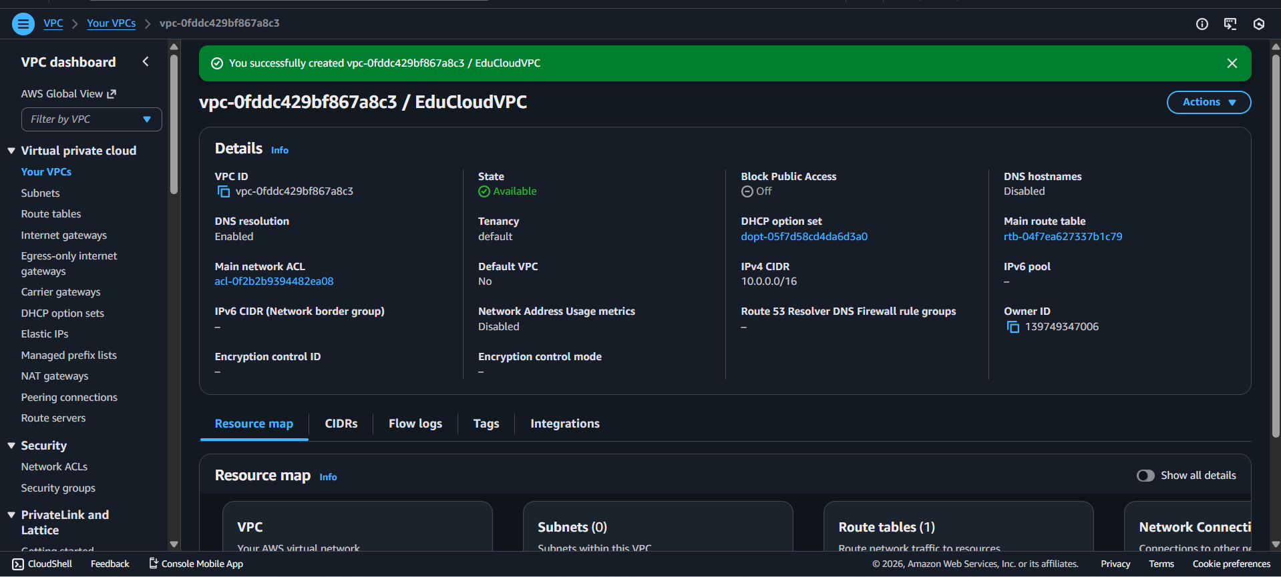

**VPC Created**

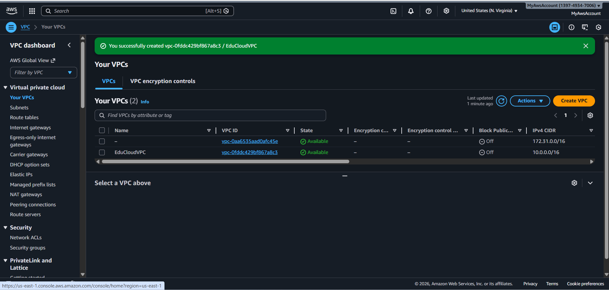

**internet gateway**

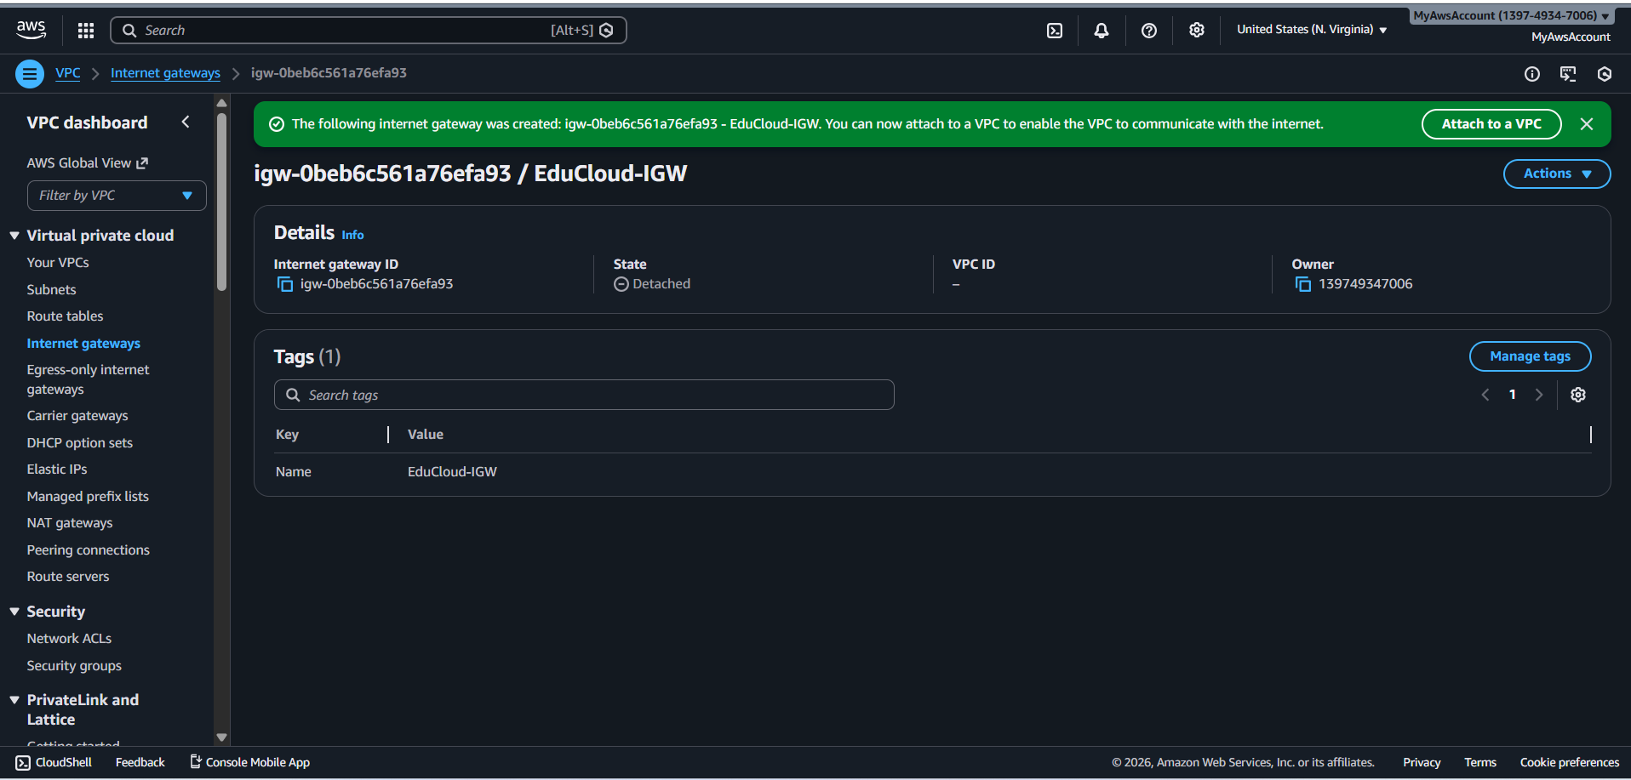

**Internet Gateway Attached to VPC**

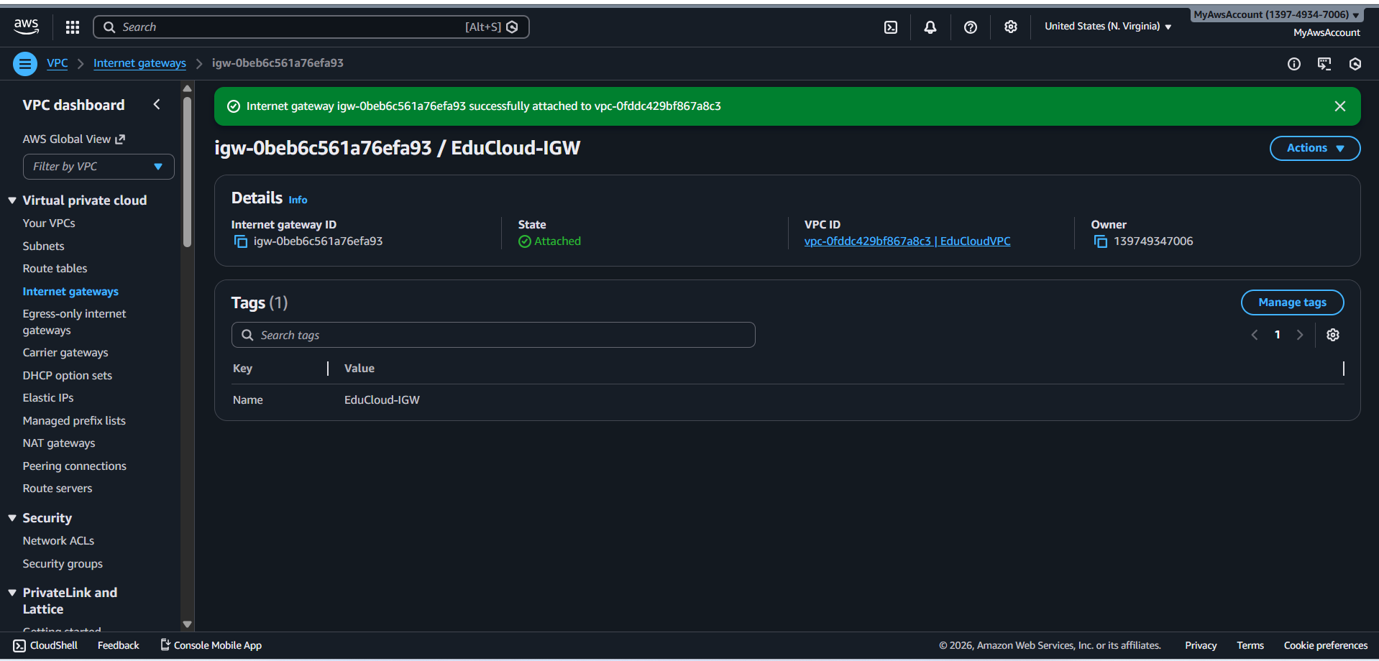

**Subnets**

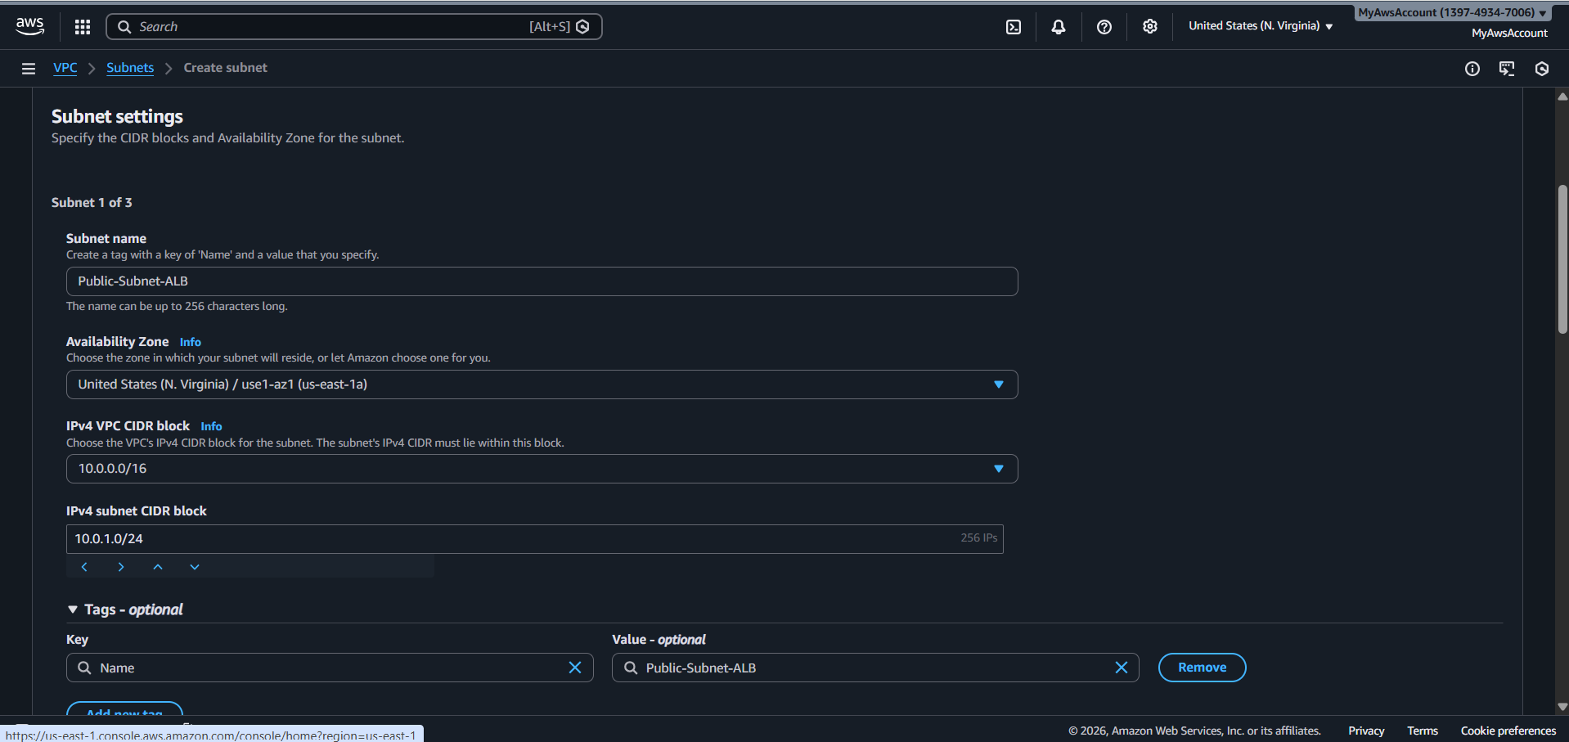

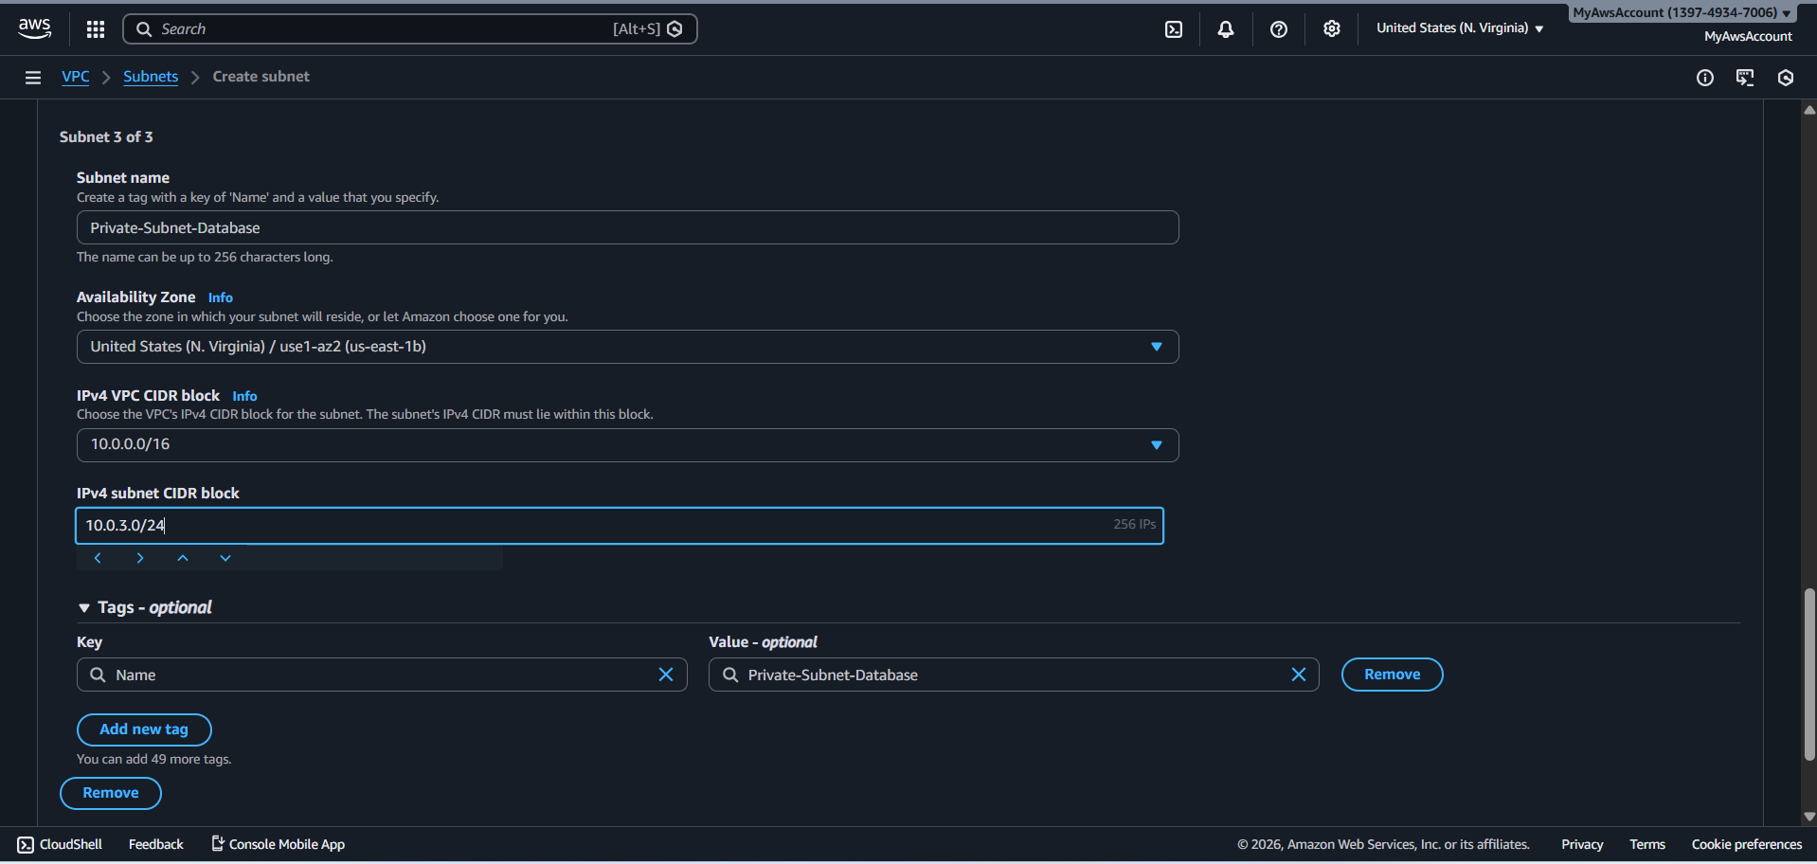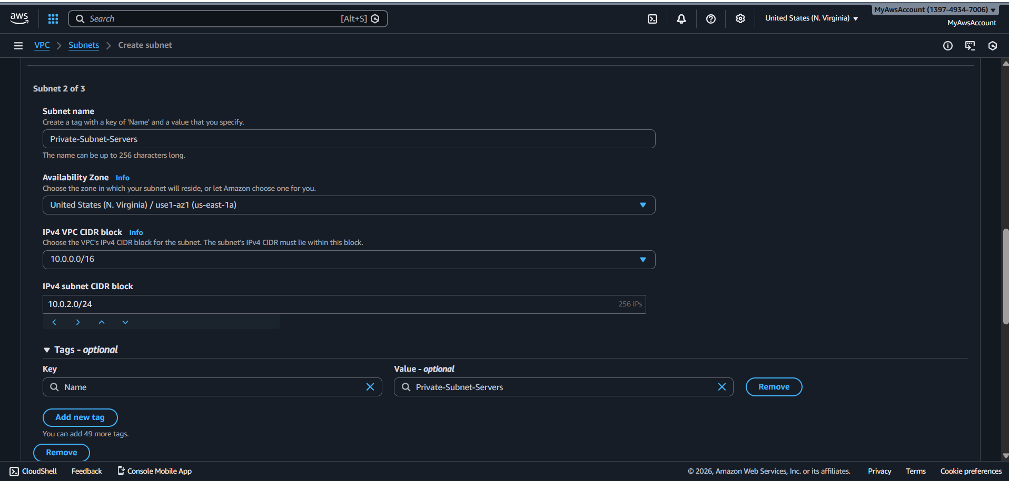

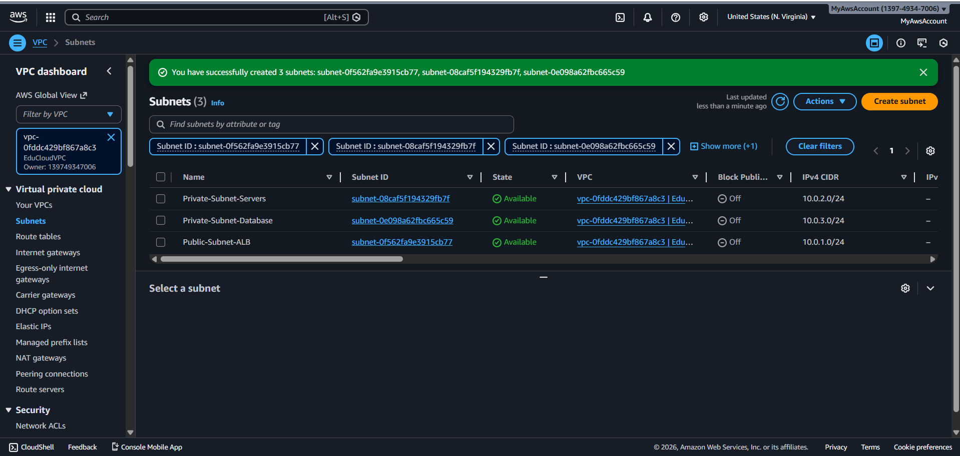

**Auto-assign IP enabled for public subnet**

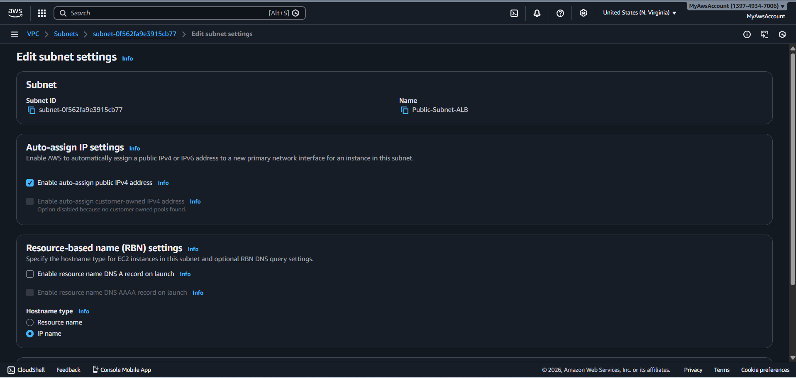

**NAT gateway**

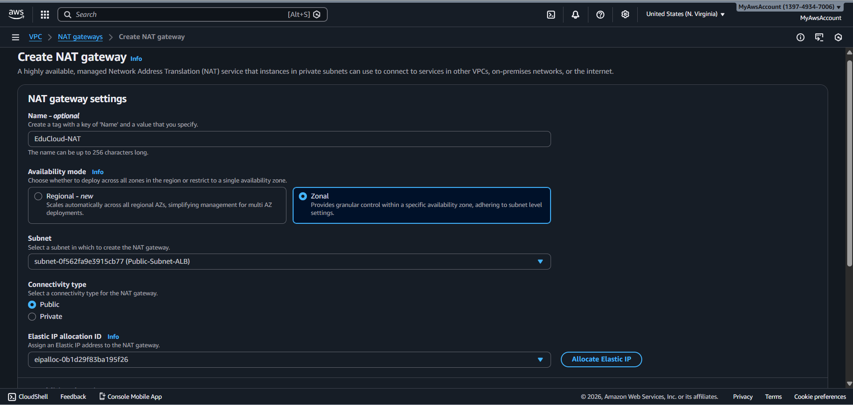

**Status Avilable**

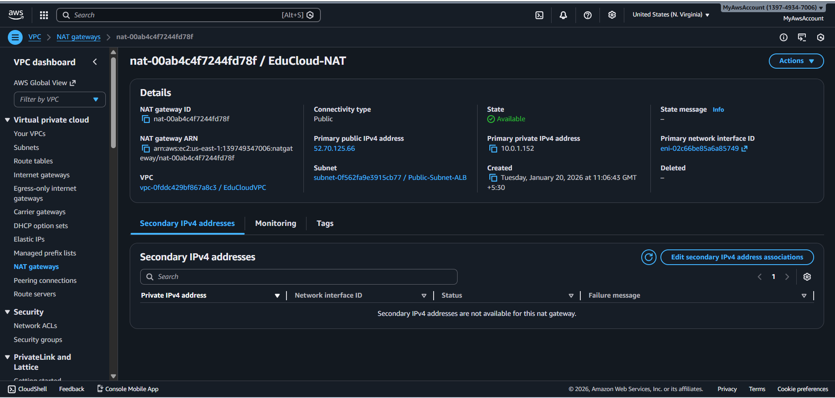

**PUBLIC ROUTE TABLE**

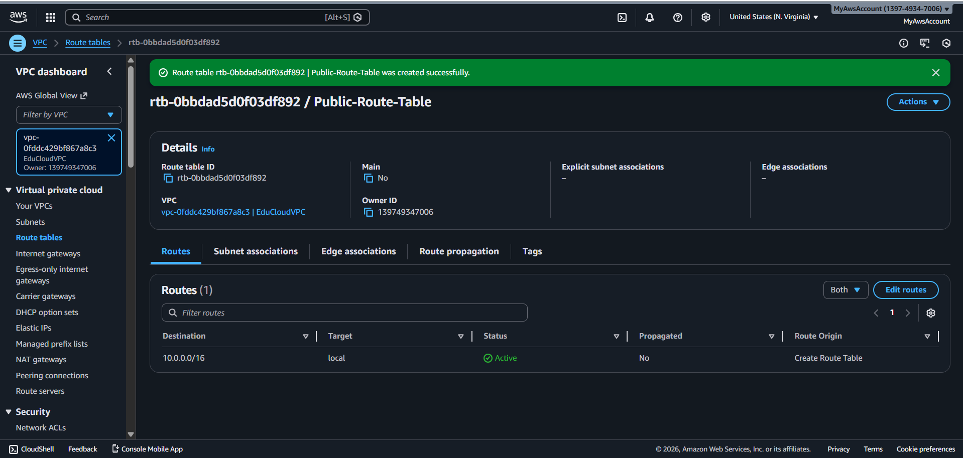

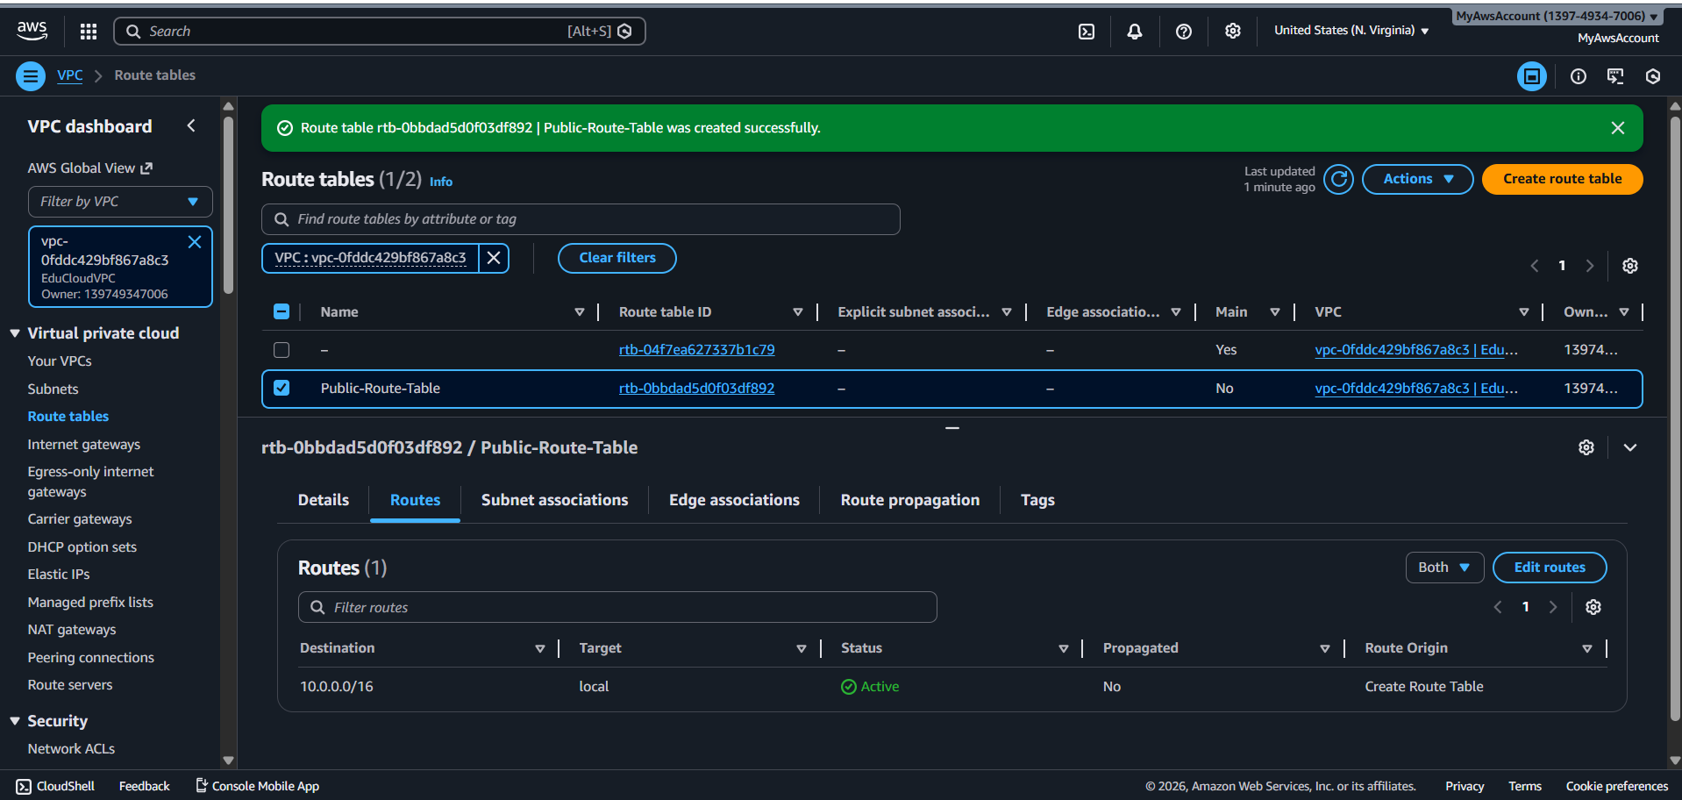

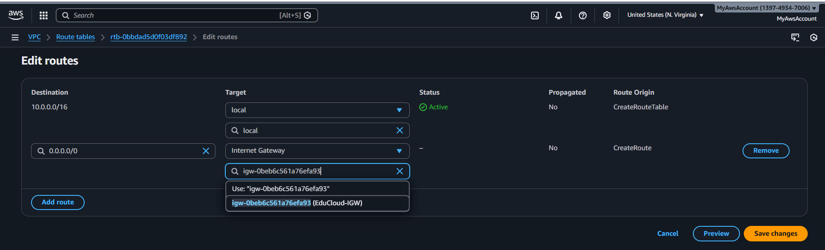

**Public Route Table with IGW route**

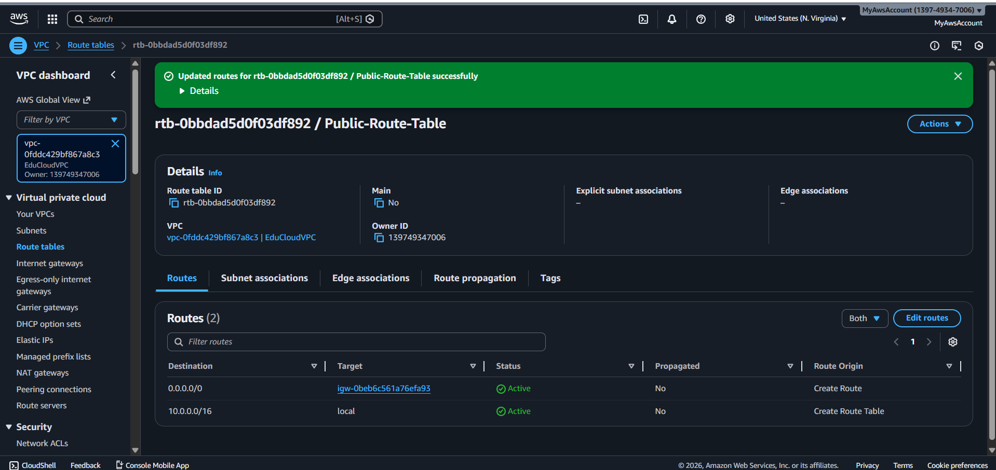

**Public subnet associated**

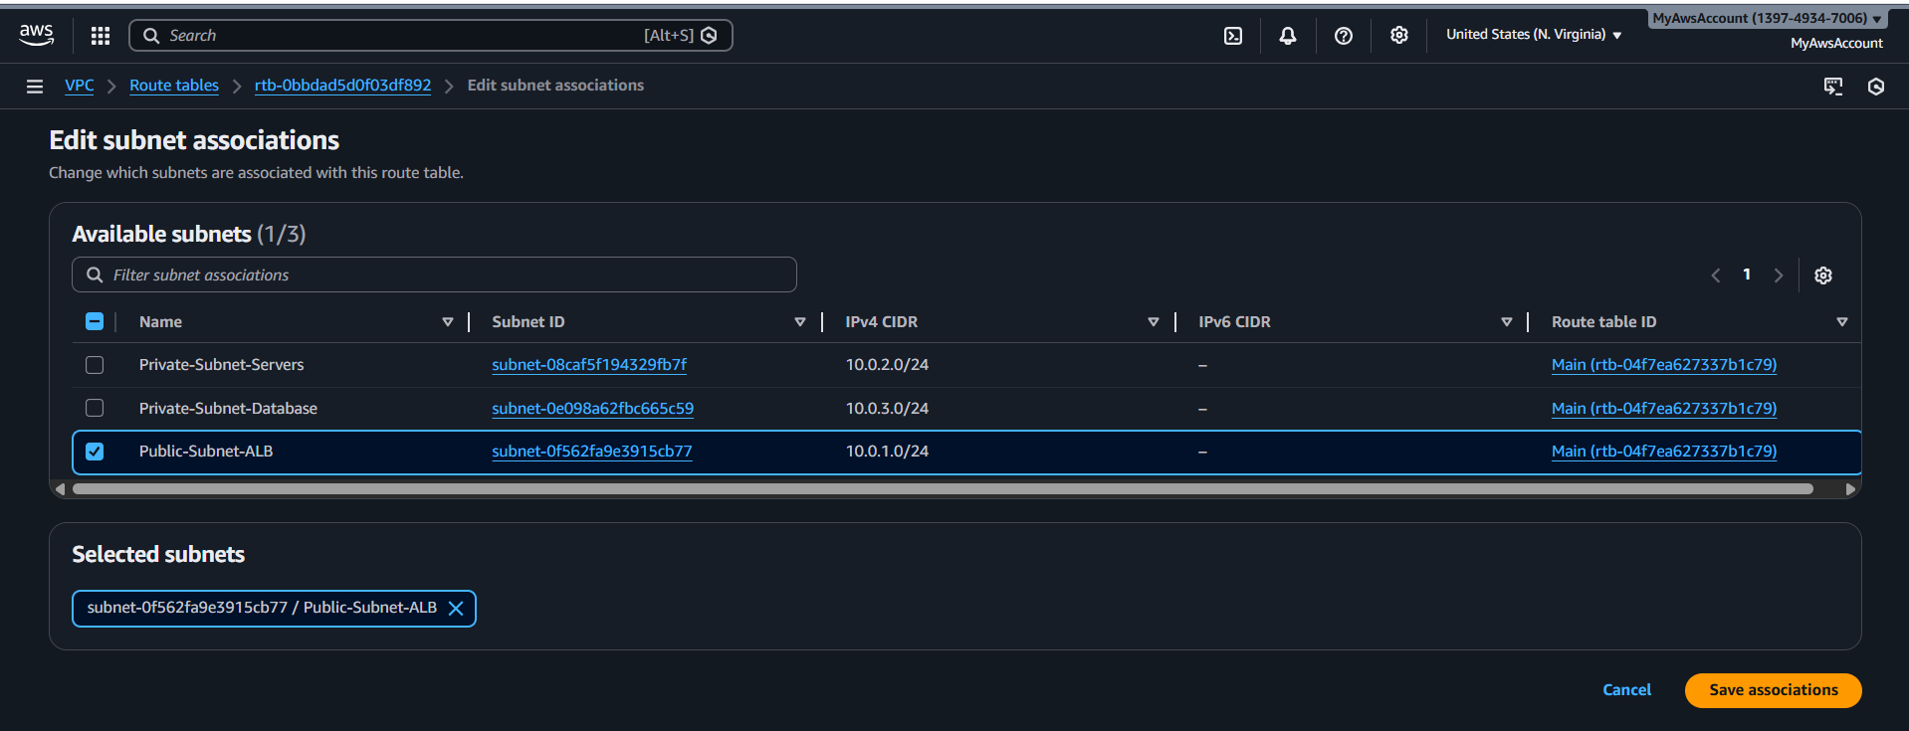

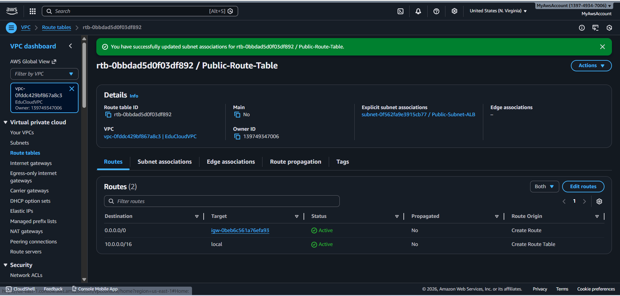

**Private-Route-Table**

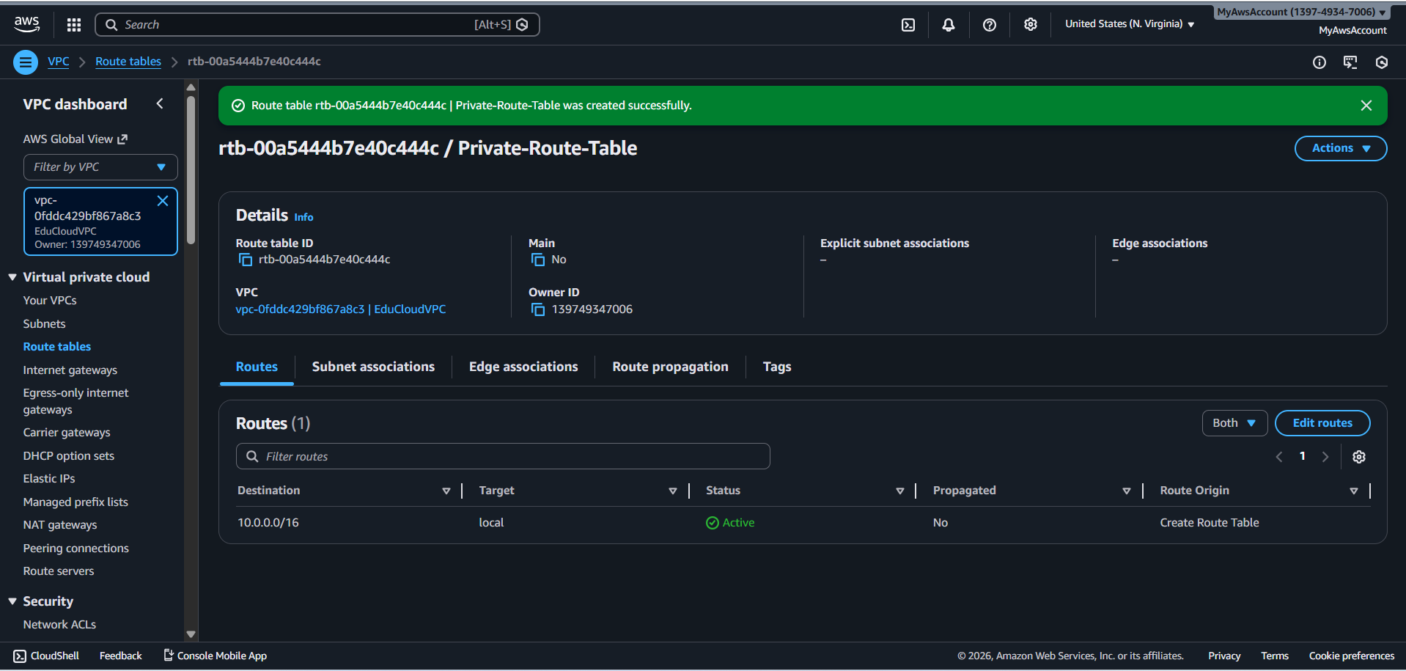

**Both private subnets associated**

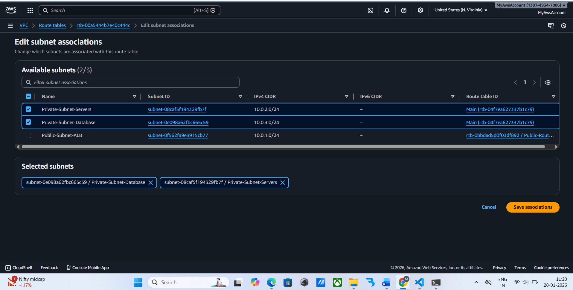

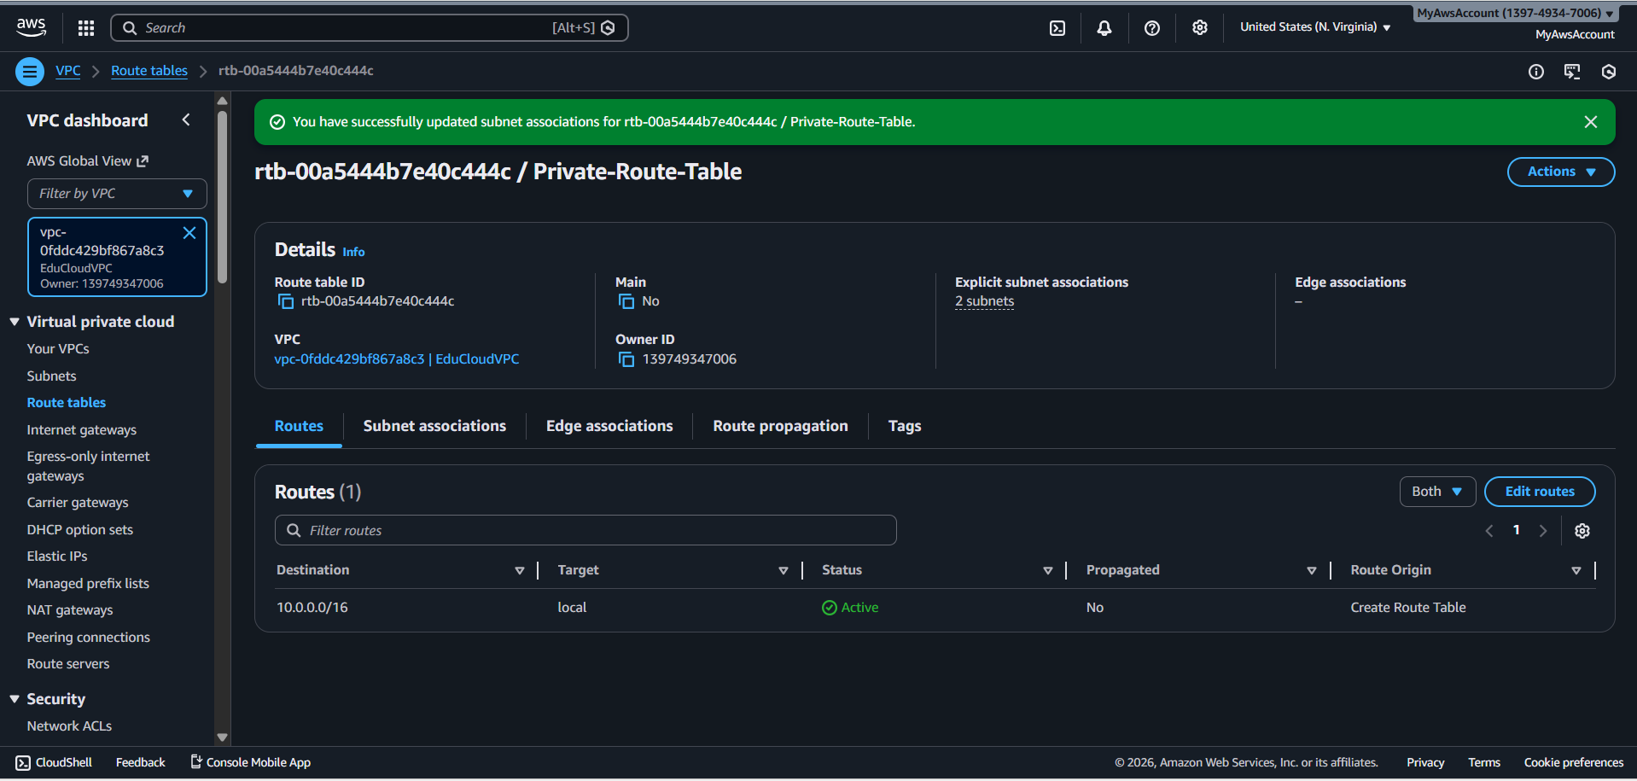

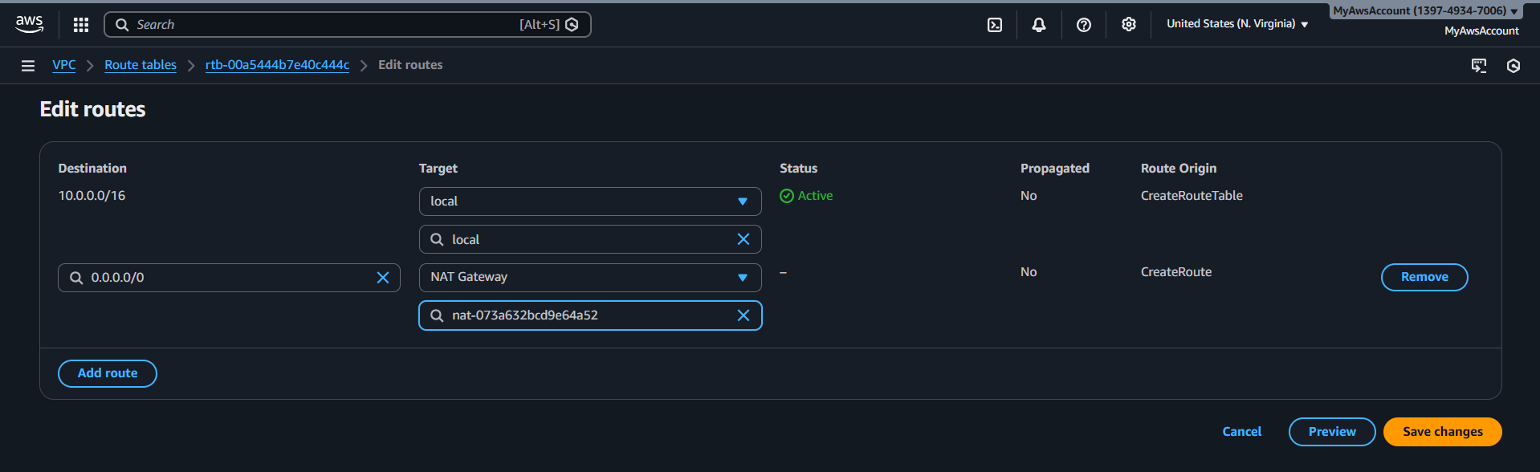

**SECURITY GROUP**

**Default security Groups**

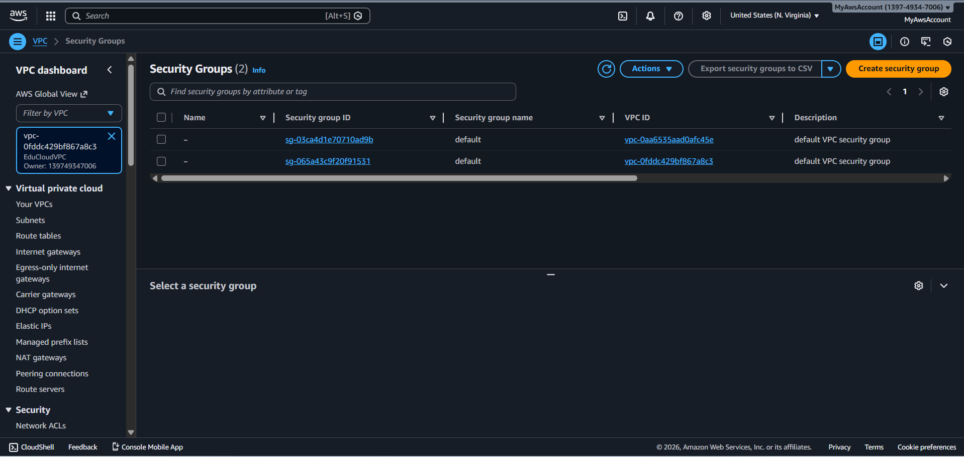

**ALB SECURITY GROUP (Public Load Balancer)**

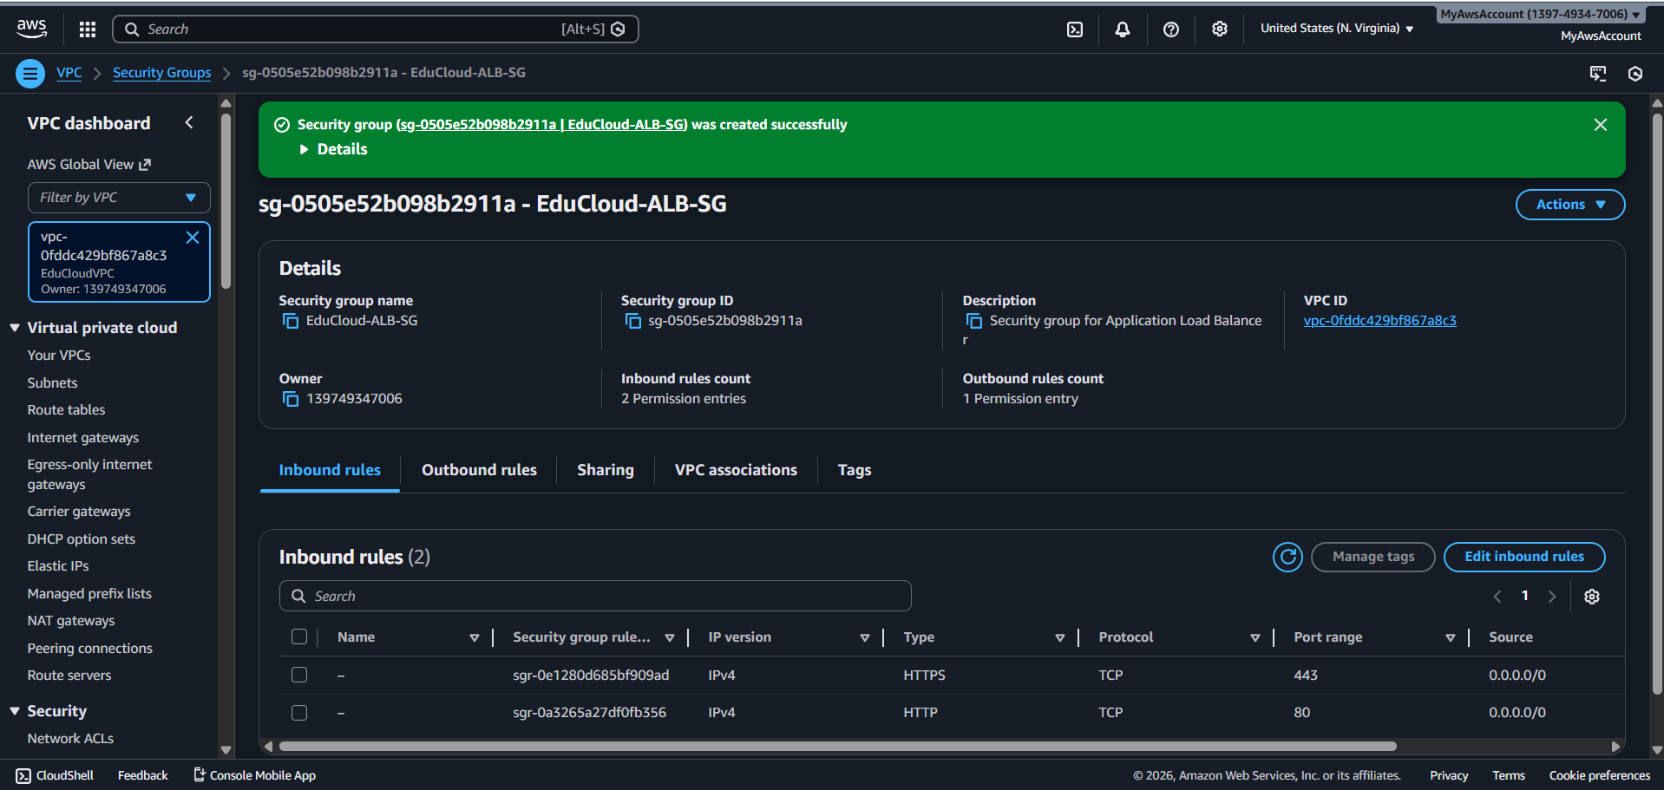

**WEBSERVER SECURITY GROUP**

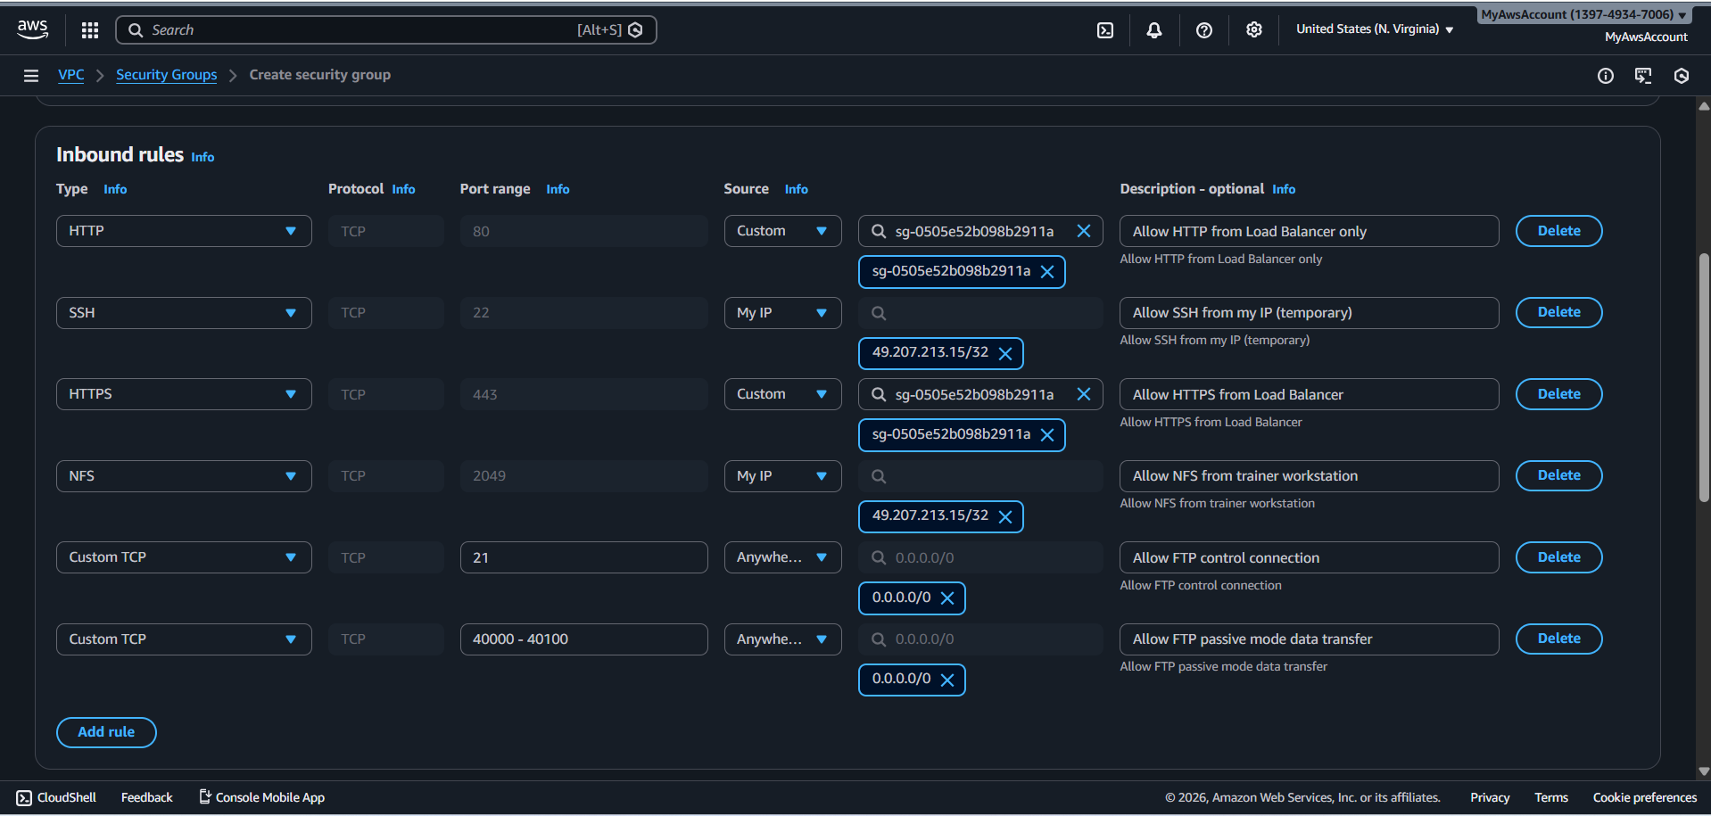

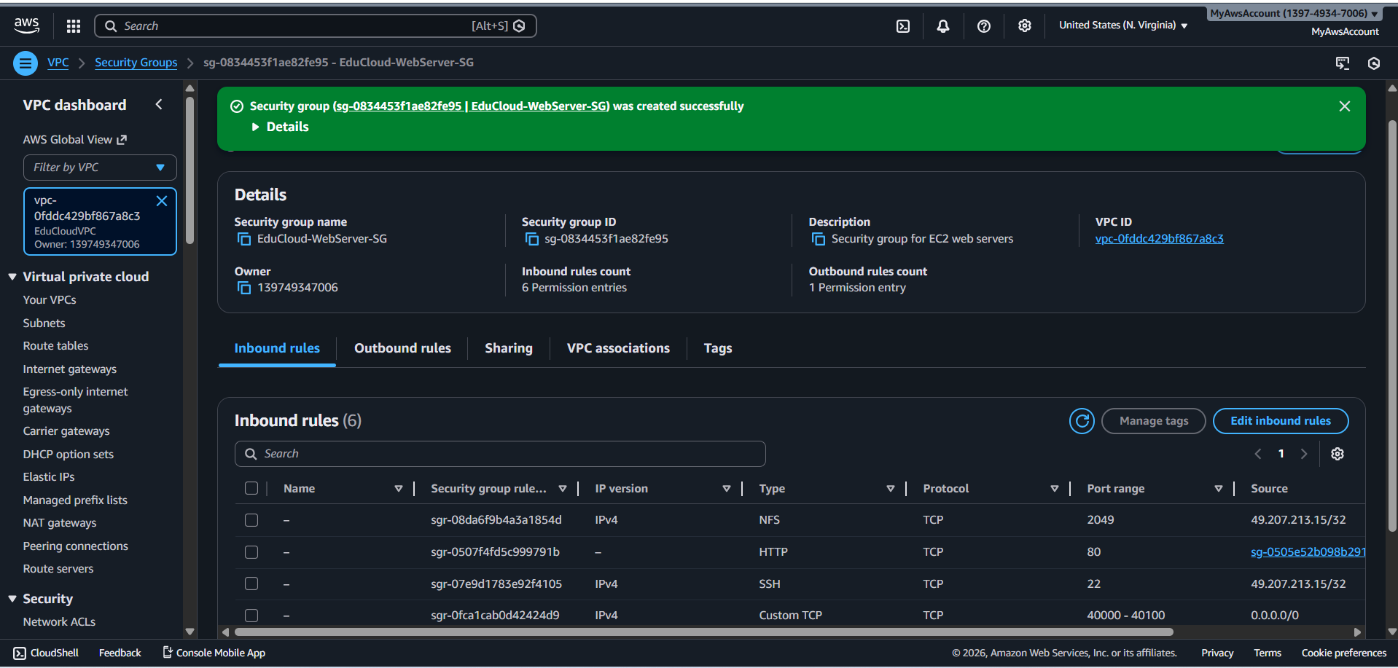

**RDS SECURITY GROUP**

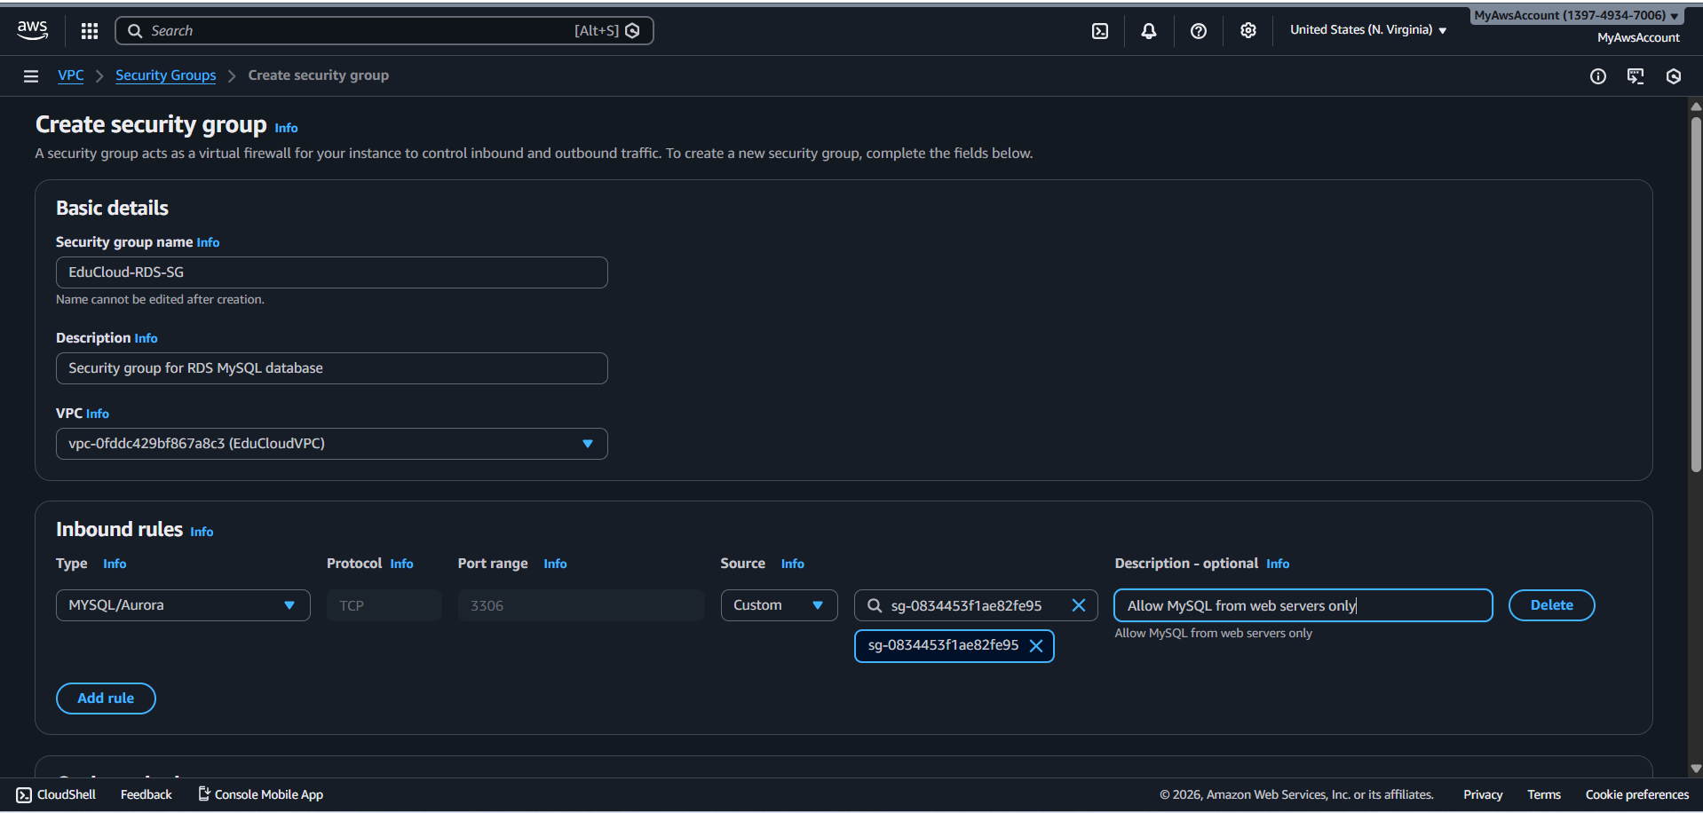

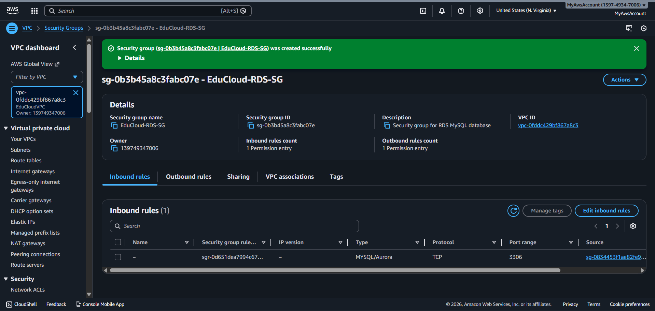

**BASTION SECURITY GROUP**

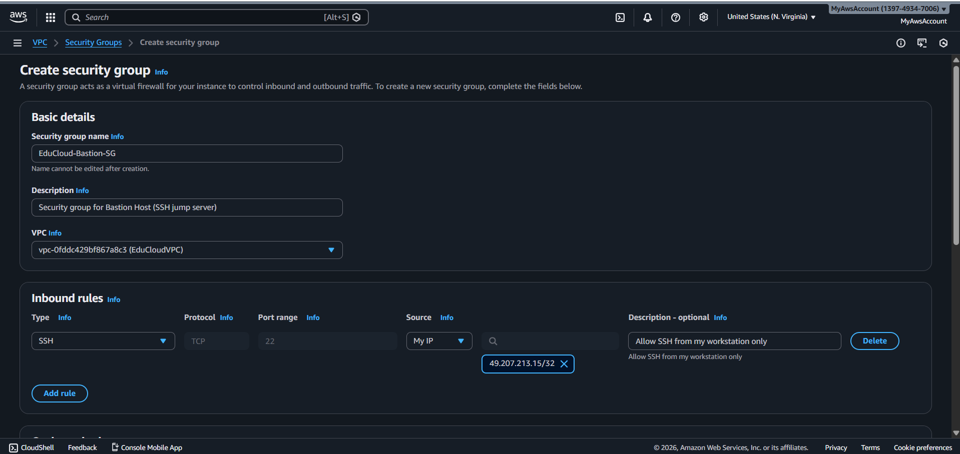

**Security Group Configuration**

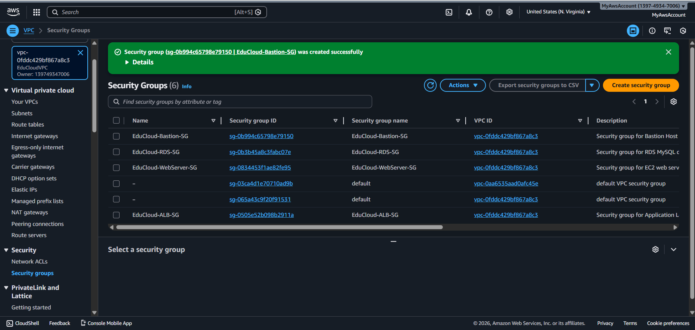

**SECURITY BEST PRACTICES IMPLEMENTED**

**Principle of Least Privilege:**

* RDS only accessible from WebServers (not from internet)
* WebServers only accept HTTP from Load Balancer
* SSH only from Bastion or specific IP

**Defense in Depth:**

* Multiple layers: ALB → WebServer → Database
* Each layer has its own security group

**Segmentation:**

* Public resources (ALB) separate from private (WebServer, RDS)
* Database completely isolated from internet

**Source Restriction:**

* SSH limited to known IPs
* NFS limited to trainer workstation
* Database only from application servers

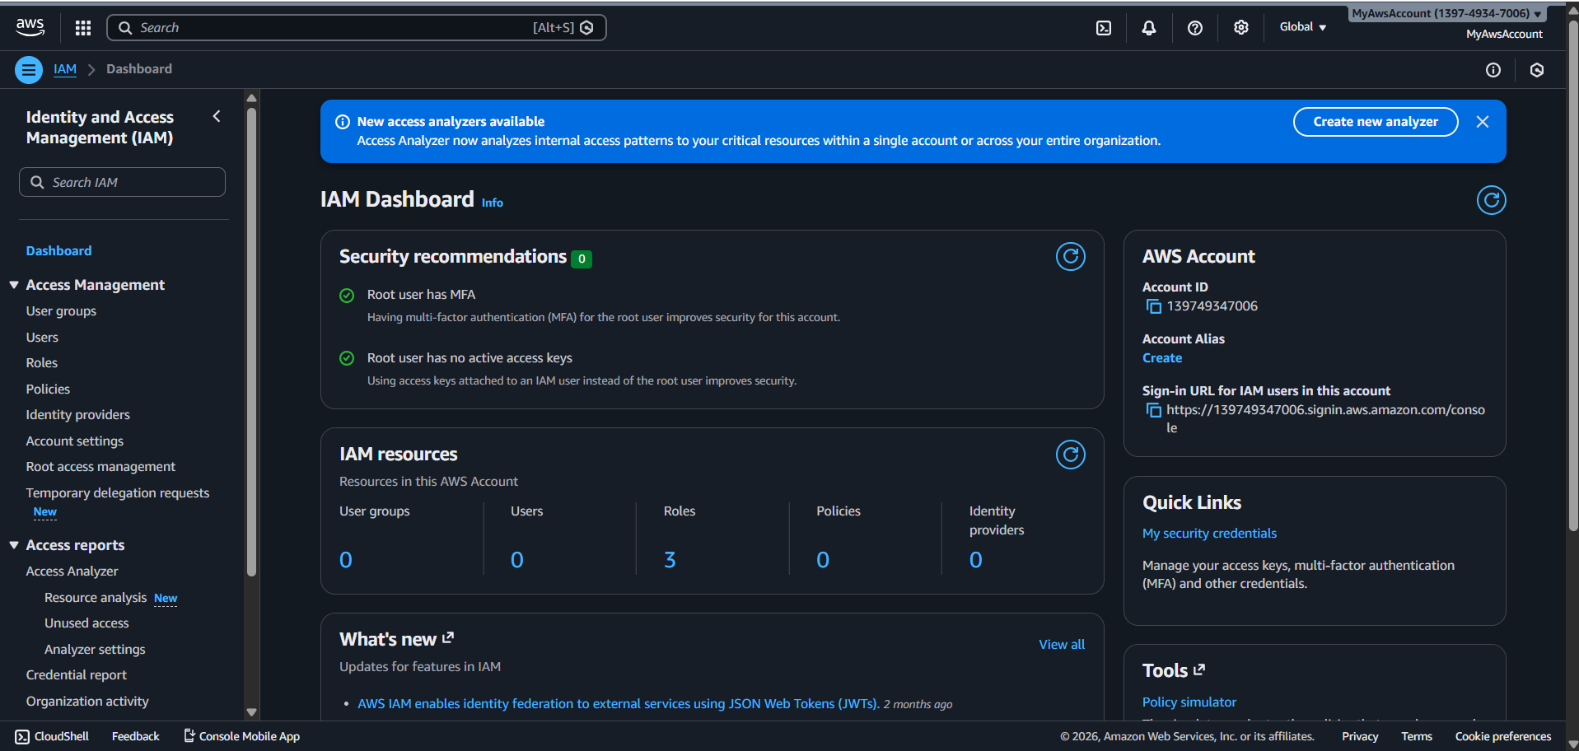

**TRAINER GROUP**

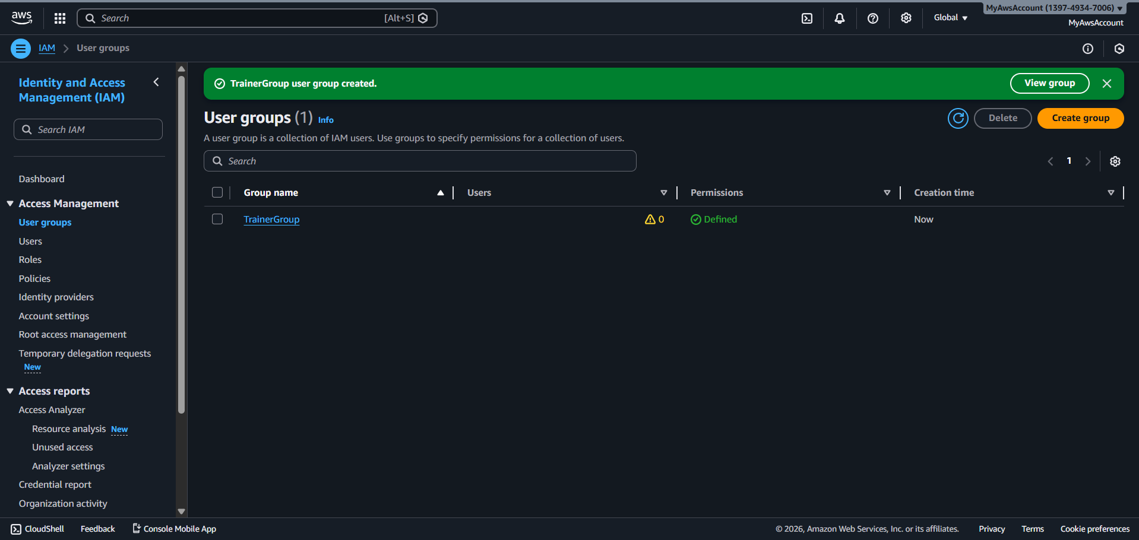

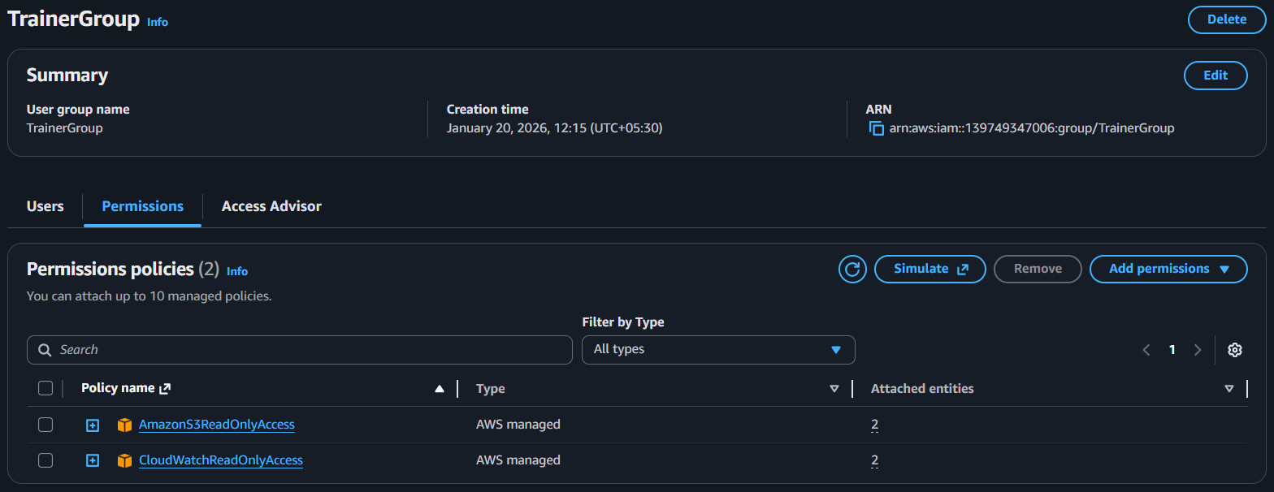

**STUDENT GROUP**

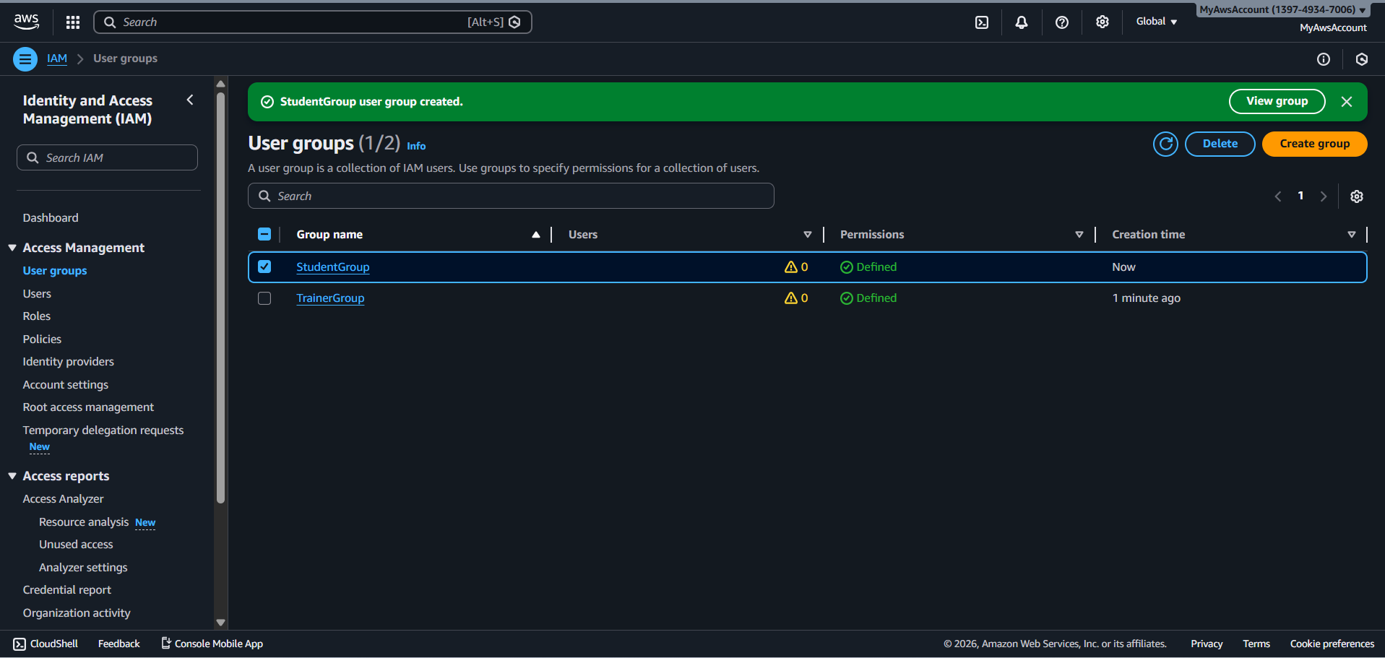

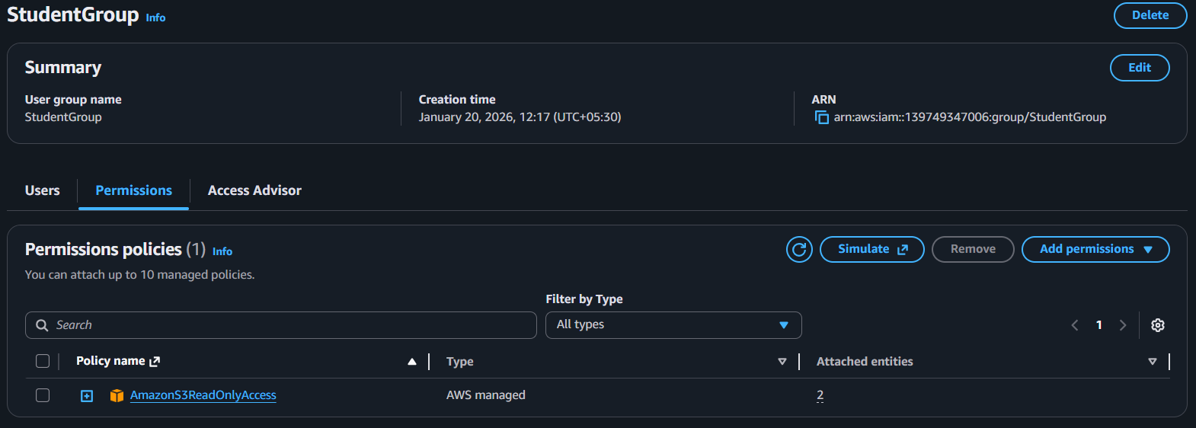

**SUPPORT GROUP**

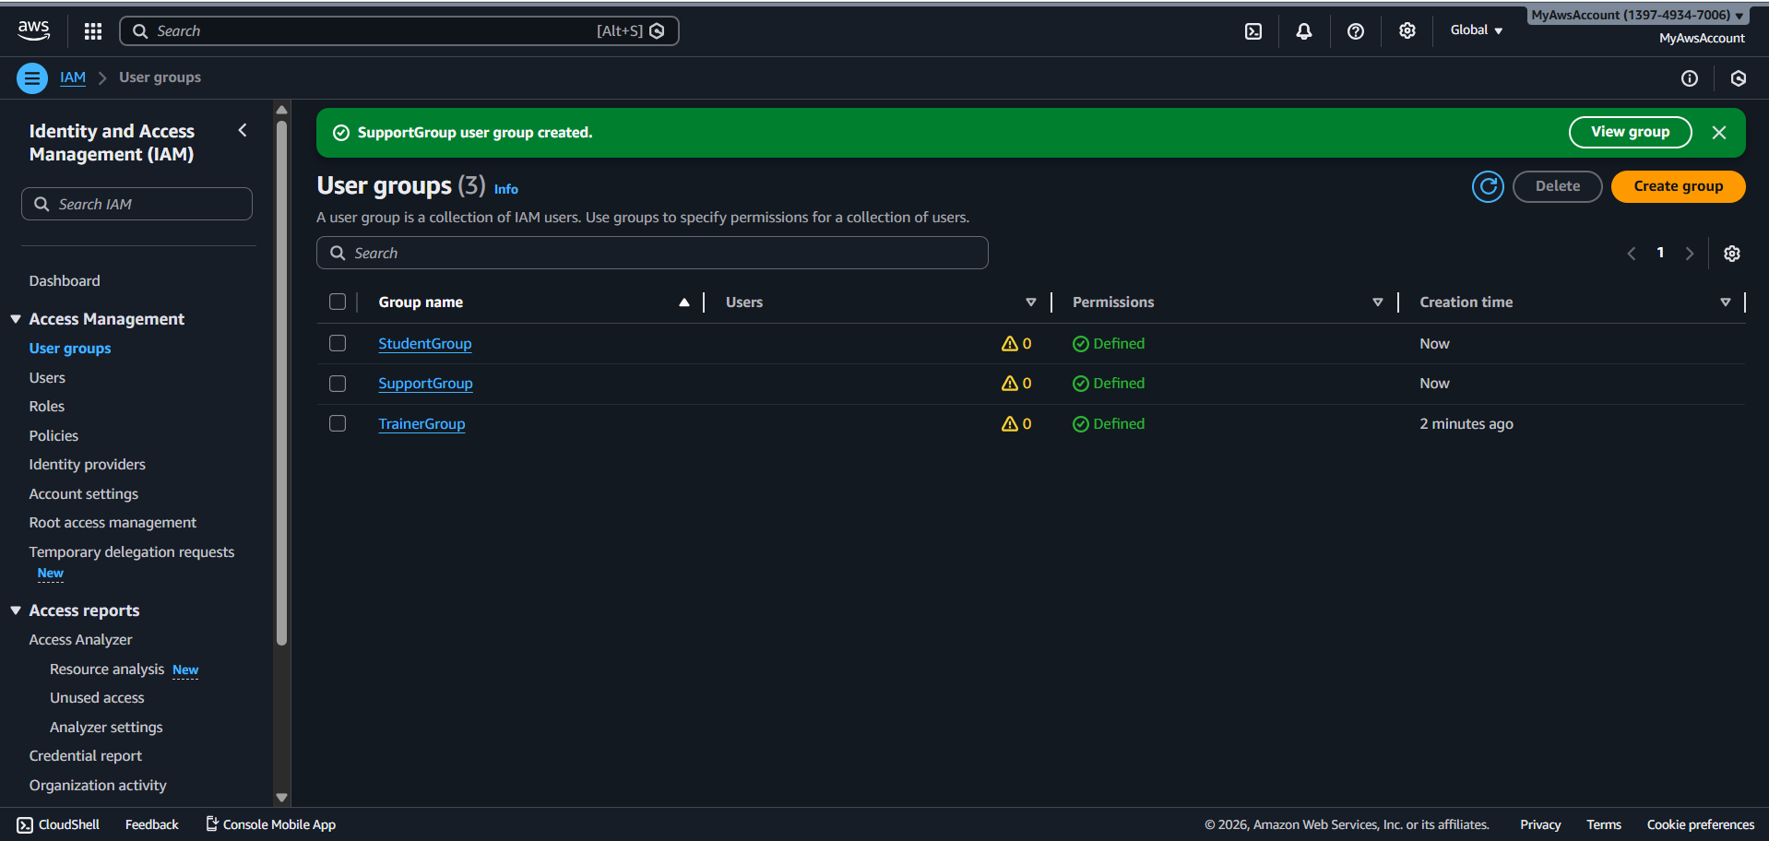

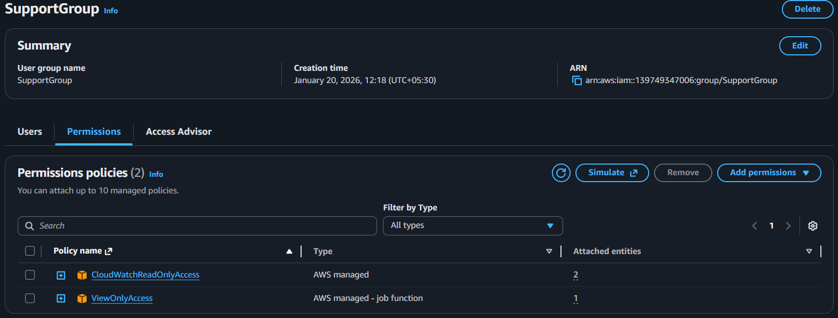

**TRAINER USERS**

**Trainer1**

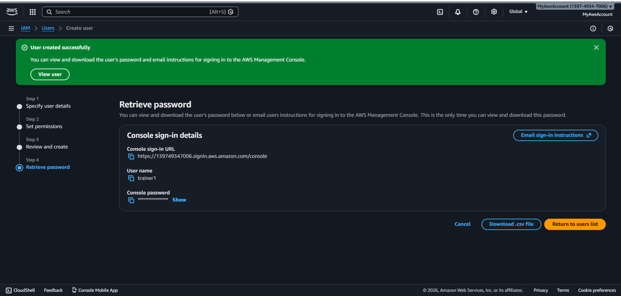

**Console sign-in URL**

<https://139749347006.signin.aws.amazon.com/console>

**User name**

trainer1

**Console password**

Trainer1@EduCloud2026!

**Trainer2**

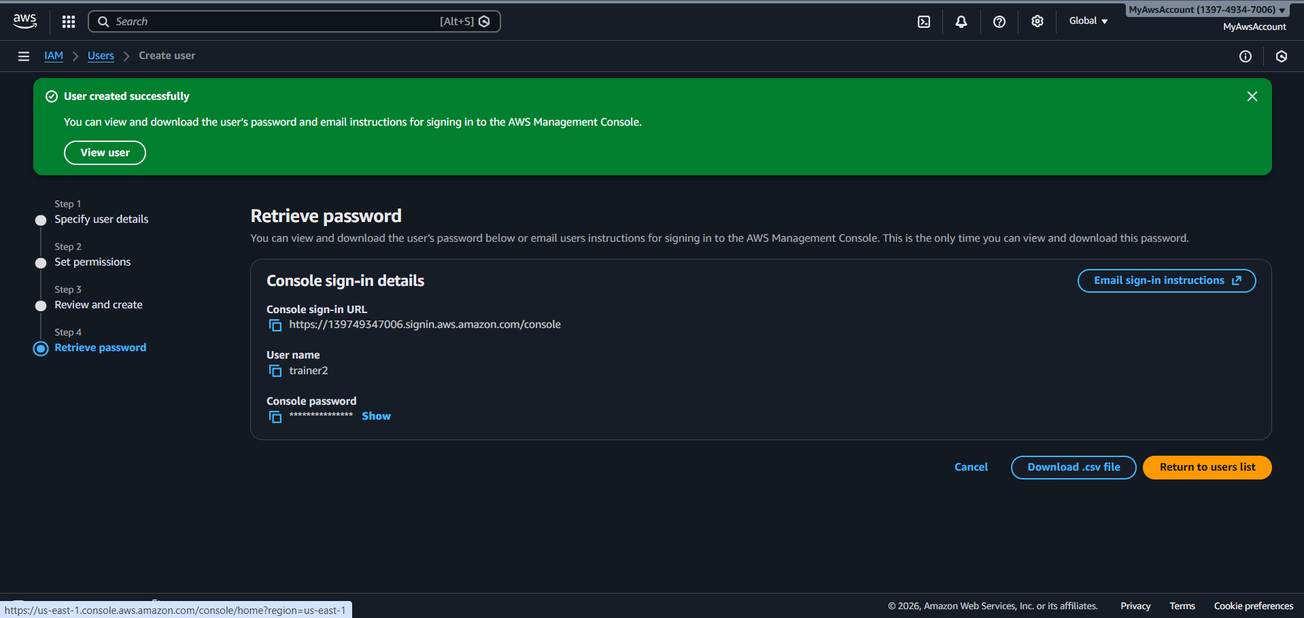

**Console sign-in URL**

<https://139749347006.signin.aws.amazon.com/console>

**User name**

trainer2

**Console password**

Trainer2@EduCloud2026!

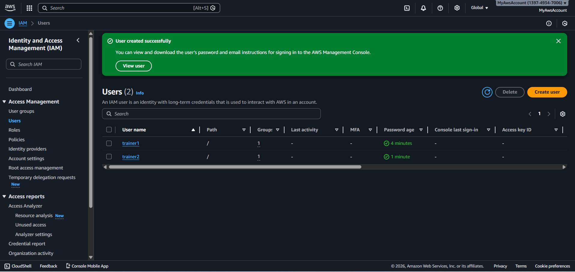

**STUDENT USERS**

**Student1**

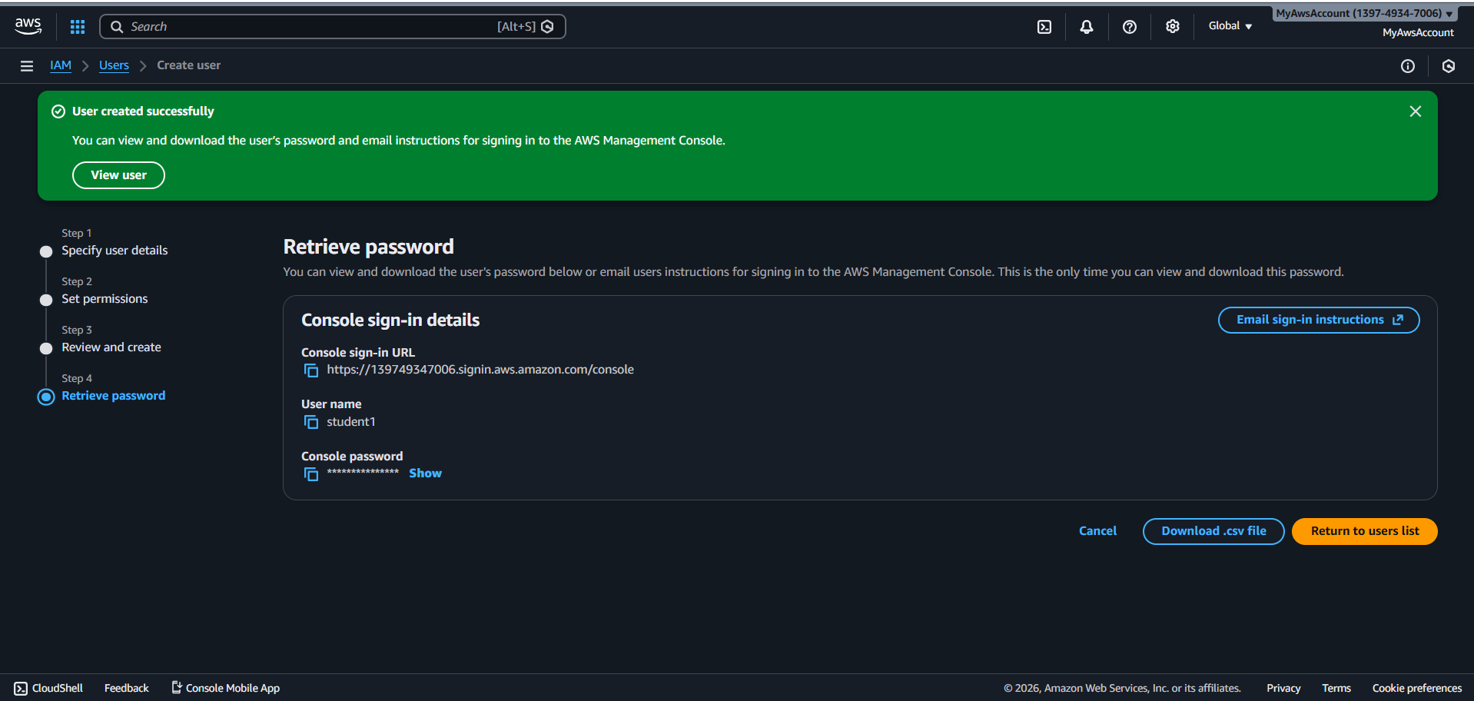

**Console sign-in URL**

<https://139749347006.signin.aws.amazon.com/console>

**User name**

student1

**Console password**

Student1@EduCloud2026!

**Student2**

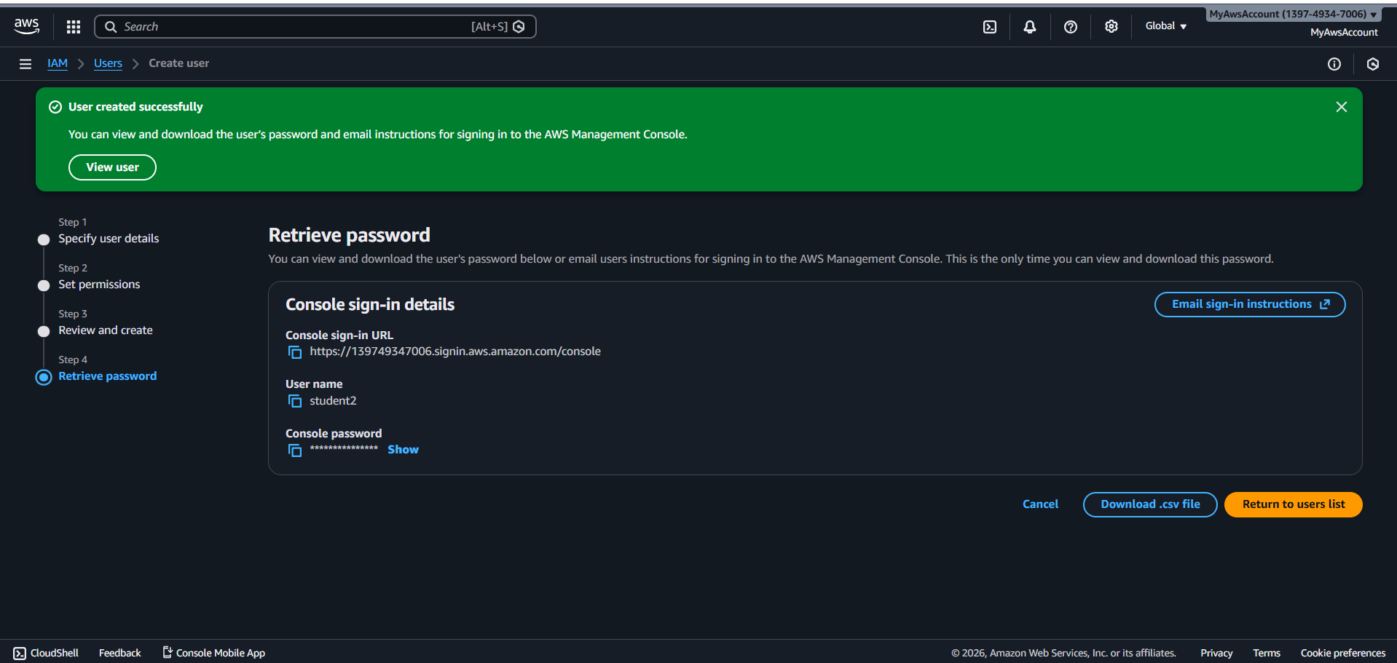

**Console sign-in URL**

<https://139749347006.signin.aws.amazon.com/console>

**User name**

student2

**Console password**

Student3@EduCloud2026!

**Student3**

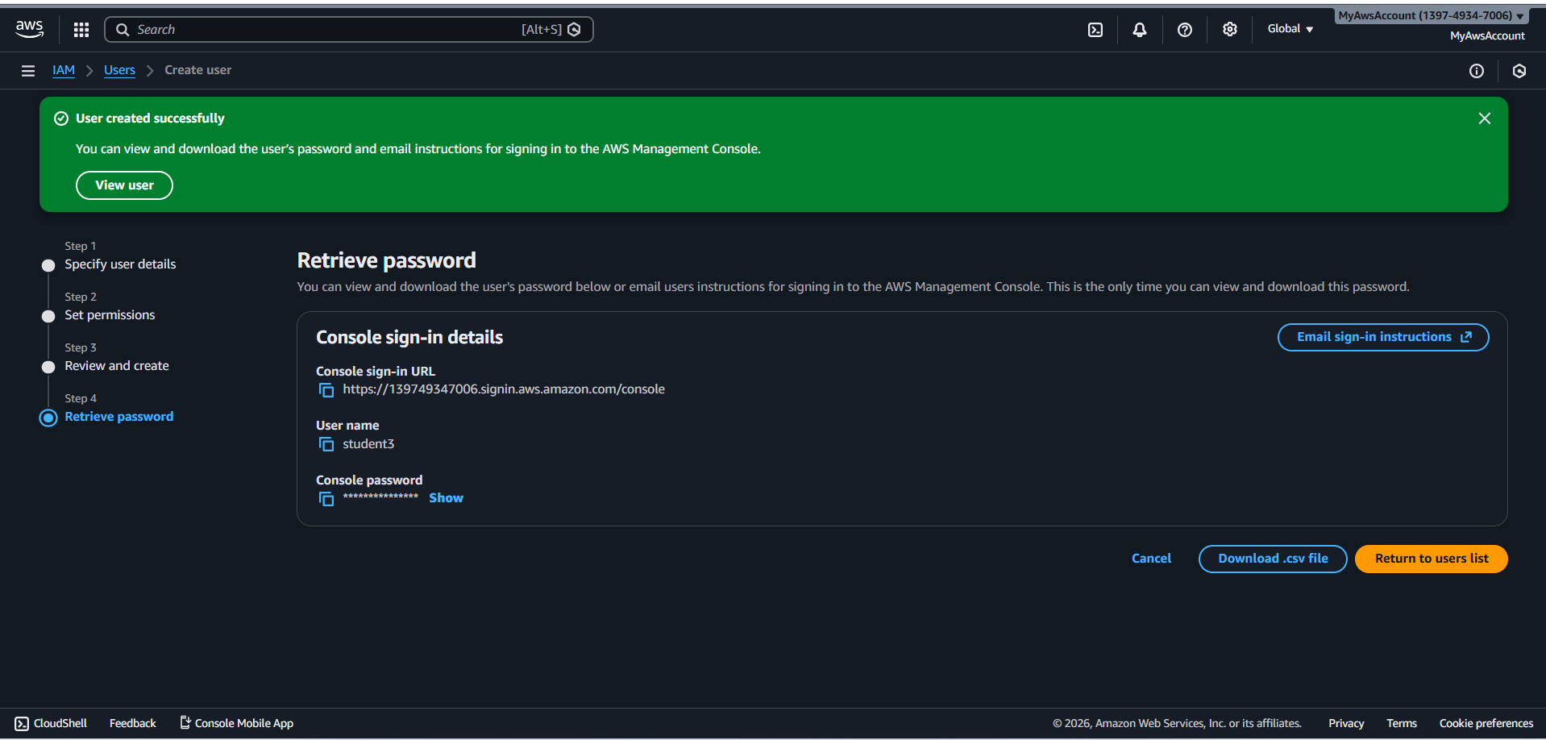

**Console sign-in URL**

<https://139749347006.signin.aws.amazon.com/console>

**User name**

student3

**Console password**

Student3@EduCloud2026!

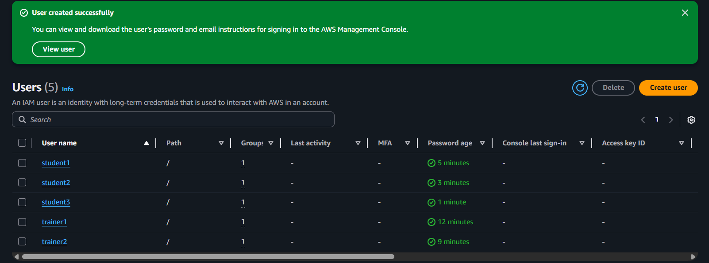

**SUPPORT USER**

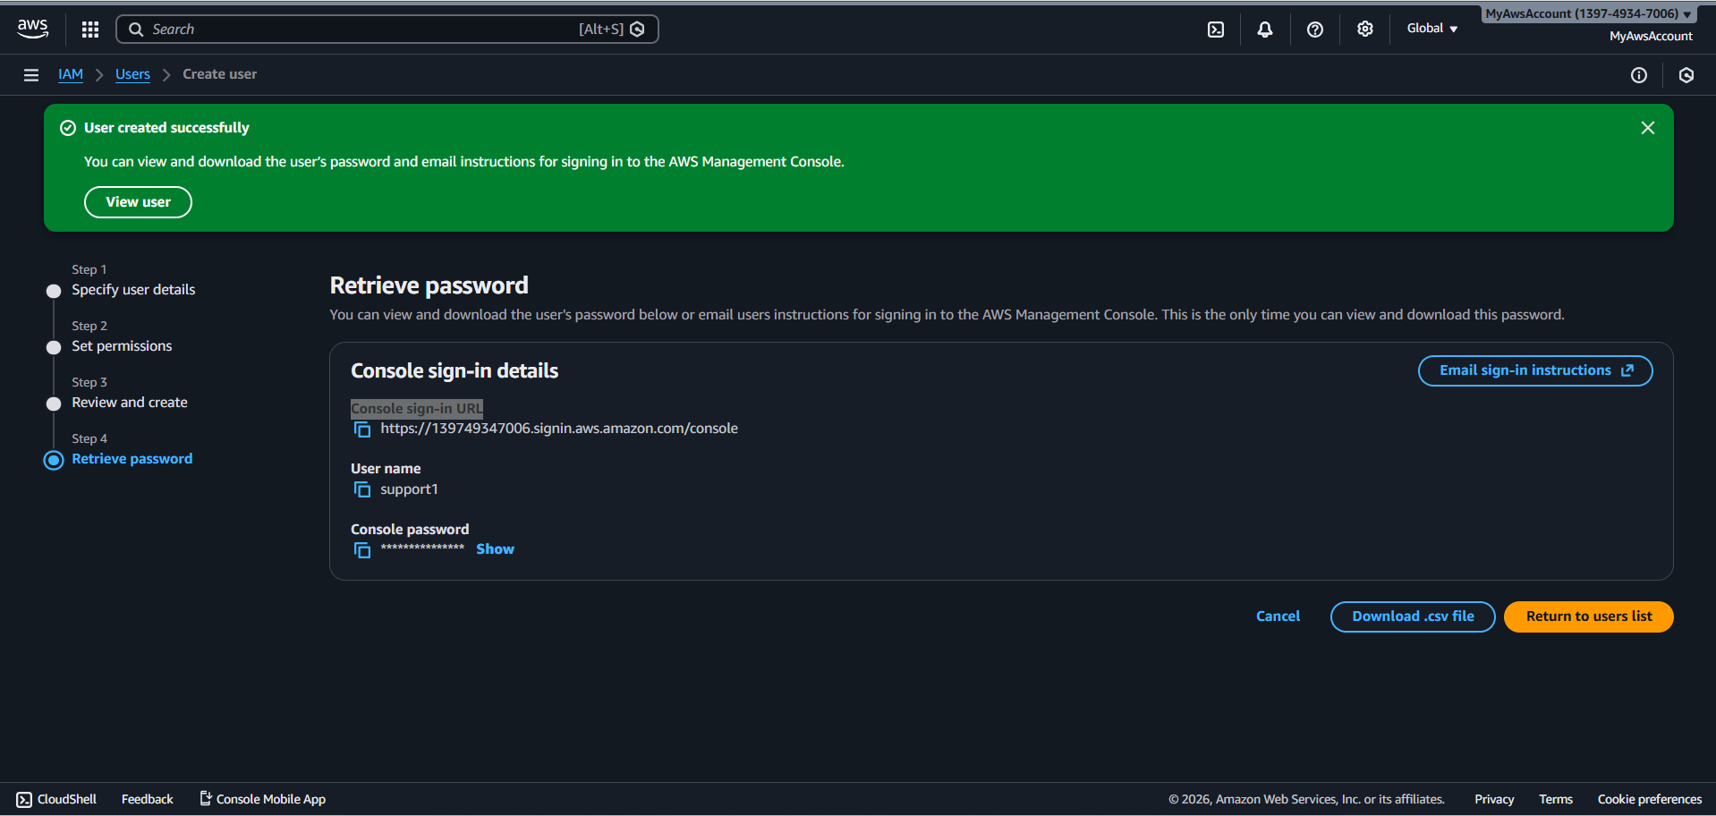

**Console sign-in URL**

<https://139749347006.signin.aws.amazon.com/console>

**User name**

support1

**Console password**

Support1@EduCloud2026!

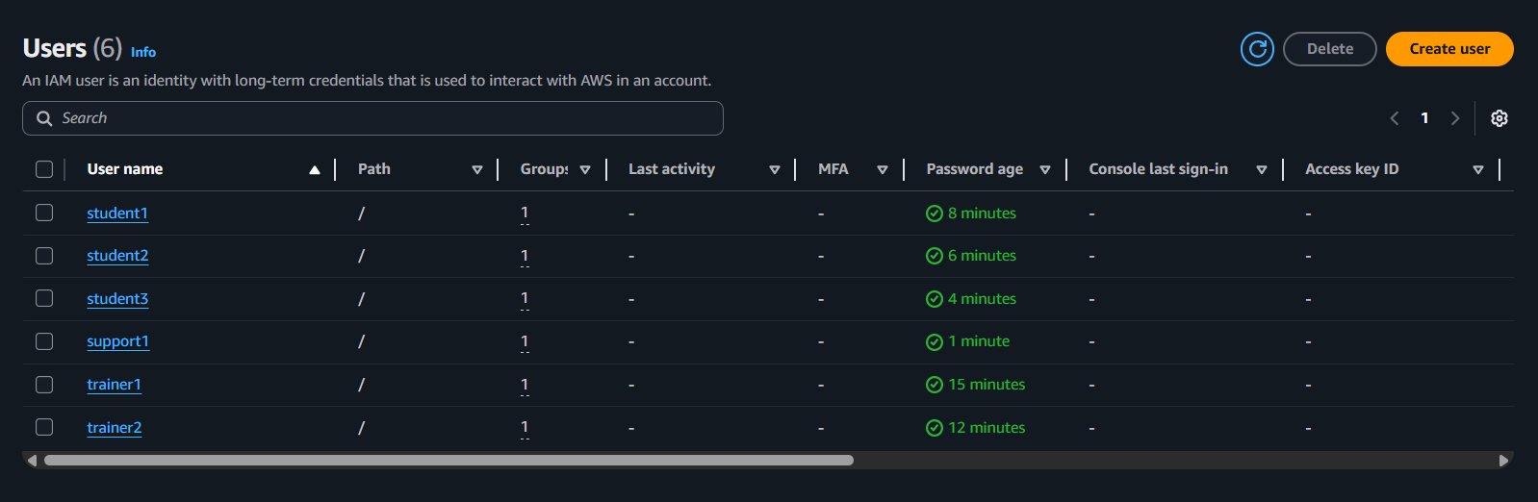

**Custom policy created**

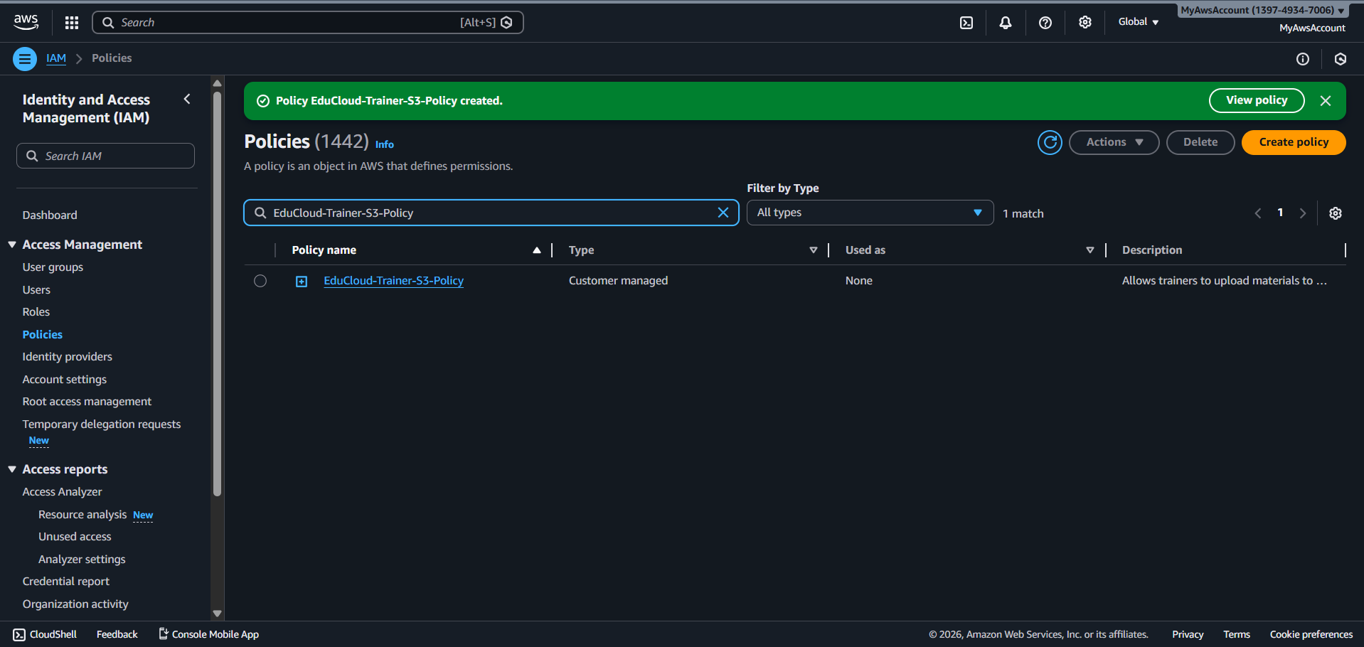

**Create policy**

{

"Version": "2012-10-17",

"Statement": [

{

"Sid": "AllowS3ListBuckets",

"Effect": "Allow",

"Action": [

"s3:ListAllMyBuckets",

"s3:GetBucketLocation"

],

"Resource": "*"

},

{

"Sid": "AllowS3MaterialsUpload",

"Effect": "Allow",

"Action": [

"s3:PutObject",

"s3:PutObjectAcl",

"s3:GetObject",

"s3:GetObjectVersion",

"s3:DeleteObject",

"s3:ListBucket"

],

"Resource": [

"arn:aws:s3:::educloud-materials",

"arn:aws:s3:::educloud-materials/*"

]

},

{

"Sid": "AllowS3MaterialsFolderAccess",

"Effect": "Allow",

"Action": [

"s3:PutObject",

"s3:GetObject",

"s3:DeleteObject"

],

"Resource": "arn:aws:s3:::educloud-materials/materials/*"

}

]

}

**ATTACH CUSTOM POLICY TO TRAINER GROUP**

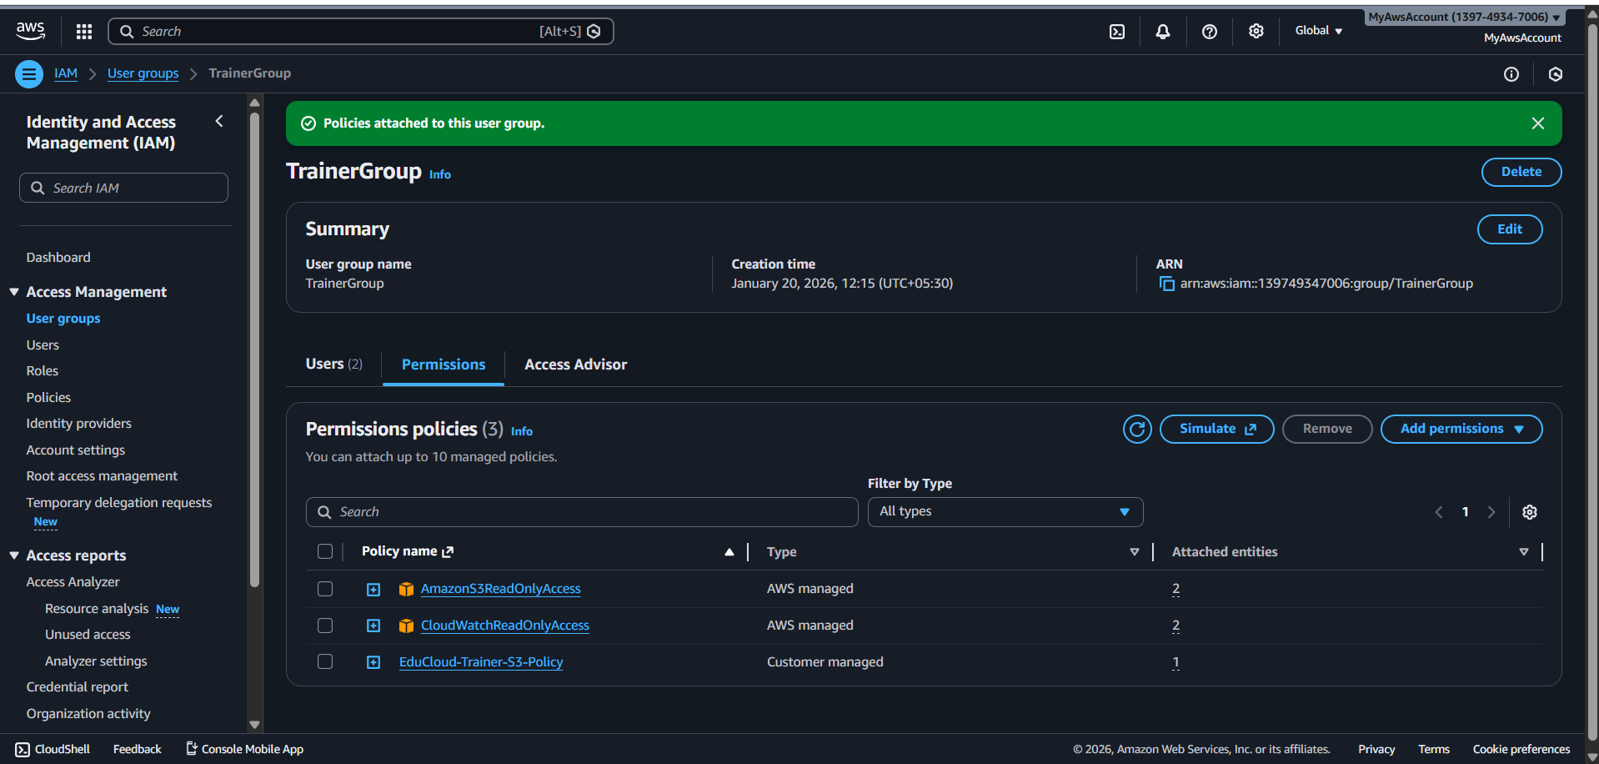

**EC2 ROLE**

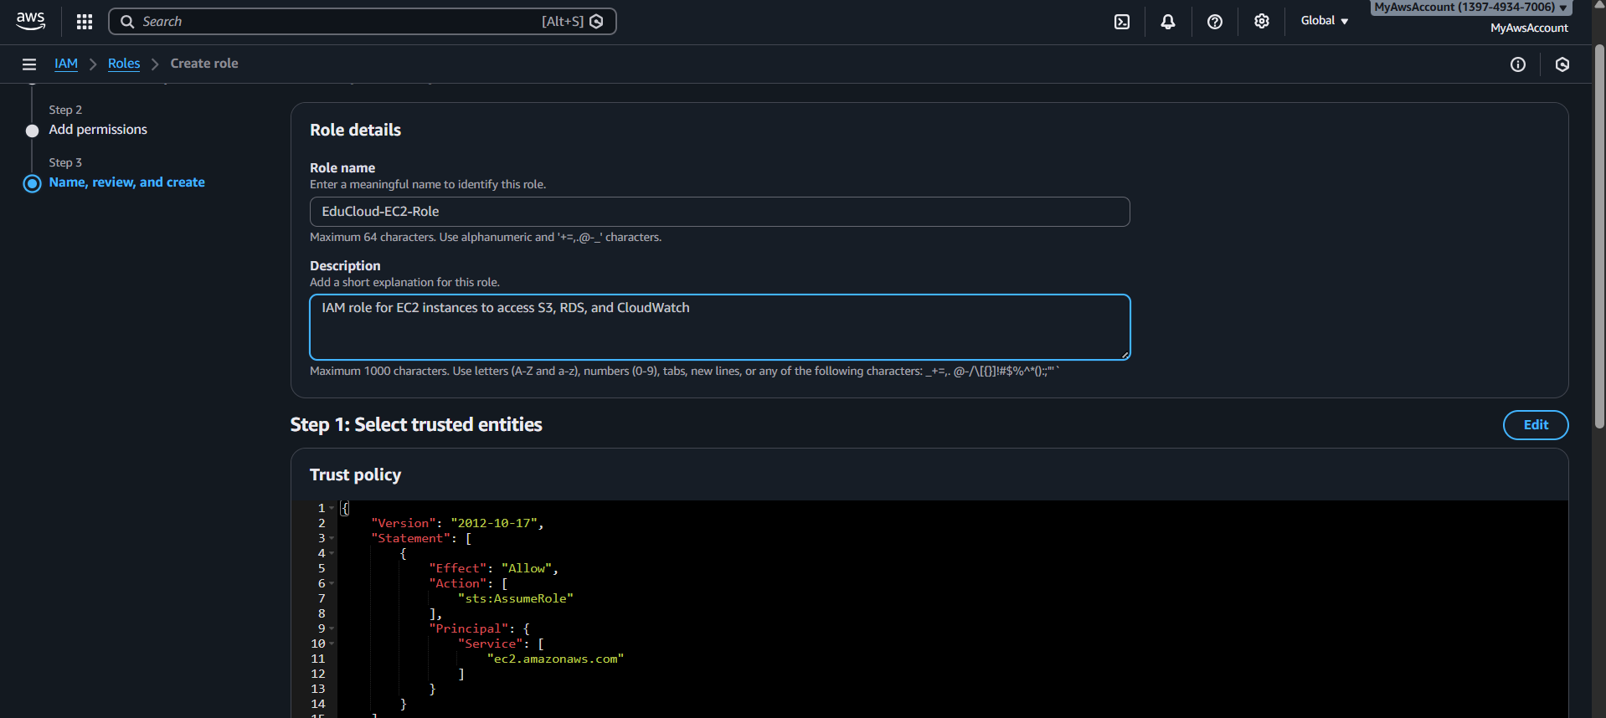

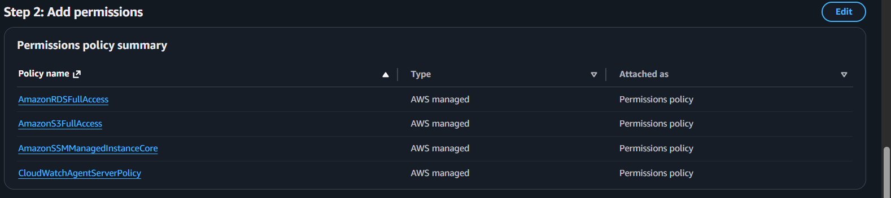

**IAM role for EC2 instances to access S3, RDS, and CloudWatch**

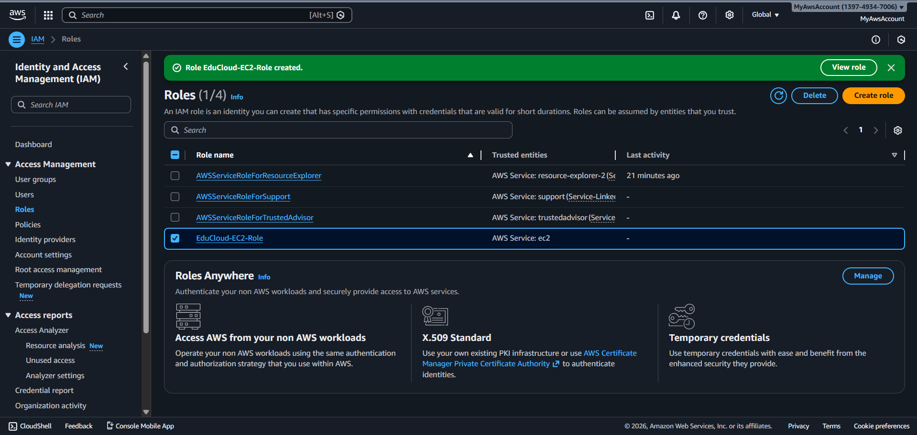

**EduCloud-Lambda-Role**

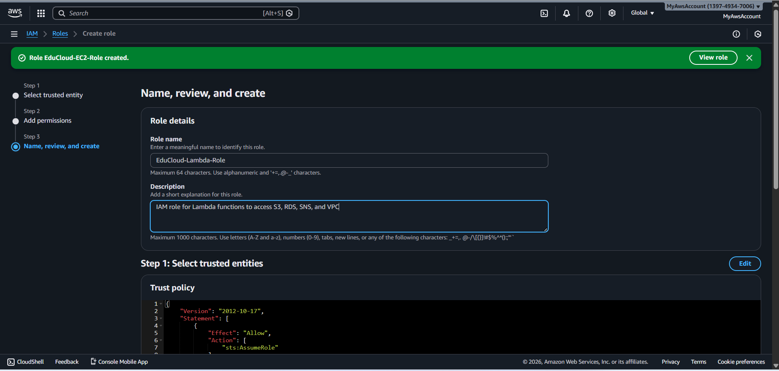

**IAM role for Lambda functions to access S3, RDS, SNS, and VPC**

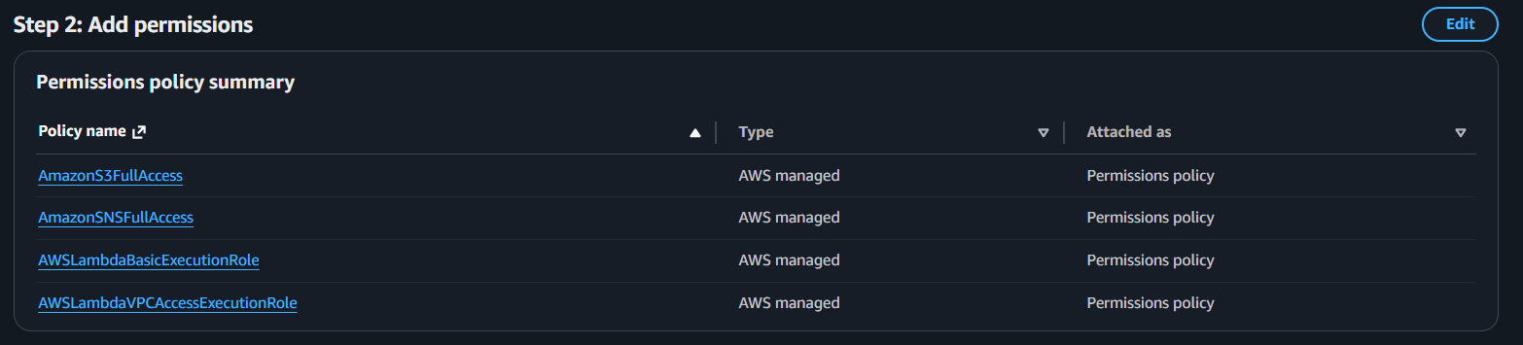

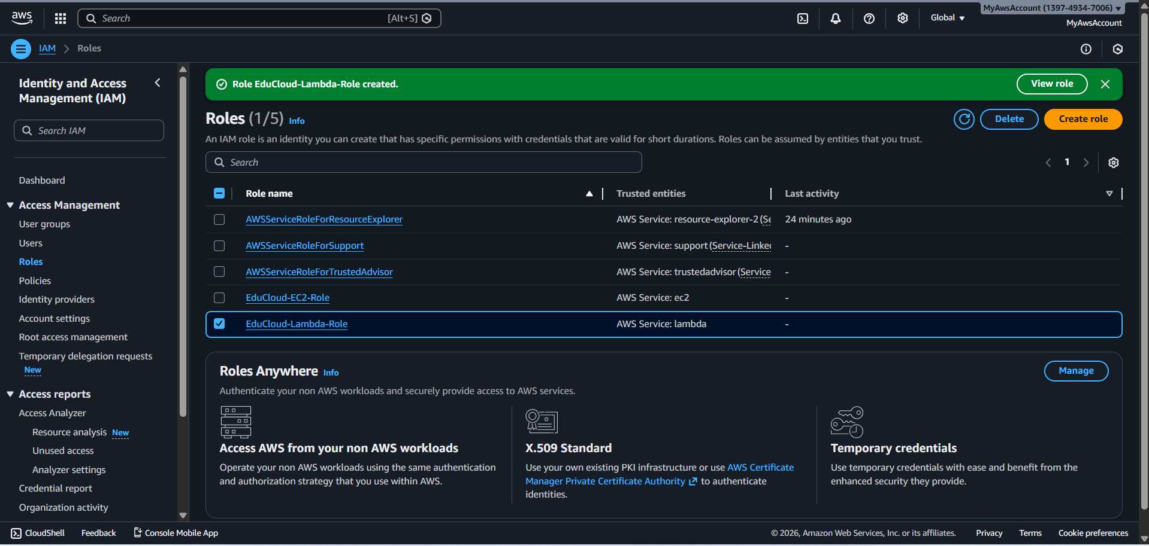

**S3 ARCHITECTURE**

**PRIMARY S3 BUCKET**

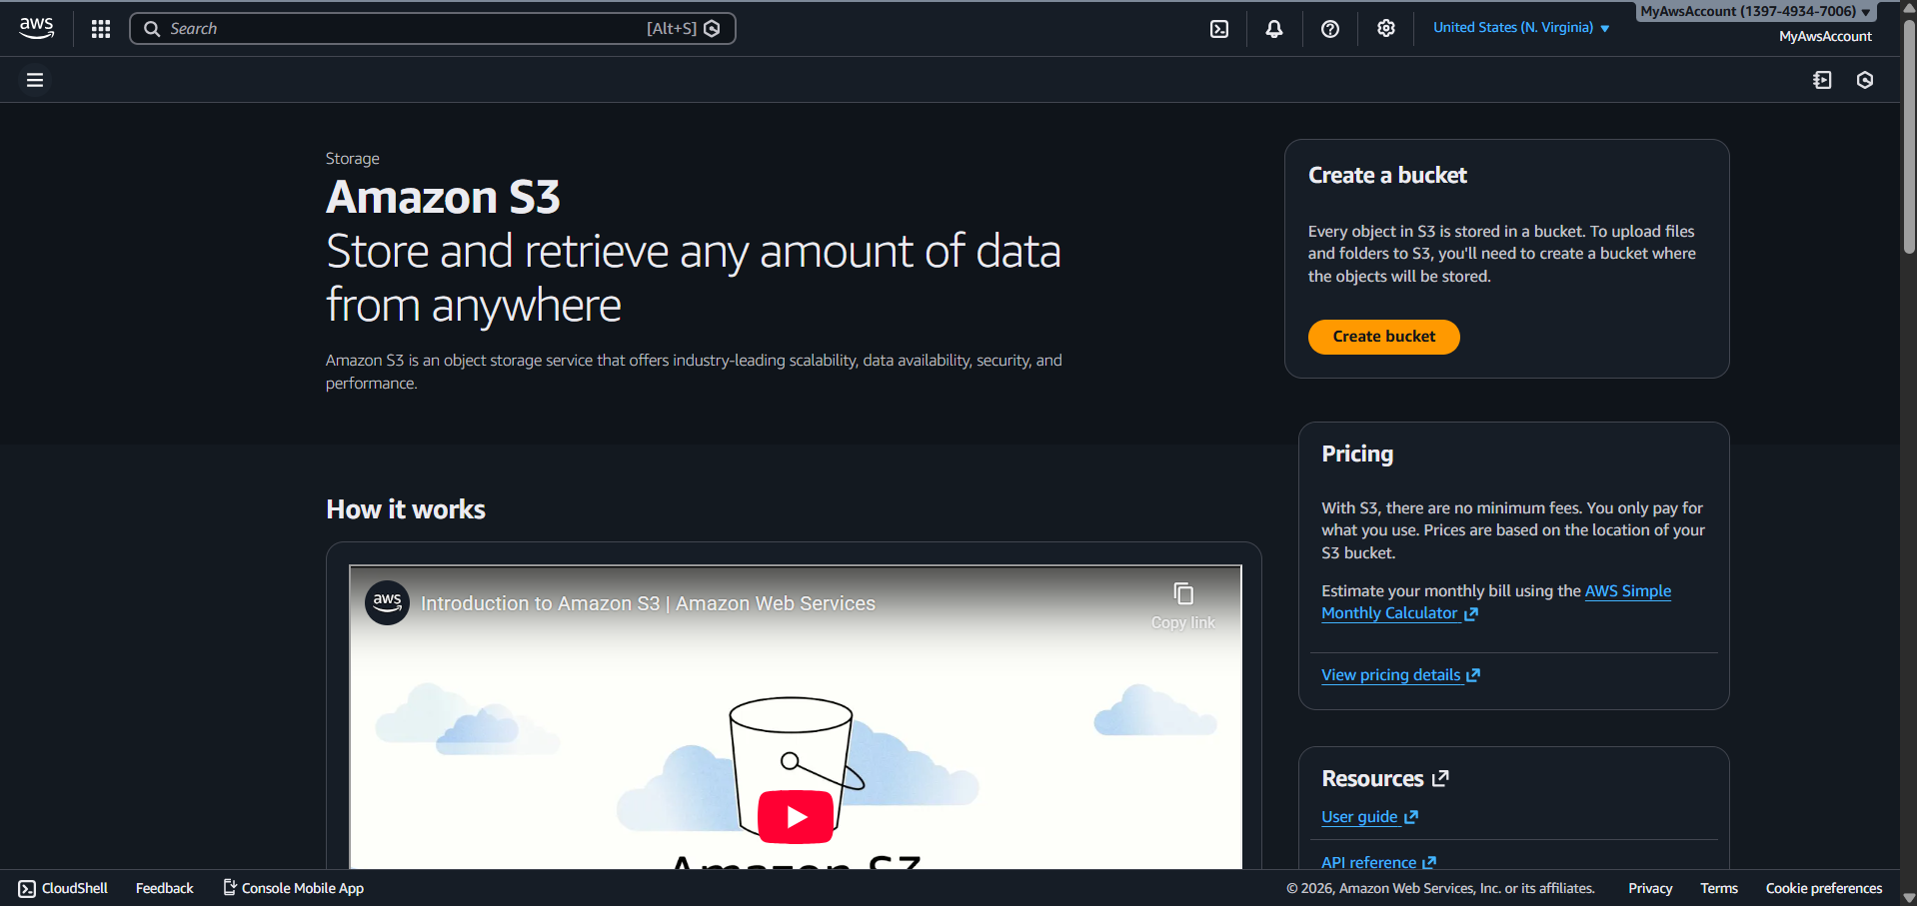

**Bucket name and region**

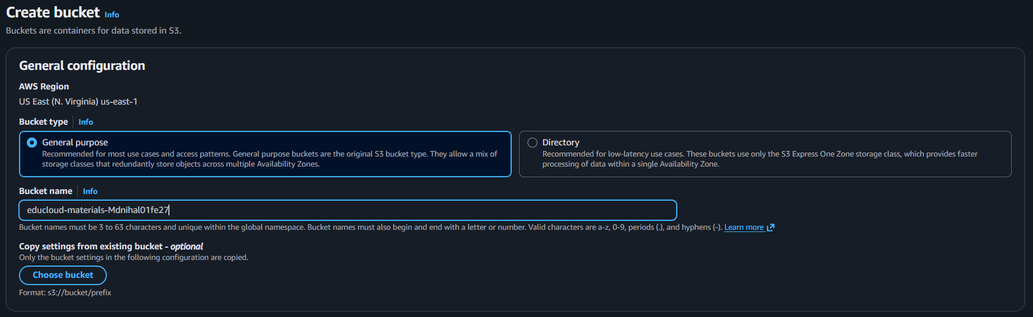

**Bucket created confirmation**

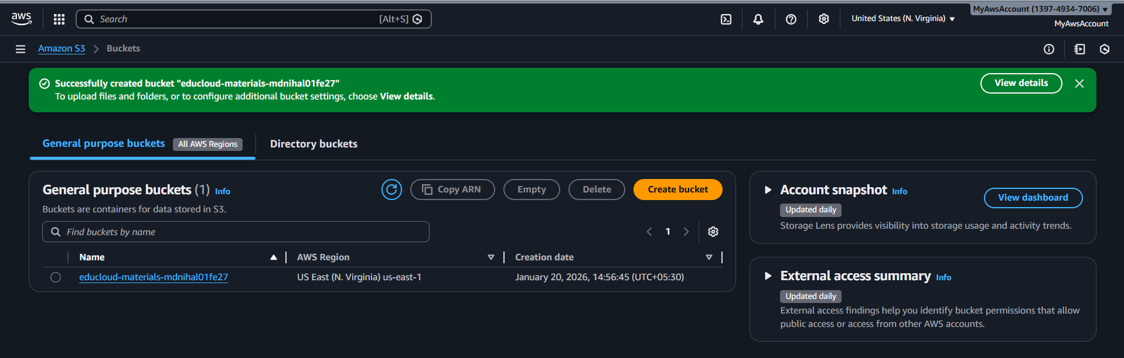

**CREATED BACKUP BUCKET - US West (Oregon) us-west-2**

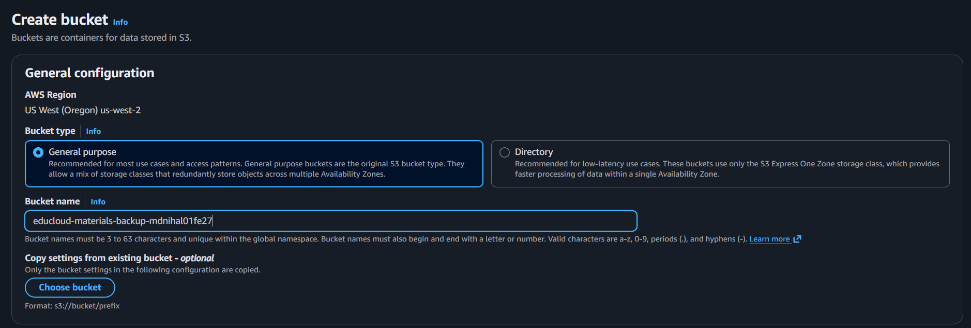

**Backup bucket created in us-west-2**

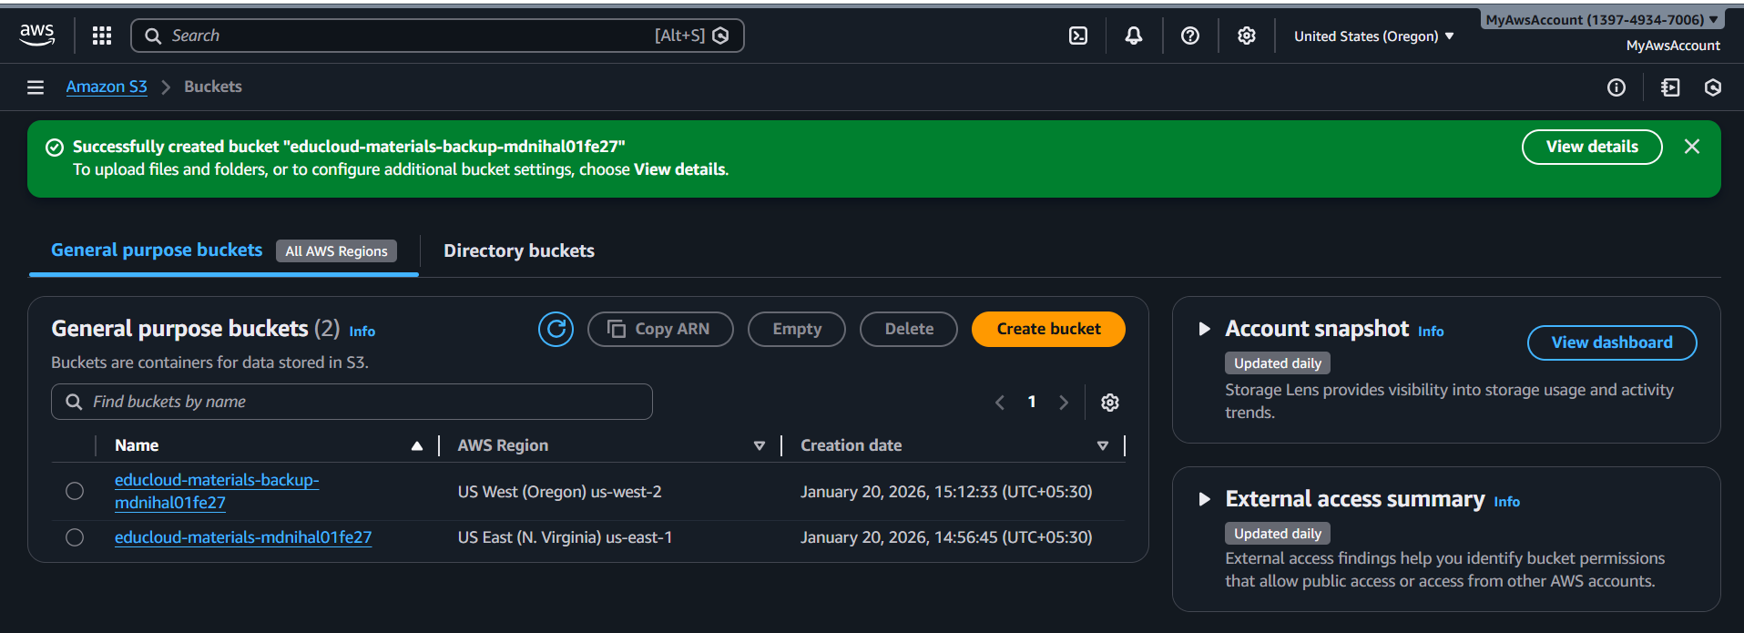

**Lifecycle rule details**

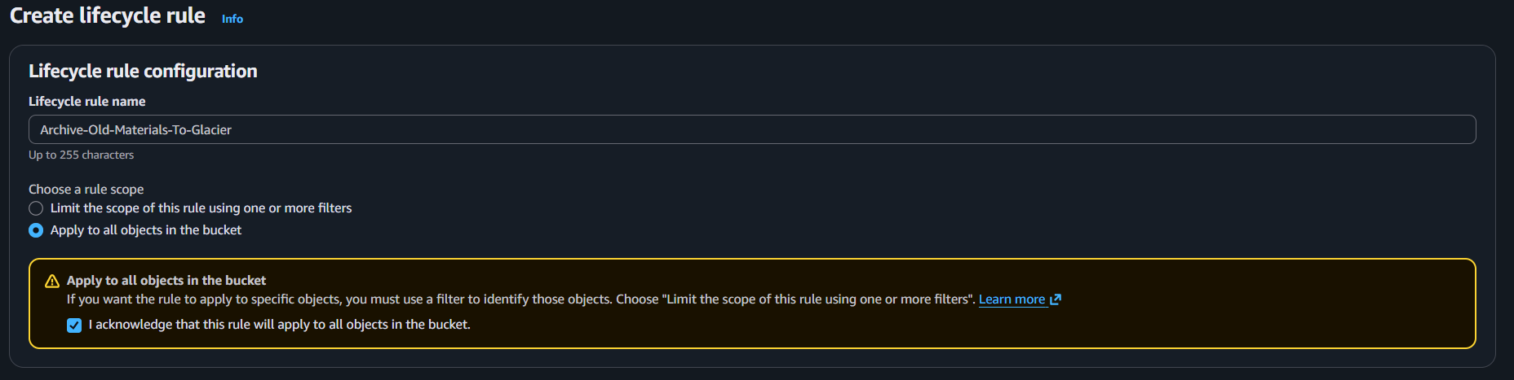

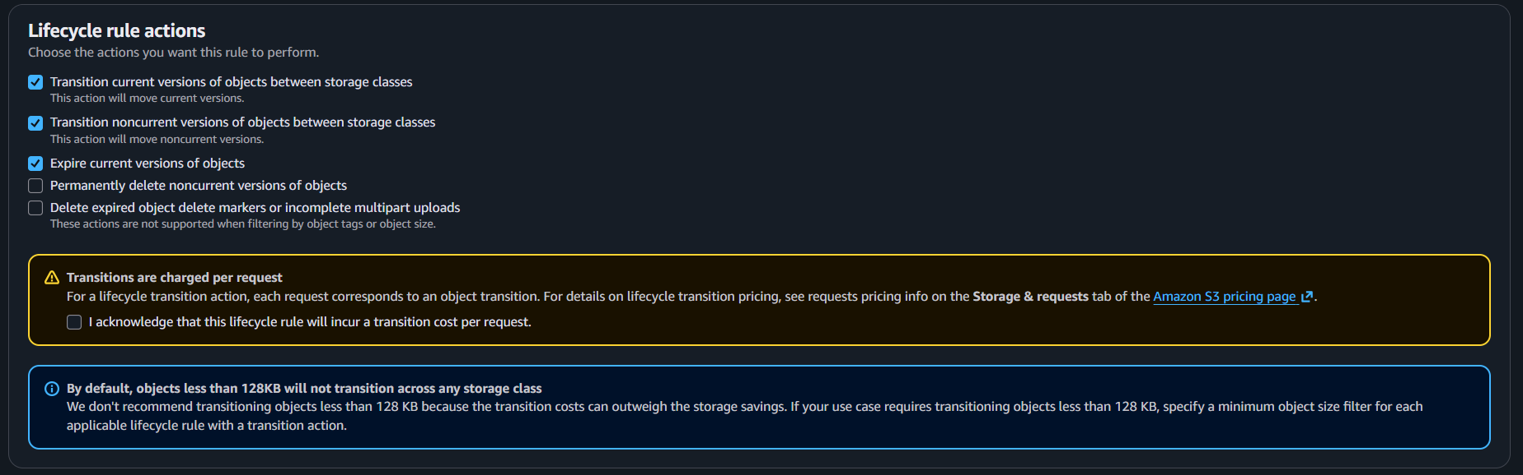

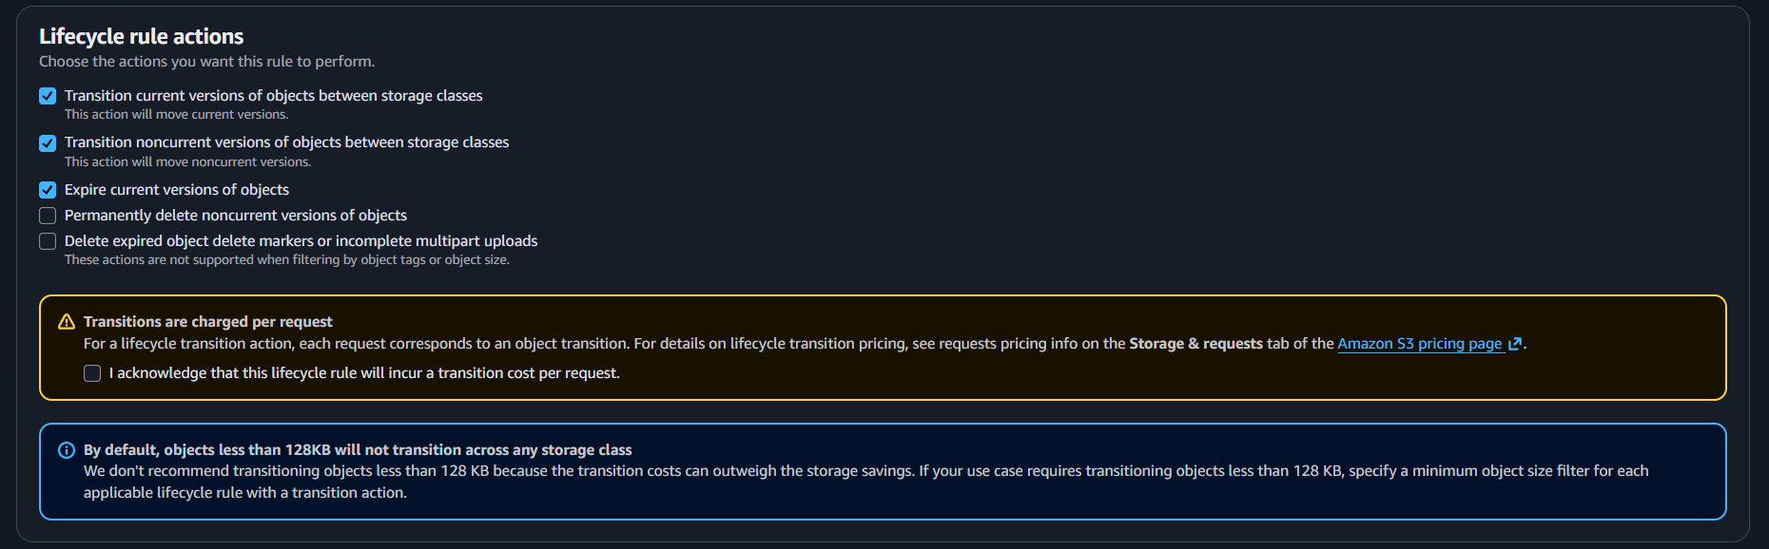

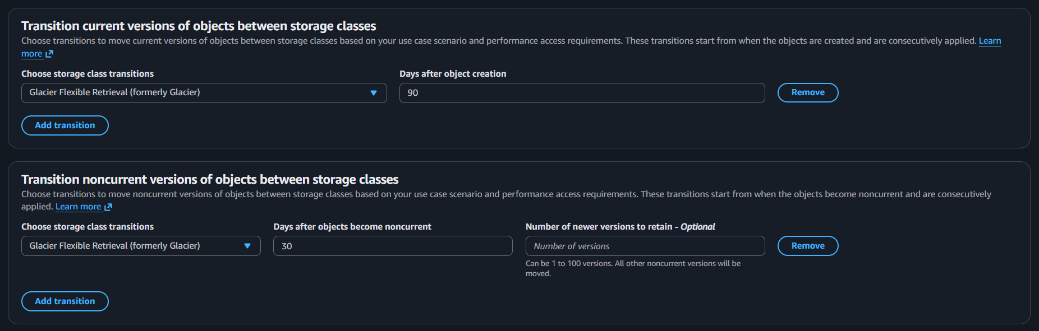

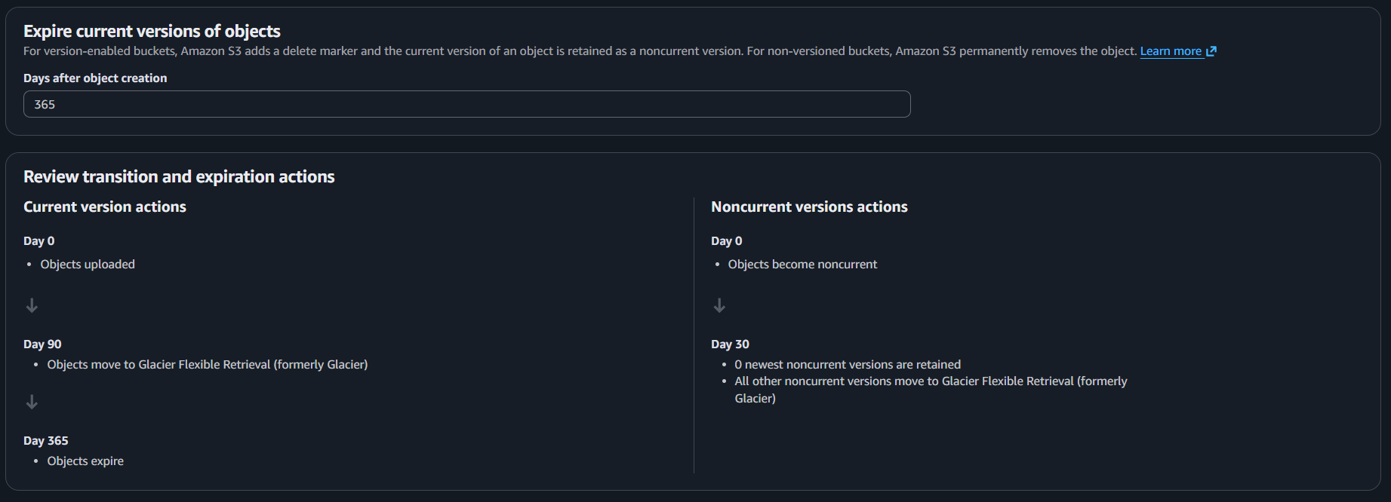

**Lifecycle rule created**

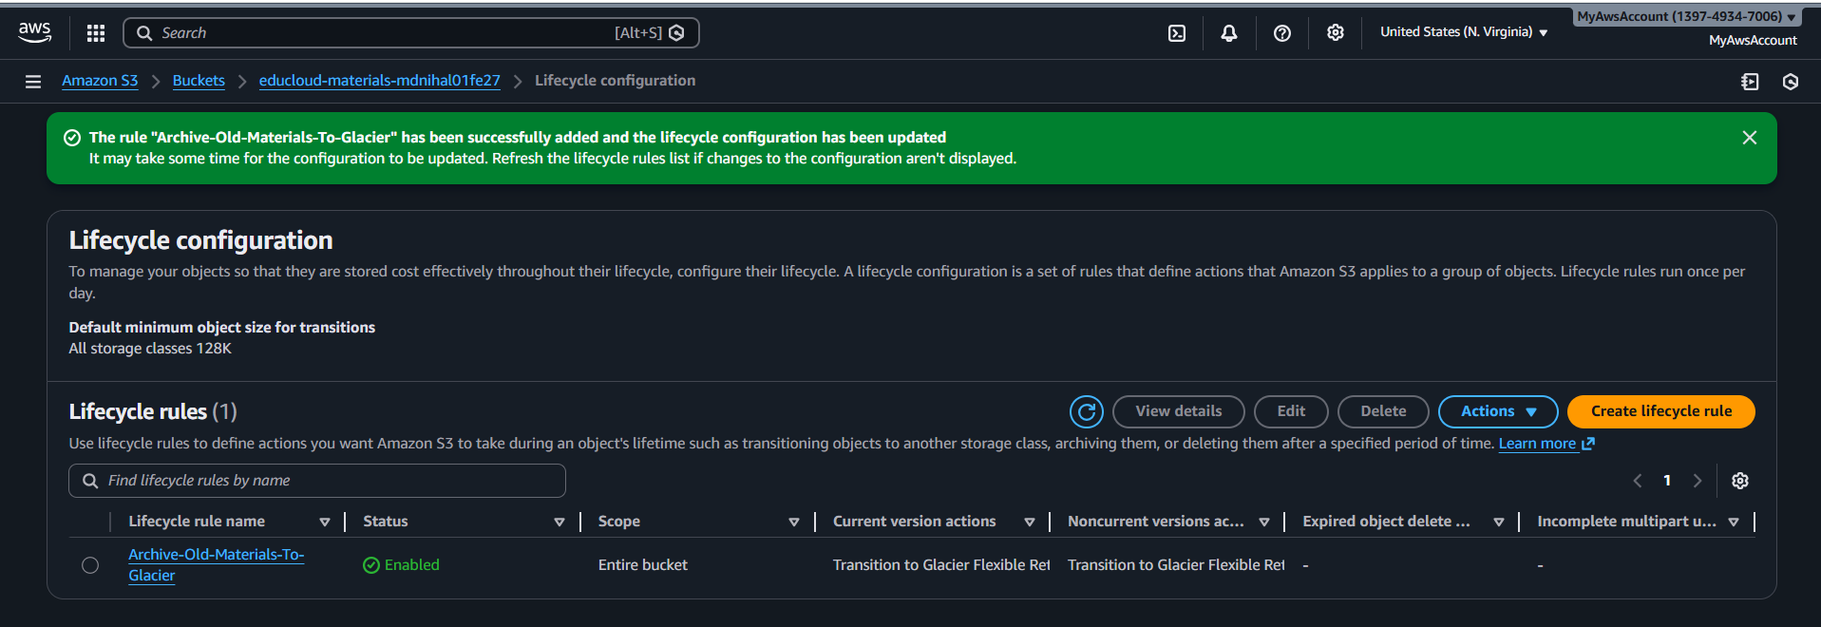

**CROSS-REGION REPLICATION**

**Custom policy for the replication**

{

"Version": "2012-10-17",

"Statement": [

{

"Effect": "Allow",

"Action": [

"s3:GetReplicationConfiguration",

"s3:ListBucket"

],

"Resource": [

"arn:aws:s3:::educloud-materials-mdnihal01fe27"

]

},

{

"Effect": "Allow",

"Action": [

"s3:GetObjectVersionForReplication",

"s3:GetObjectVersionAcl",

"s3:GetObjectVersionTagging"

],

"Resource": [

"arn:aws:s3:::educloud-materials-mdnihal01fe27/*"

]

},

{

"Effect": "Allow",

"Action": [

"s3:ReplicateObject",

"s3:ReplicateDelete",

"s3:ReplicateTags"

],

"Resource": [

"arn:aws:s3:::educloud-materials-mdnihal01fe27/*"

]

}

]

}

**Custom Policy attached to the replication role**

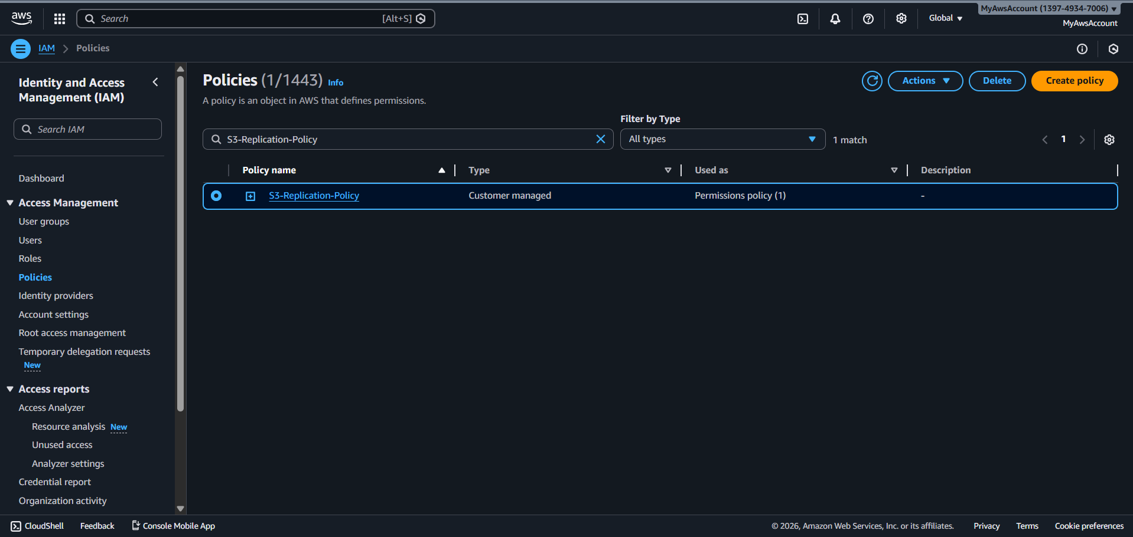

**S3 replication role**

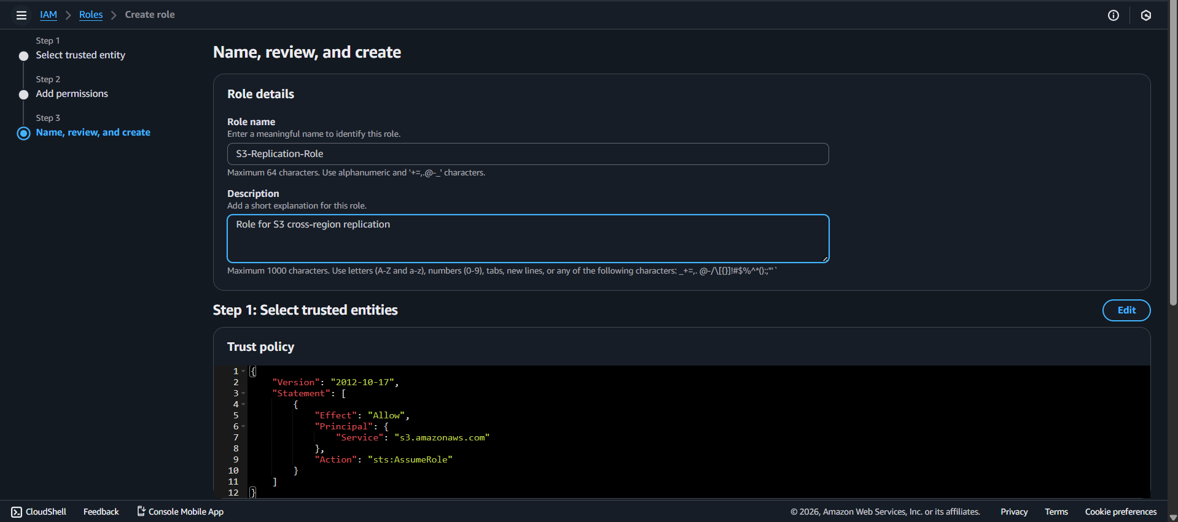

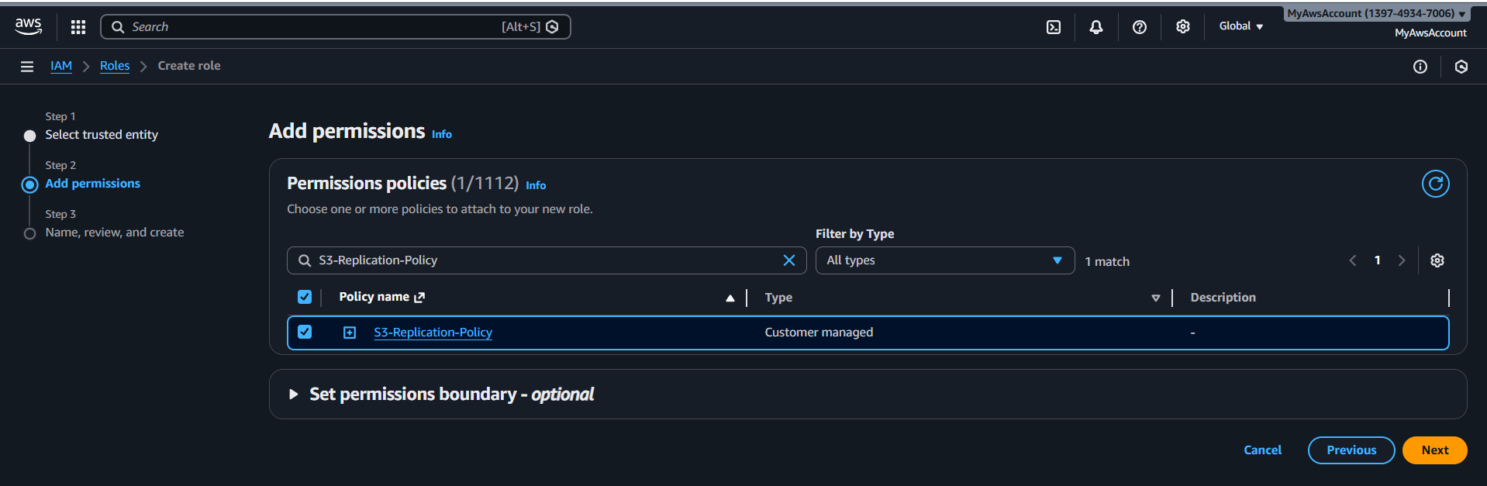

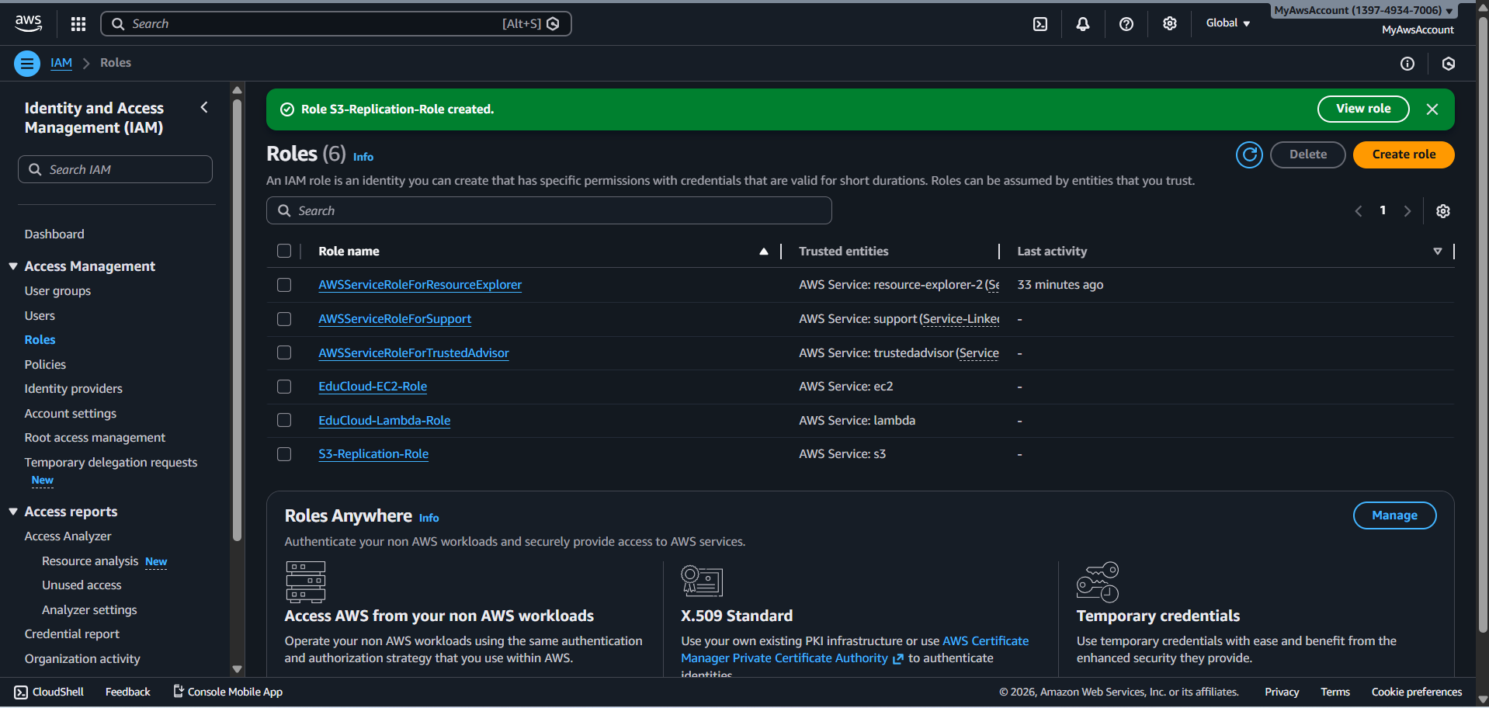

**Replication rule created**

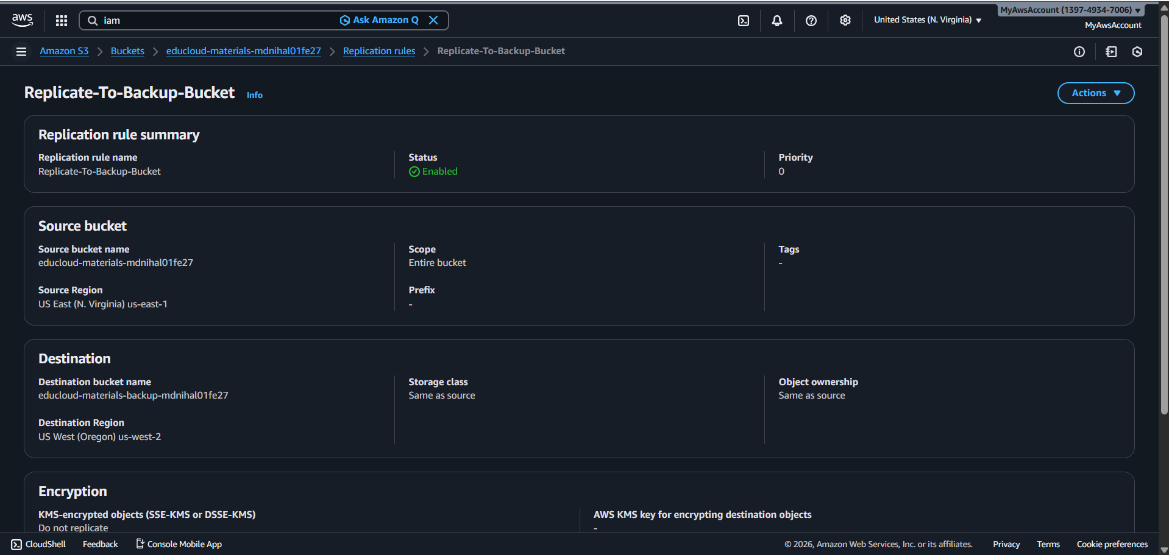

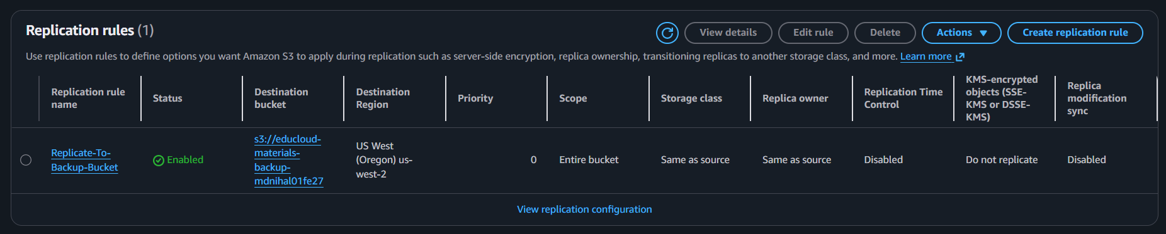

**CONFIGURE CORS FOR WEB ACCESS**

**CORS Configuration**

[

{

"AllowedHeaders": [

"*"

],

"AllowedMethods": [

"GET",

"HEAD",

"PUT",

"POST"

],

"AllowedOrigins": [

"*"

],

"ExposeHeaders": [

"ETag",

"x-amz-request-id"

],

"MaxAgeSeconds": 3000

}

]

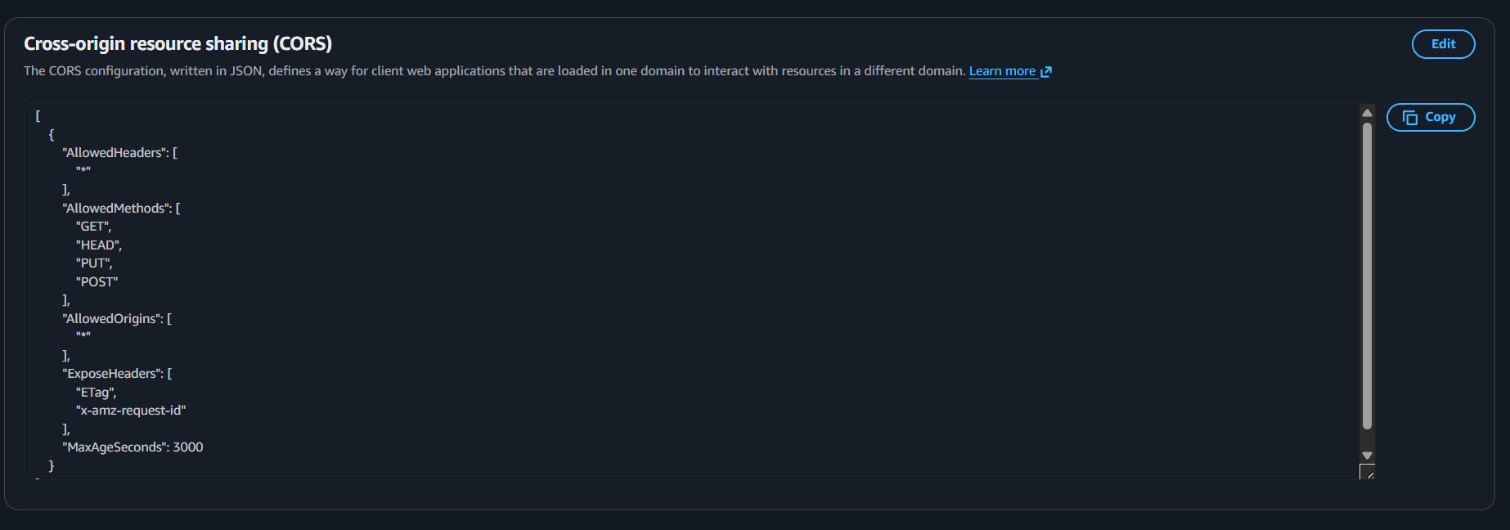

**CONFIGURE BUCKET POLICY (FOR CLOUDFRONT)**

{

"Version": "2012-10-17",

"Statement": [

{

"Sid": "AllowCloudFrontServicePrincipal",

"Effect": "Allow",

"Principal": {

"Service": "cloudfront.amazonaws.com"

},

"Action": "s3:GetObject",

"Resource": "arn:aws:s3:::educloud-materials-YOURNAME/*",

"Condition": {

"StringEquals": {

"AWS:SourceArn": "arn:aws:cloudfront::ACCOUNT-ID:distribution/DISTRIBUTION-ID"

}

}

}

]

}

**ENABLE SERVER ACCESS LOGGING**

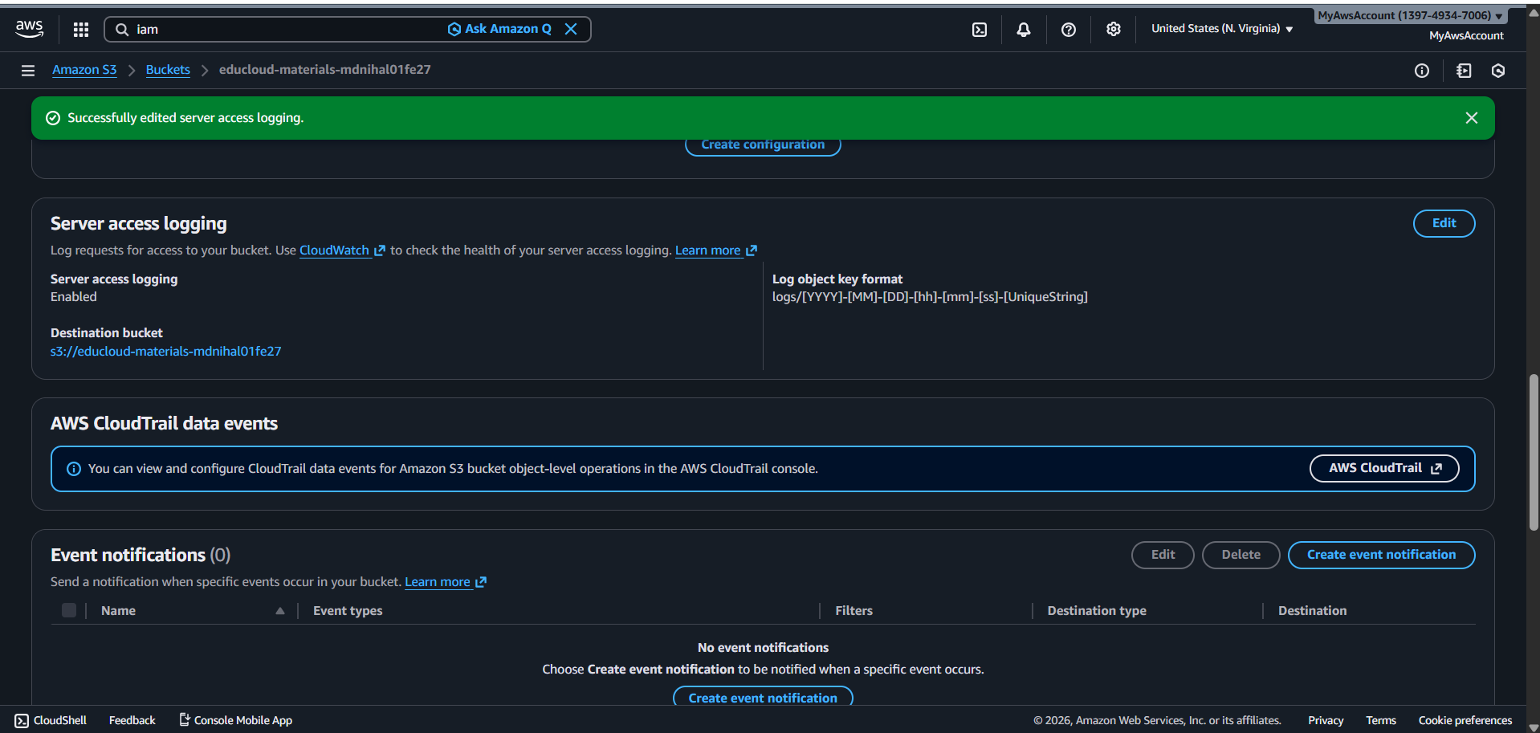

**CONFIGURE S3 EVENT NOTIFICATIONS (FOR LAMBDA )**

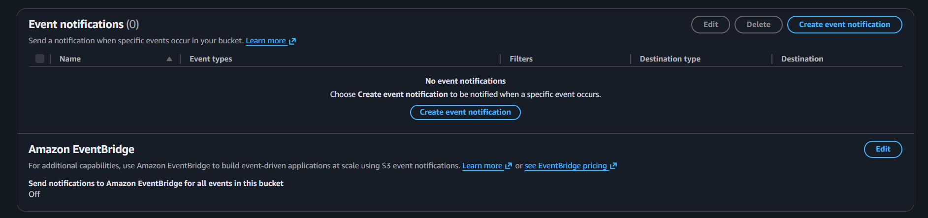

**File upload material folder (test)**

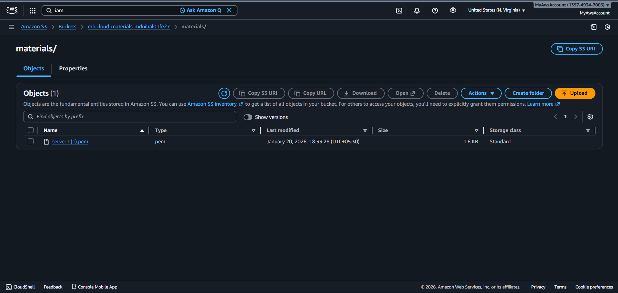

**File upload Multiple versions showing (test)**

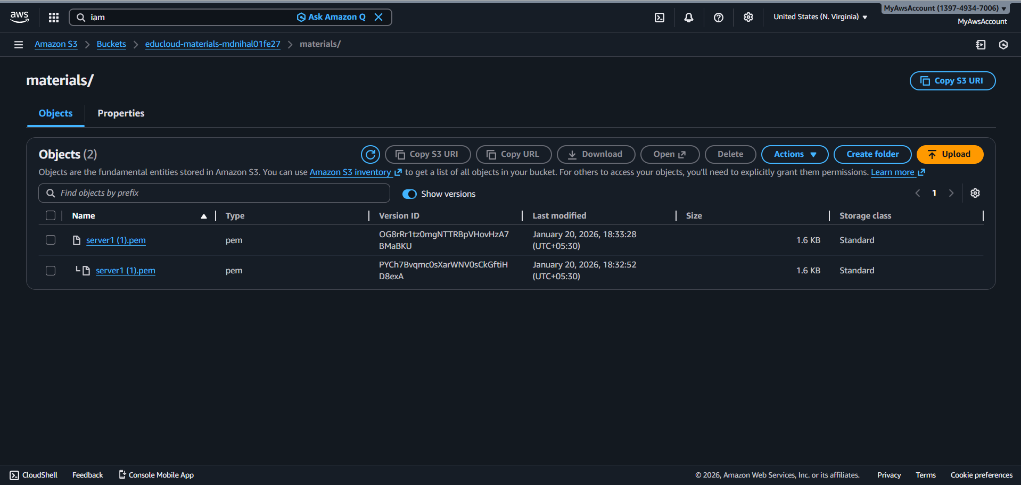

**File replicated to backup bucket**

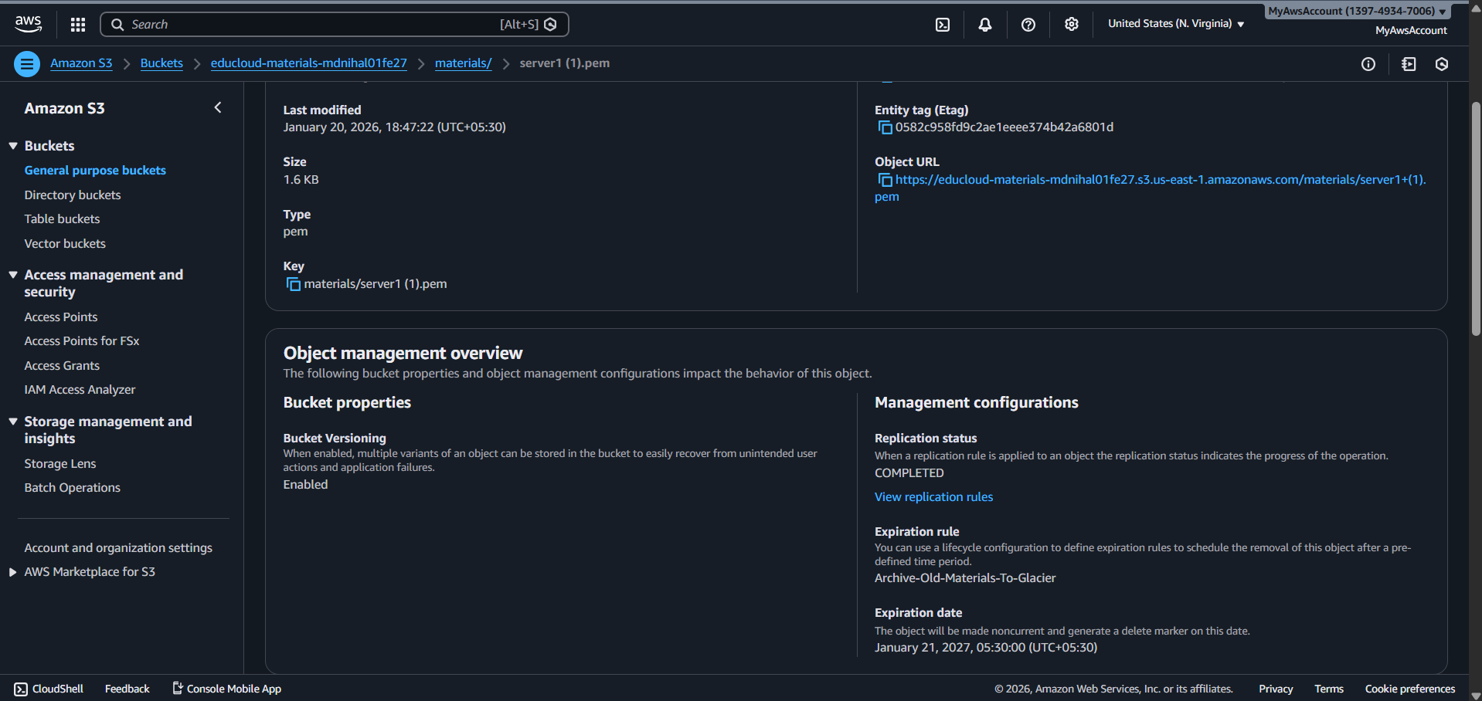

**Server Access logging**

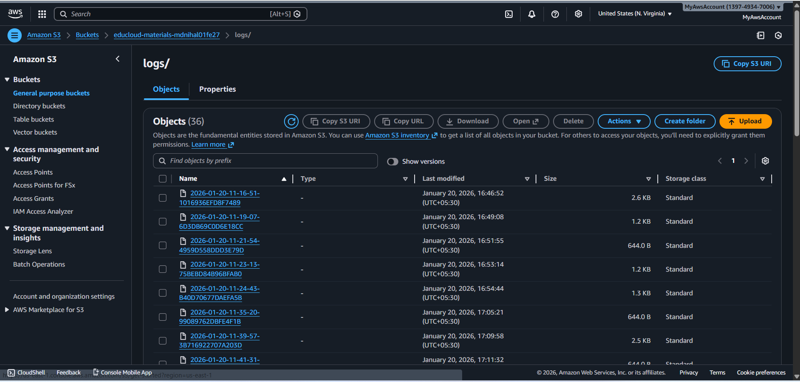

**WHAT IS SERVER ACCESS LOGGING?**

Server Access Logging records every request made to your S3 bucket:

* Who accessed it
* What files they viewed/downloaded
* When it happened
* What operation (GET, PUT, DELETE, etc.)
* HTTP status code (success/failure)

**IP address of requester**

**BENEFITS:**

1. **Security Auditing**
   * Track unauthorized access attempts
   * Monitor who's accessing sensitive files
   * Detect unusual activity patterns
2. **Compliance**
   * Required for many regulations (HIPAA, PCI-DSS, SOX)
   * Provides audit trail for investigations
3. **Usage Analytics**
   * Which files are most popular
   * Peak usage times
   * Student engagement metrics

**Primary Bucket (us-east-1):**

educloud-materials- mdnihal01fe27 created

Versioning enabled

Encryption (SSE-S3) enabled

4 folders created (materials, assignments, logs, backups)

Test file uploaded successfully

**Backup Bucket (us-west-2):**

educloud-materials-backup-mdnihal01fe27 created

Versioning enabled

Encryption enabled

**Configuration:**

Lifecycle rule created (Glacier after 90 days)

Cross-region replication configured and working

CORS configuration added

IAM replication role created

Server access logging enabled (optional)

**Testing:**

Test file uploaded

Multiple versions visible

File replicated to backup bucket

**RDS MYSQL DATABASE SETUP**

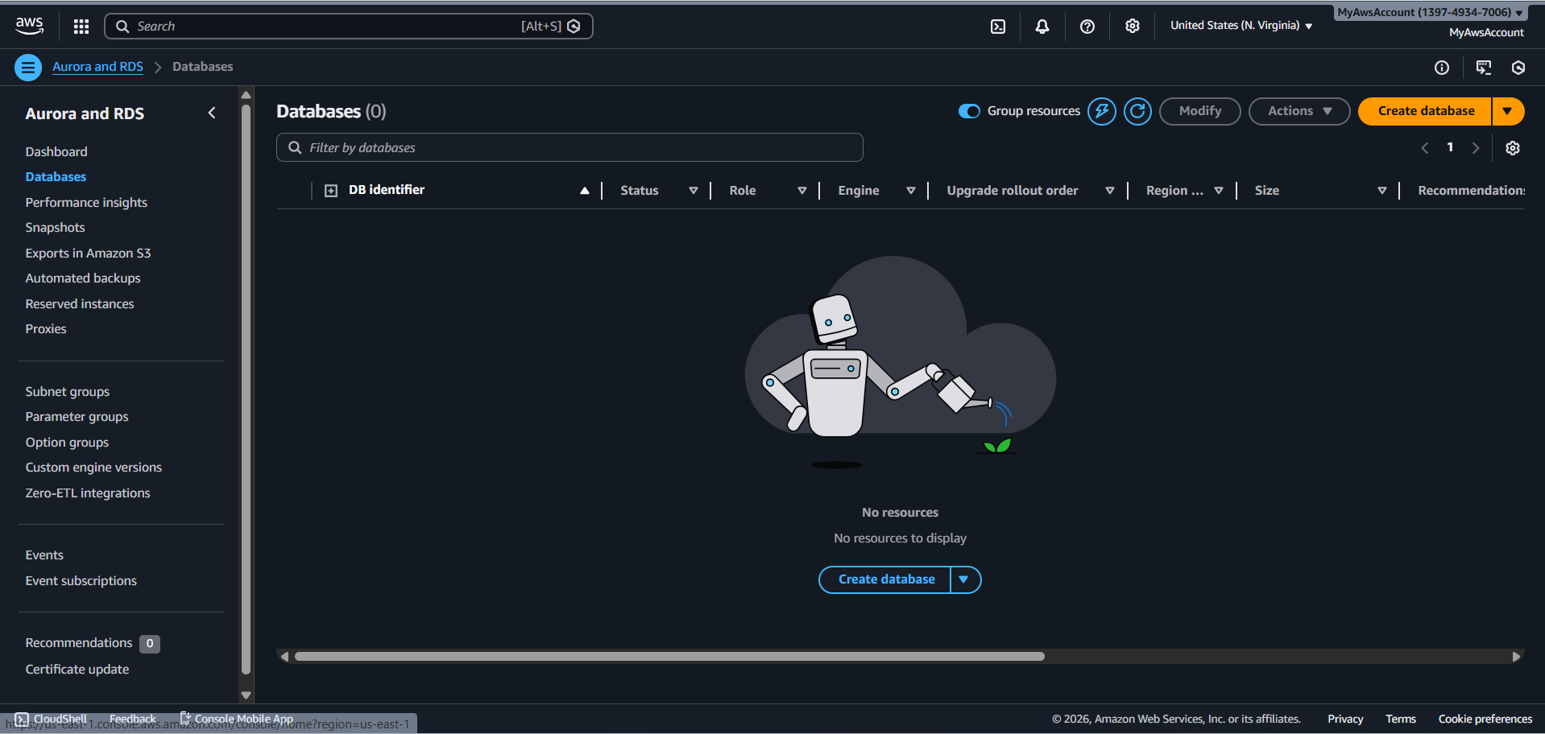

**CREATE DB SUBNET GROUP**

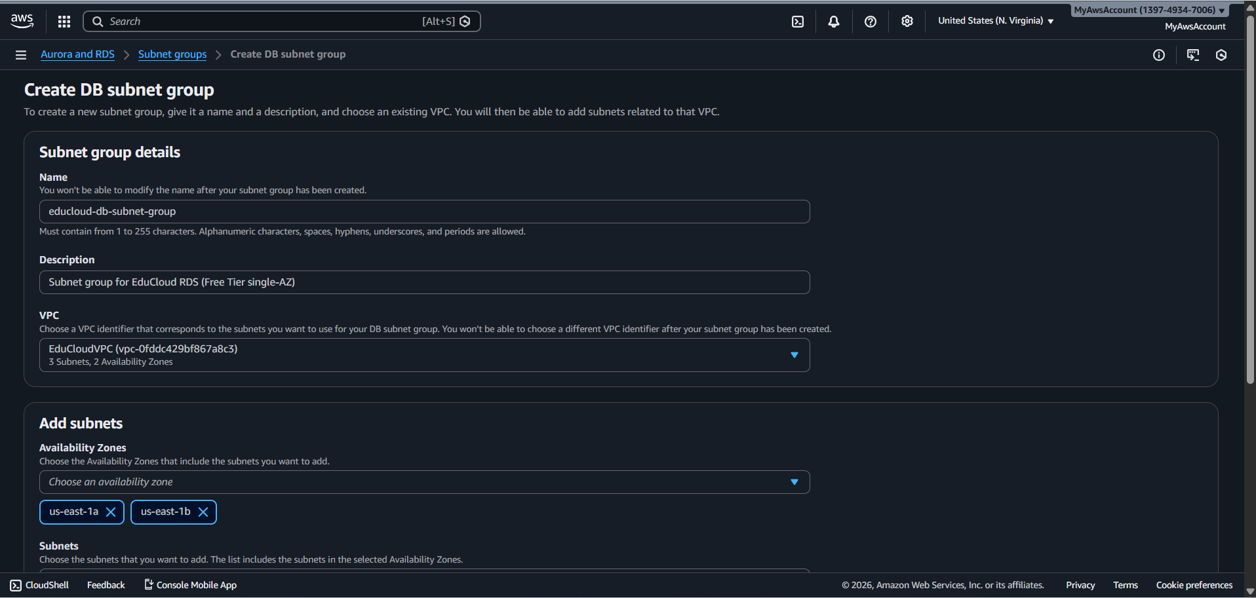

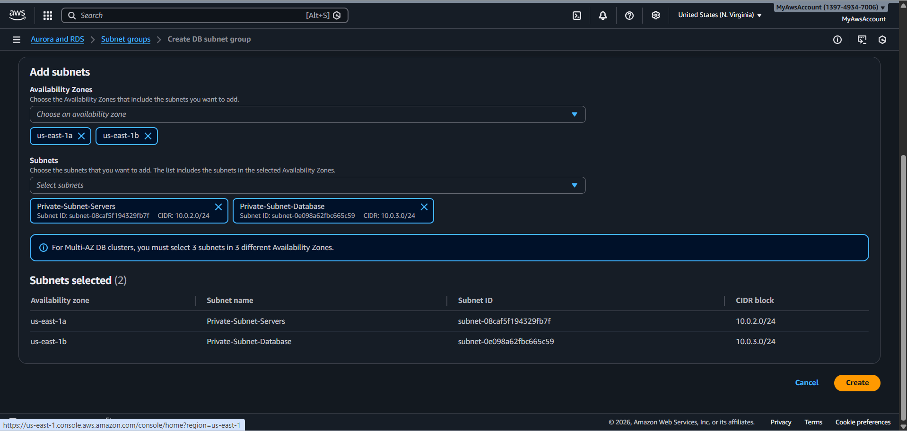

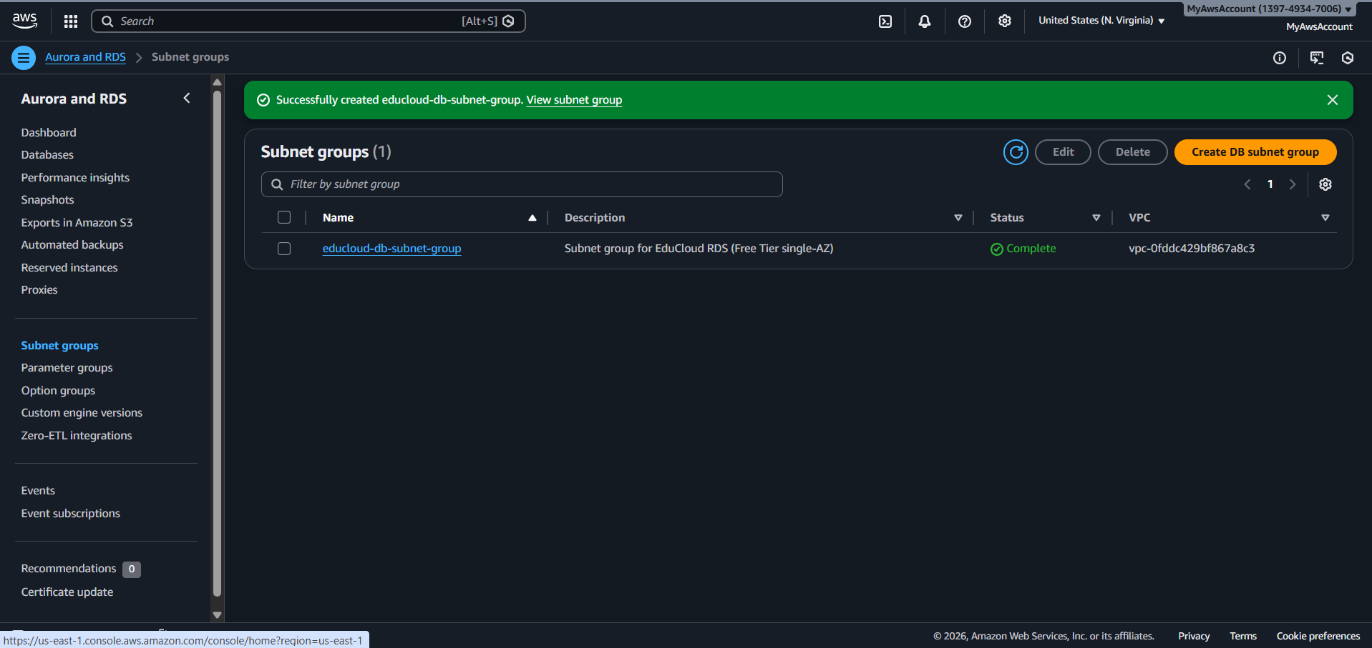

**DB instance identifier**

educloud-mysql-db

**Master username**

Admin

**Master password**

Mdnihal2000

**Endpoint**

educloud-mysql-db.c6n4sgm4gf6o.us-east-1.rds.amazonaws.com

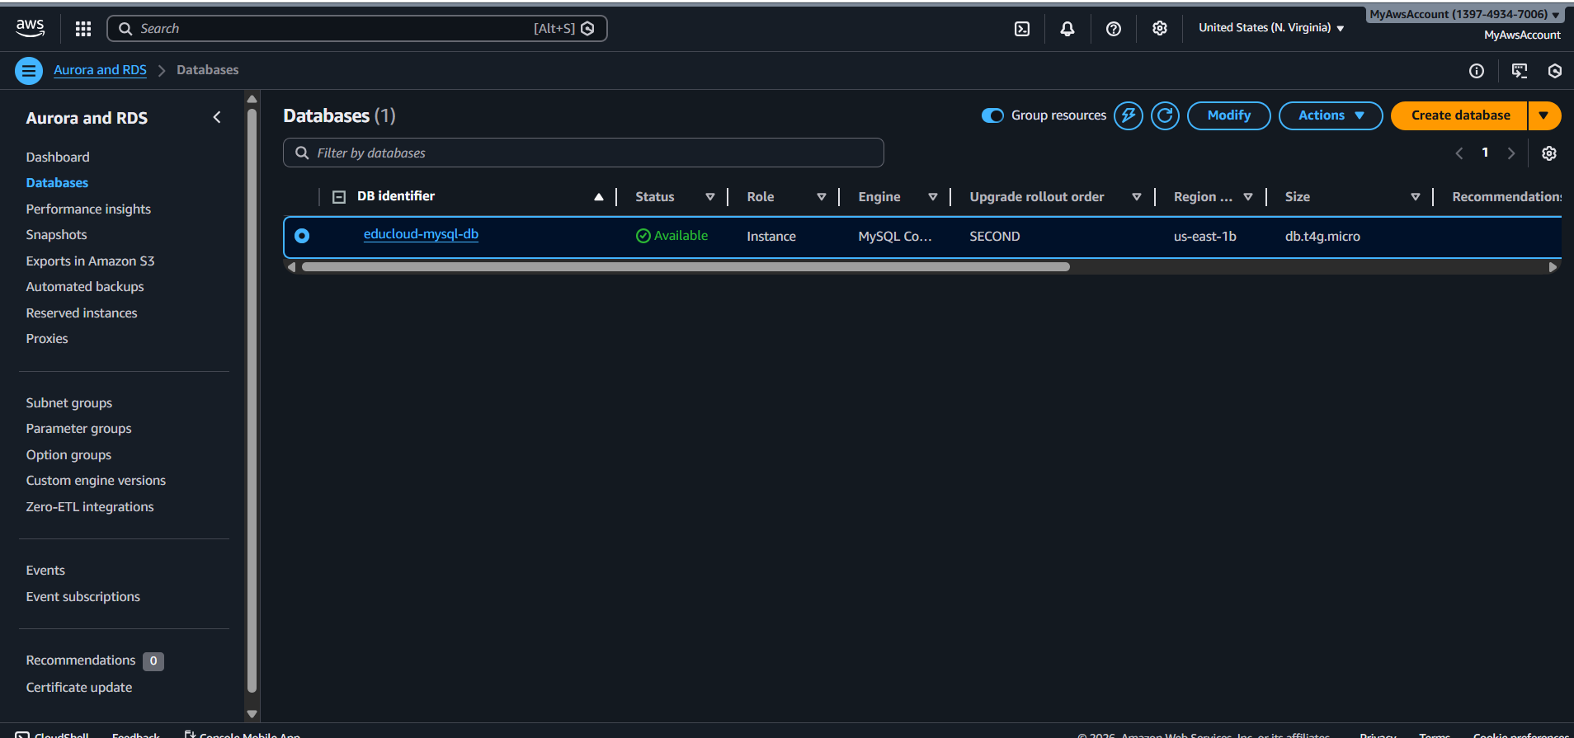

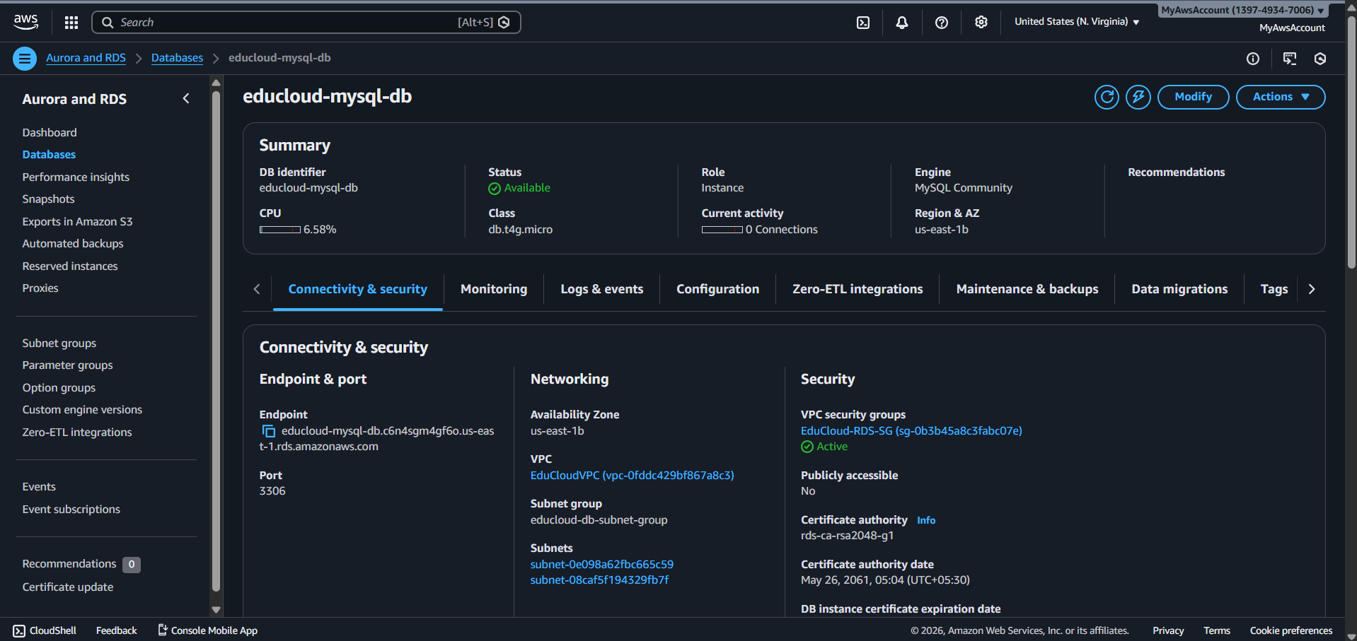

**RDS database is correctly configured for security - it's private and not accessible from the internet!**

**Allowed connection only from the Web-server-sg**

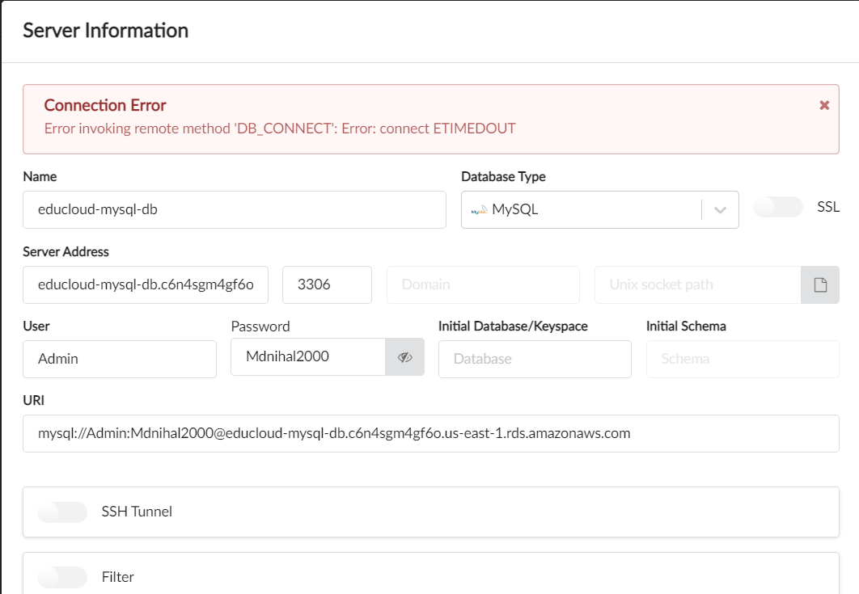

**LAUNCH EC2 INSTANCE**

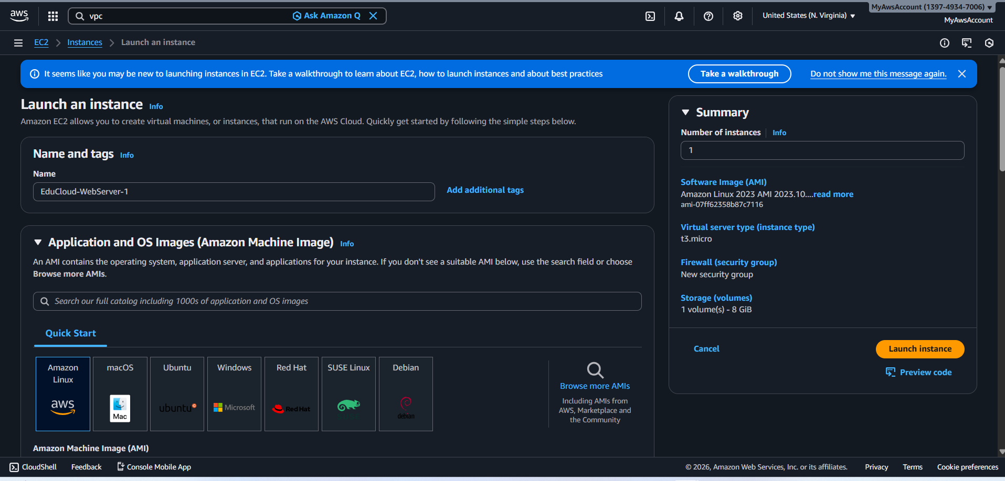

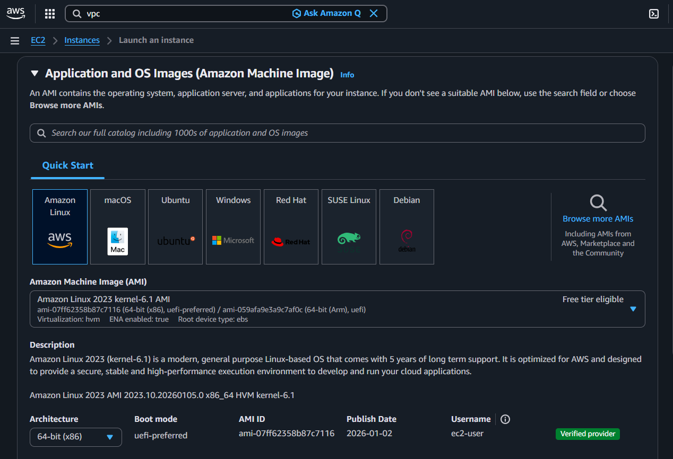

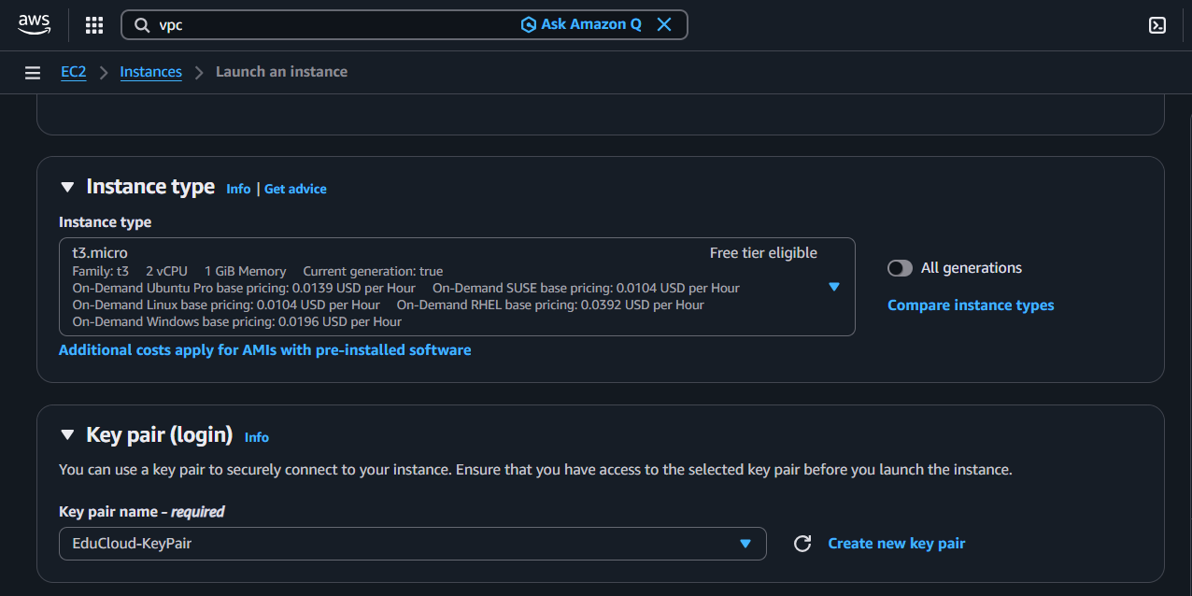

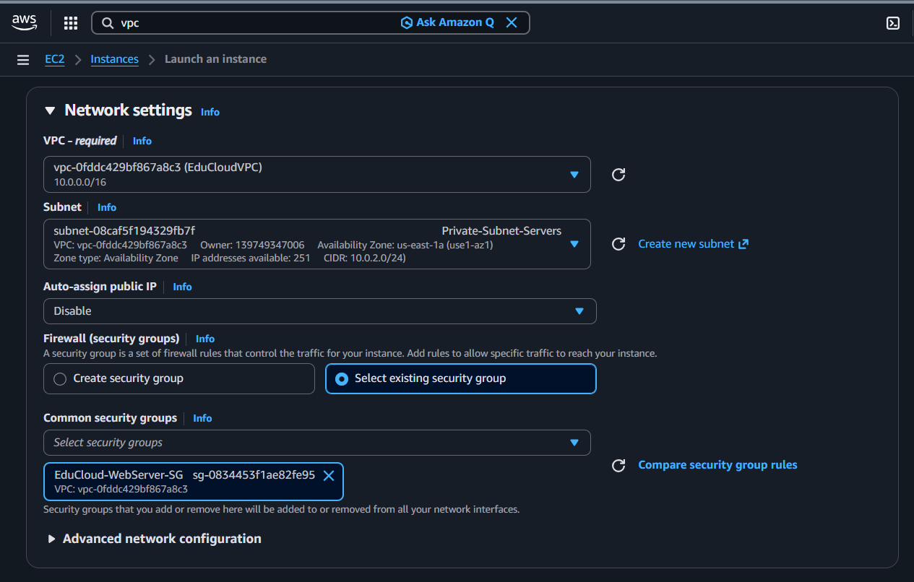

**Launch success message**

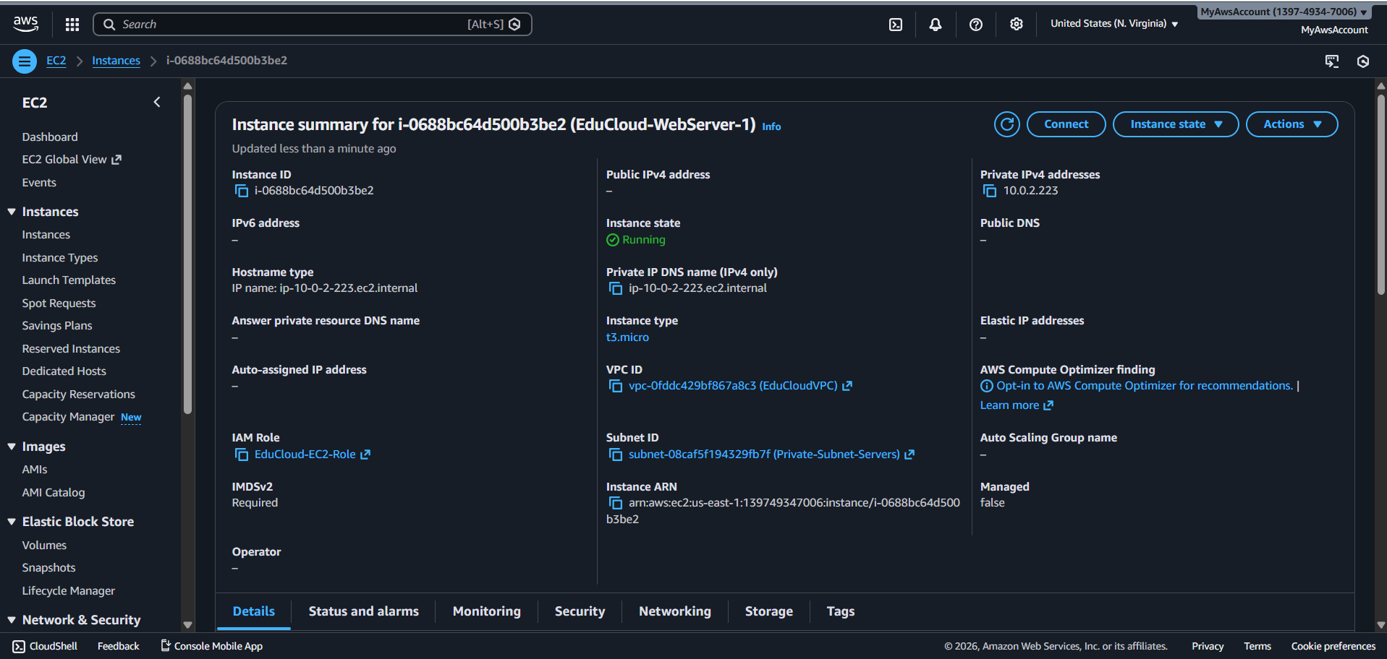

**Instance running with 2/2 status checks**

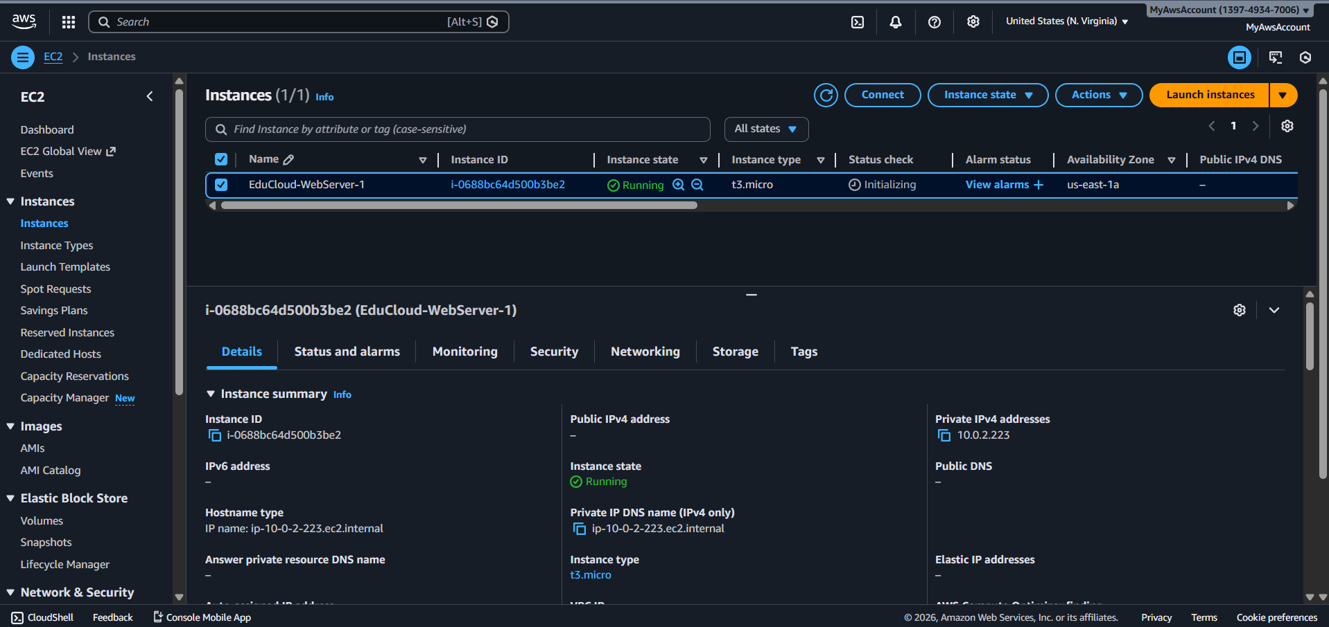

**BASTION HOST ARCHITECTURE**

**EduCloud-WebServer-SG to allow ssh only from the bastion host(jump server)**

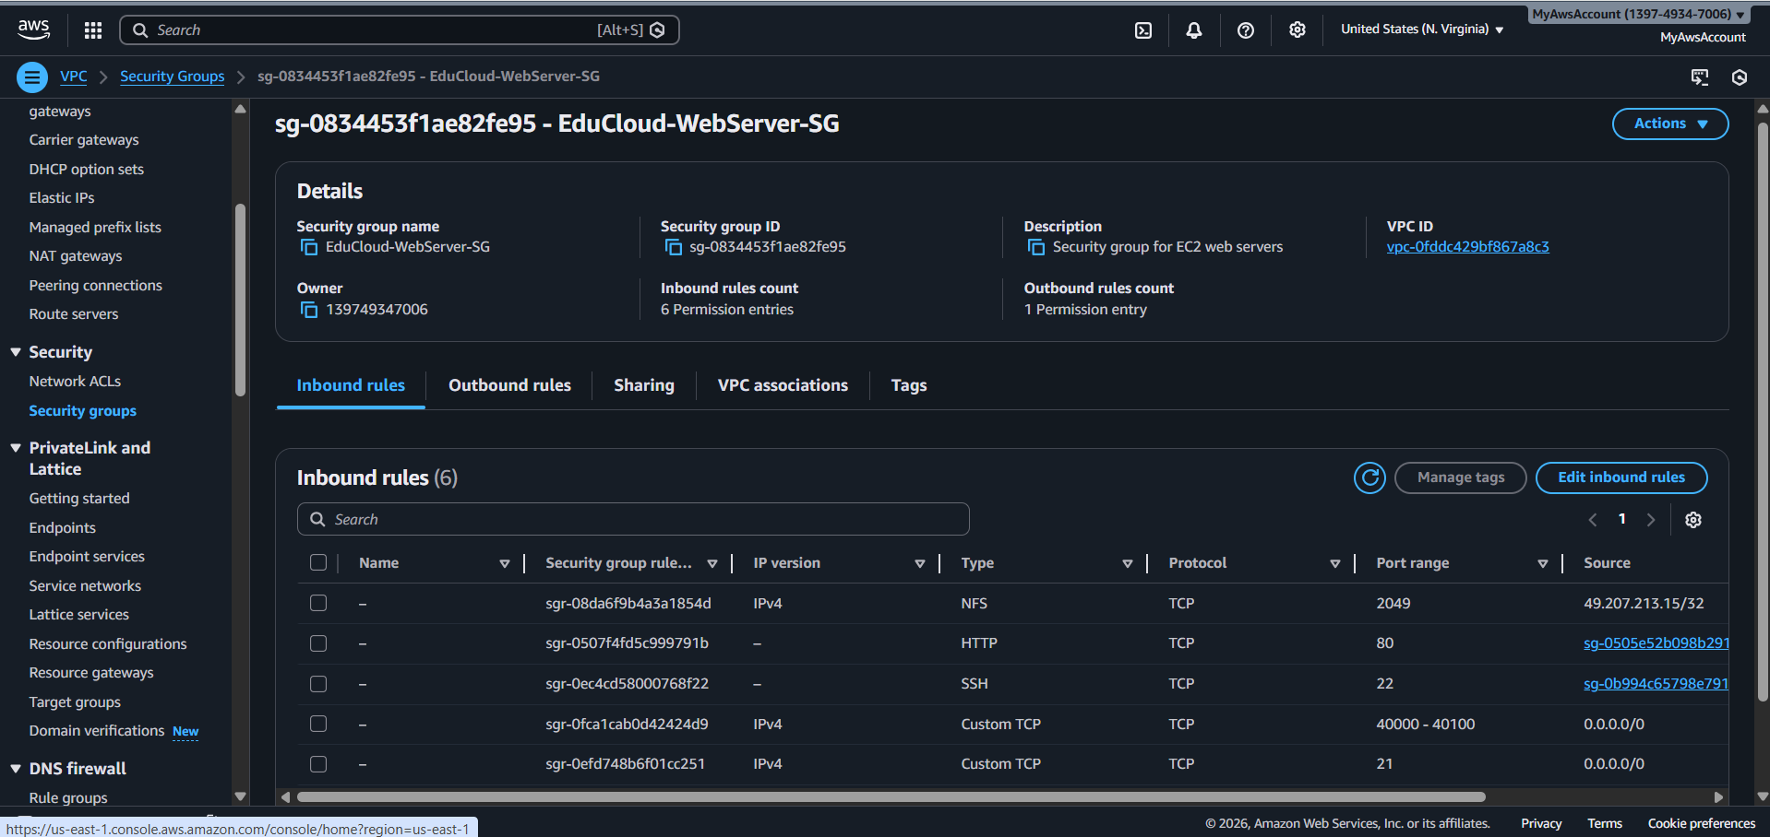

**EduCloud-Bastion-SG only allow ssh from the system’s ip from the local machine**

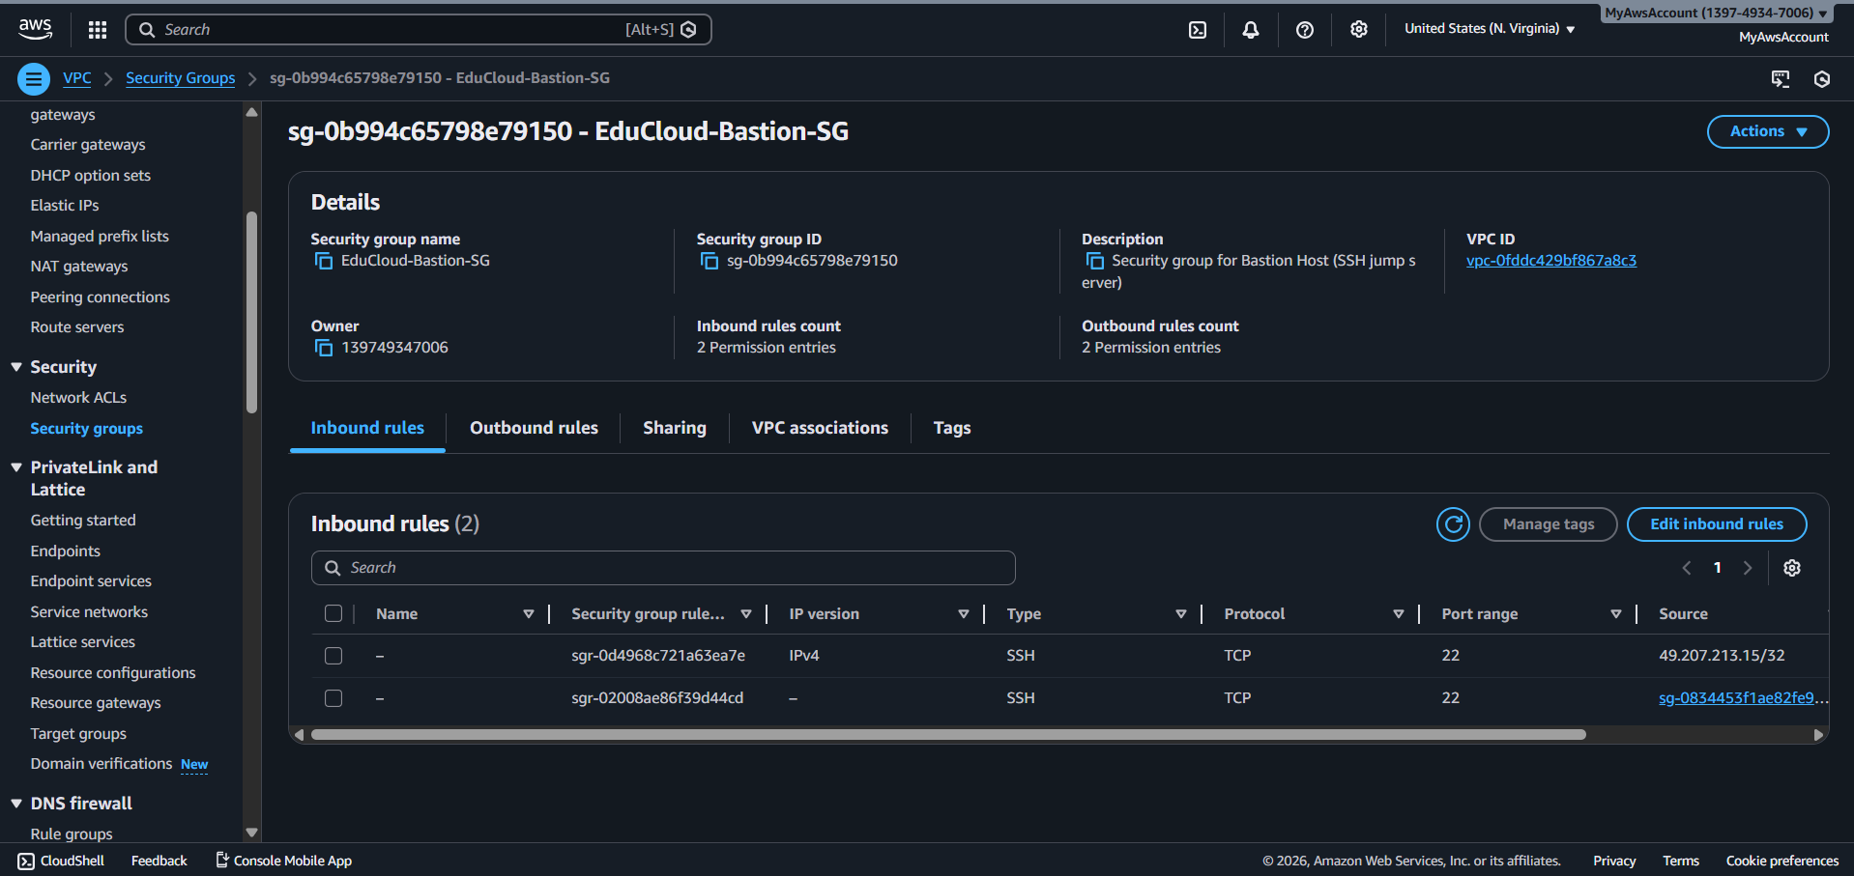

**LAUNCHING BASTION HOST**

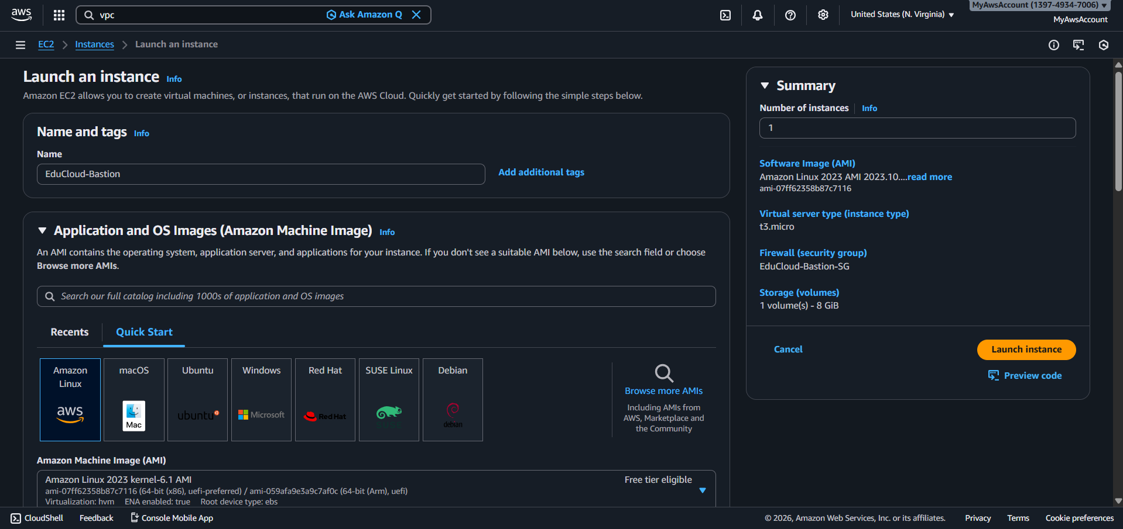

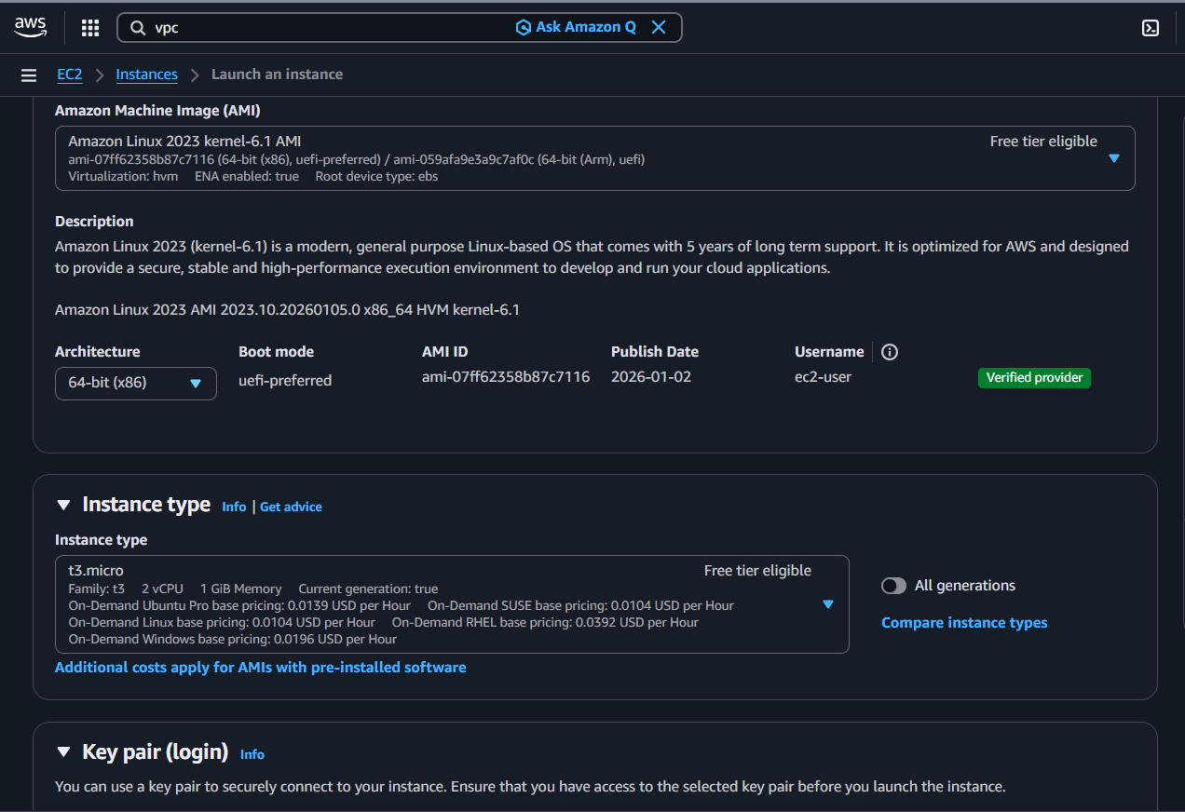

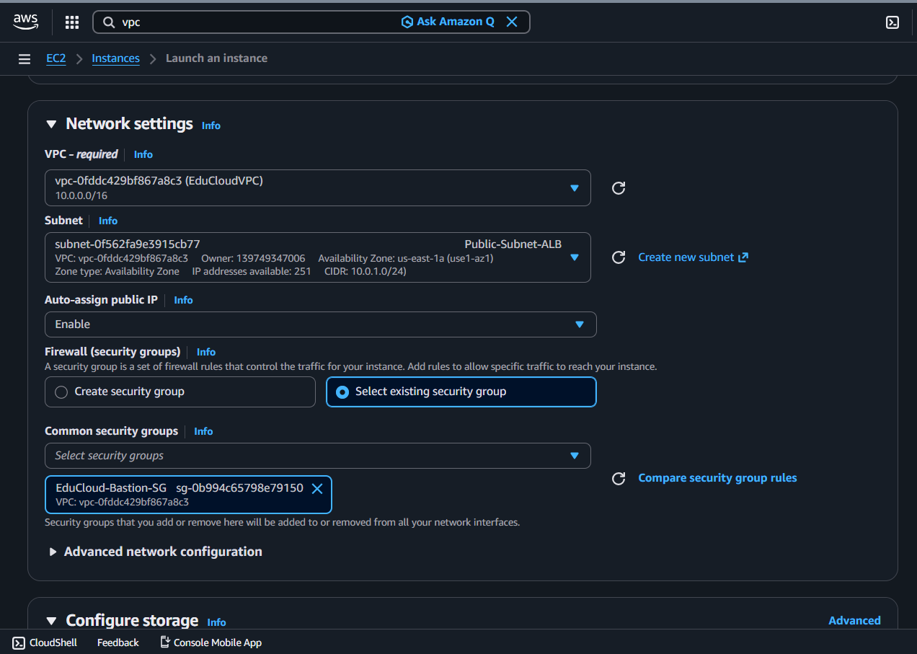

**SSH to bastion host via system’s IP in security group use Myip instead custom ip**

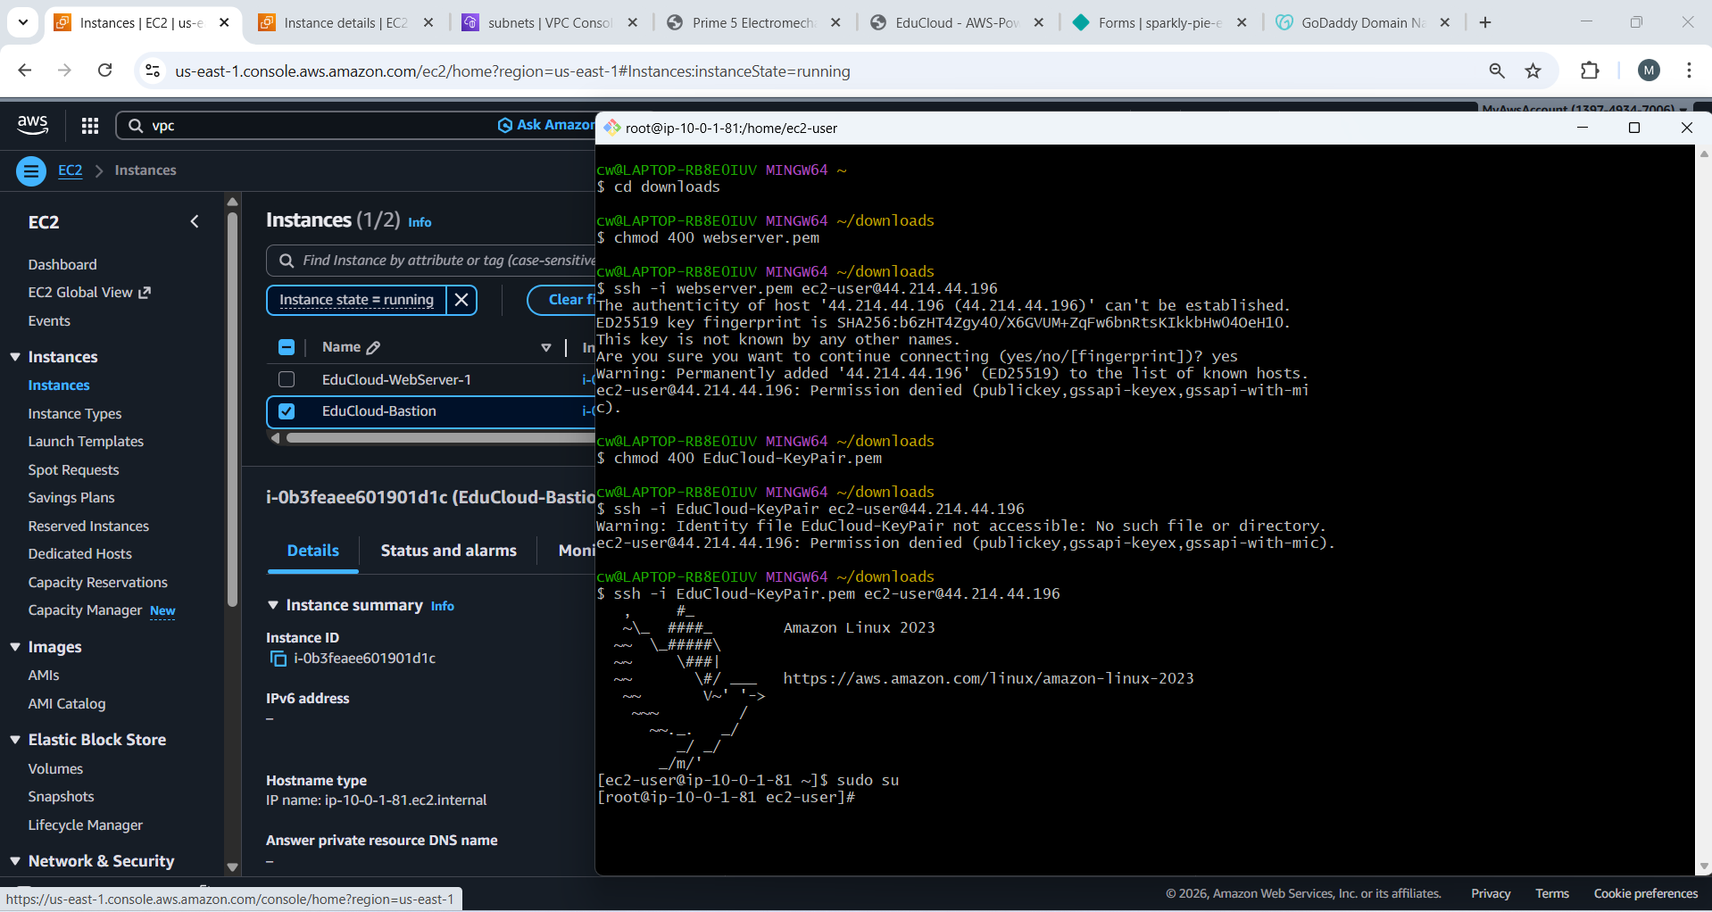

**BASTION CONNECTIVITY**

**Ping google.com working because if NAT and ping EduCloud-WebServer-1 working because in same VPC**

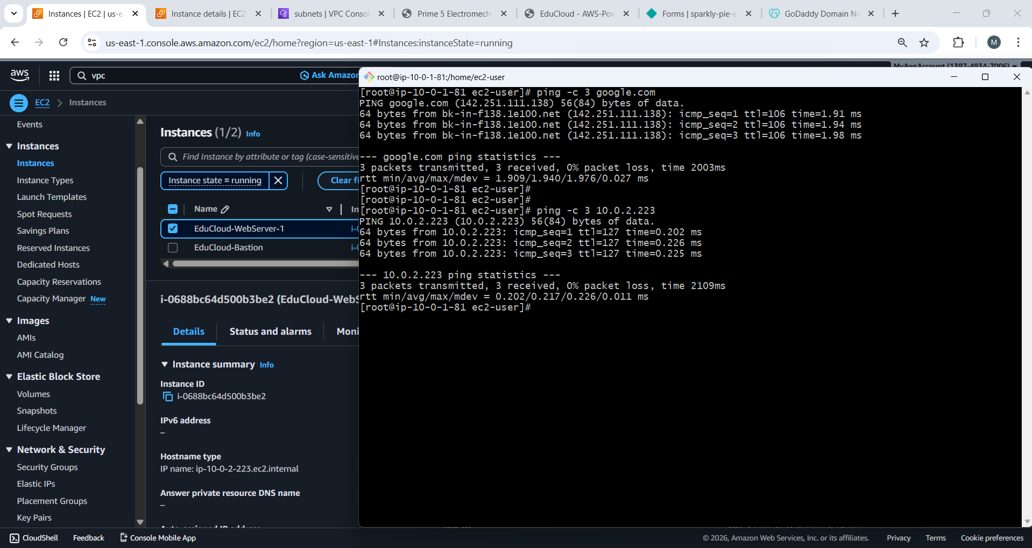

**SSH FROM BASTION TO PRIVATE EC2 (JUMP)**

**Two way ssh from local machine for myip only 🡪 basition host and from bastion host(only from my system not from others) 🡪 Private-webserver-1 (allowed only for the bastion host not from others)**

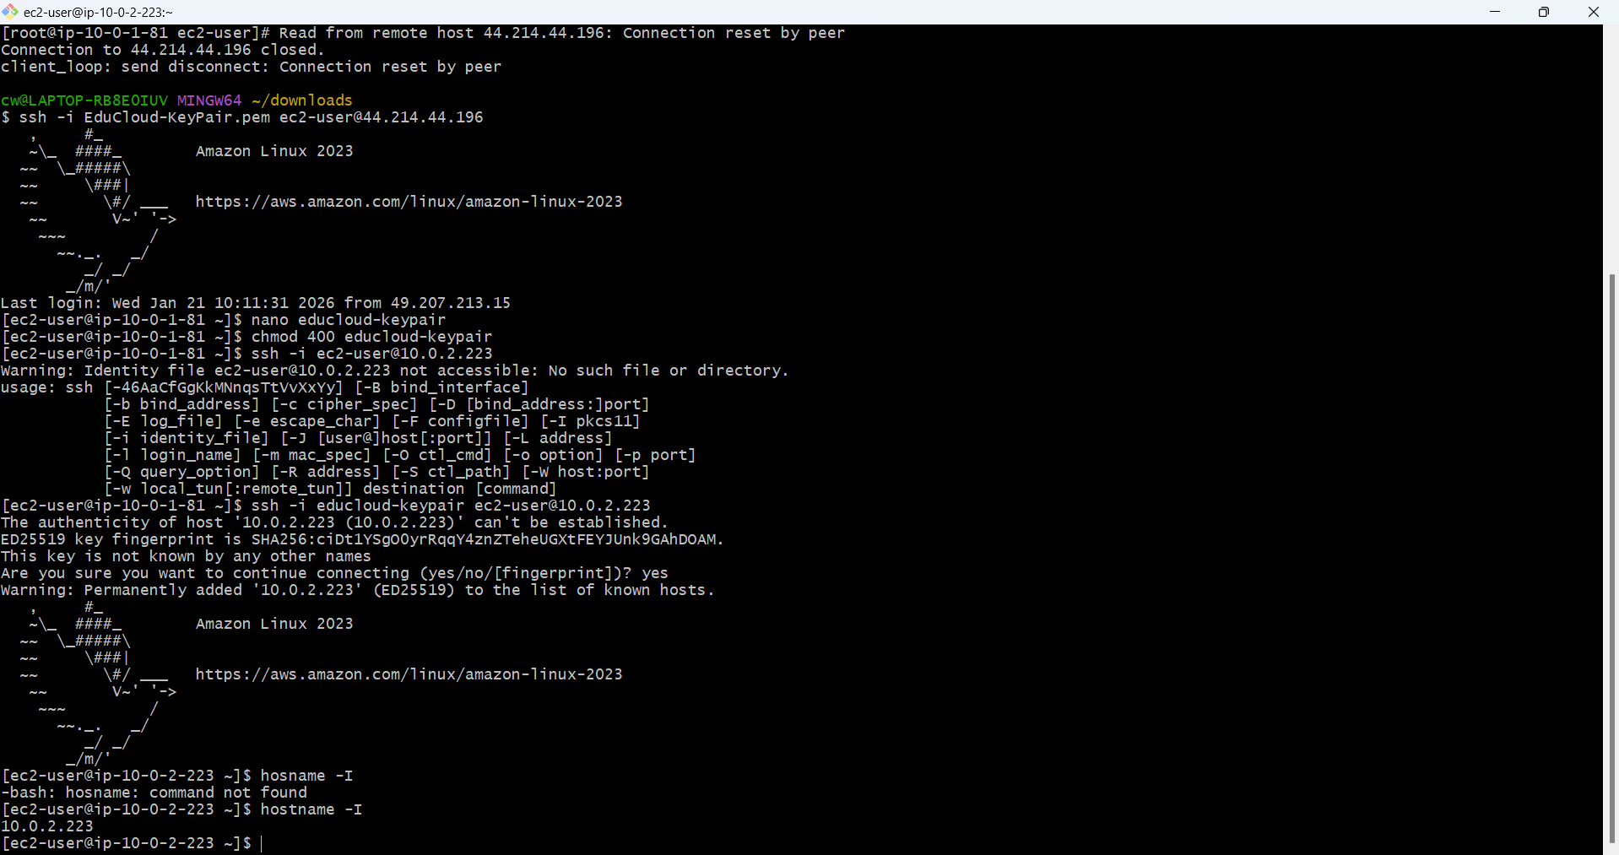

**Connect to private-webserver-1 via jump server with the help of NAT for the internet inbound connection installed mariadb105**

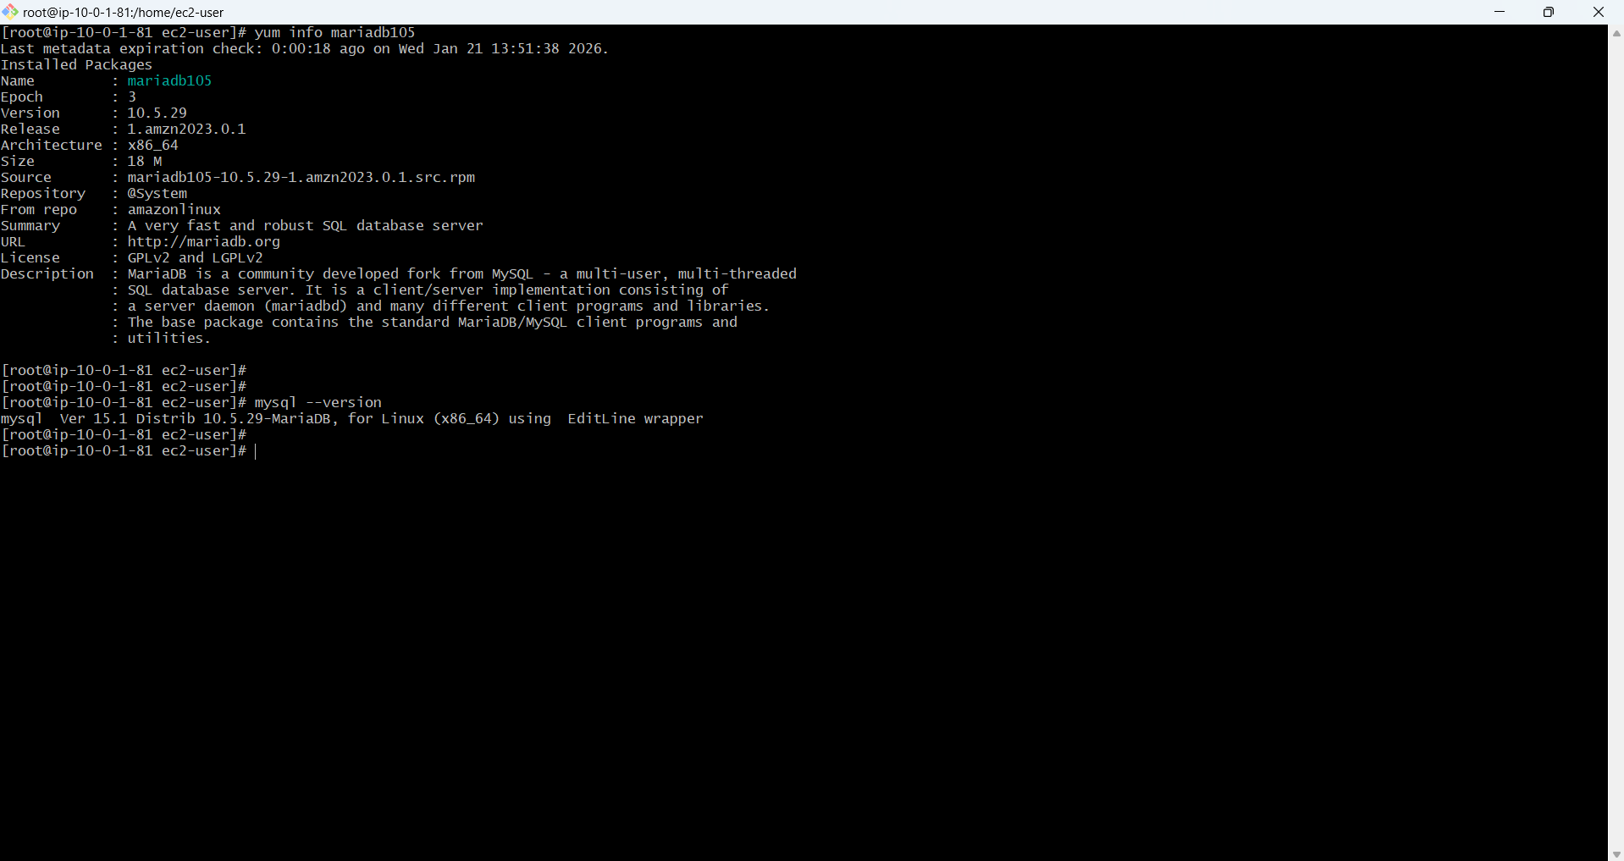

**Successfully connected RDS Data base with private-webserver-1 rds allow traffic only from**

**Private-webserver-1**

**SHOW DATABASE;**

**To list created db and the time of creation of rds ie educloud_db**

**Pwd:Mdnihal2000**

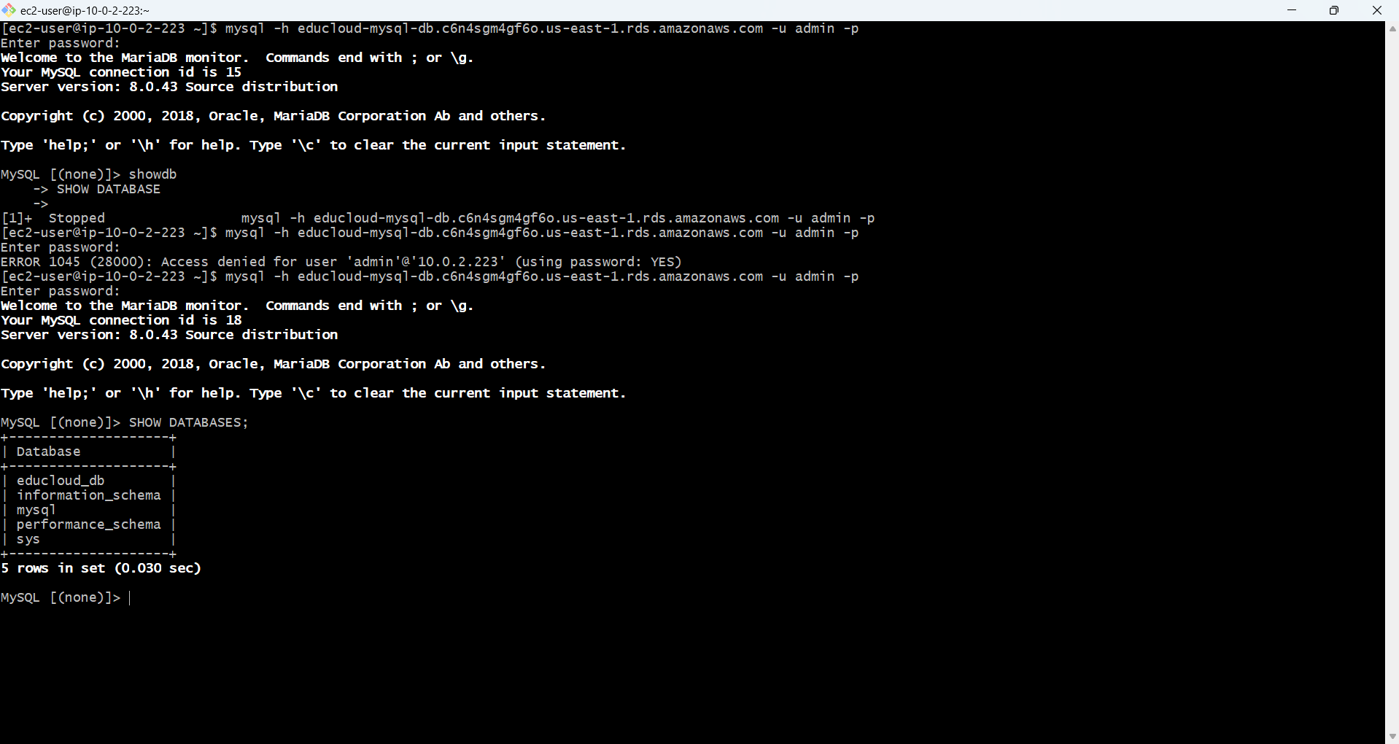

**CREATE & ATTACH EBS VOLUME**

**EBS volume created (20GB, Available)**

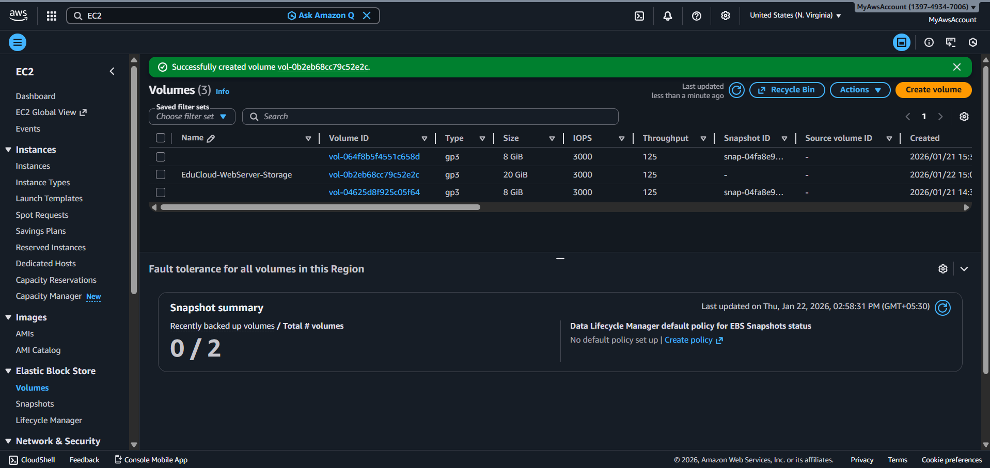

**Volume attached to WebServer**

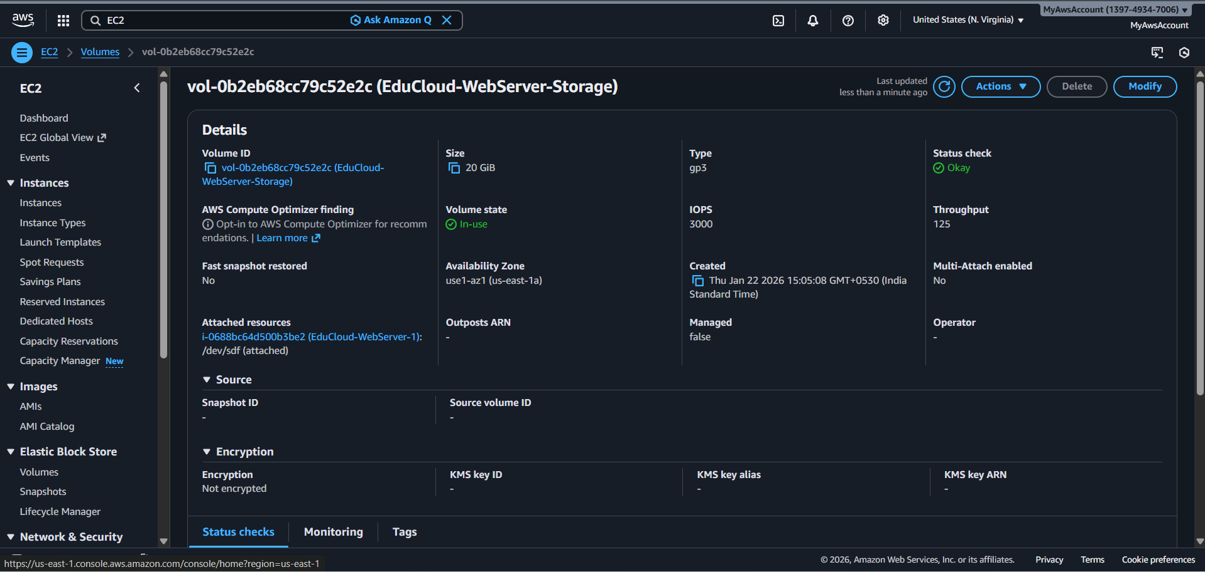

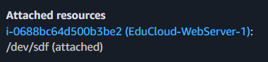

**output showing 20GB nvme1n1 disk**

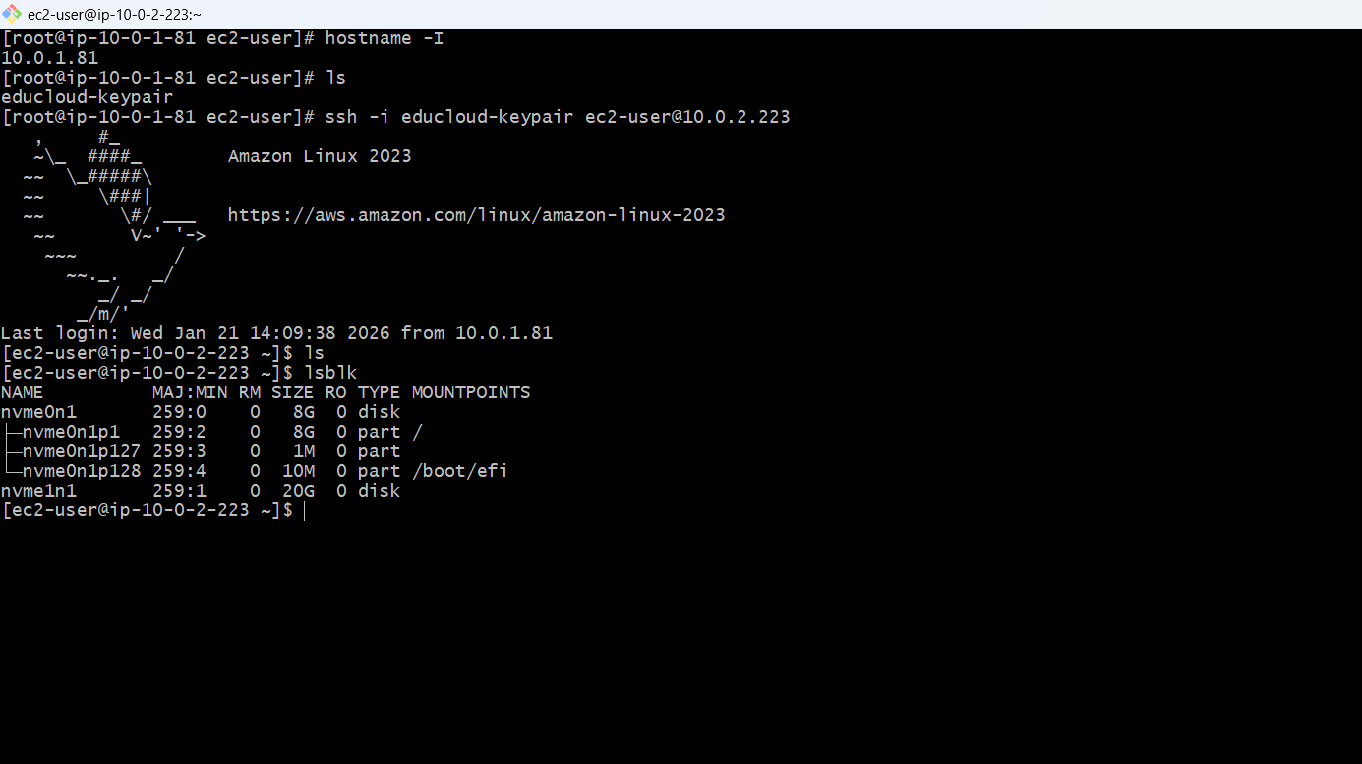

**no filesystem**

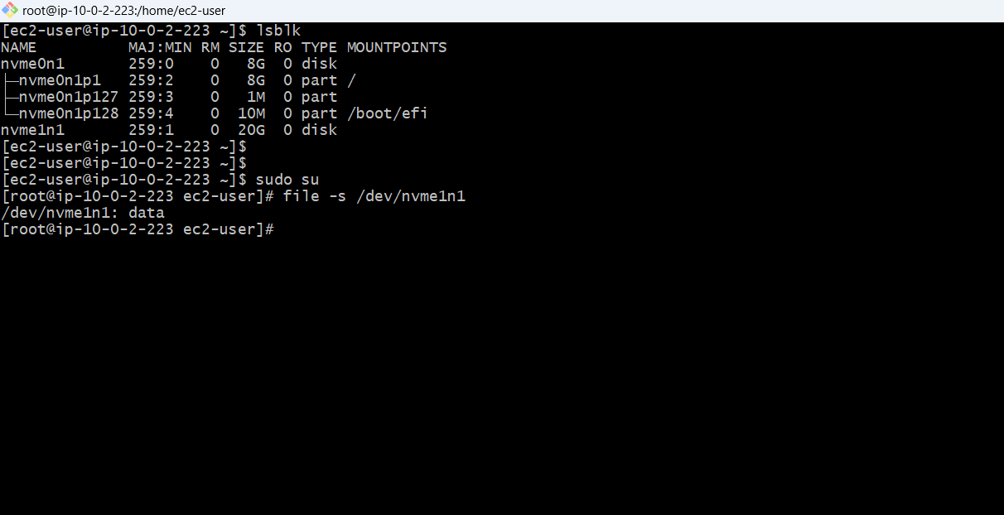

**Disk formatted successfully**

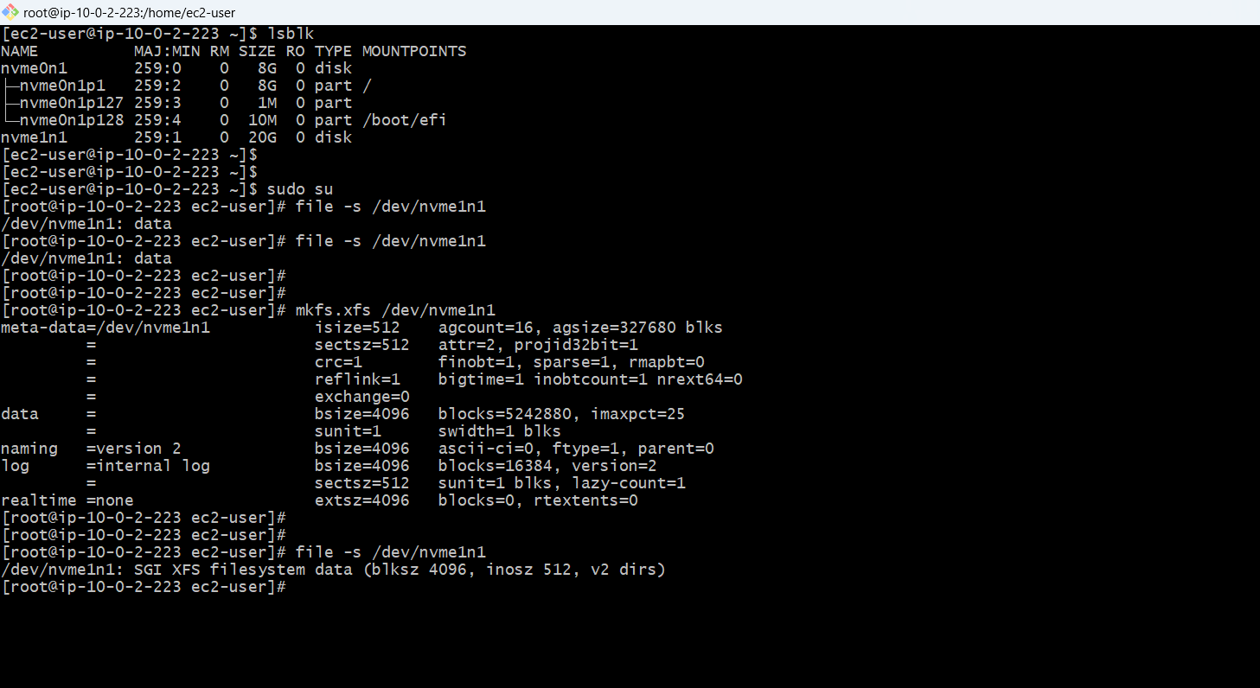

**CREATED MOUNT POINT**

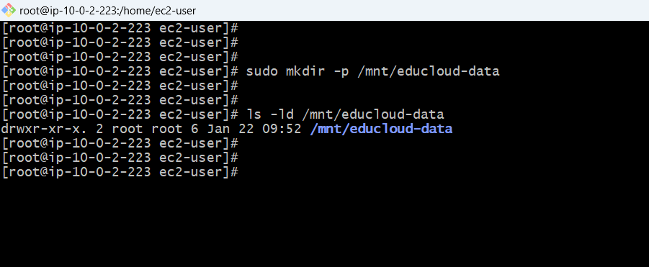

**MOUNTED THE DISK**

**20GB disk mounted**

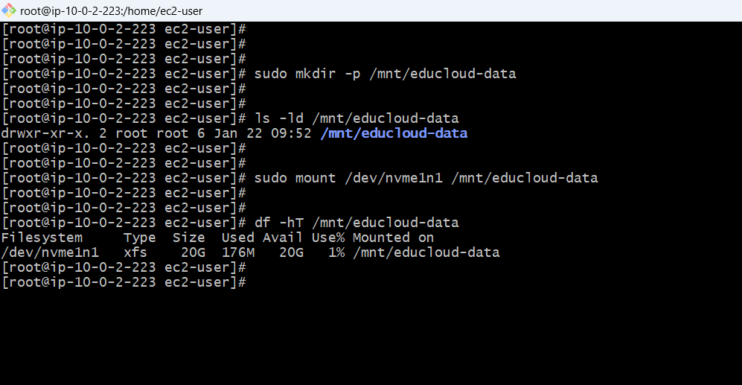

**CONFIGURED AUTO-MOUNT ON REBOOT /etc/fstab**

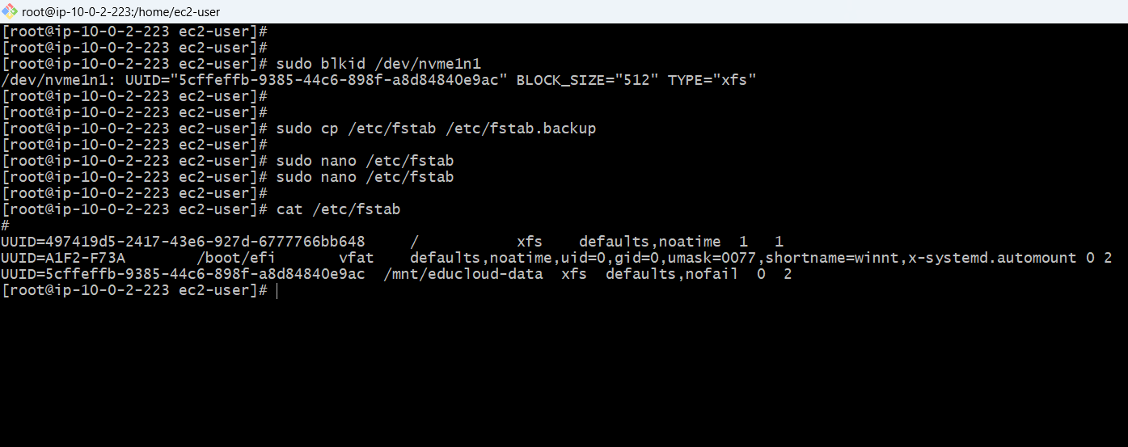

**CREATE DIRECTORIES FOR PROJECT**

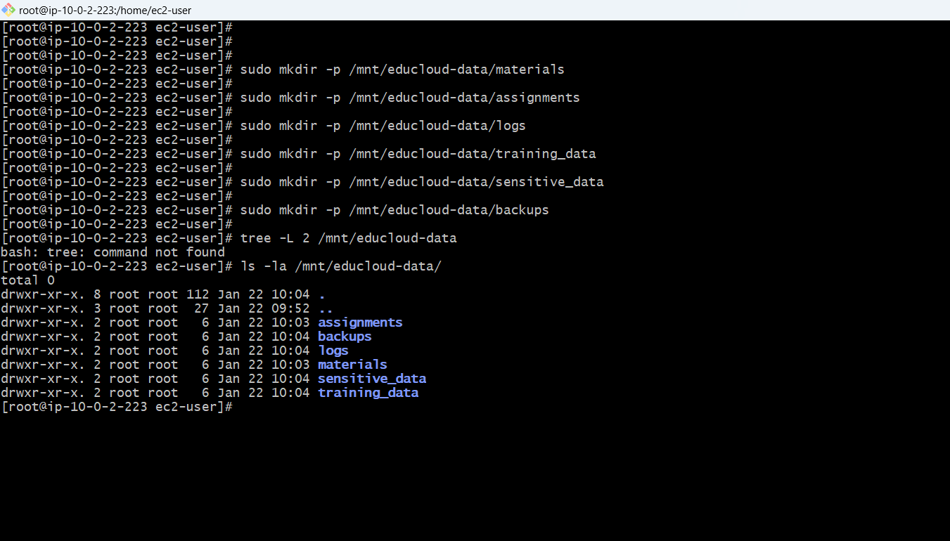

**Set proper ownership and permissions**

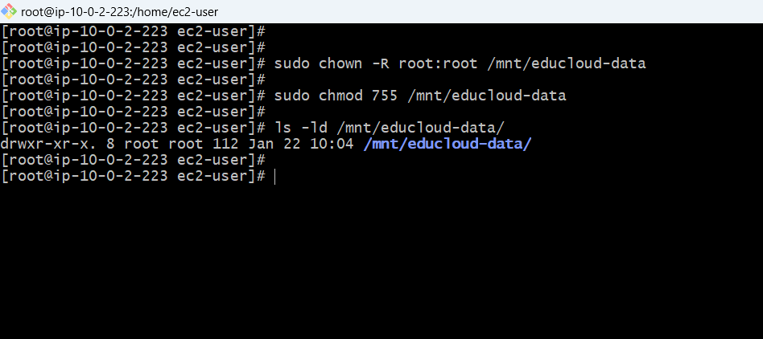

**Initial permissions for subdirectories**

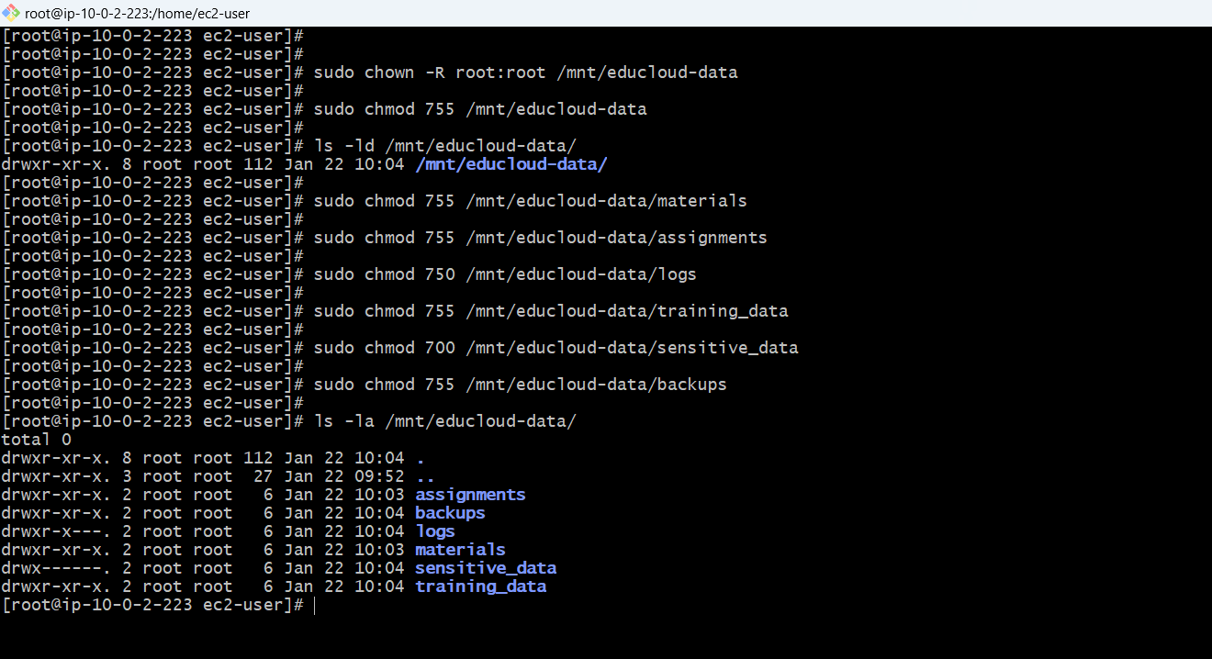

**VOLUME DETAILS:**

Device: /dev/xvdf

Size: 20 GB

Filesystem: XFS

Mount Point: /mnt/educloud-data

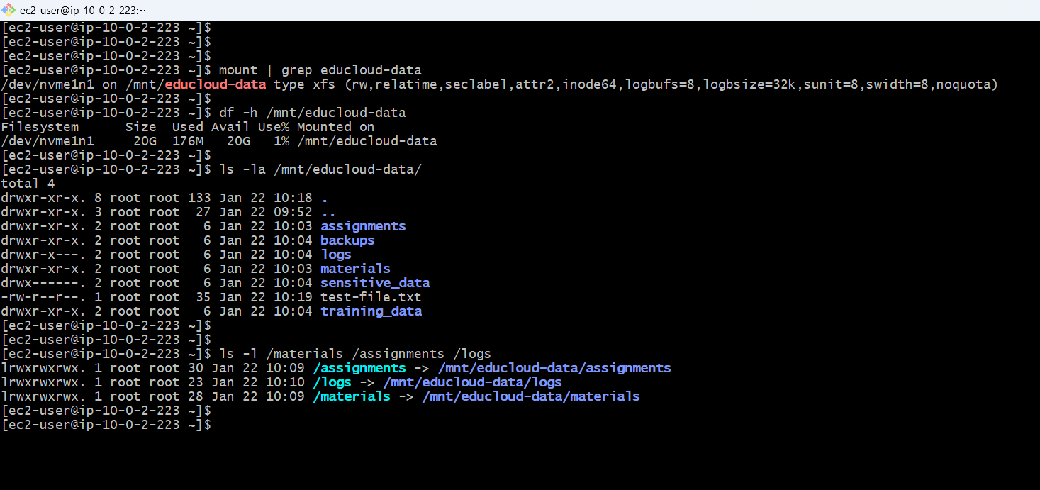

**SOFTWARE INSTALLATION & SYSTEM UPDATE**

**APACHE WEB SERVER**

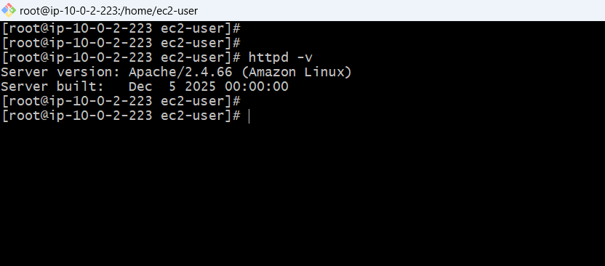

**INSTALL MySQL CLIENT**

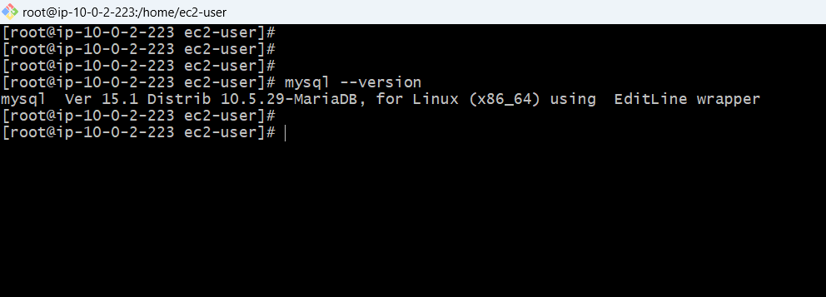

**INSTALL FILE SHARING & STORAGE TOOLS**

**INSTALL NFS UTILITIES**

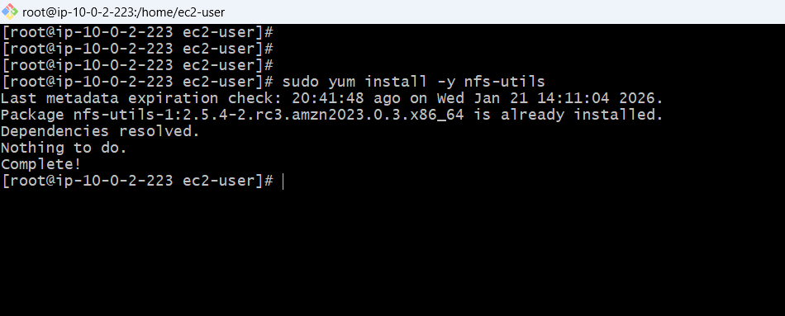

**INSTALL FTP SERVER (vsftpd)**

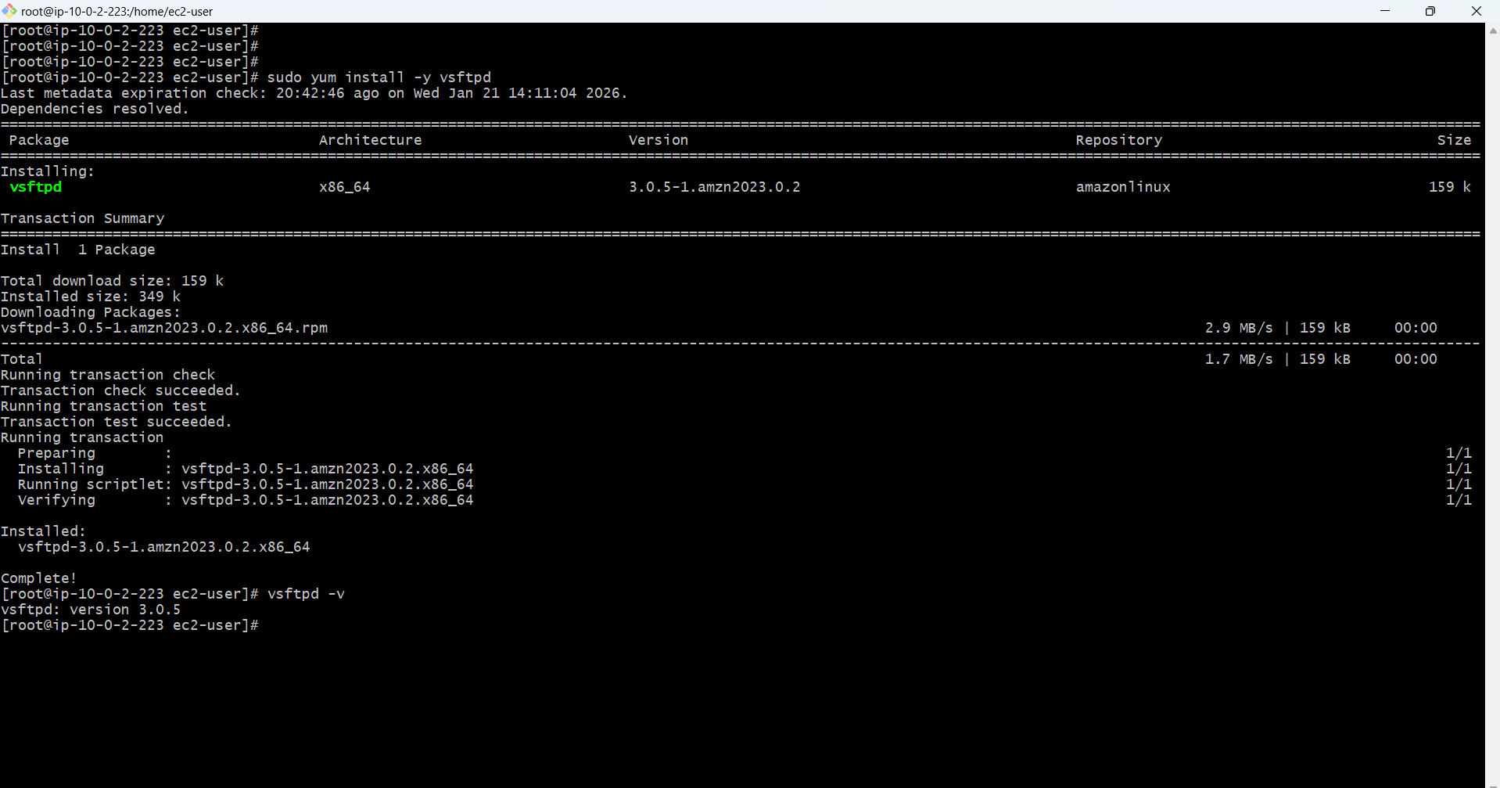

**INSTALL STORAGE MANAGEMENT TOOLS**

**INSTALL LVM TOOLS**

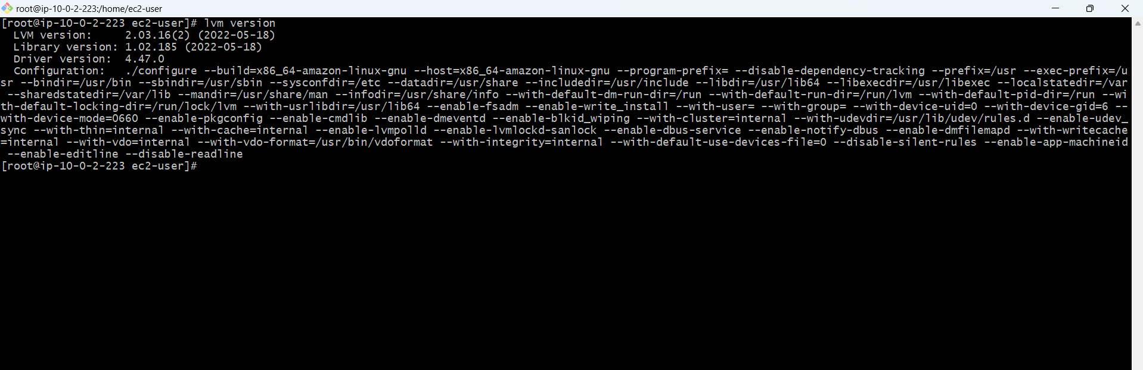

**INSTALL ENCRYPTION TOOLS**

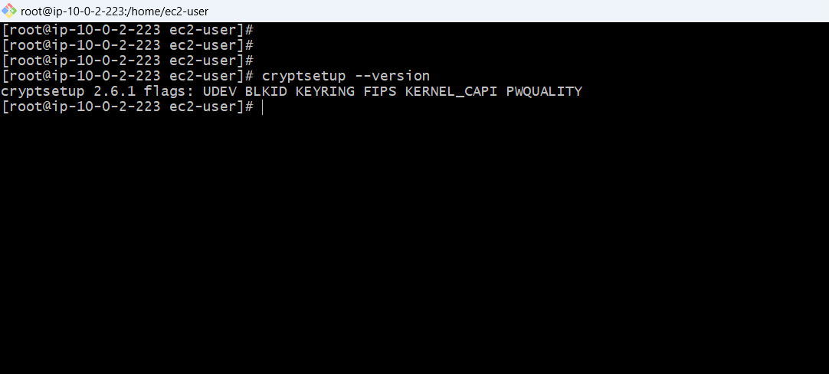

**INSTALL ACL & UTILITIES**

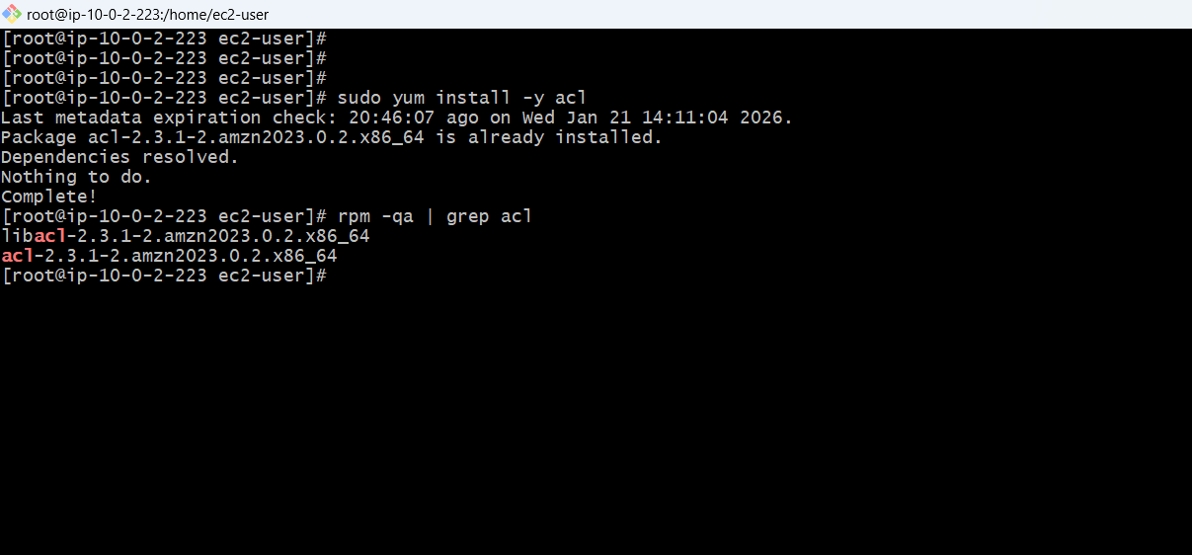

**INSTALL UTILITY TOOLS**

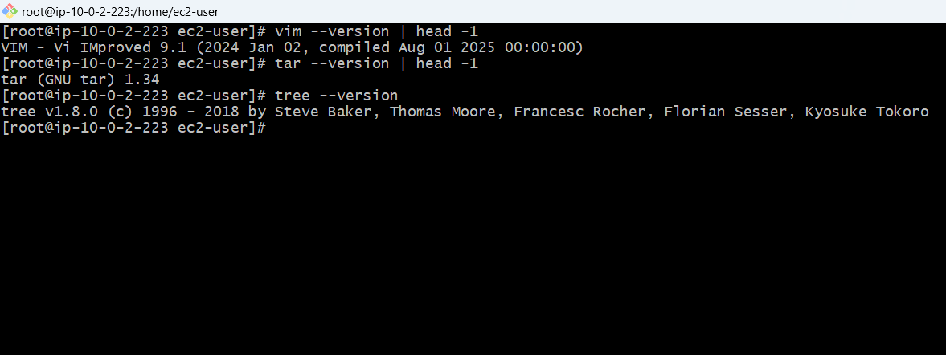

**START & ENABLE SERVICES**

**START APACHE WEB SERVER**

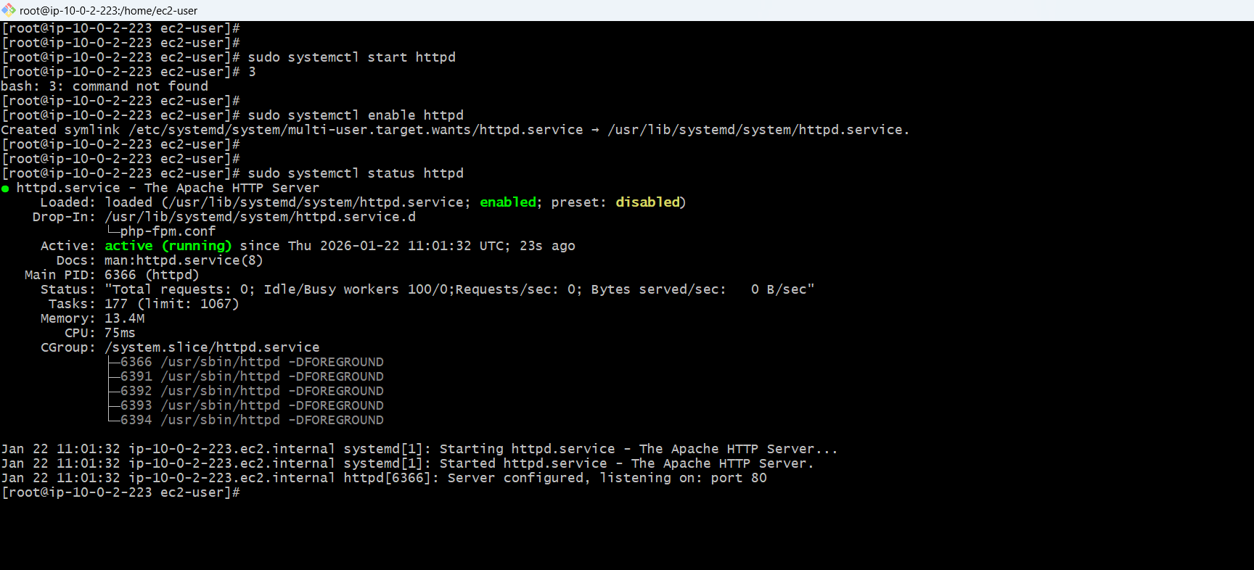

**START NFS SERVER**

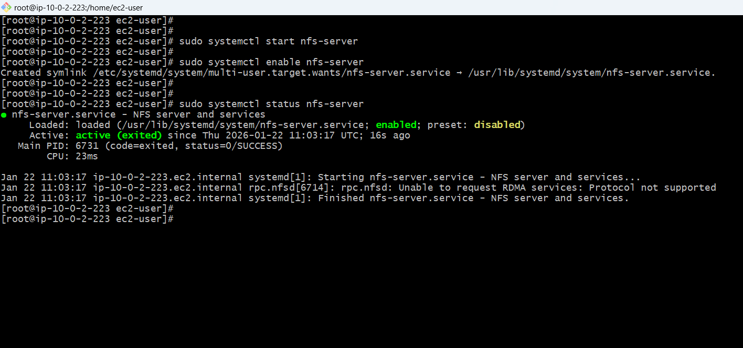

**START FTP SERVER**

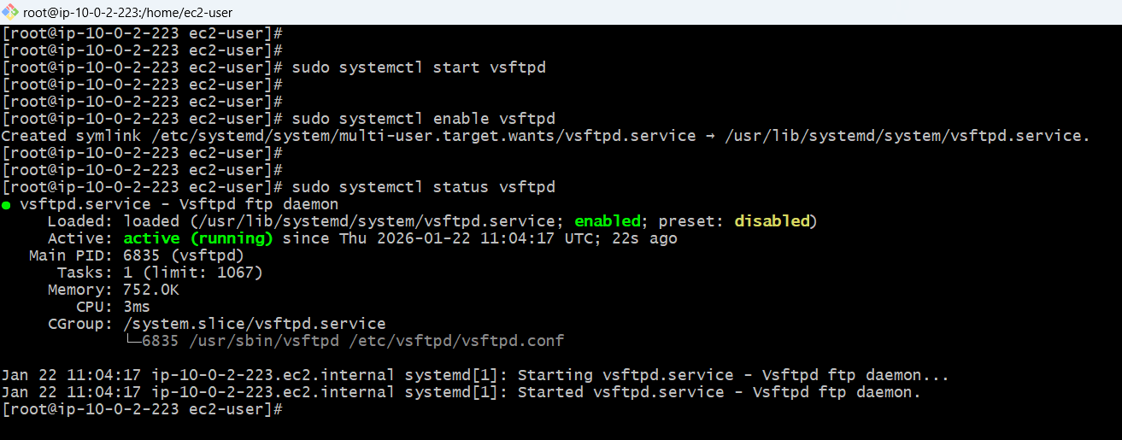

**STRESS TOOL**

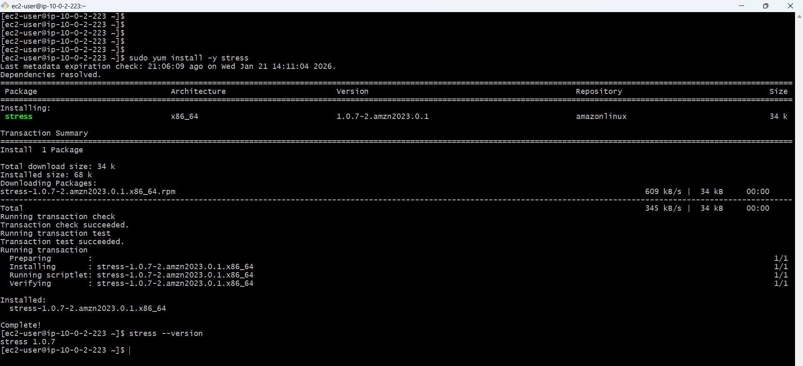

**INSTALLED SOFTWARE SUMMARY**

**Complete data base connection test manually and via php script Configured Security group, IAM Roles**

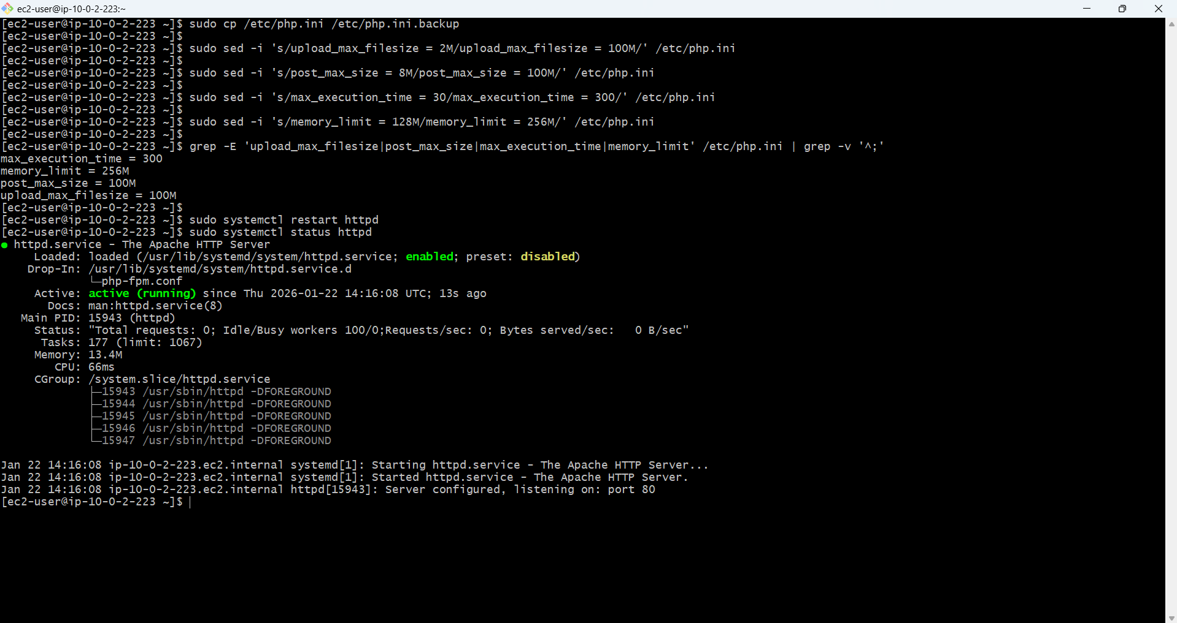

Full LAMP stack (Linux, Apache, MySQL client, PHP)

NFS server ready (configure in Task 16)

FTP server ready (configure in Task 17)

LVM tools ready (use in Task 13)

Encryption tools ready (use in Task 14)

All services running and enabled

Complete software inventory

**PASSWORD POLICY CONFIGURATION**

**Security requirement for multi-user system where trainers, students, and support staff have different access levels**

**1.BACKUP EXISTING CONFIGURATION:**

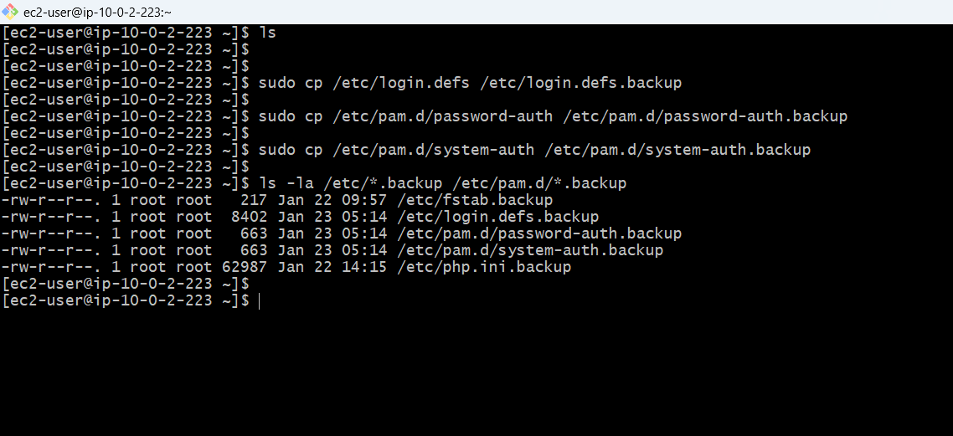

**CONFIGURING PASSWORD EXPIRY (30 DAYS)**

**Edit /etc/login.defs to set password aging policies**

**ORIGINAL VALUES**

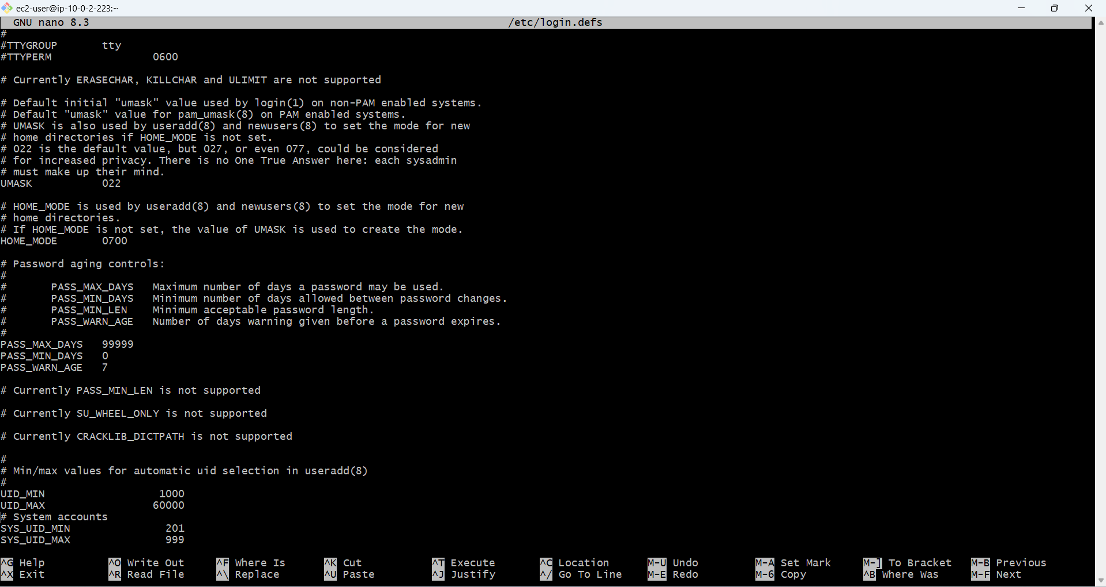

**CHANGED TO:**

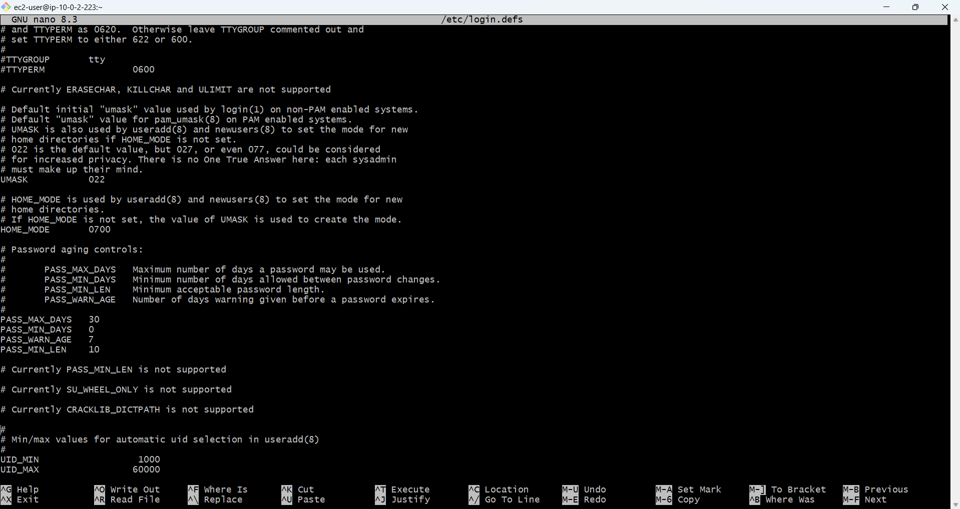

**CONFIGURE PASSWORD COMPLEXITY**

**INSTALLED PASSWORD QUALITY LIBRARY**

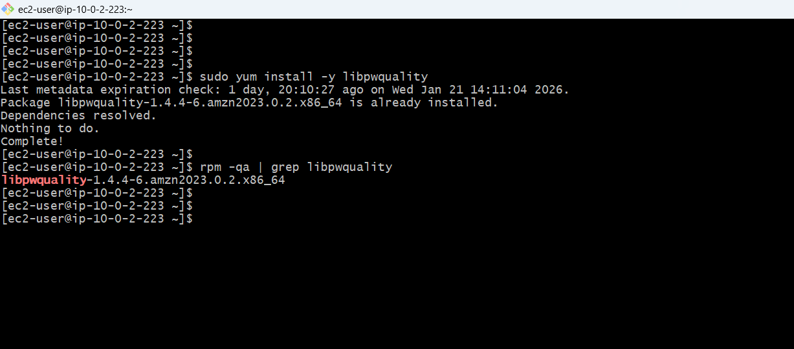

**CONFIGURE PASSWORD COMPLEXITY REQUIREMENTS**

**At least 1 uppercase, 1 digit, 1 special character**

**password requisite pam_pwquality.so try_first_pass local_users_only retry=3 minlen=10 ucredit=-1 dcredit=-1 ocredit=-1 lcredit=-1**

* minlen=10 → Minimum 10 characters
* ucredit=-1 → At least 1 uppercase letter (U)
* dcredit=-1 → At least 1 digit (D)
* ocredit=-1 → At least 1 special character (O = other)
* lcredit=-1 → At least 1 lowercase letter (L)
* retry=3 → Allow 3 attempts to set password

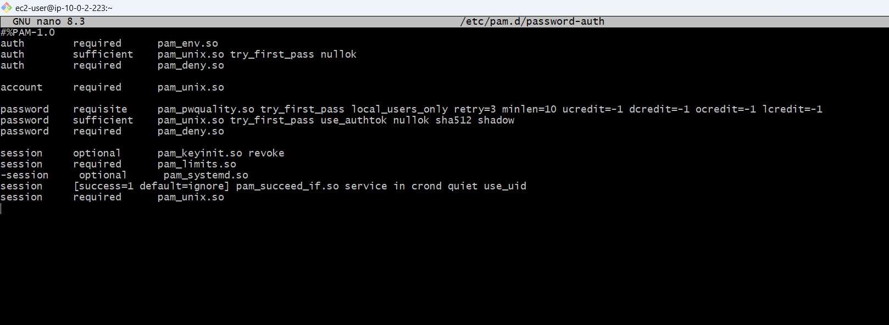

**Change in both the lines**

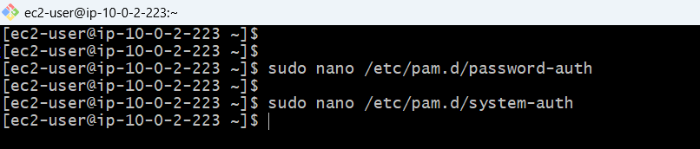

**CREATE PASSWORD QUALITY CONFIG FILE**

**sudo nano /etc/security/pwquality.conf**

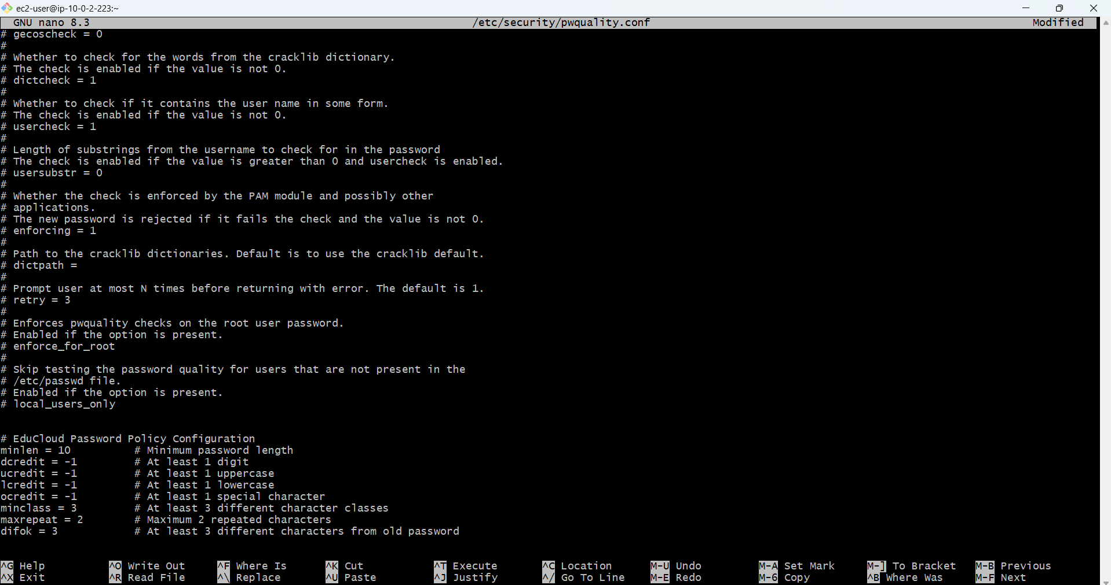

**Password quality check**

Password:12345678

Password: abcdefghij

Password: ABCDEFGH12

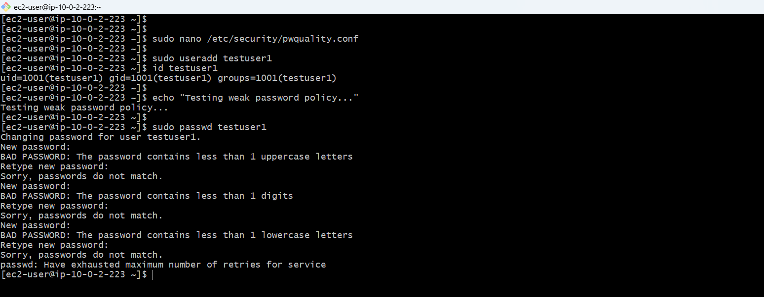

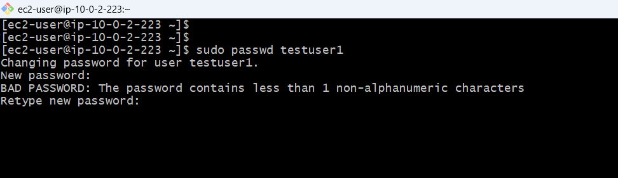

**VALID PASSWORD**

Password:TestUser@2026

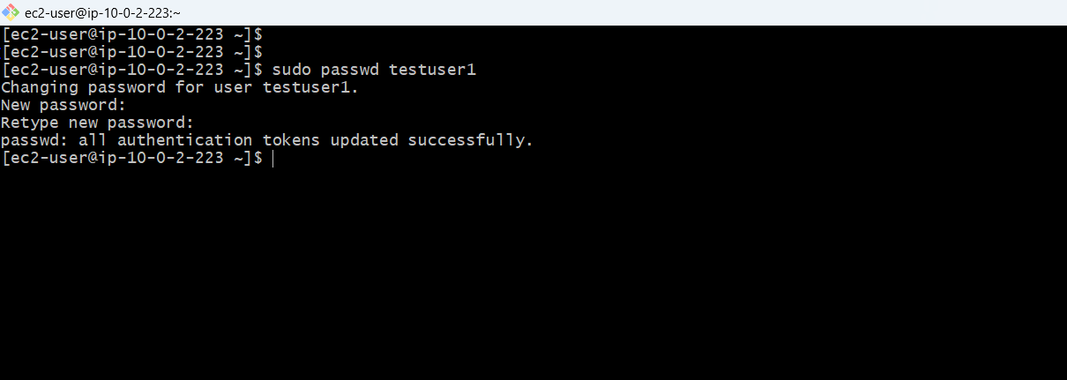

**Enforced Policy:**

Maximum number of days between password change: 30

Number of days of warning before password expires: 7

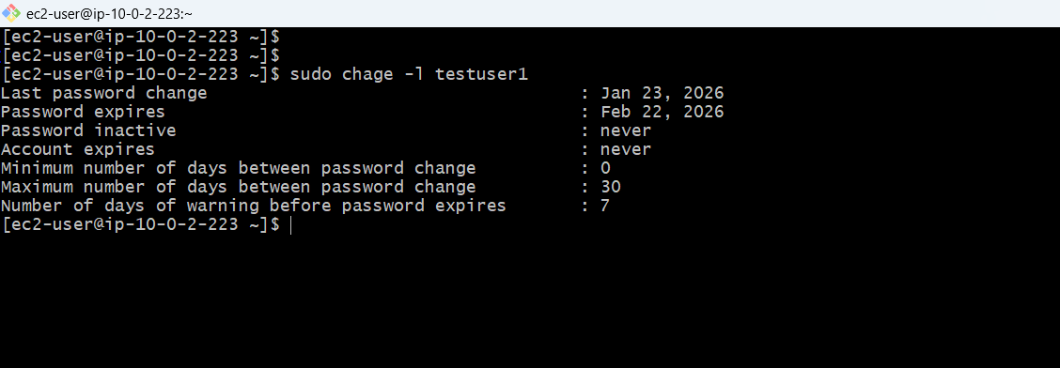

**MANUALLY SET PASSWORD EXPIRY**

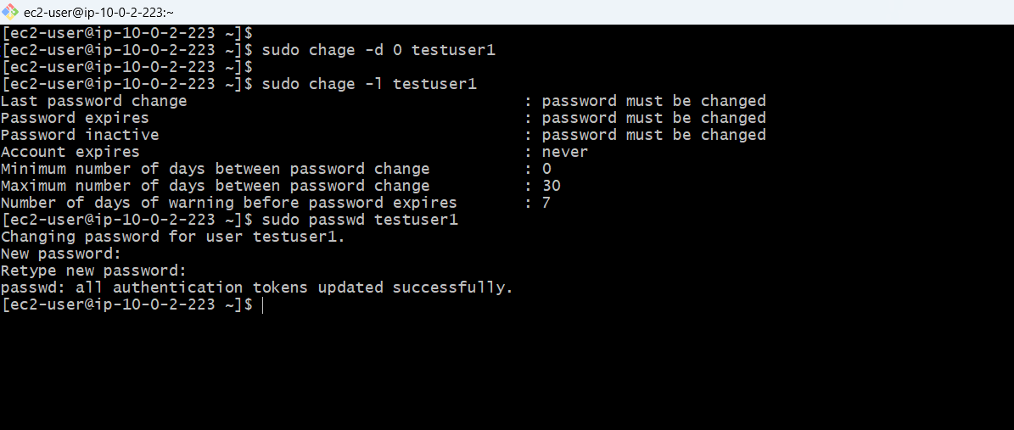

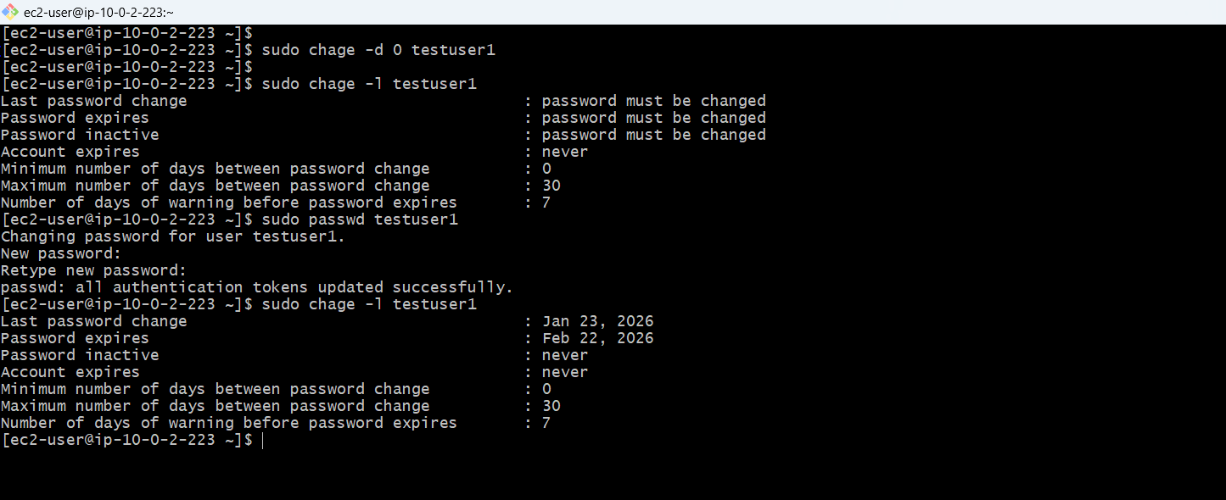

**PASSWORD POLICY DOCUMENT**

Maximum password age: 30 days (PASS_MAX_DAYS)

Minimum password age: 0 days (PASS_MIN_DAYS)

Minimum password length: 10 characters (PASS_MIN_LEN)

Password expiry warning: 7 days (PASS_WARN_AGE)

**PASSWORD COMPLEXITY REQUIREMENTS:**

Minimum length: 10 characters

At least 1 uppercase letter (A-Z)

At least 1 lowercase letter (a-z)

At least 1 digit (0-9)

At least 1 special character (!@#$%^&*)

At least 3 different character classes

Maximum 2 repeated consecutive characters

At least 3 different characters from old password

**Configuration Files:**

**- /etc/pam.d/password-auth**

**- /etc/pam.d/system-auth**

**- /etc/security/pwquality.conf**

**VALID PASSWORD EXAMPLES:**

TestUser@2026 (10 chars, U, l, d, special)

Student#Pass123 (14 chars, U, l, d, special)

Trainer$2026Abc (14 chars, U, l, d, special)

Support!Login99 (14 chars, U, l, d, special)

**INVALID PASSWORD EXAMPLES:**

password123 (no uppercase, no special char)

PASSWORD123 (no lowercase, no special char)

Password (too short, no digit, no special char)

Pass@123 (too short - only 8 chars)

12345678910 (no letters, no special char)

**FORCING PASSWORD CHANGE ON FIRST LOGIN:**

----------------------------------------

Command: sudo chage -d 0 <username> Example: sudo chage -d 0 student1

**LINUX USERS & GROUPS CREATION**

**CREATED THREE GROUPS**

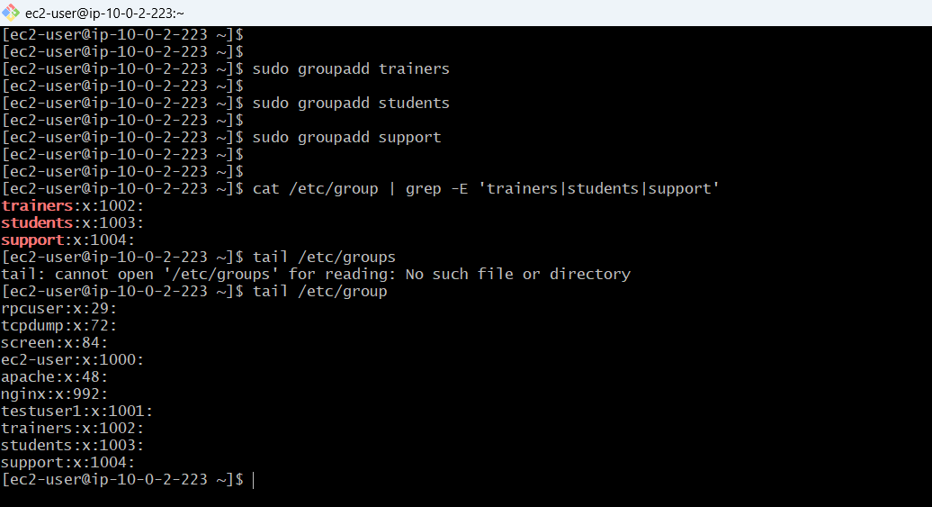

**CREATED TRAINER USERS**

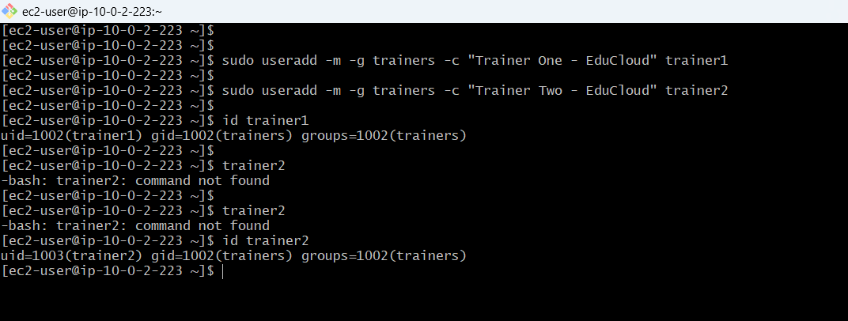

**CREATE STUDENT USERS**

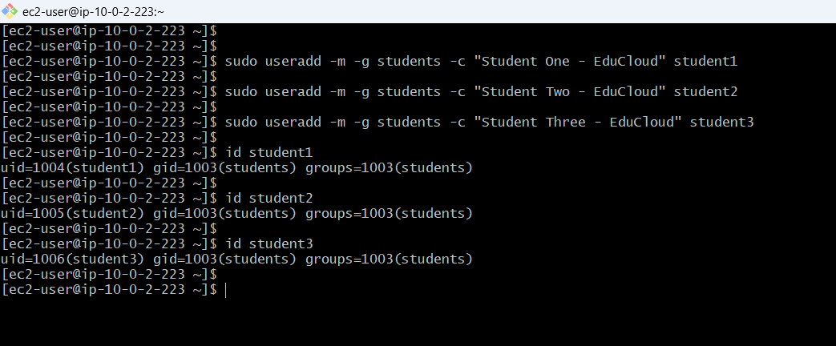

**CREATED SUPPORT USER**

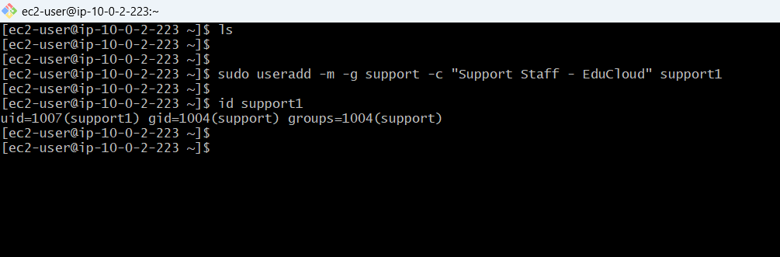

**All users created**

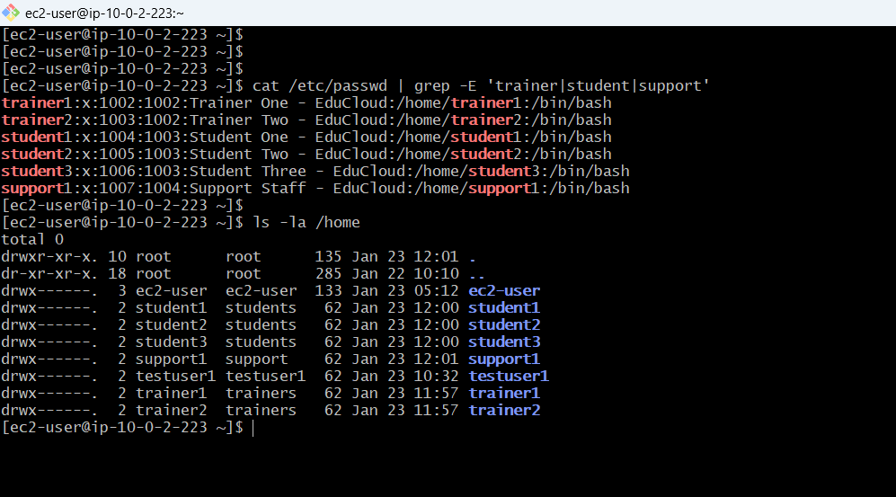

**SET PASSWORDS**

**SET PASSWORDS FOR TRAINERS**

Trainer1

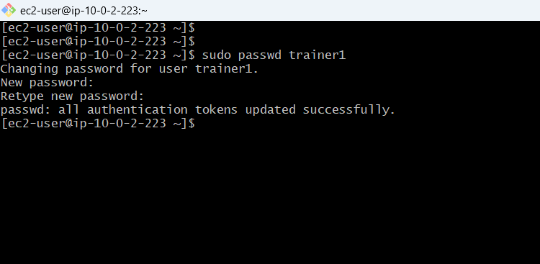

**Password:** Trainer@2026

**Tried including trainer name in the pssword**

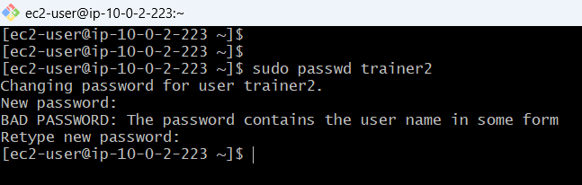

Trainer2

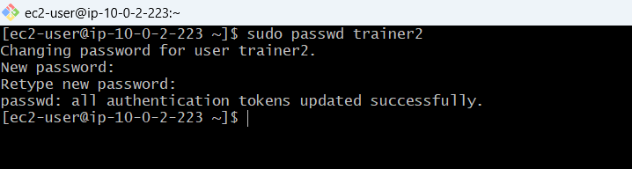

**Password:**Trainertwo@2026

**SET PASSWORDS FOR STUDENTS**

**Student1**

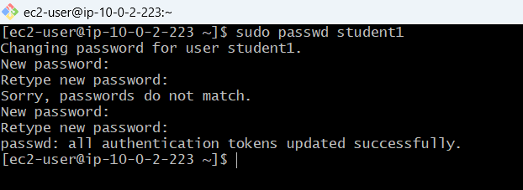

Password:EduCLoud@123

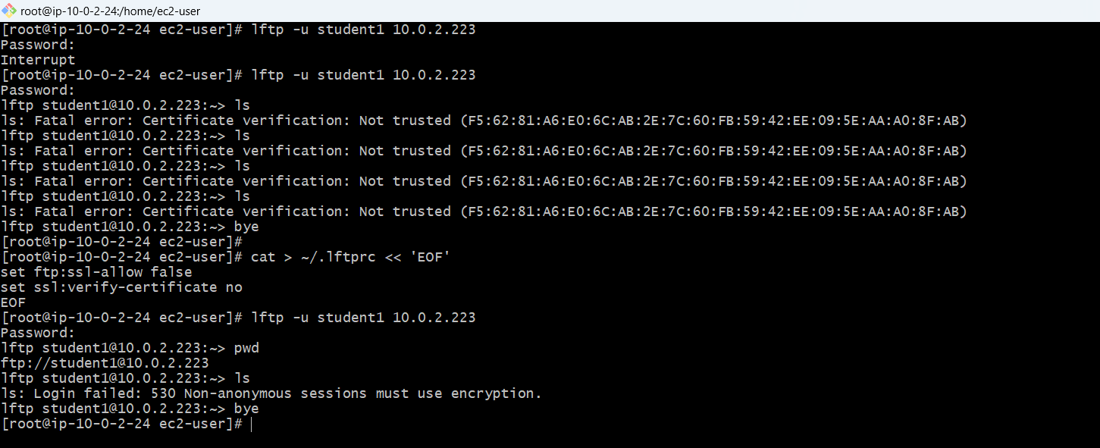

**Student2**

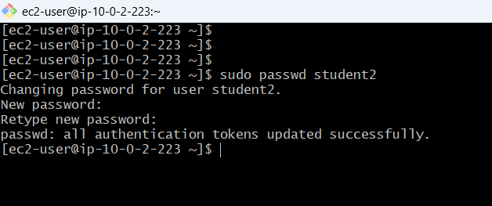

Password: Learning#456

**Student3**

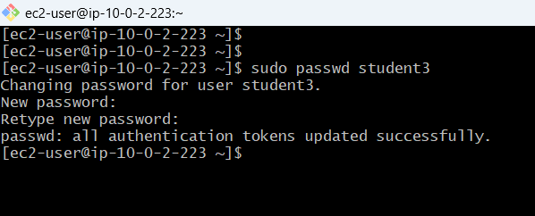

Password:Scholer$789

**SET PASSWORD FOR SUPPORT**

**Support**

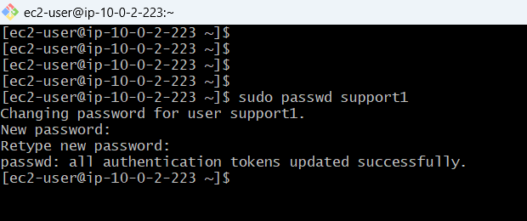

Password:HelpDesk$99

**PASSWORD AGING POLICY LIST**

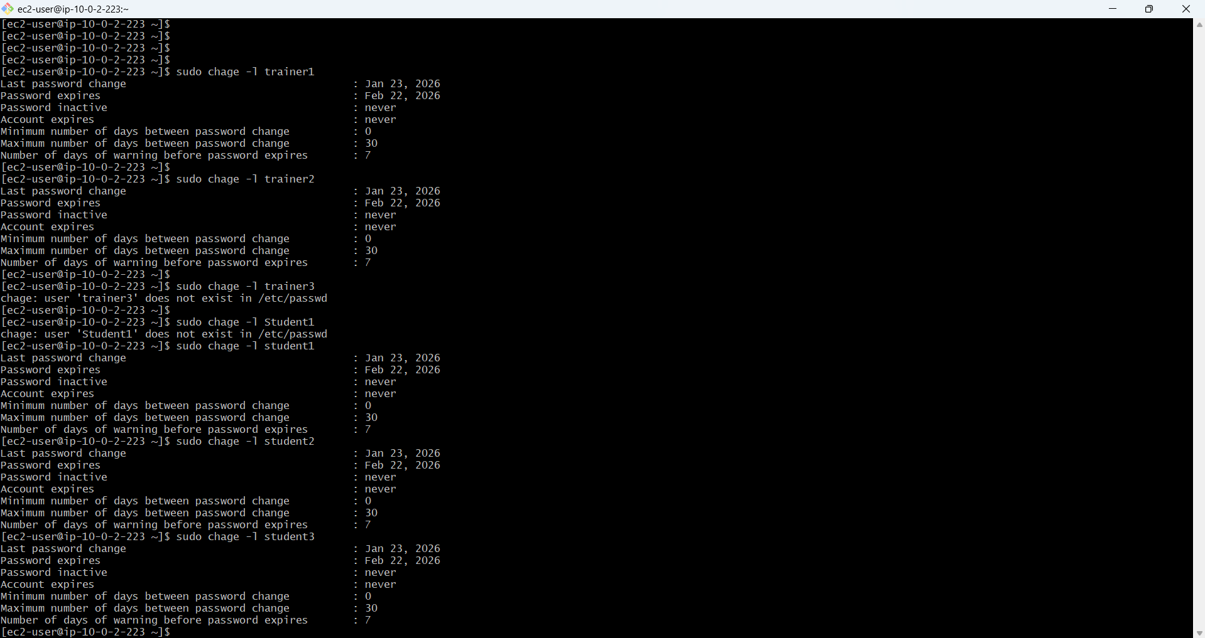

**TRAINERS (trainer1, trainer2):**

- Upload study materials to /materials (via NFS)

- Read/Write access to /materials - Read-only access to /assignments

- Read/Write access to /logs

- Can manage student records in RDS

- Can trigger backups to S3

- Access to encrypted /sensitive_data (LUKS)

**STUDENTS (student1, student2, student3):**

- Download materials from /materials (read-only via NFS)

- Upload assignments to /assignments (via FTP)

- Read/Write access to /assignments

- No access to /logs

- No access to /sensitive_data

- Can view own records in RDS

**SUPPORT (support1):** -

Monitor system logs in /logs (read-only)

- Upload logs and backups to S3

- Read-only access to /logs

- CloudWatch monitoring access

- No access to /materials or /assignments

- No access to /sensitive_data

**All 6 users created successfully**

All users assigned to correct groups

All passwords meet complexity requirements

Password aging configured (30 days)

User login tested (trainer1, student1)

Password change on first login tested

Home directories created with proper permissions

**CREATED MAIN PROJECT DIRECTORIES**

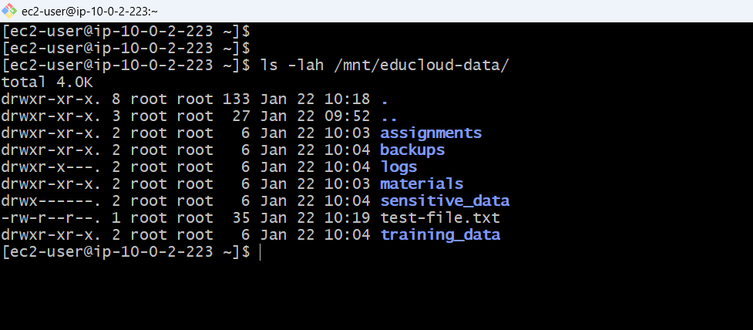

**SET OWNERSHIP FOR /materials**

**Trainers upload study materials here**

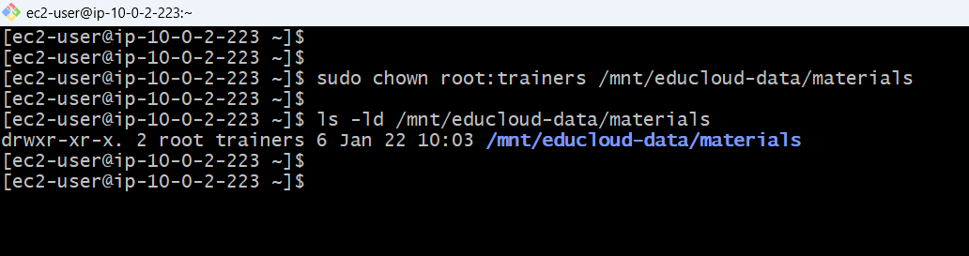

Owner: root (administrative control)

Group: trainers (trainers can write files)

**SET OWNERSHIP FOR /assignments**

**Students submit assignments here**

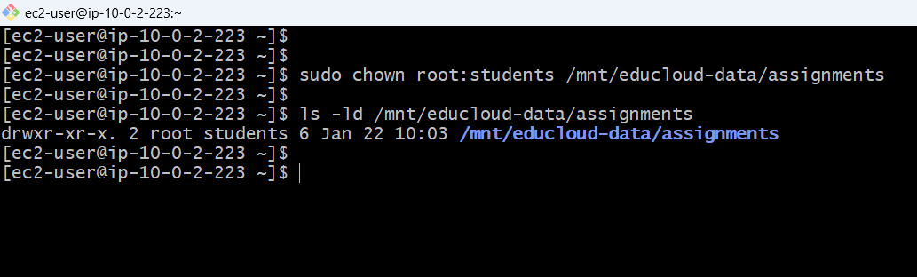

**SET OWNERSHIP FOR /logs**

**System and application logs**

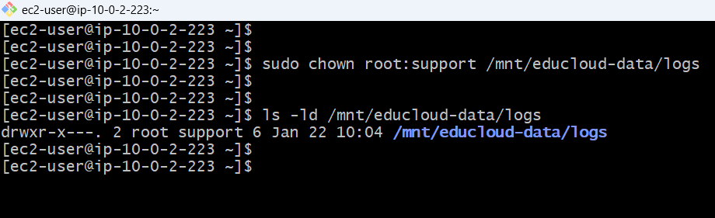

**SET OWNERSHIP FOR /training_data (FOR LVM)**

**Will be used for LVM**

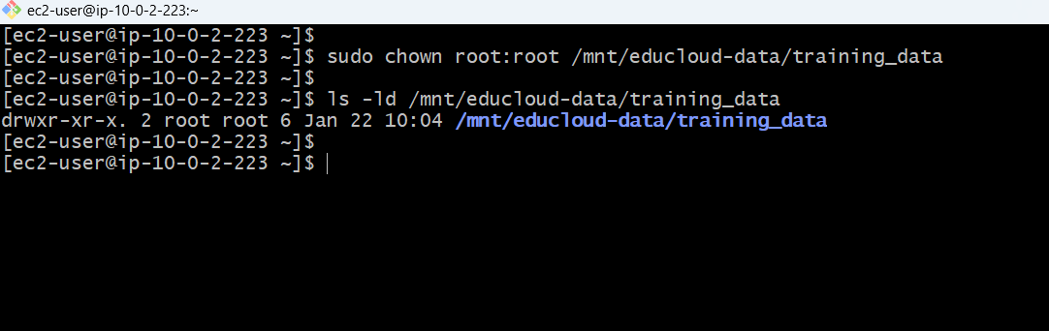

**SET OWNERSHIP FOR /sensitive_data (FOR LUKS)**

**Will be encrypted with LUKS (trainers only)**

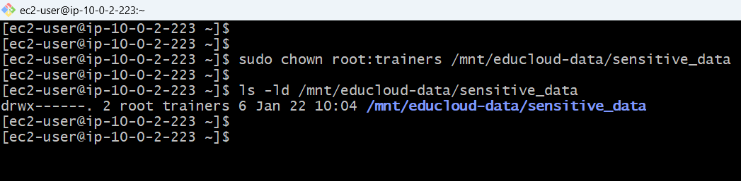

**SET BASIC PERMISSIONS**

**SET PERMISSIONS FOR /materials**

Trainers = Read/Write, Students = Read-only

**SET PERMISSIONS FOR /assignments**

Students = Read/Write, Trainers = Read-only

**SET PERMISSIONS FOR /logs**

Support = Read-only, Trainers = Read/Write, Students = No access

**SET PERMISSIONS FOR /training_data**

755 permissions (accessible to all for LVM )

**SET PERMISSIONS FOR /sensitive_data**

Trainers only

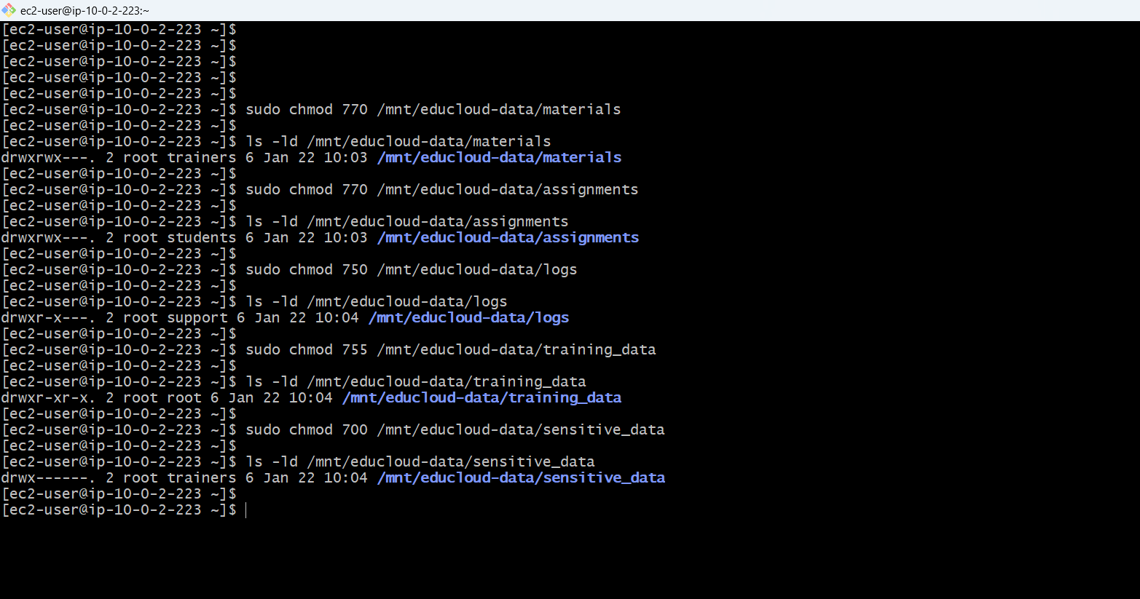

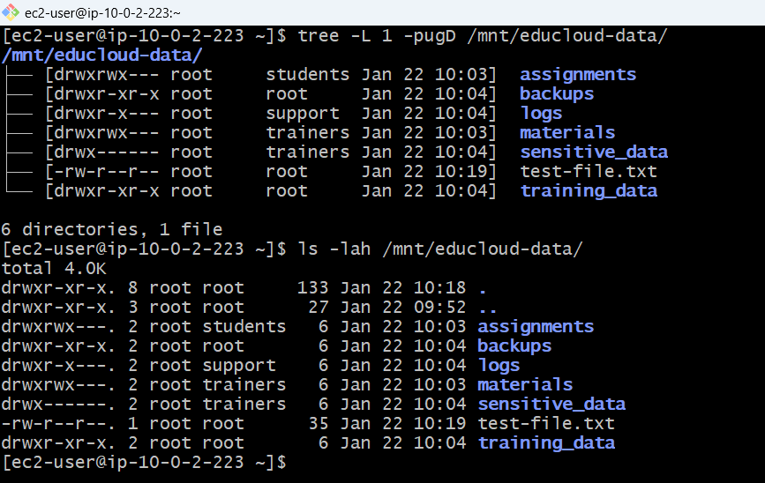

**CREATING TEST FILES IN DIRECTORIES TO CHECK THE TEST ACCES FRPOM THE DIFFERENT USER**

Adding test content to the test file and setting proper ownership to the files and also giving proper permission

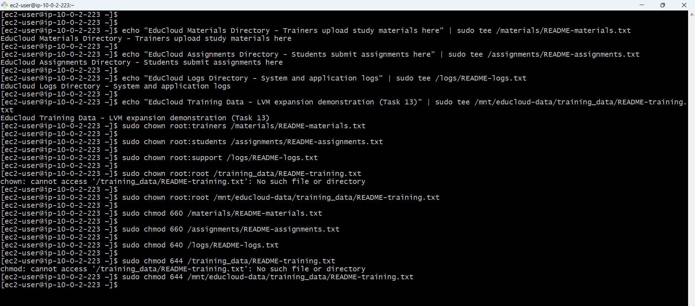

**No access to ec2-user only student, trainer and support these group member have the permission**

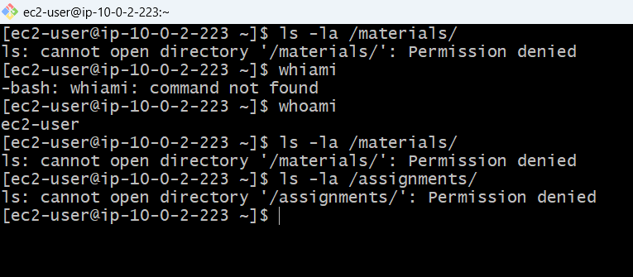

**TEST ACCESS WITH DIFFERENT USERS**

**TEST TRAINER ACCESS**

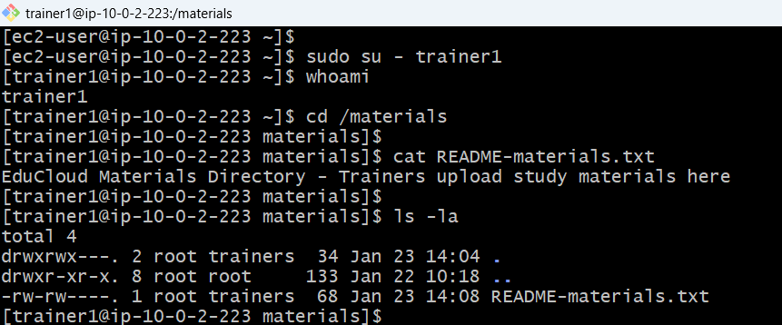

**Access test after proper ACL……. To be continued**

**TEST SUPPORT ACCESS**

All behaviours working as expected

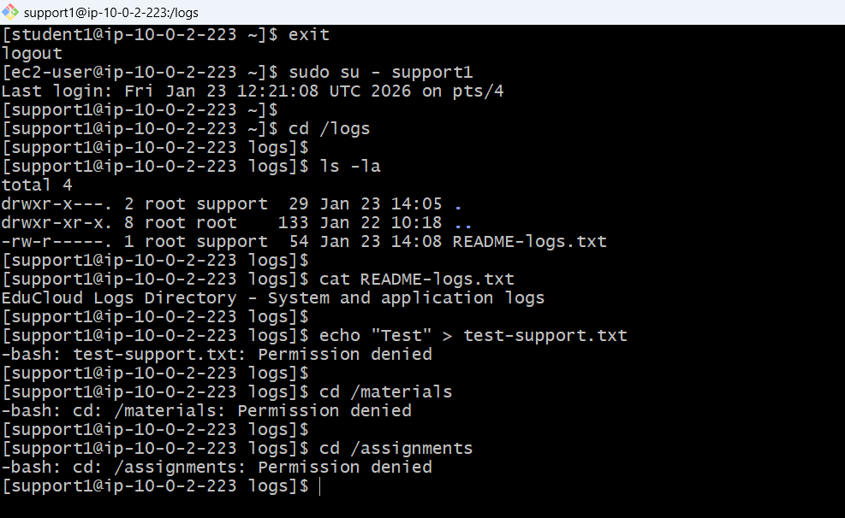

**FILE PERMISSIONS & ACLs CONFIGURATION**

**CONFIGURING ACLs FOR /materials**

Trainers = Read/Write, Students = Read-only

Current ACL

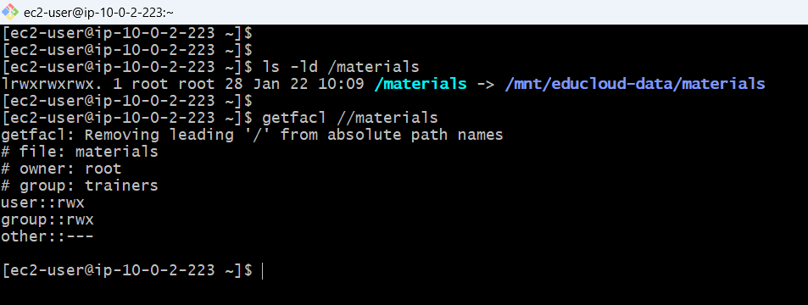

**ADD ACL FOR STUDENTS (READ-ONLY)**

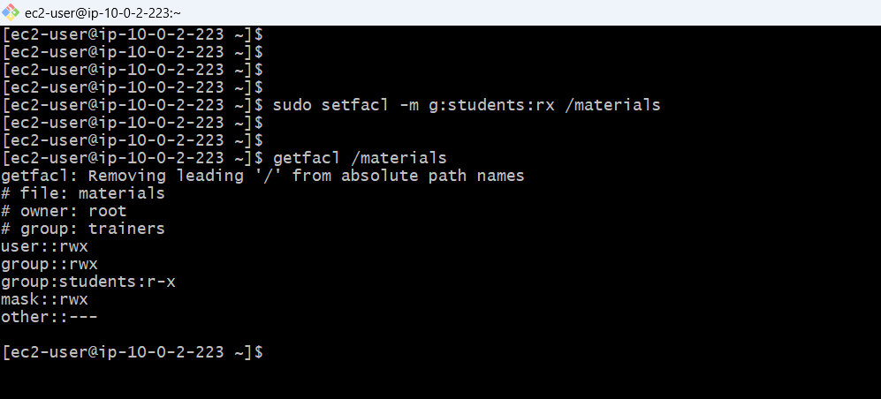

ACL added to /materials for students read only

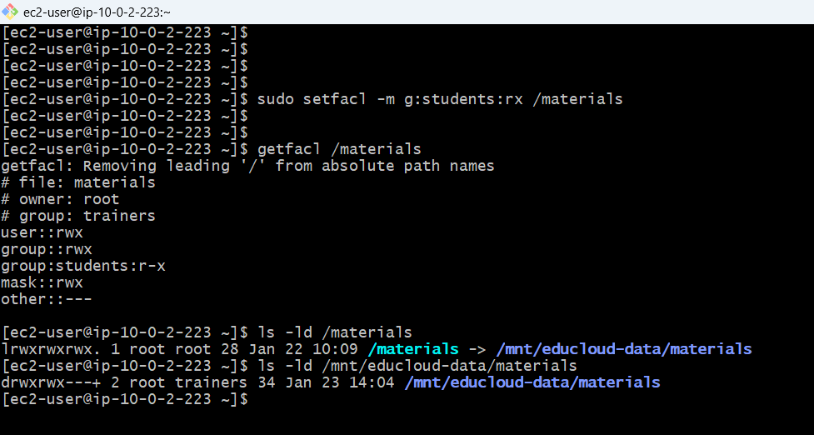

**SET DEFAULT ACL ON /materials**

Default ACLs ensure new files inherit the same permissions:

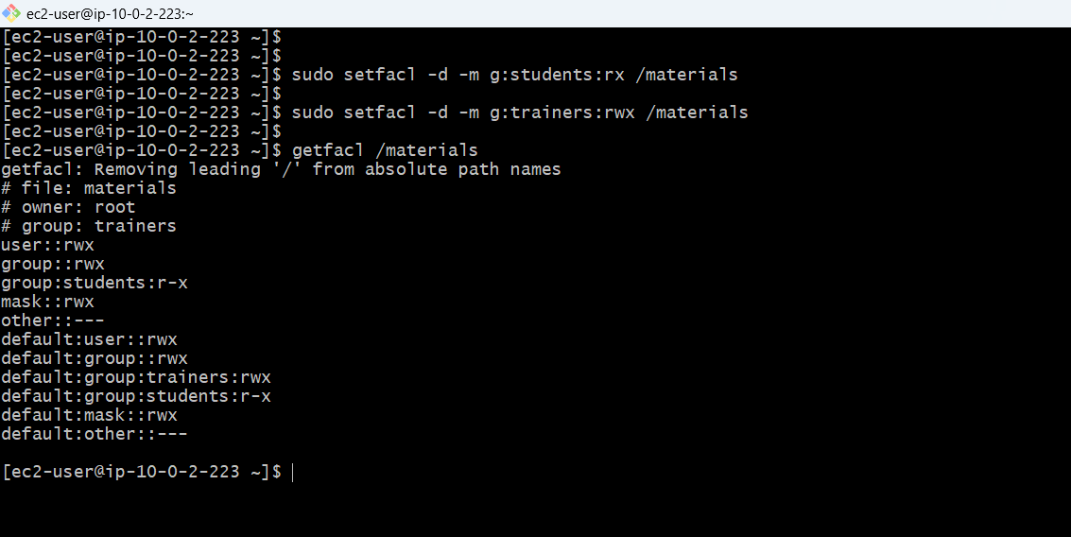

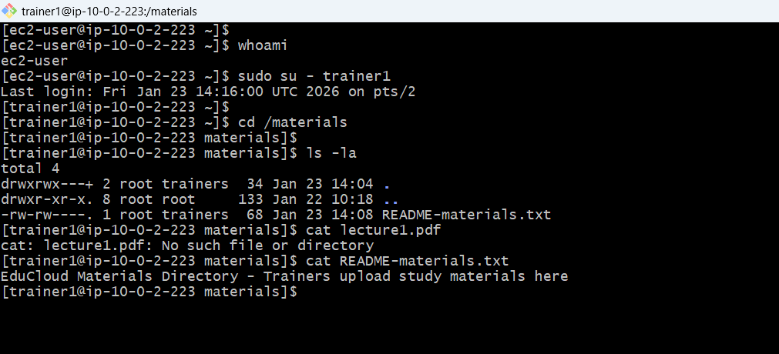

New file created in materials inherits r-w for in /materials

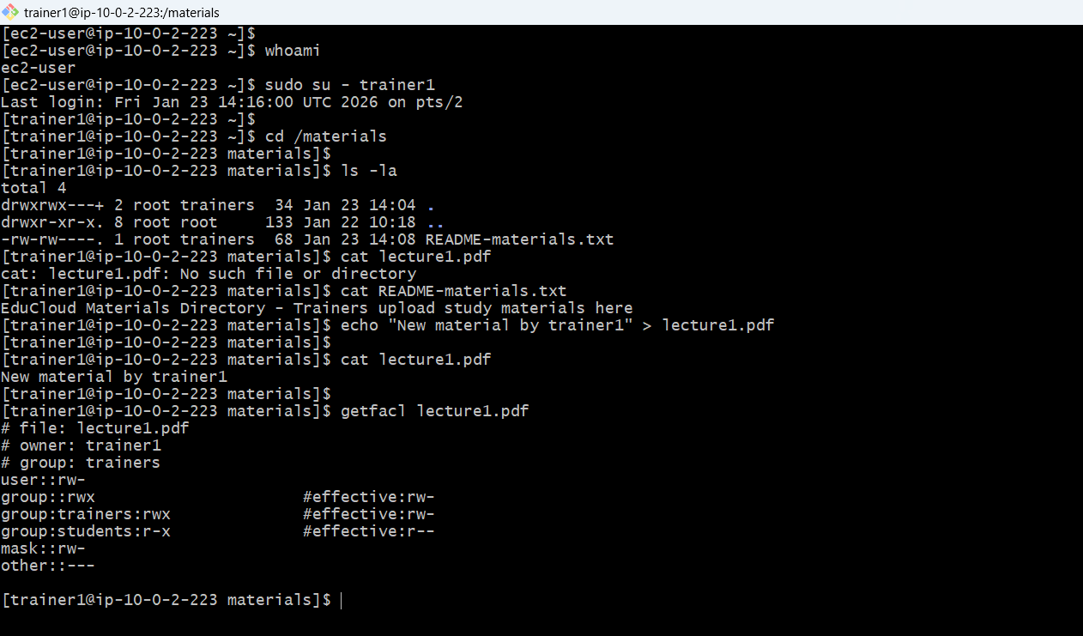

**write access denied for student to create files in materials**

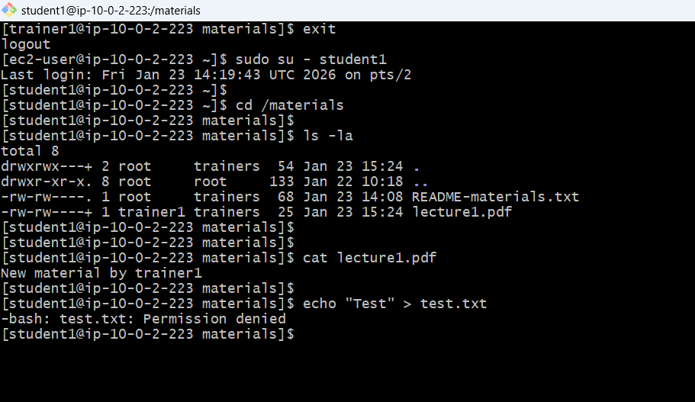

**CONFIGURE ACLs FOR /assignments**

**Students = Read/Write, Trainers = Read-only**

Give trainers group read and execute permissions

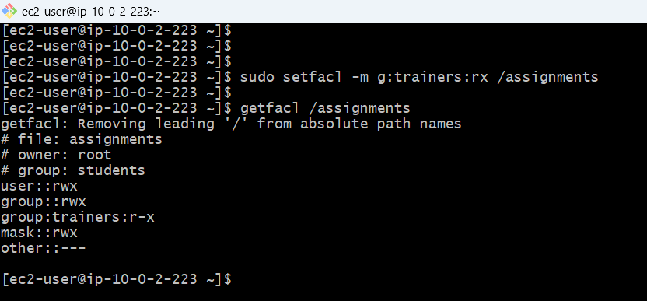

**SET DEFAULT ACL ON /assignments**

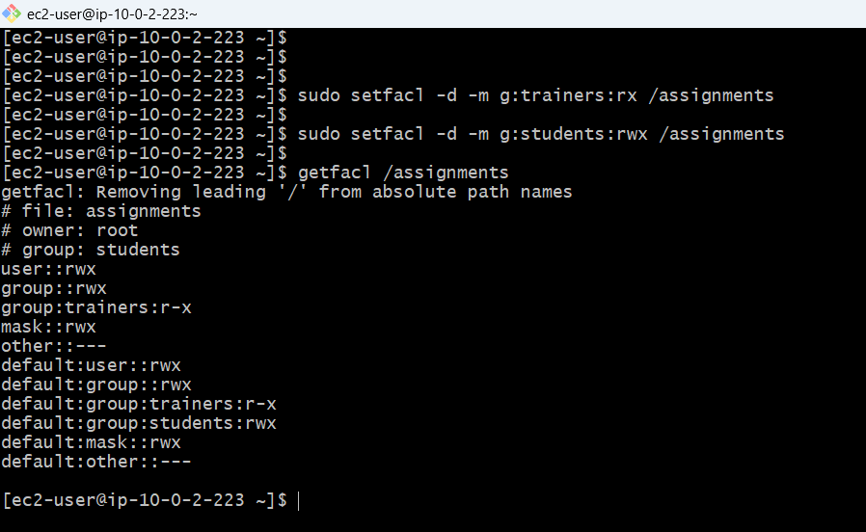

**TEST /assignments ACCESS**

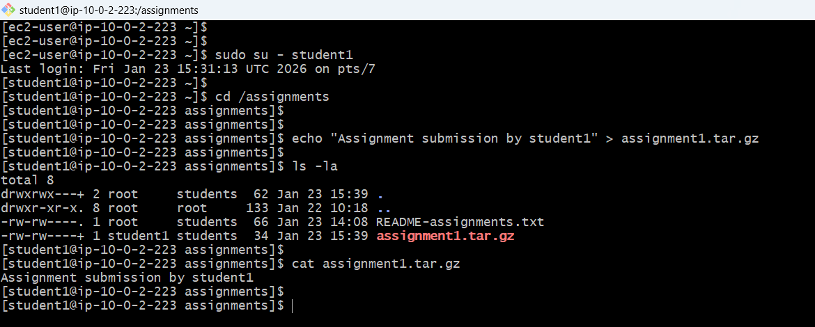

**Trainer rest on assignment and materials**

Trainers can read /assignments but cannot write

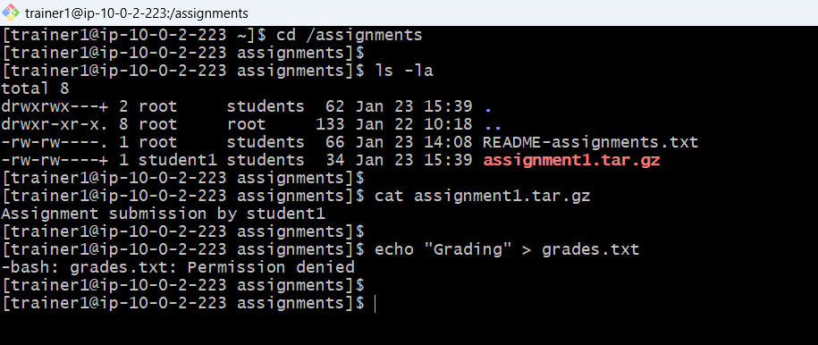

**CONFIGURE ACLs FOR /logs**

Support = Read-only, Trainers = Read/Write, Students = No access

**ADD ACL FOR TRAINERS (READ/WRITE) ON /logs**

trainers group read, write, and execute permissions

Support group already has r-x from basic permissions

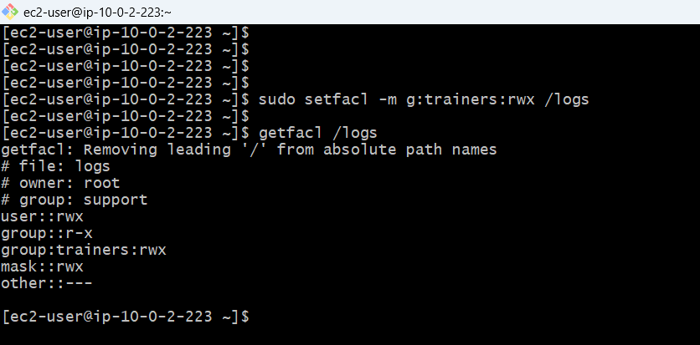

**SET DEFAULT ACL ON /logs**

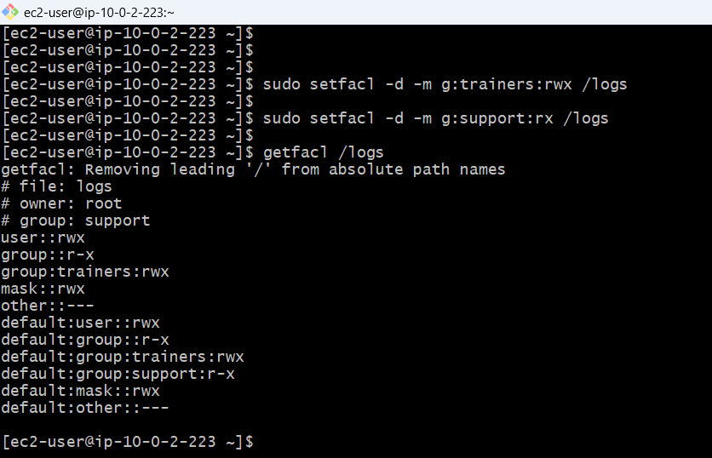

**TEST /logs ACCESS**

trainers group read, write, and execute permissions

**Trainer**

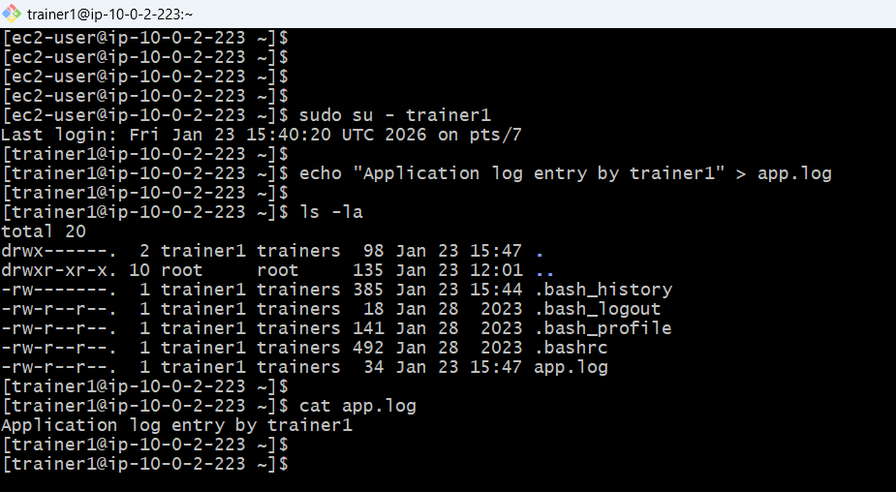

**/logs access control working correctly**

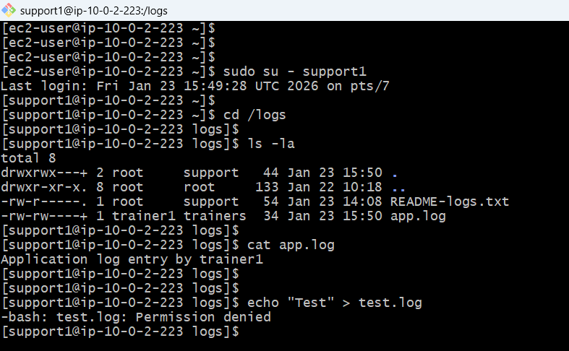

**Complete ACL configuration summary**

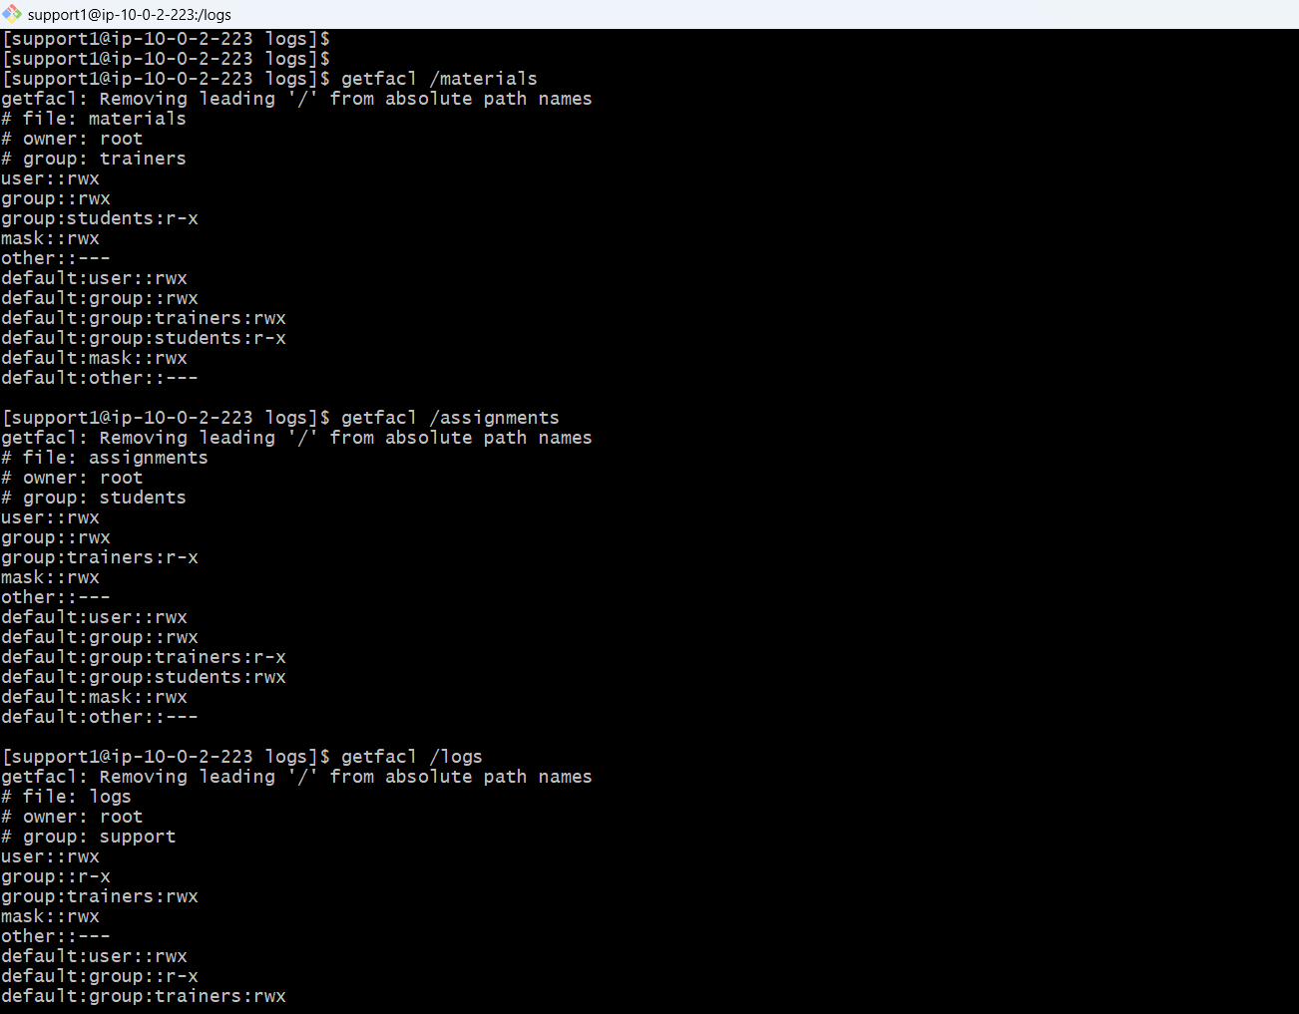

**TEST FILES CREATION AND VERIFY INHERITANCE**

**/materials**

**students:r-x inherited**

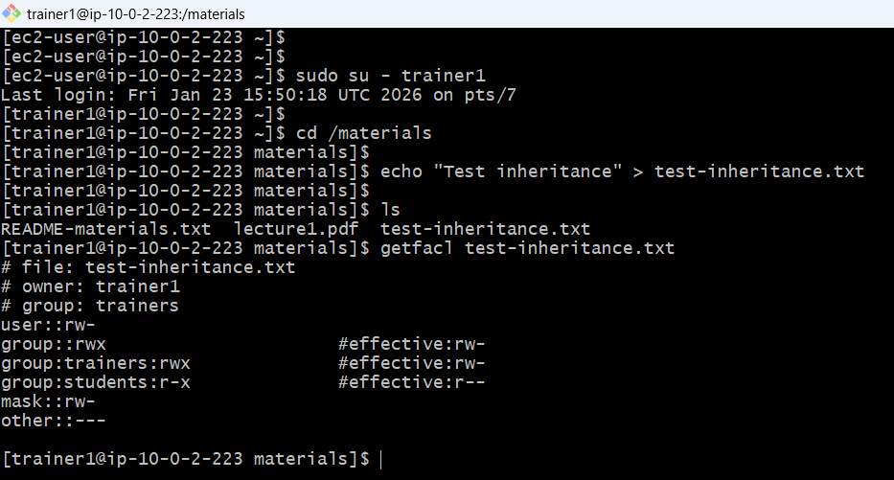

Test file creation as student1 in /assignments

trainers: r-x inherited

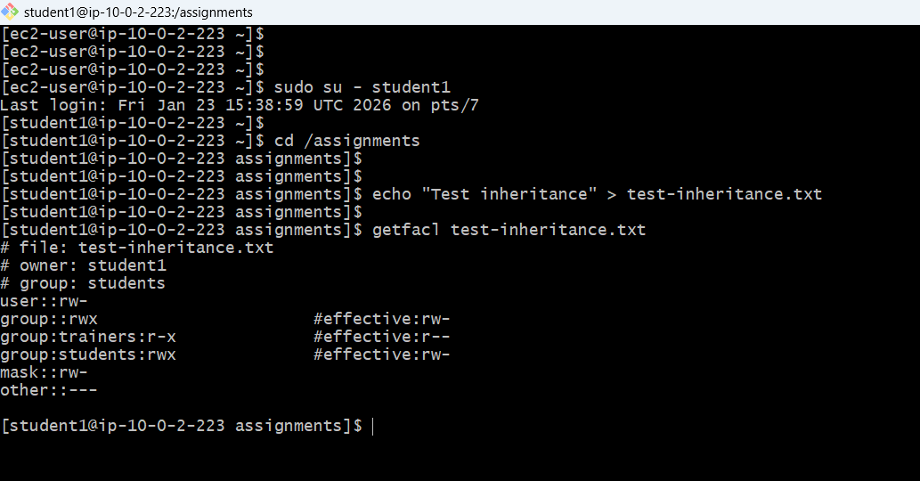

**LVM STORAGE SETUP**

**CURRENT STORAGE**

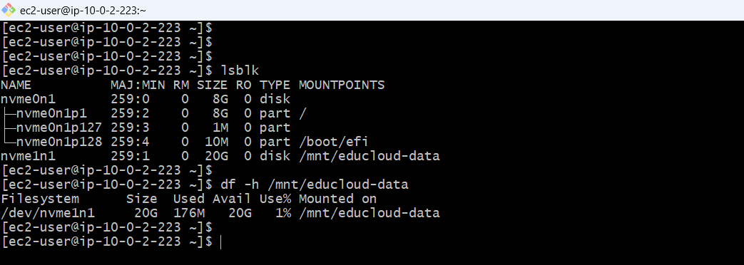

**BACKUP ALL DATA**

**Backup all data preserves permissions**

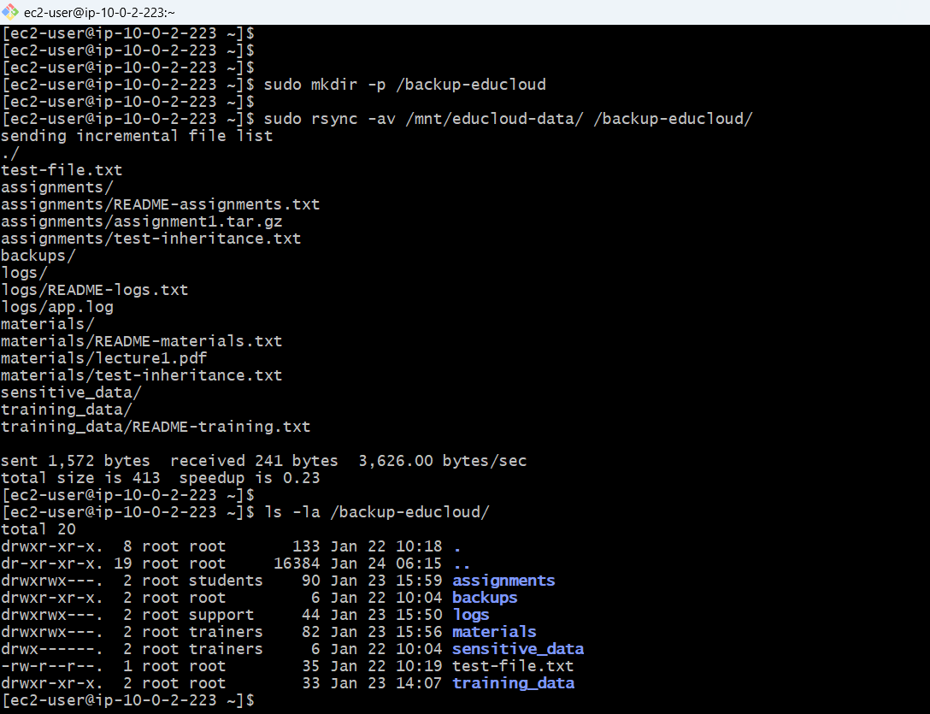

Fstab backup

REMOVE EXISTING FSTAB ENTRY

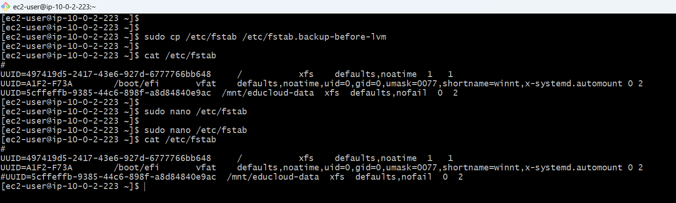

**UNMOUNT THE DISK**

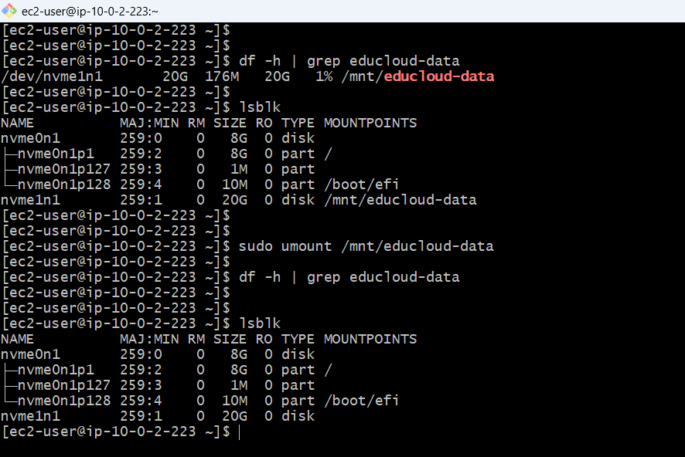

**REPARTITIONING THE DISK**

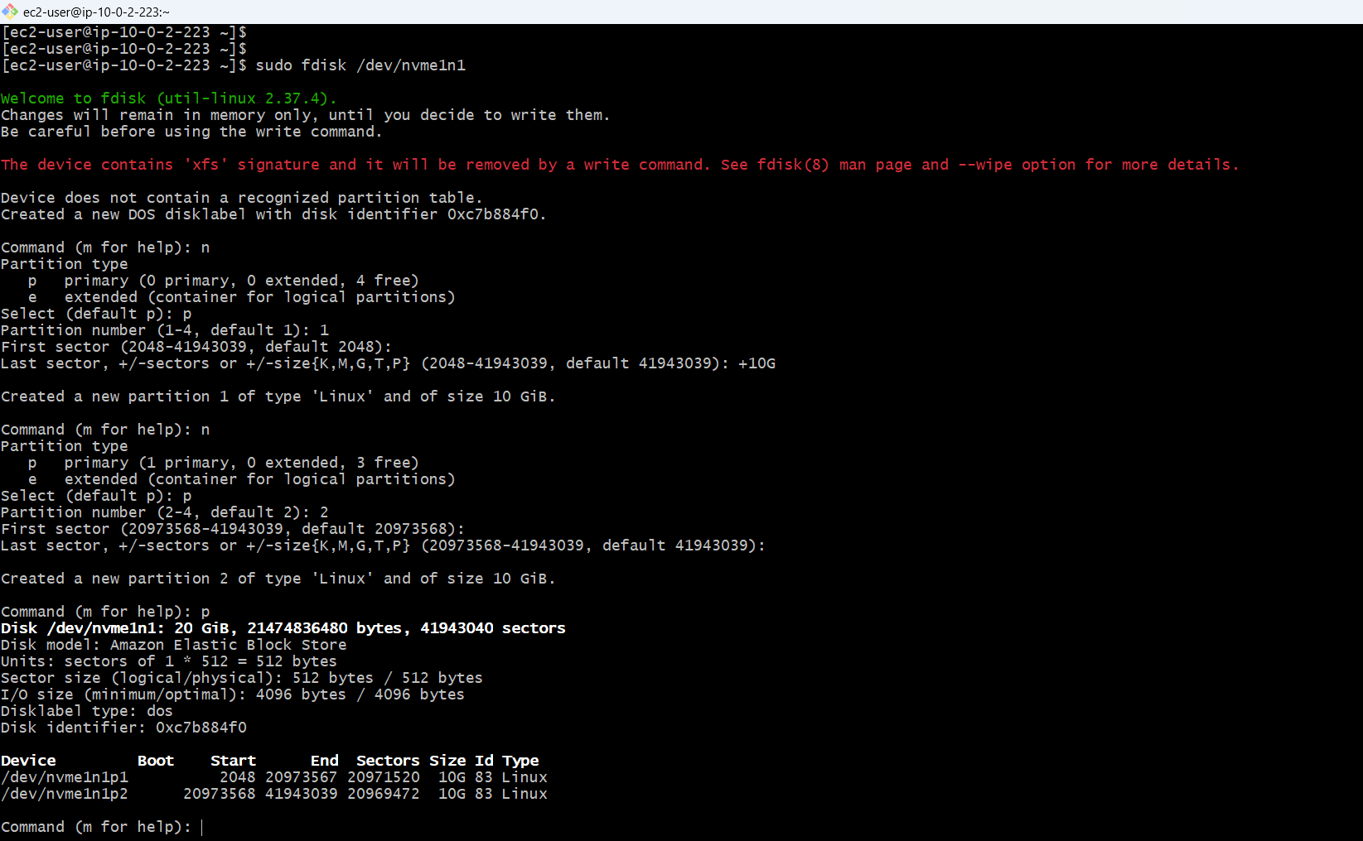

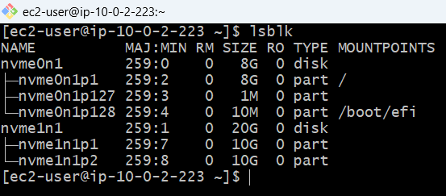

**FORMAT AND RESTORE DATA PARTITION**

**FORMATING FIRST PARTITION 10GB FOR OLD DATA**

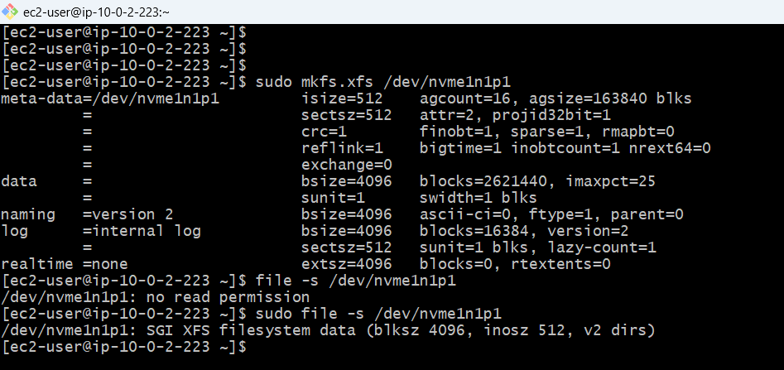

**MOUNTED DATA TO PARTITION**

**10GB Partition for Educloud data**

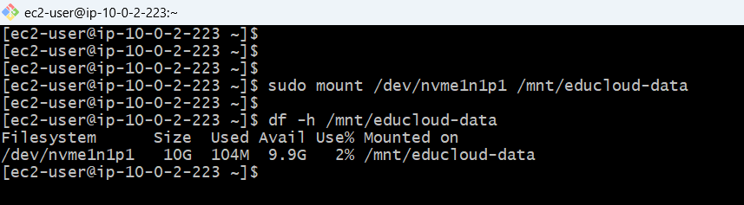

**RESTORED DATA**

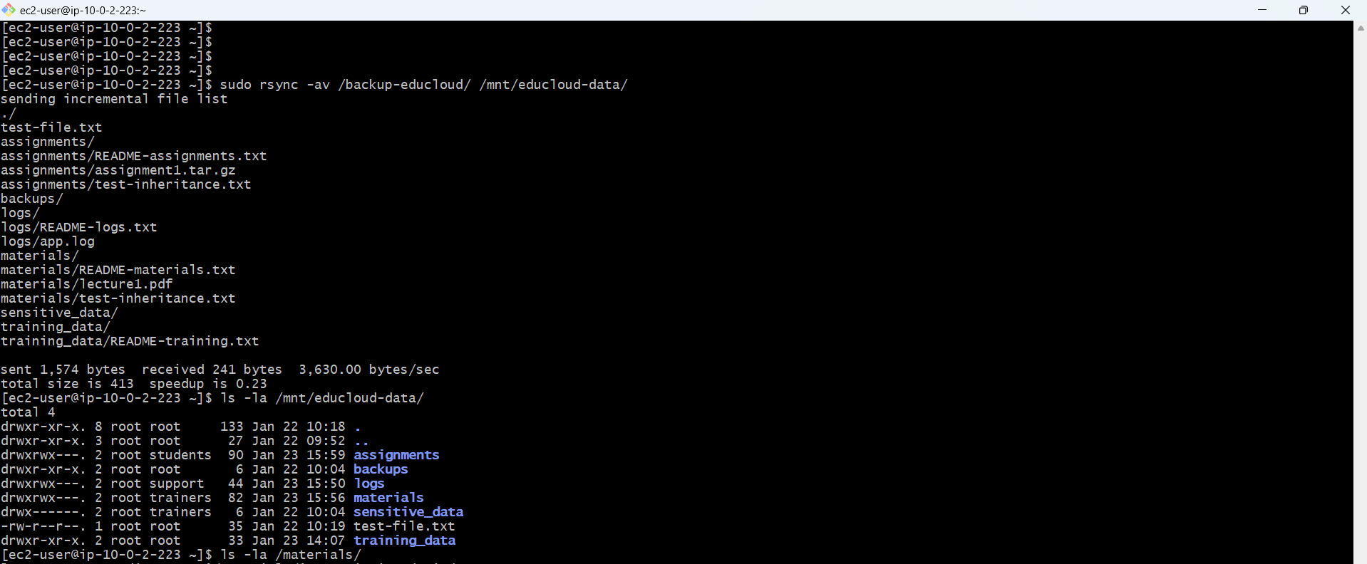

**Data restored to 10GB partition**

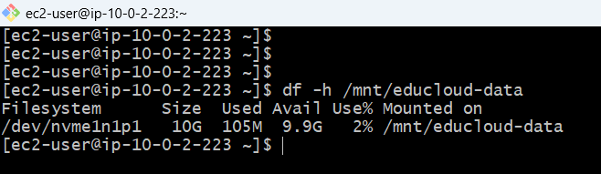

**UPDATING FSTAB FOR DATA PARTITION**

**/mnt/educloud-data is attached to the new partition 10GB**

**Removed backup to free space**

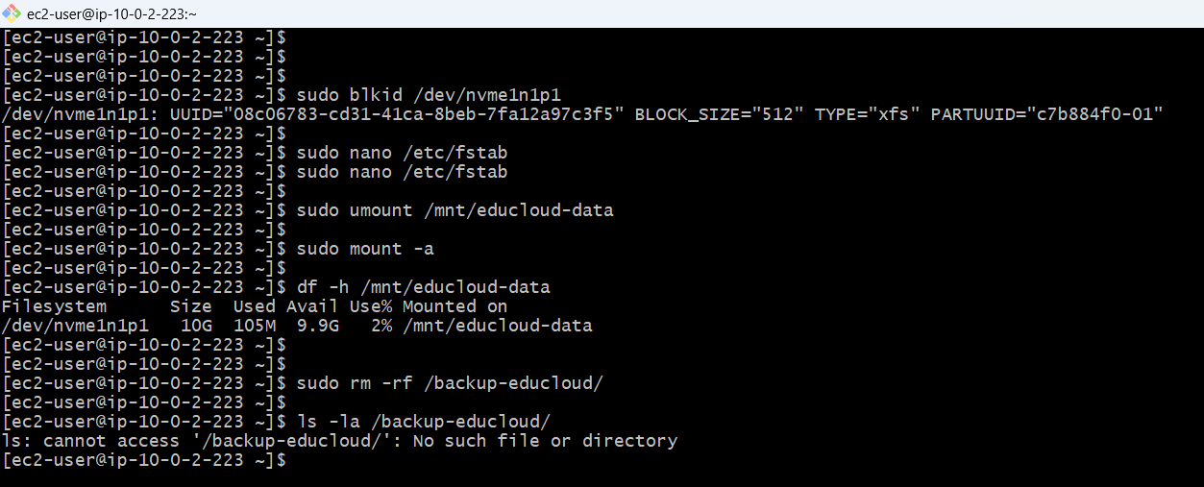

**CREATE PHYSICAL VOLUME**

Creating Physical Volume on partition 2

Creating Volume Group named "training_vg" with 10GB capacity

Volume Group created (10GB)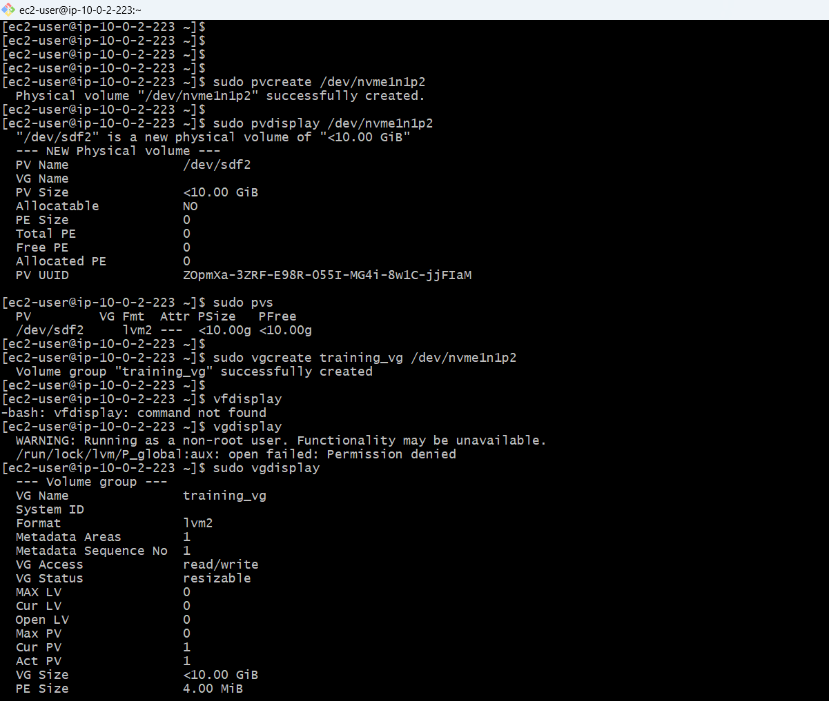

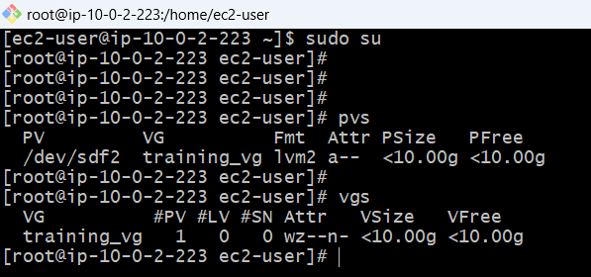

**CREATE LOGICAL VOLUME (5GB)**

Created 5GB Logical Volume

Logical volume "training_lv"

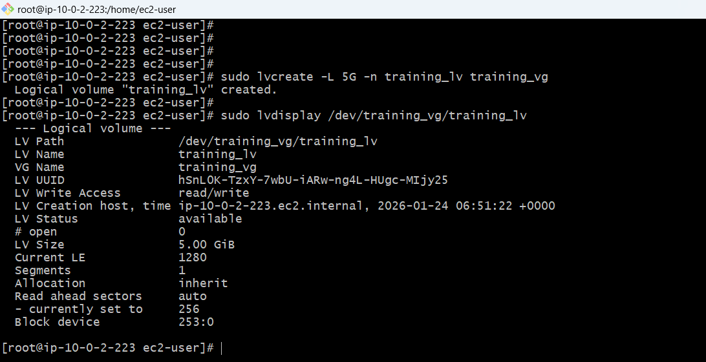

**Partition structure**

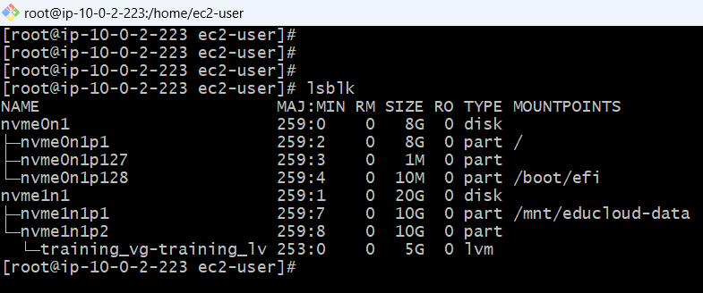

**FORMATING AND MOUNTING LVM VOLUME**

**FORMATING LOGICAL VOLUME**

**5GB LVM volume is mounted!**

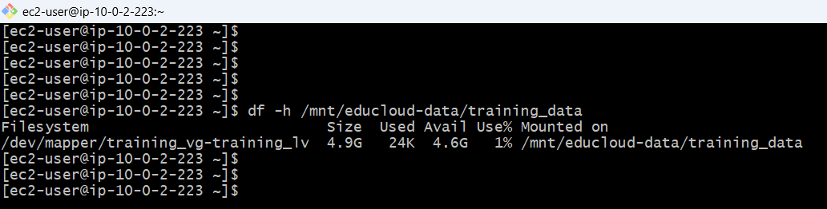

**CONFIGURE AUTO-MOUNT /etc/fstab for new mount /training_data auto-mount**

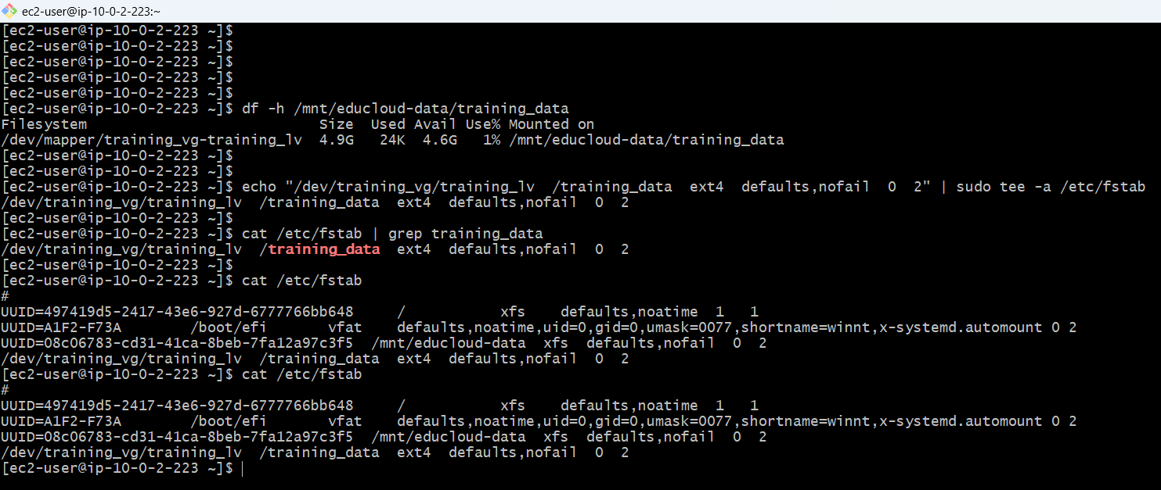

**DISK USAGE**

**Pushed some demo file to track the usage**

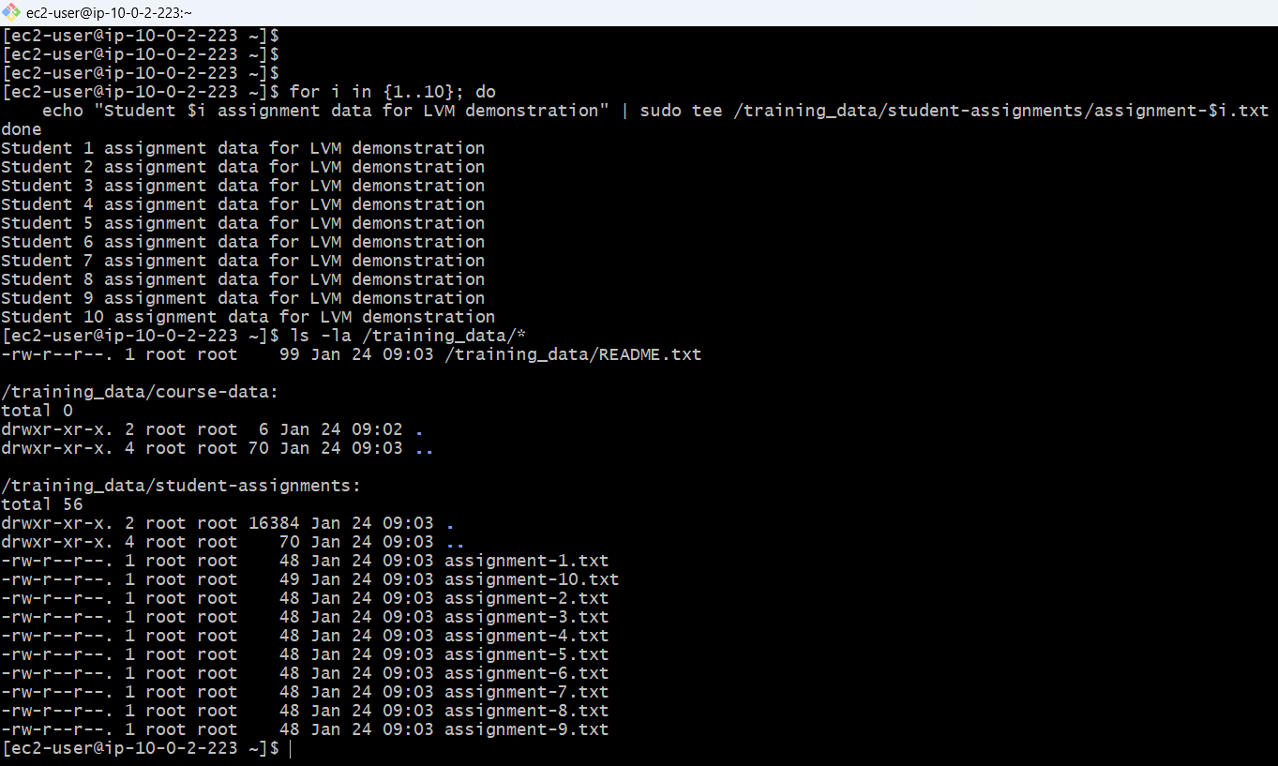

**Current usage**

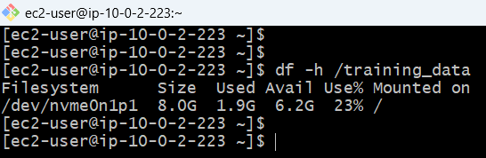

**FILLED DISK TO 80% CAPACITY**

Create large file to fill disk to 80%+

created 3.8GB file

sudo dd if=/dev/zero of=/training_data/large-dataset.img bs=1M count=3800

**DISK TO 80% CAPACITY**

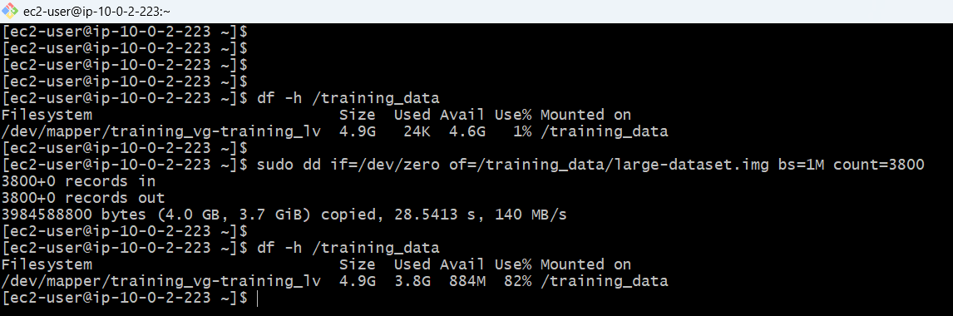

/training_data at 84% capacity

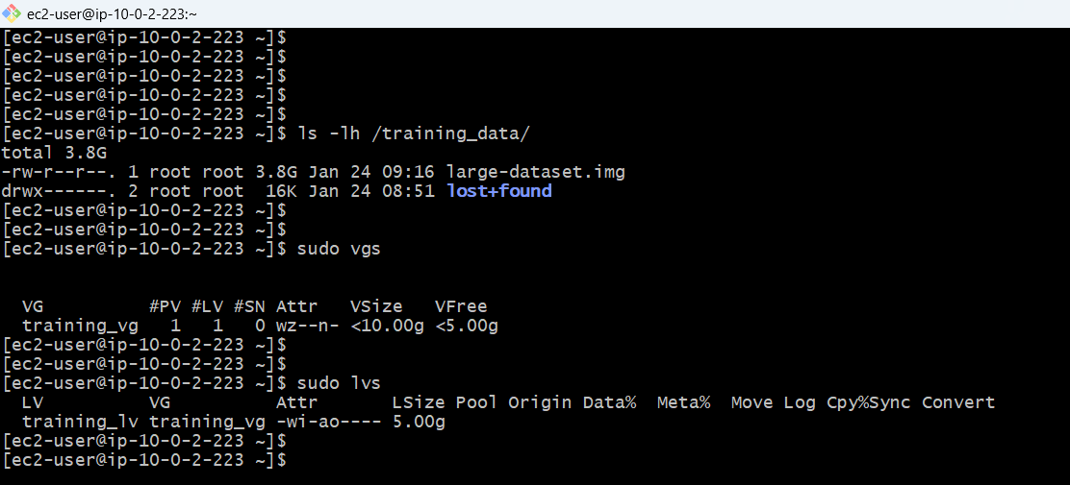

**5gb in vg**

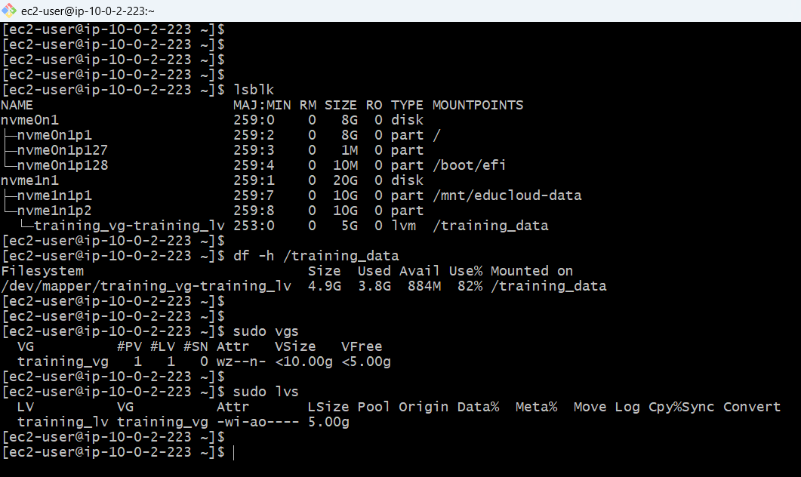

**EXTENDED LOGICAL VOLUME TO 10GB**

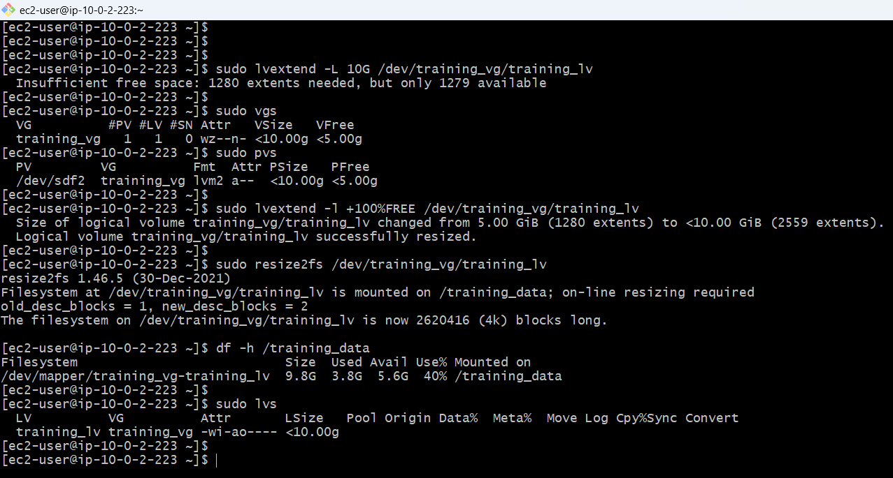

**~10gb**

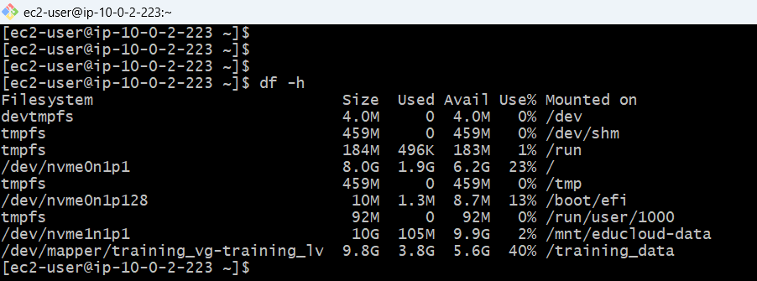

**ALL DATA PREVESRVED AS IT IS BEFOR EXPANSION**

**DATA INTEGRITY**

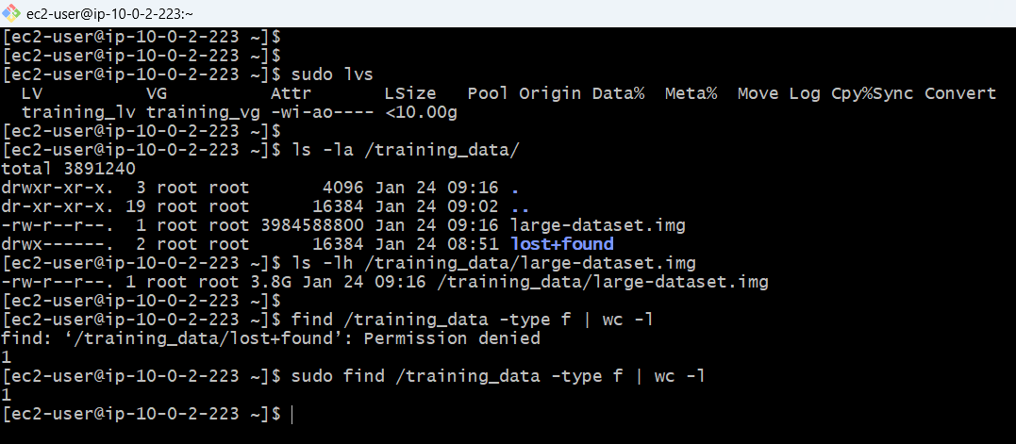

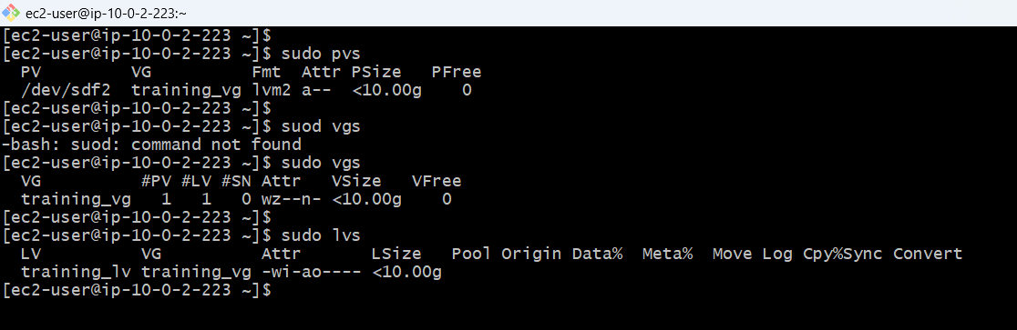

**Disk Repartitioning:**

Data backed up successfully

20GB disk repartitioned into 10GB + 10GB

Data restored to 10GB partition

Fstab updated for data partition

**Physical Volume (PV):**

PV 10GB size

**Volume Group (VG):**

Initial free space: 10GB

**Logical Volume (LV):**

LV "training_lv" created at 5GB

**VG free space: 5GB after LV creation**

Mounted to /training_data

Test data created to fill the disk with 80%

**Disk filled to 80%+**

**LVM Expansion:**

LV extended from 5GB to 10GB

Filesystem resized online

No unmount during expansion

All data preserved

Post-expansion shows ~42% usage

**LUKS ENCRYPTION SETUP**

/sensitive_data partition (2GB) with LUKS encryption for trainer-only access

**INITIAL CHECK**

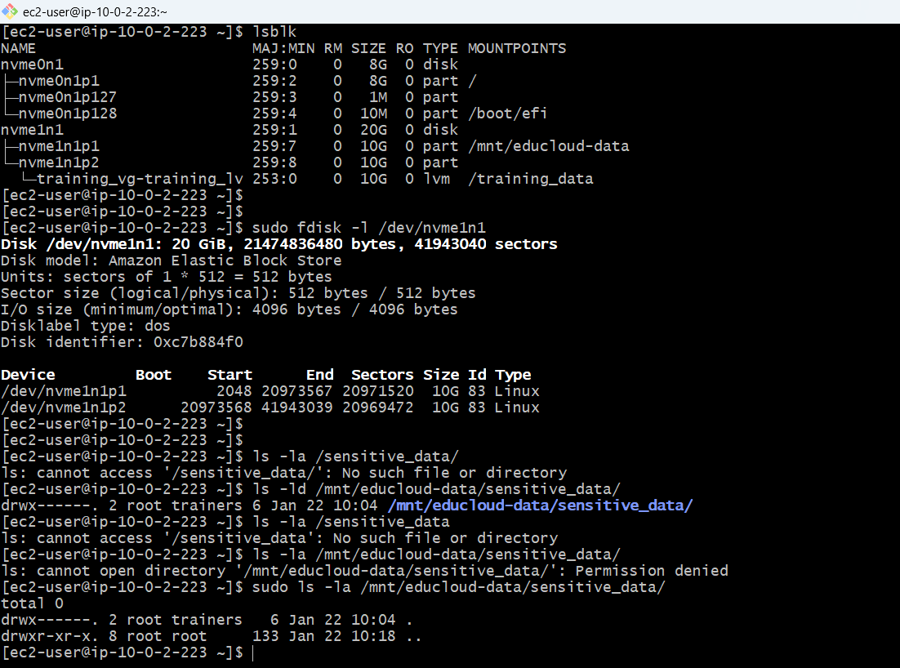

**Current Disk Layout**

**Available Space on nvme1n1**

**/sensitive_data Directory**

**cryptsetup Installed**

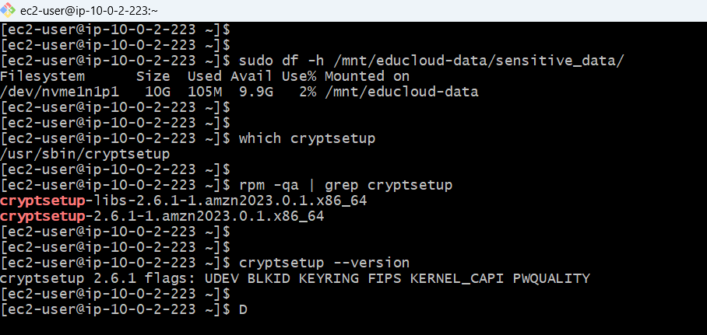

**taking backup of the file if there is any data present already**

**verifying backup**

**unmounting if mounted before**

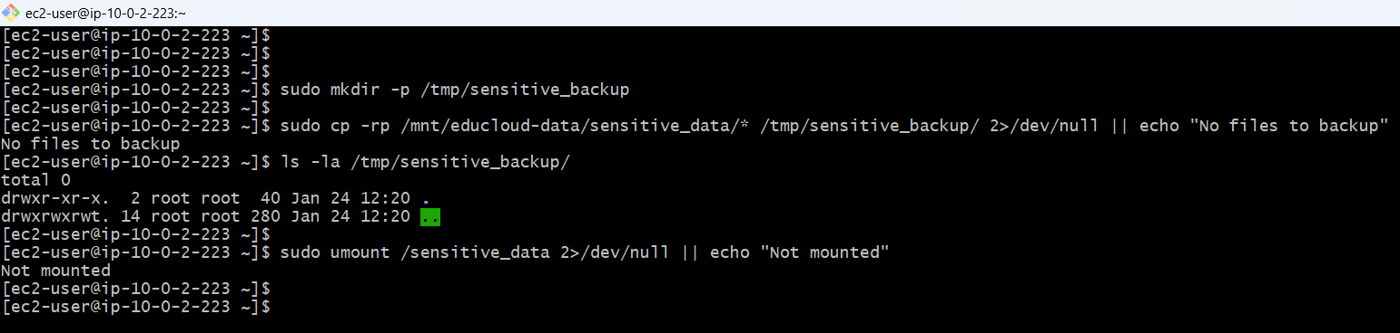

**Creating 2GB Partition**

**Check LVM Usage**

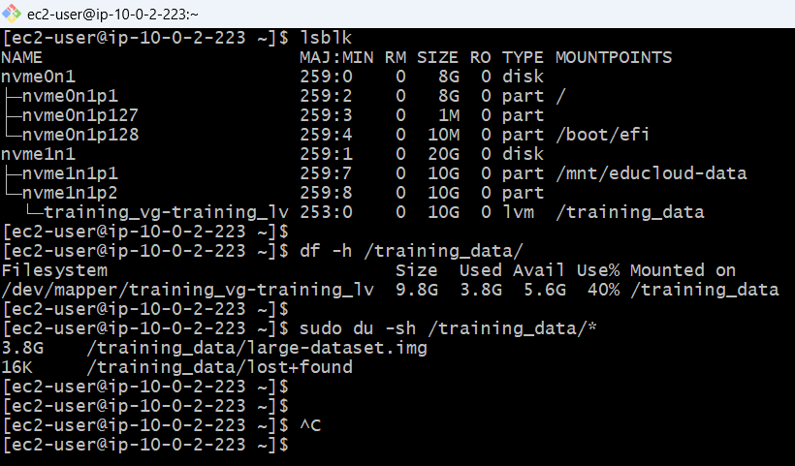

**VG/LV/PV Status**

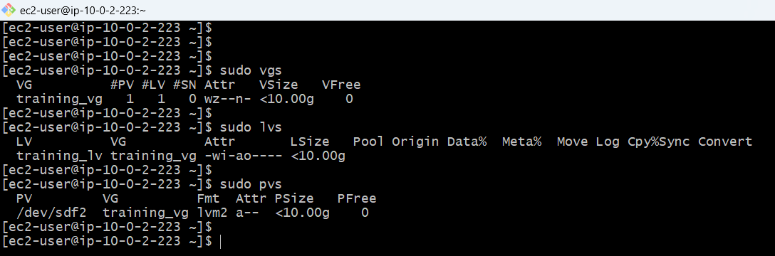

**Backing up Training Data**

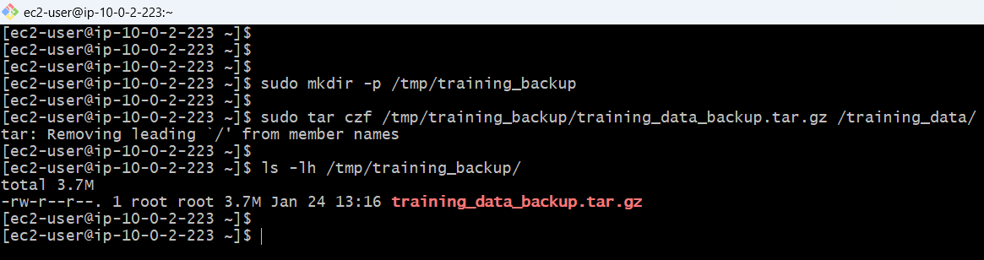

**Unmount /training_data**

**Check Filesystem**

**Resize Filesystem to 8GB**

**Shrink Logical Volume to 8GB**

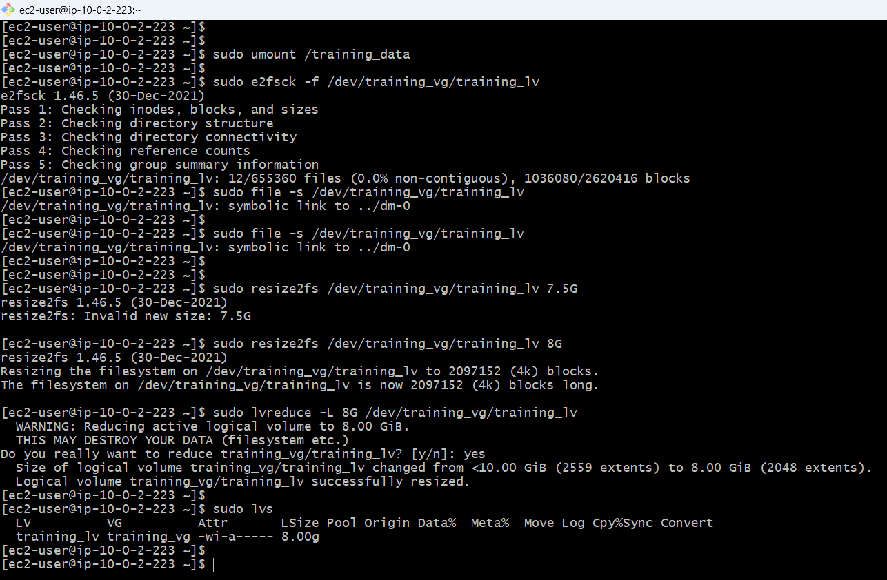

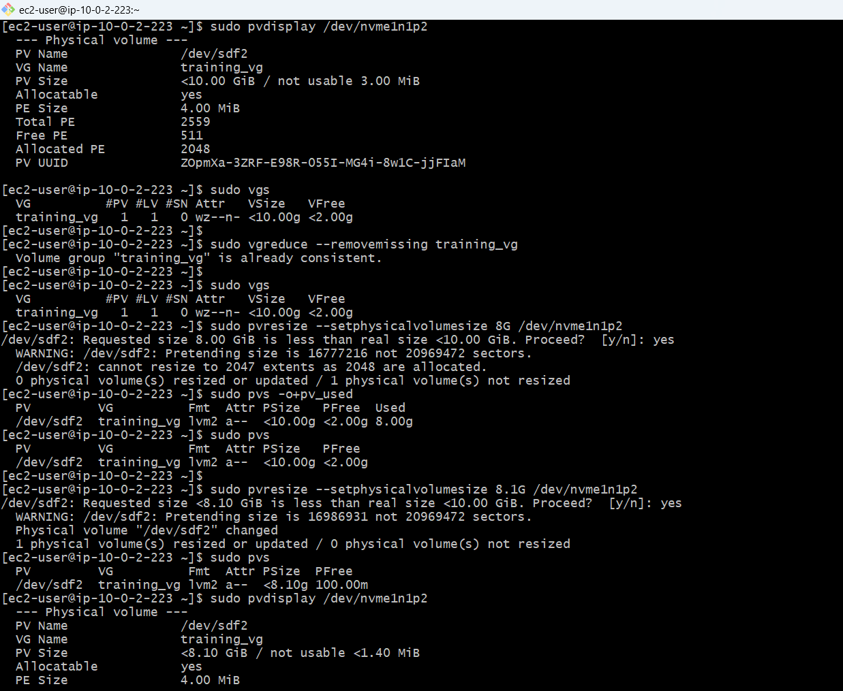

**Pvs,lvs,vgs**

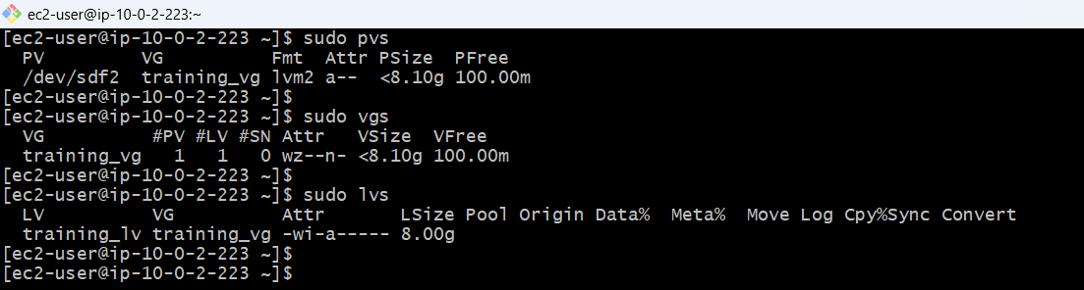

**Remounted /training_data**

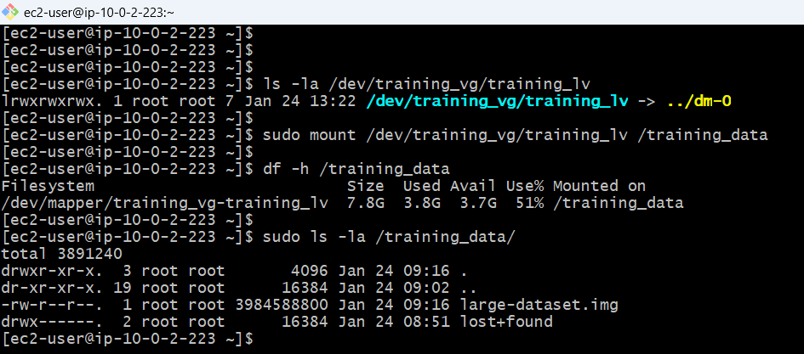

**Before:**

**p2: sectors 20973568 to 41943039 (10GB)**

**After:**

**text**

**p2: sectors 20973568 to ~37748735 (8GB)**

**for p3:**

**FREE: sectors ~37748736 to 41943039 (2GB) ← Available for p3!**

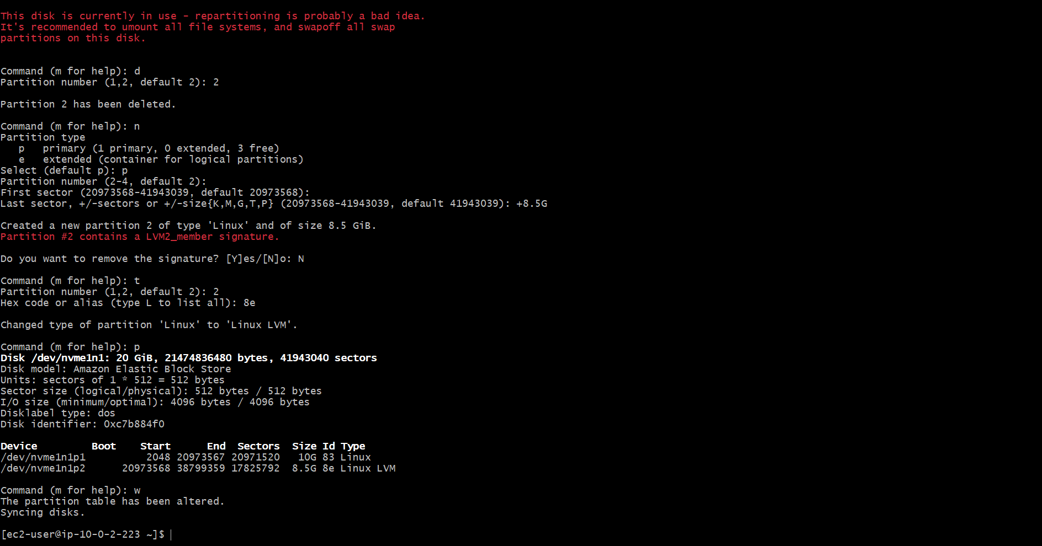

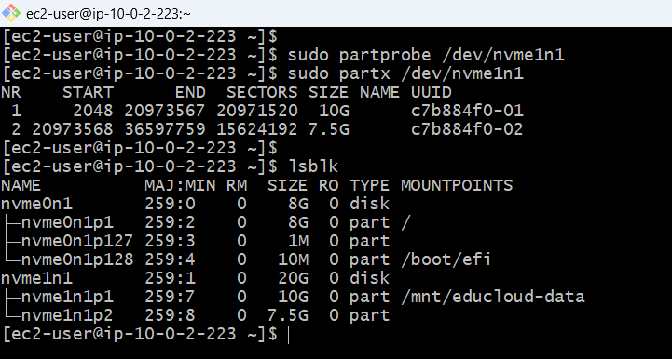

**Resized P2 pv, vg, lv**

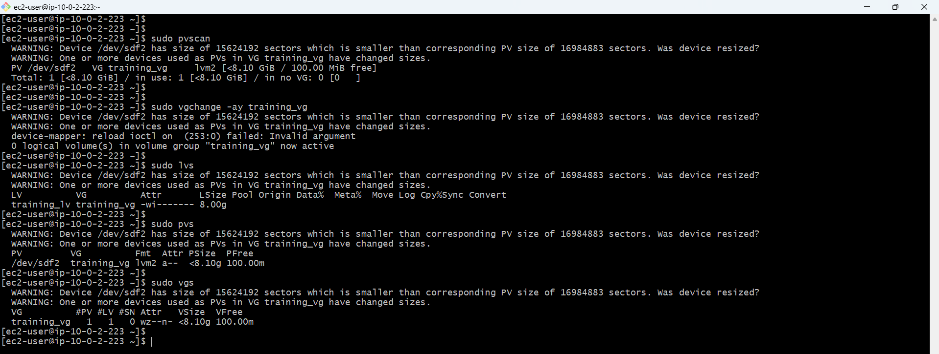

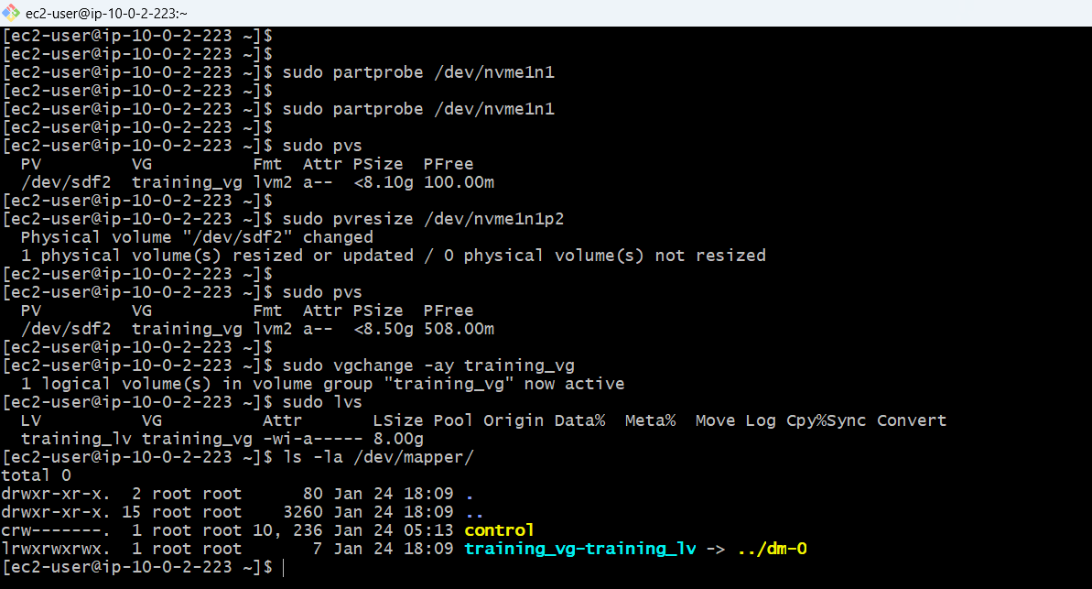

**Mounted training data, verified data integrity**

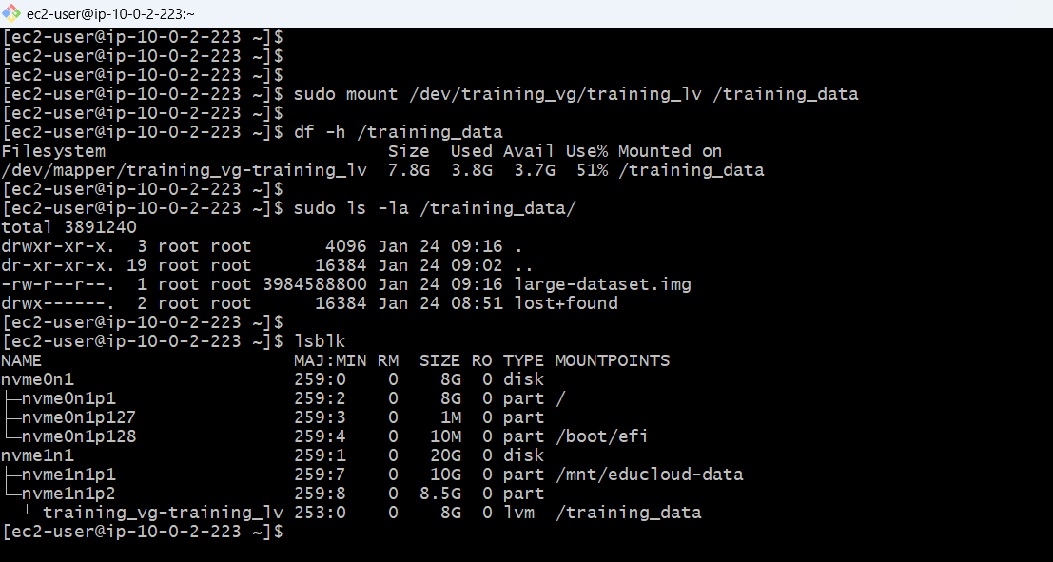

**Create Partition 3 (2GB for LUKS)**

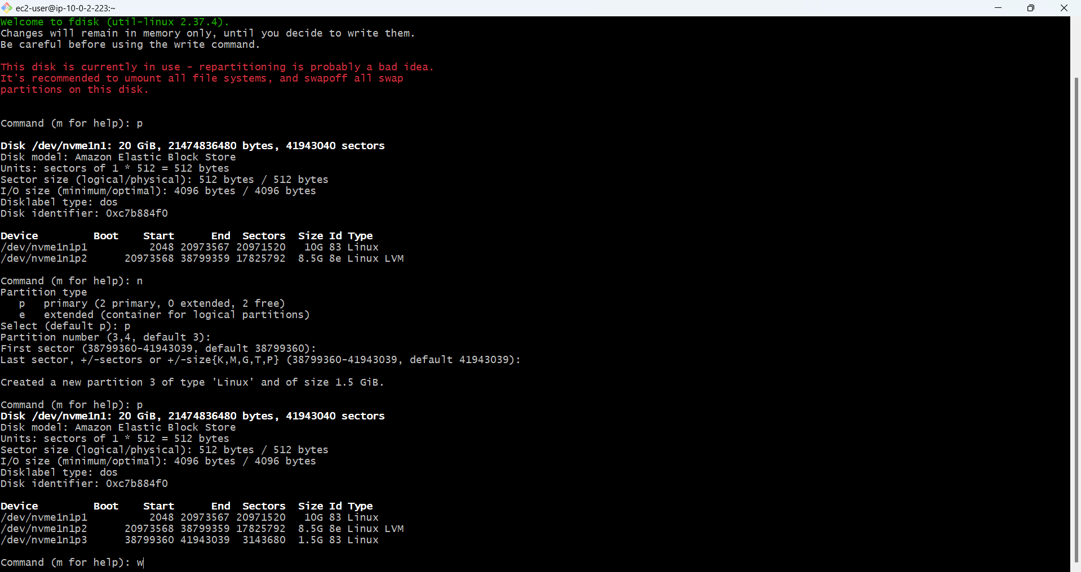

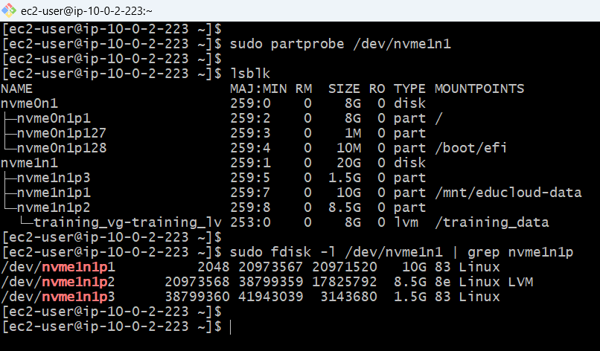

**Why 1.5gb not 5gb**

**Original Plan**: 10GB + 8GB + 2GB = 20GB

**Reality**: 10GB + 8.5GB + 1.5GB = 20GB

Why 8.5GB for p2? Because: - LVM needs 8.1GB minimum (metadata says so) - 8.0GB partition = only 7.5GB usable (overhead) - 8.5GB partition = 8.1GB usable - Extra 0.5GB needed for LVM to fit comfortably

**BEFOR:**

**P1 -> Sector: 2048 → 20973567**

**P2 -> Sector: 20973568 → 41943039**

**after**

**P1sectors:** **2048 → 20973567**

**P2 sectors:** **20973568 → 38799359**

**P3 sectors:** **38799360 → 41943039**

**Result: 20GB - 10GB - 8.5GB = 1.5GB left for p3**

**uppercase 'yes': YES**

**passphrase: Trainer@2026!Secure**

**Verify passphrase: Trainer@2026!Secure**

**Partition is LUKS encrypted**

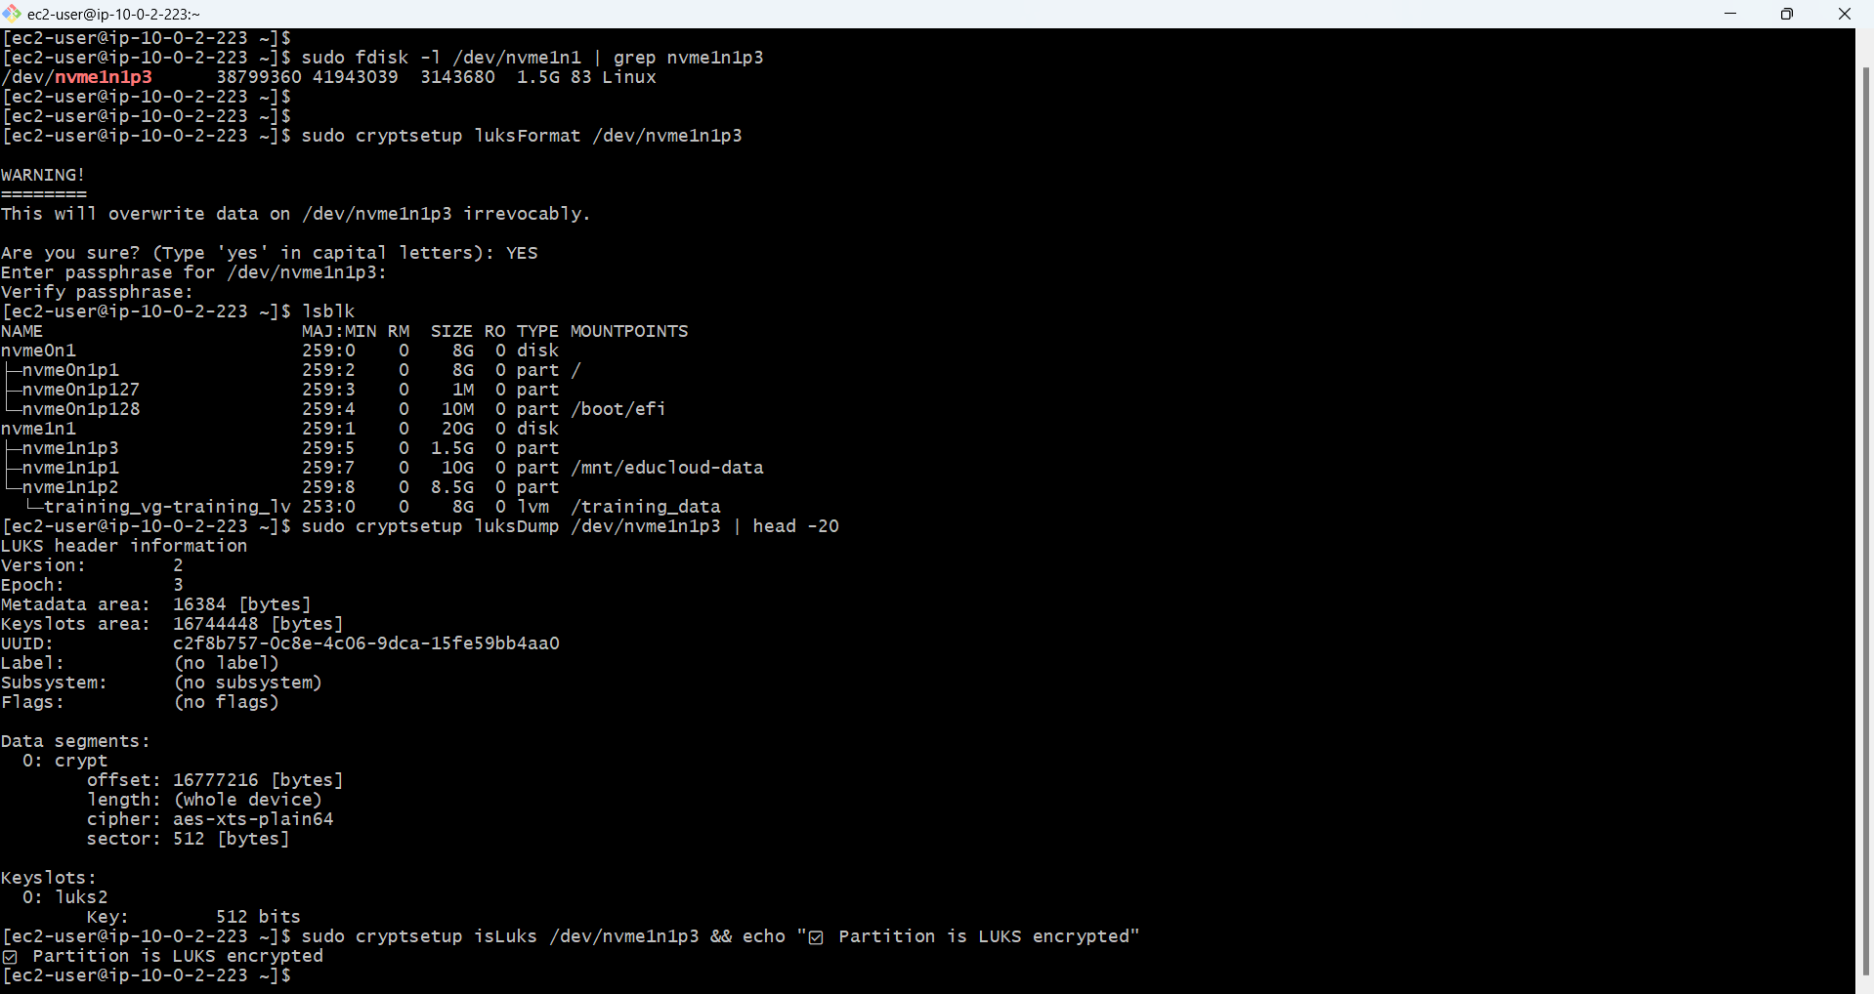

**Mounting /sensitive_data**

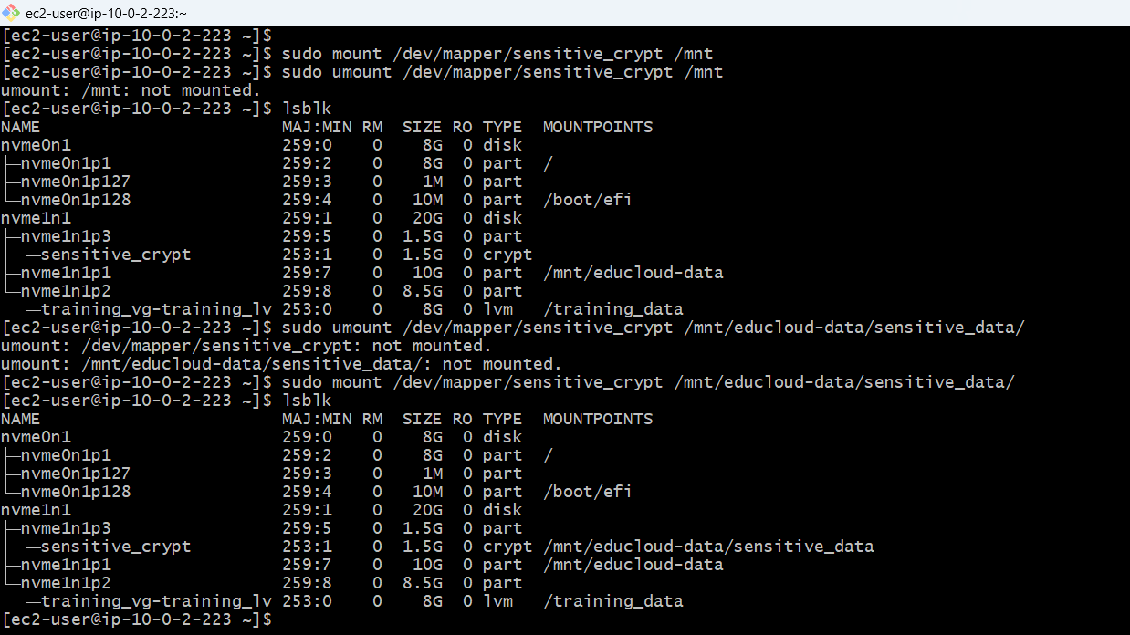

**Opening LUKS Partition**

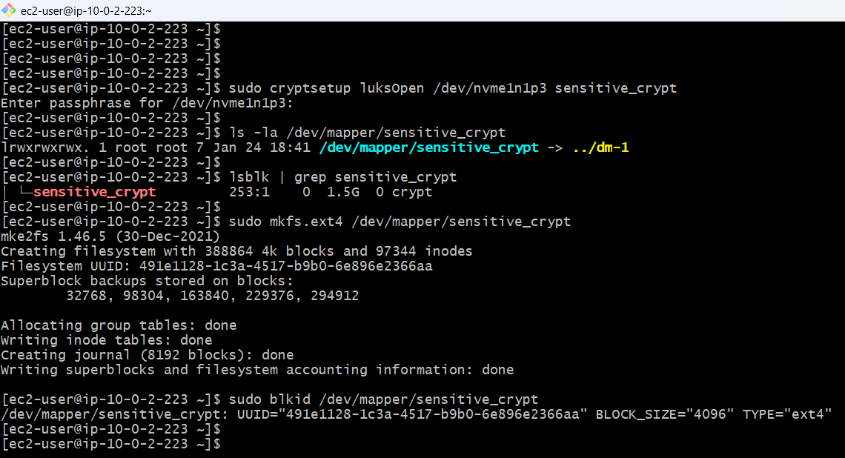

**Trainer-Only Permissions (Root Access Only)**

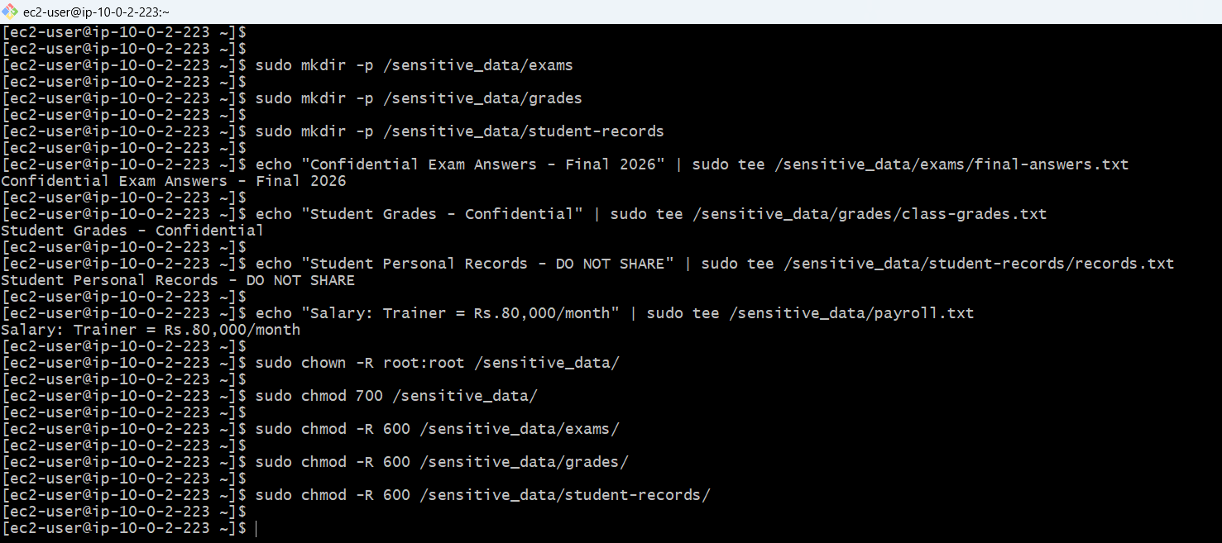

**Test Root Access**

Attempts read as ec2-user: Permission denied

Reads as root (should work)

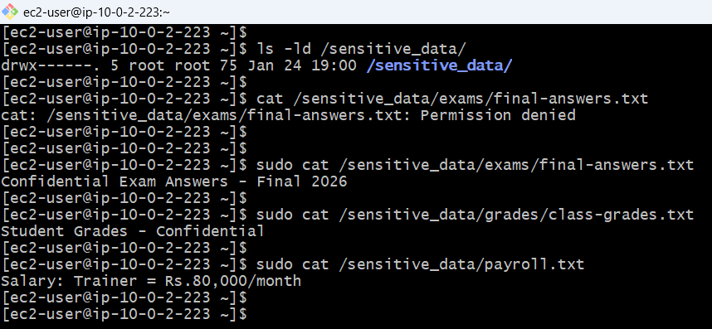

**LUKS Encryption Active**

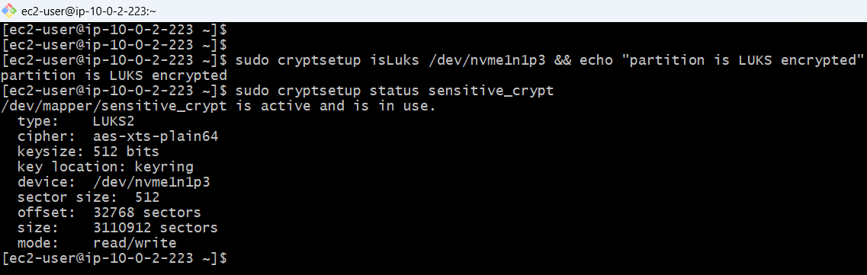

**Encrypted partition mounted and status**

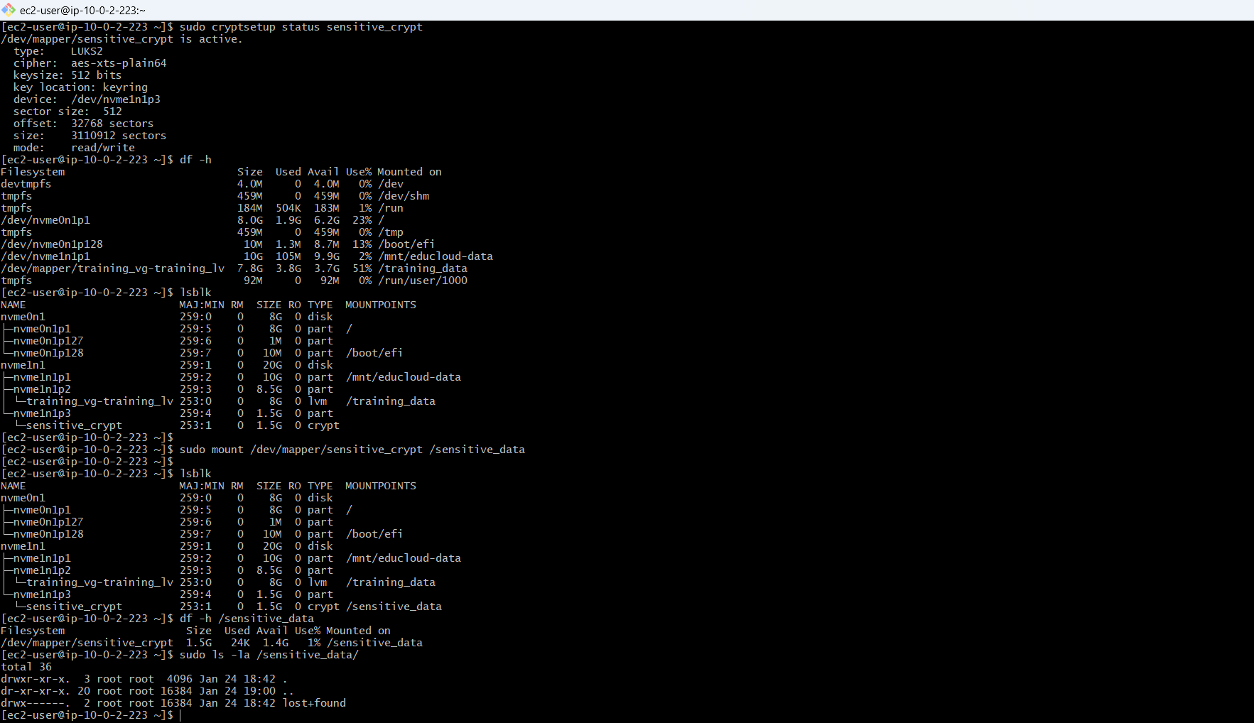

**Unmounted sensitive data**

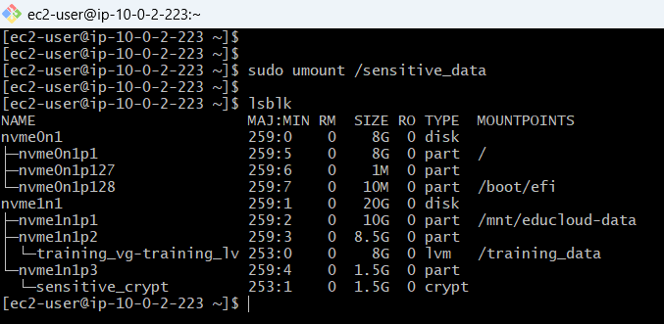

**Closed partition**

**Status inactive**

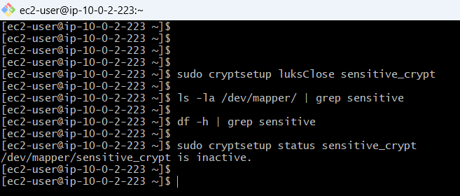

**Mounted again /sensitive_data, status active,**

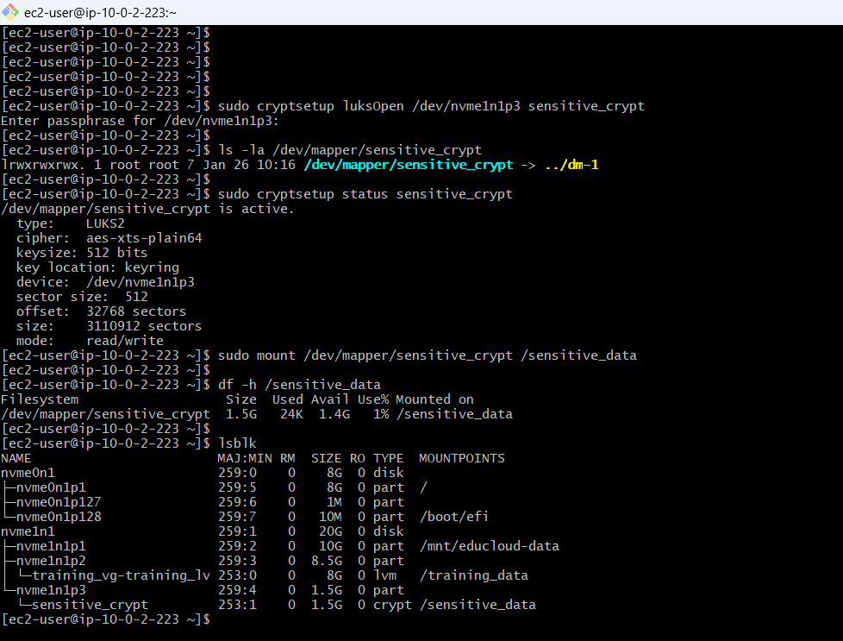

**Script for mount/luksclose: /usr/local/bin/mount-sensitive.sh**

**Script for unmount: /usr/local/bin/umount-sensitive.sh**

**UNLOCK & MOUNT (Open Encrypted Partition)**

Step 1: Unlock the encrypted partition

sudo cryptsetup luksOpen /dev/nvme1n1p3 sensitive_crypt

Enter passphrase: Trainer@2026!Secure

Step 2: Mount the decrypted device

sudo mount /dev/mapper/sensitive_crypt /sensitive_data

Step 3: Verify mounted

df -h /sensitive_data

**UNMOUNT & LOCK (Close Encrypted Partition)**

Step 1: Unmount the filesystem

sudo umount /sensitive_data

Step 2: Lock the encrypted partition

sudo cryptsetup luksClose sensitive_crypt

Step 3: Verify closed

sudo cryptsetup status sensitive_crypt

# Should show: inactive

**RDS MYSQL DATABASE SCHEMA SETUP**

**Install MySQL Client & Connect to RDS**

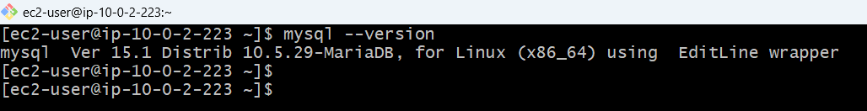

**Created educloud_db default while creating rds database**

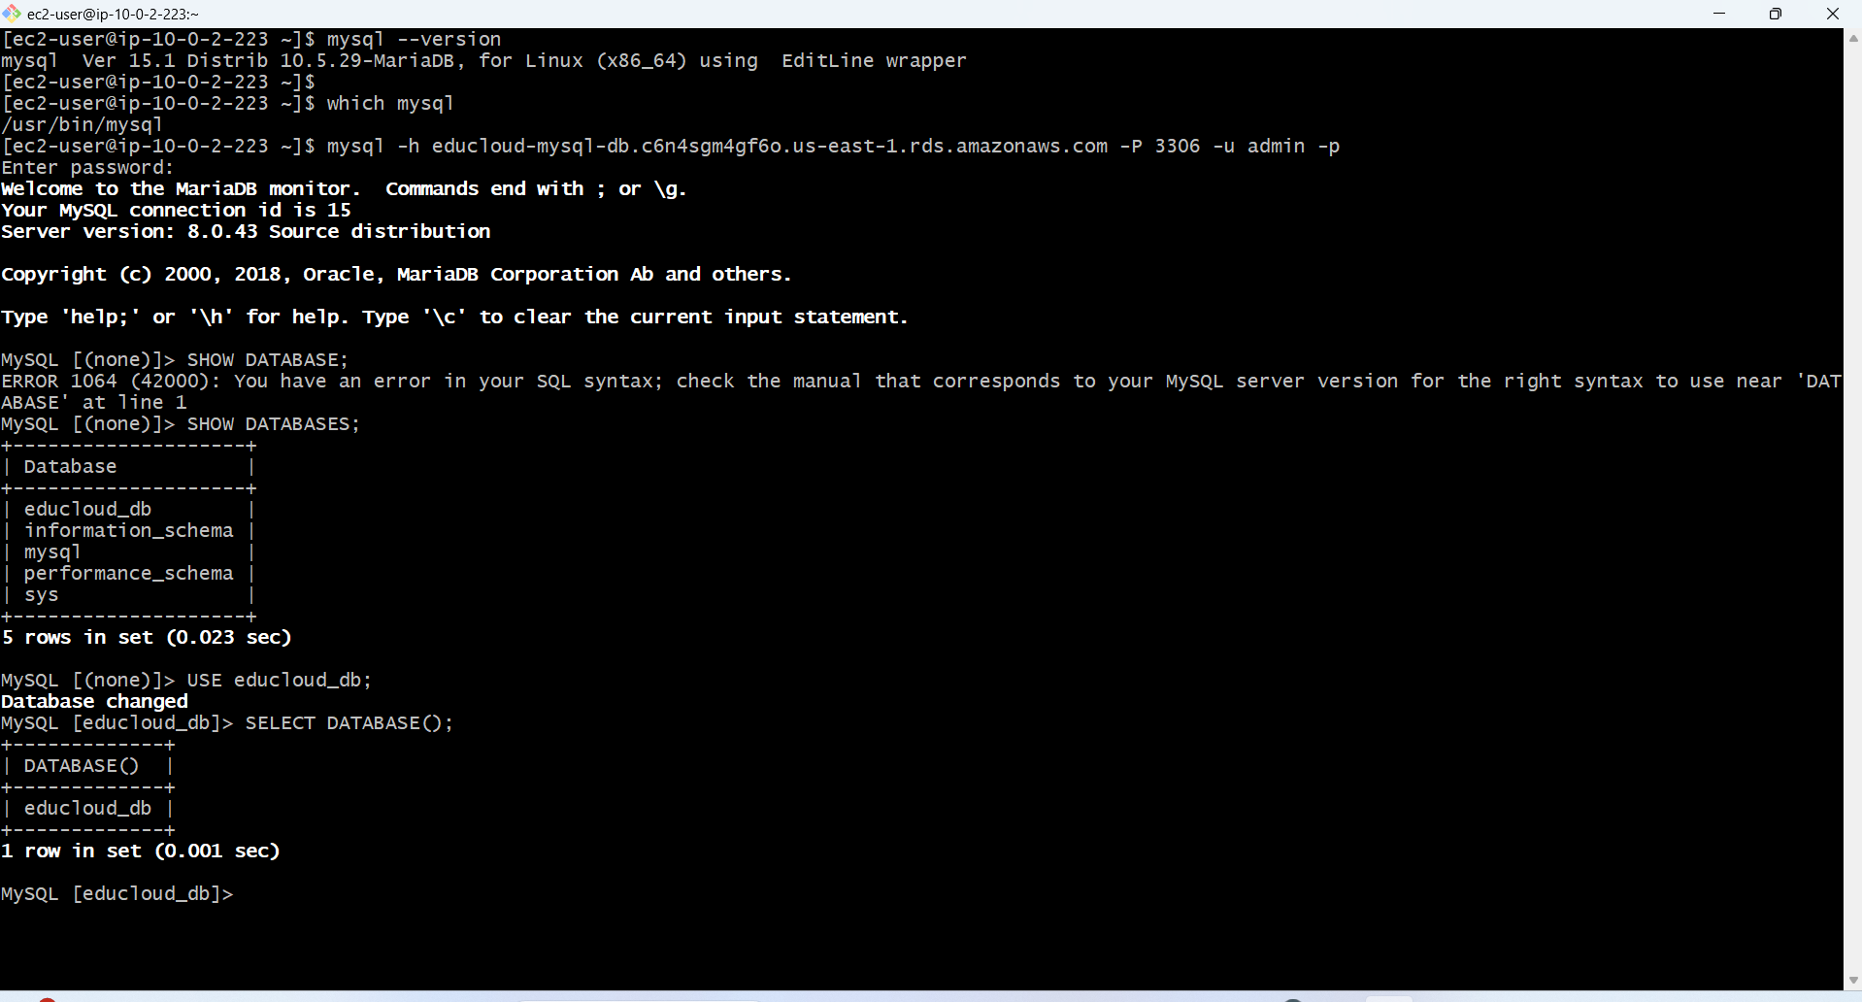

**Creating Students Table**

**students table**

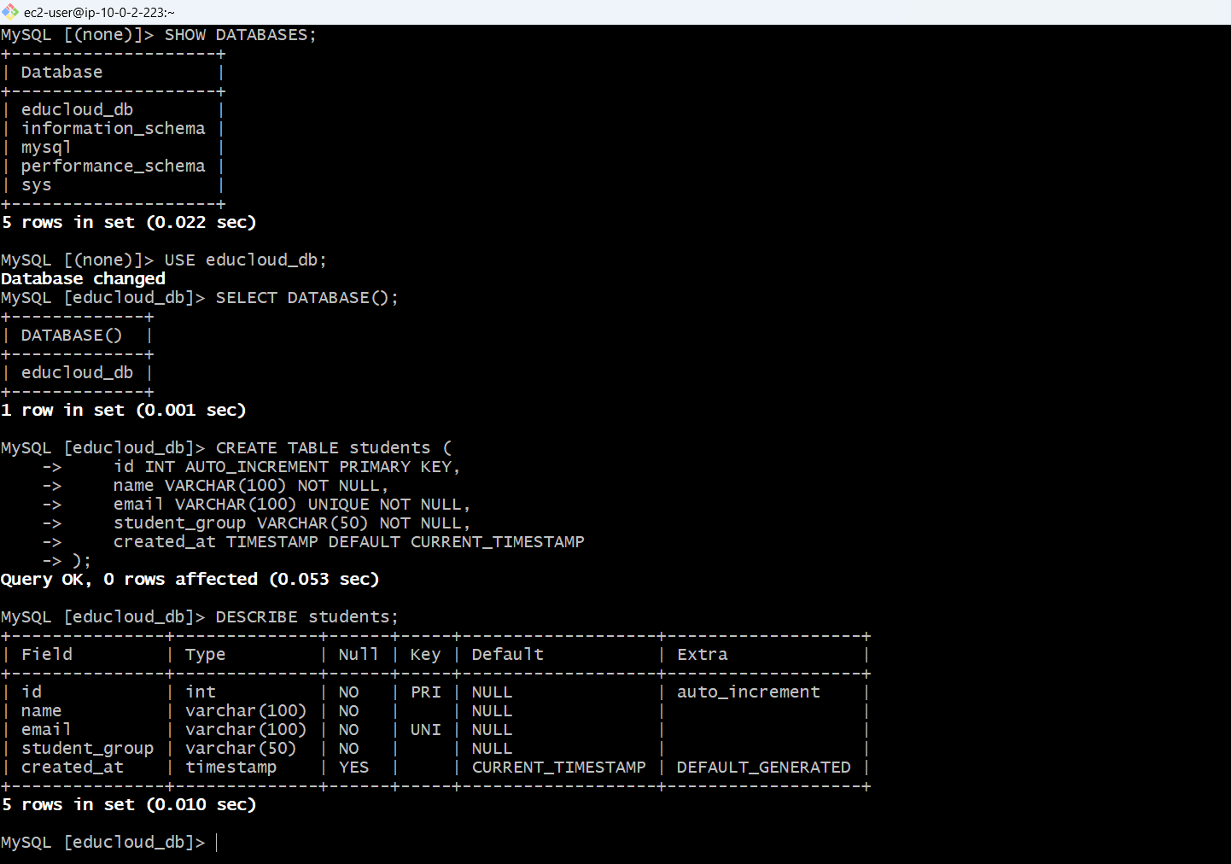

**CreatingTrainers Table**

**trainers table**

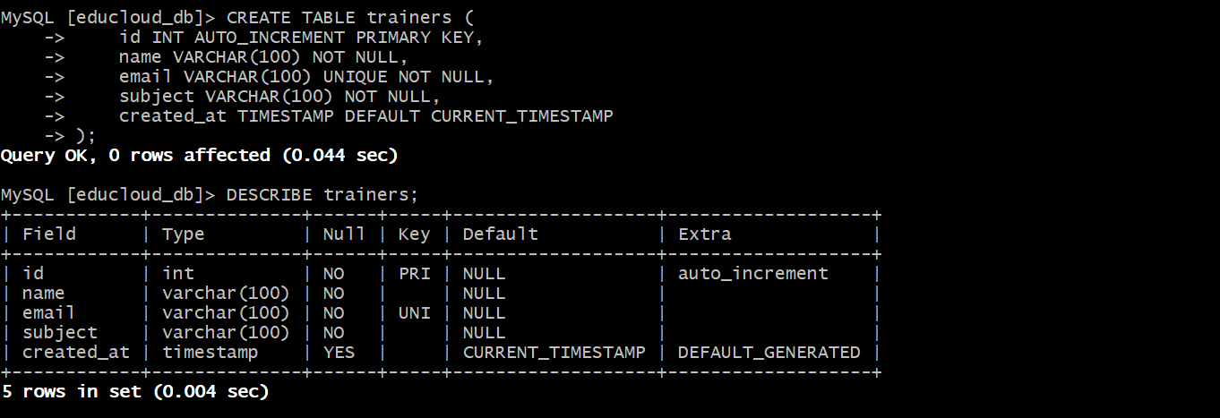

**Creating Uploads Table**

**uploads table**

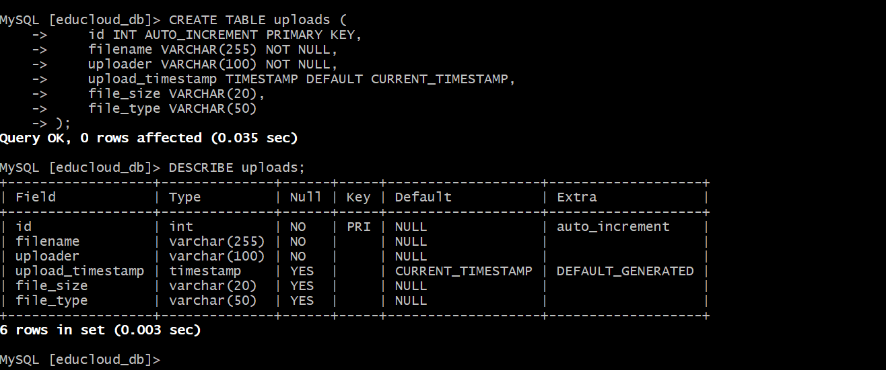

**all tables in database**

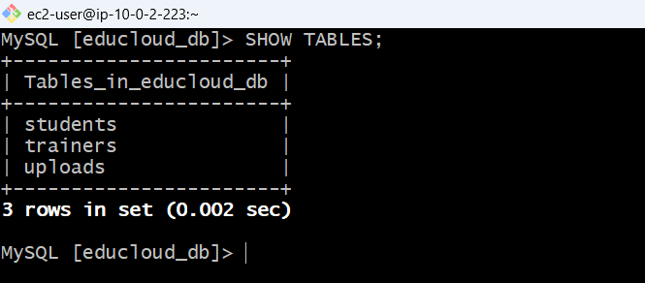

**Inserting Sample Data – Students**

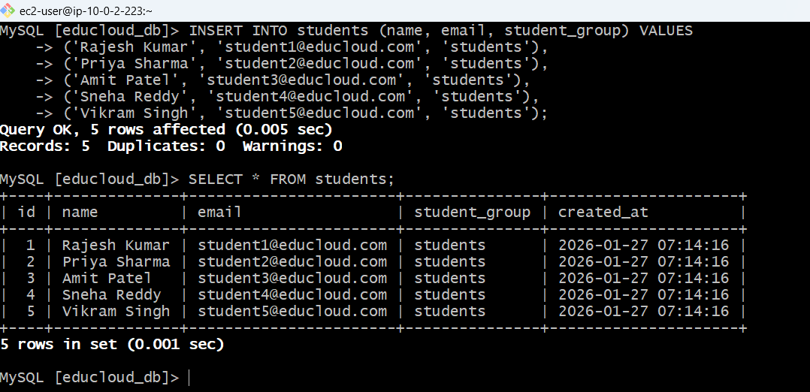

**Inserting Sample Data – Trainers**

**Inserting 3 trainers**

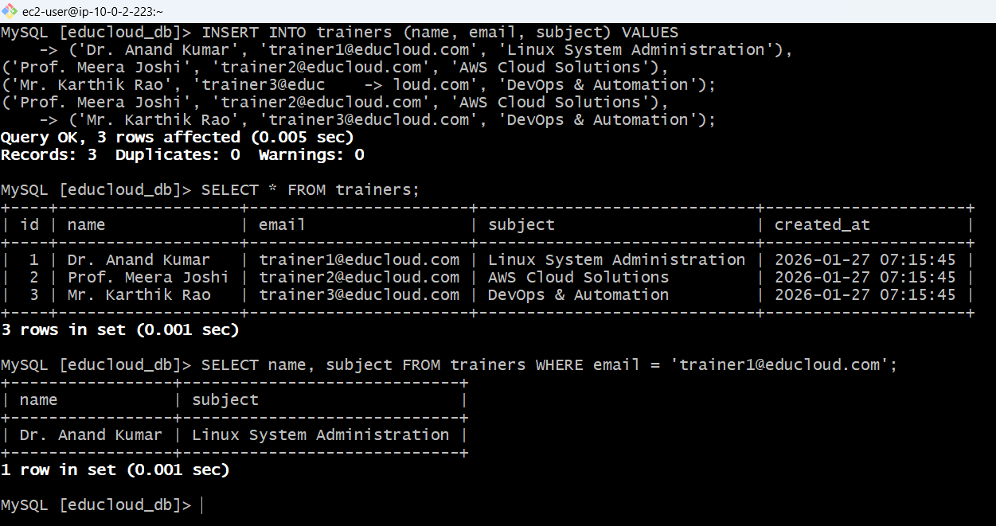

**Inserting Sample Data – Uploads**

**Insert upload records**

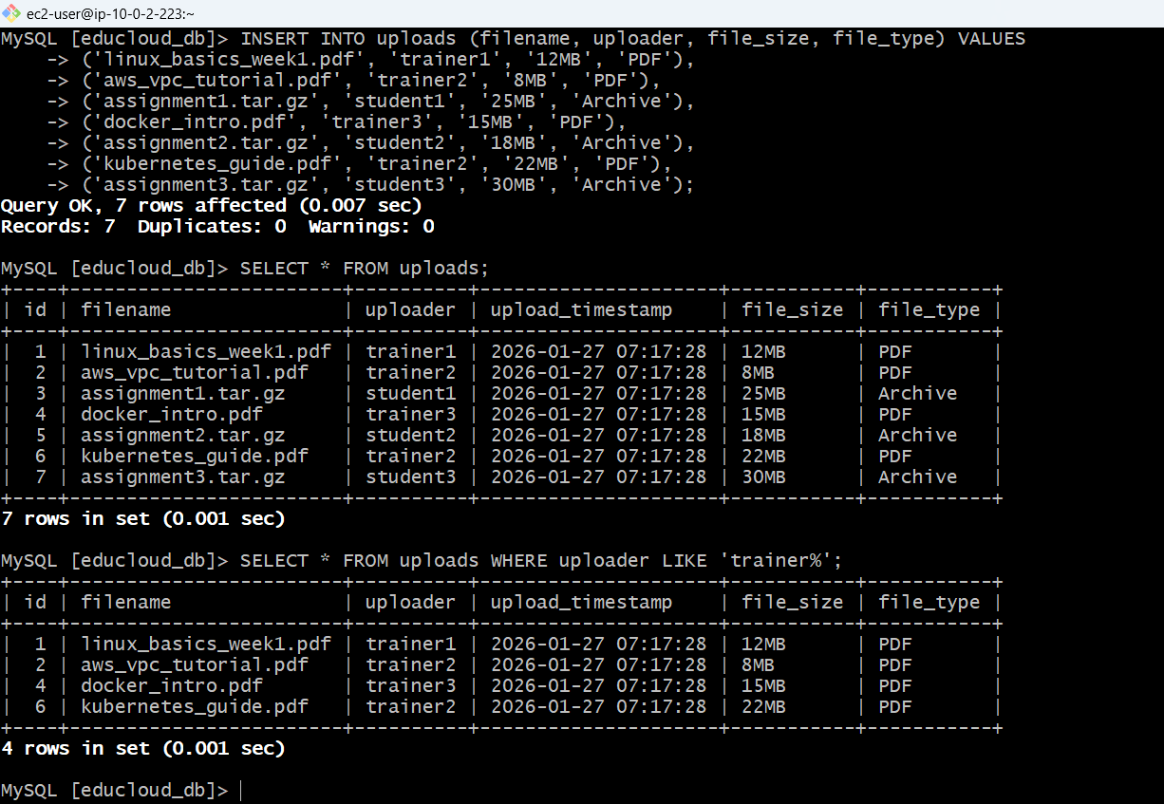

**Count uploads per uploader, recent uploads (last 7 entries), students with their email group**

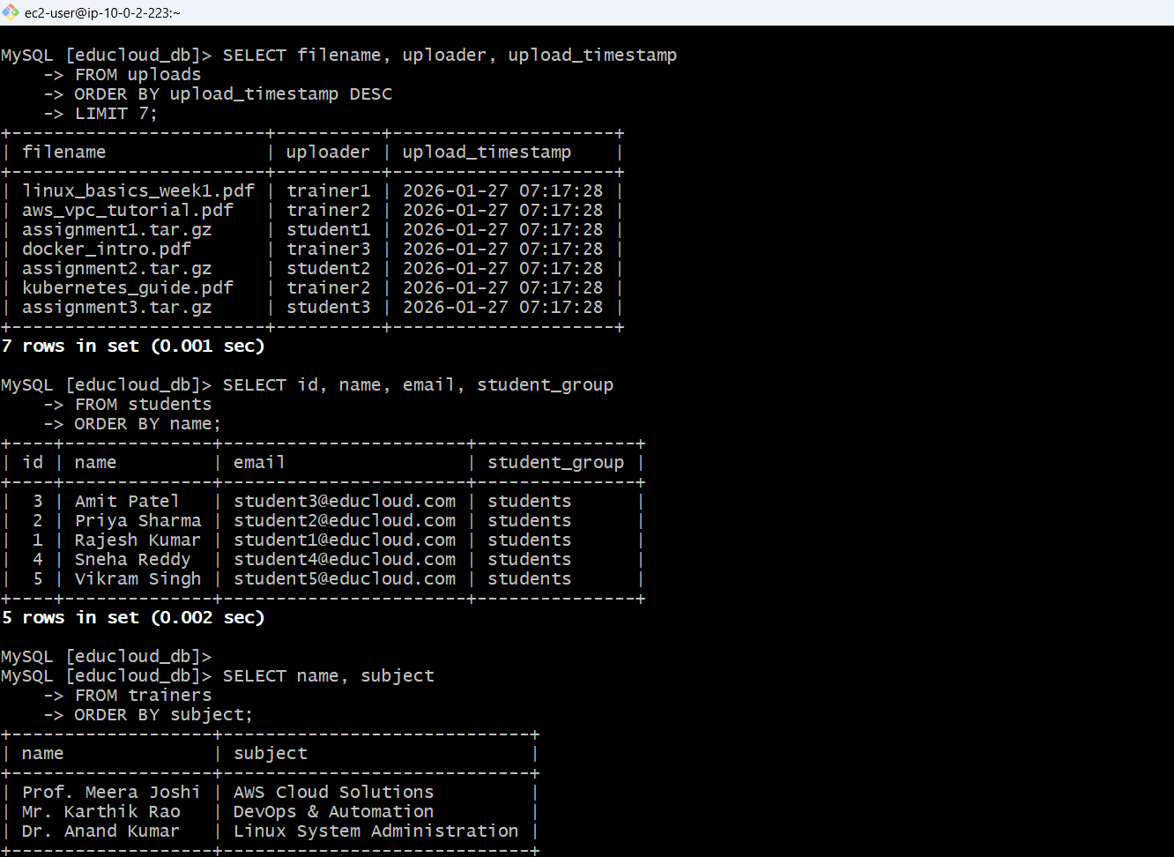

**db layer access control, INSERT, UPDATE, SELECT to trainers**

**Created trainer user (full access)**

**Created student user (read-only), only SELECT to students**

**Create support user (logs monitoring), Grant SELECT to support**

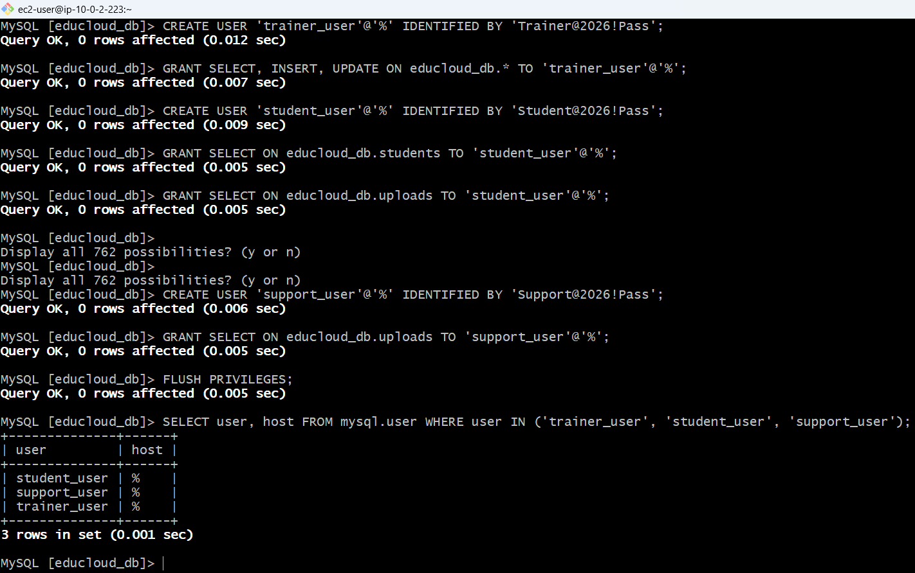

**Testing with trainer user, INSERT, UPDATE, SELECT**

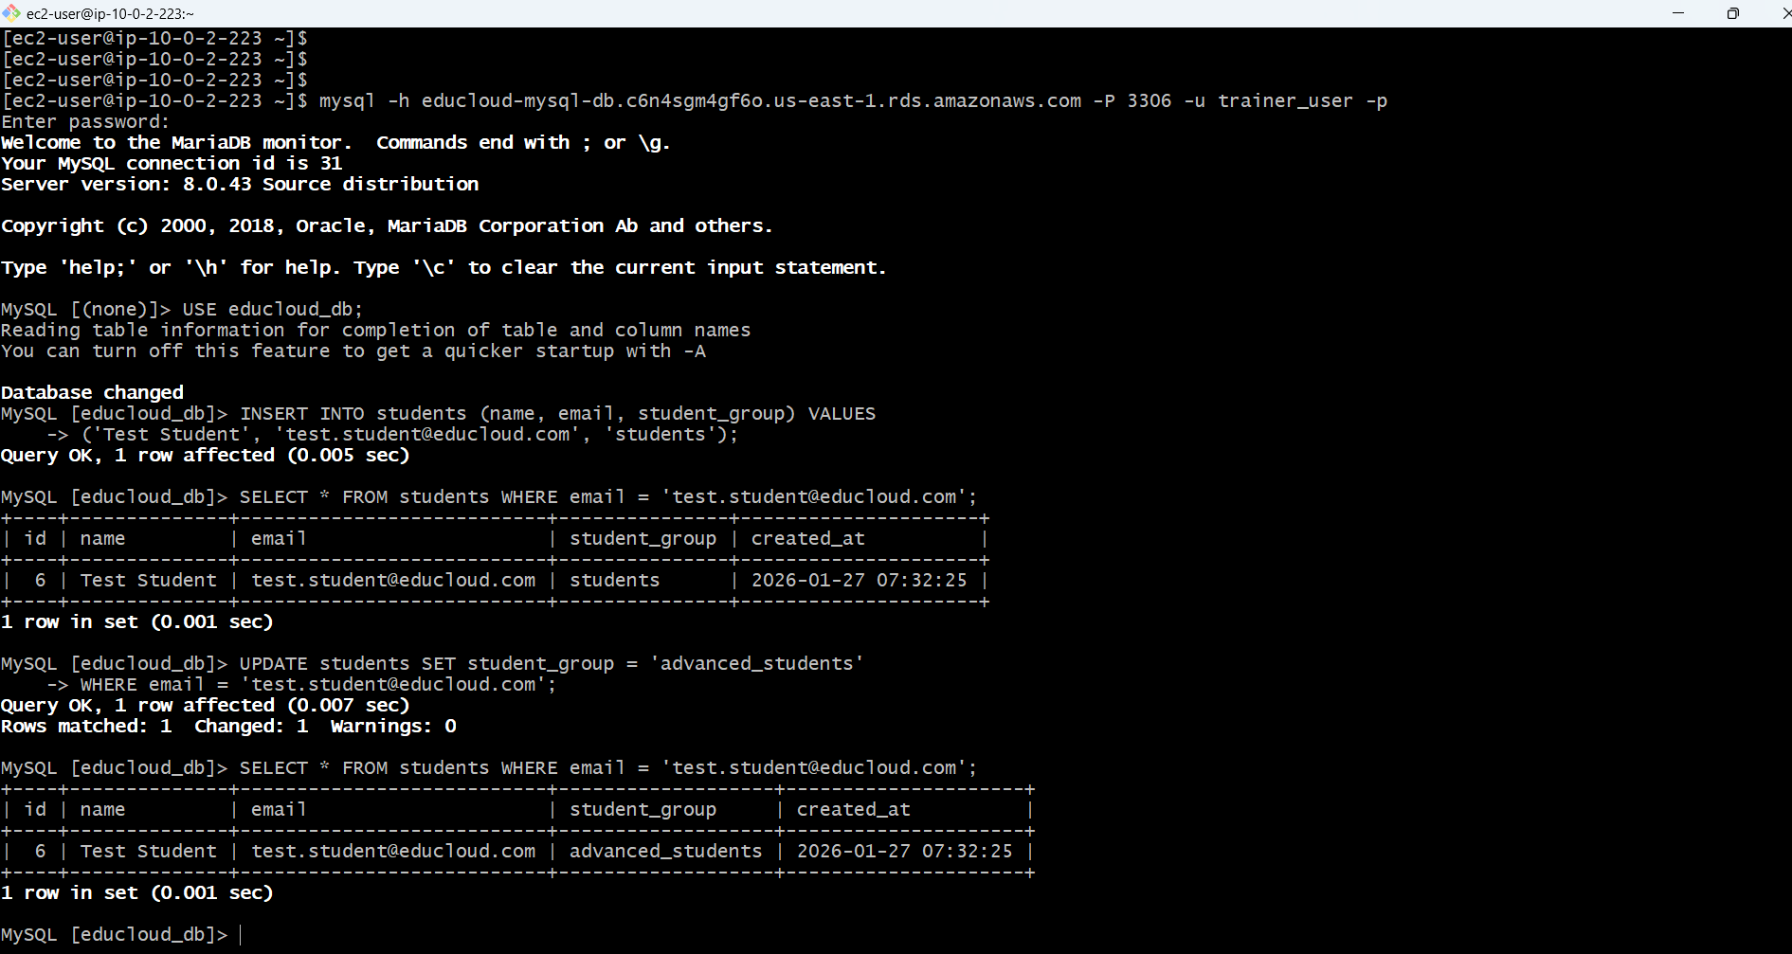

**Test Student User Access (Read-Only)**

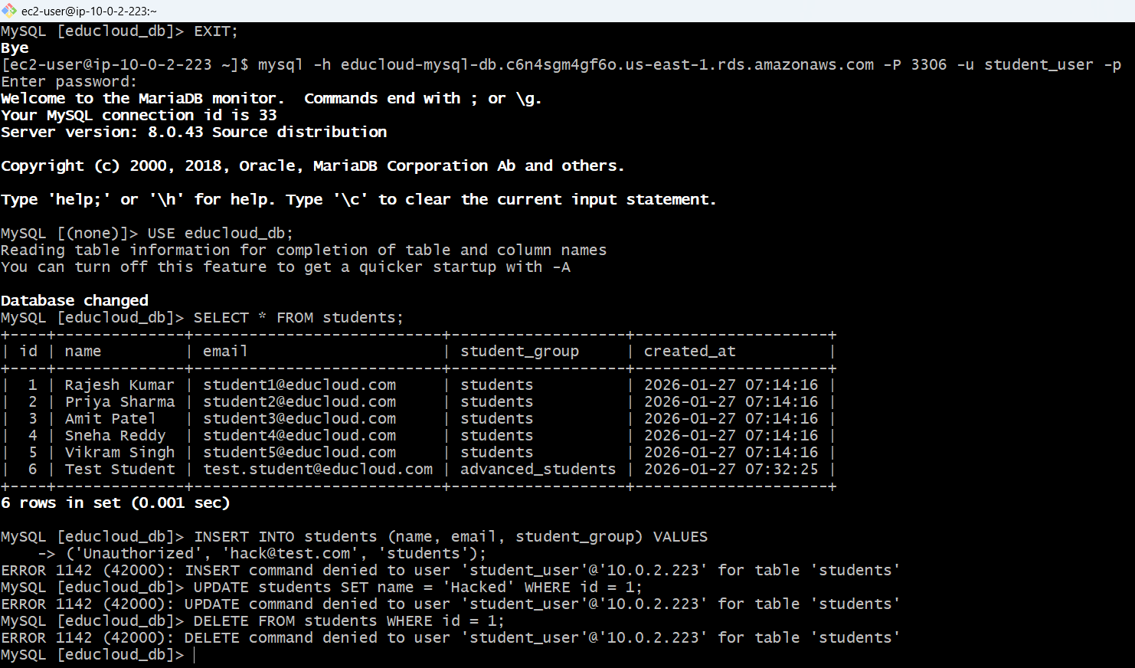

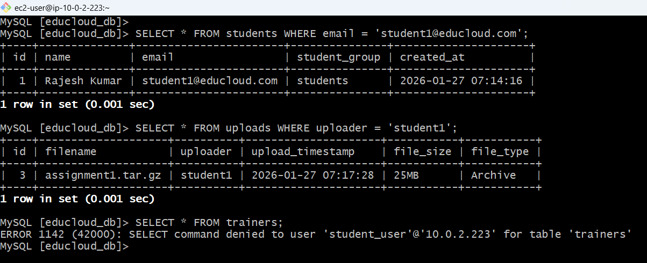

**Admin User - Full Database Operations**

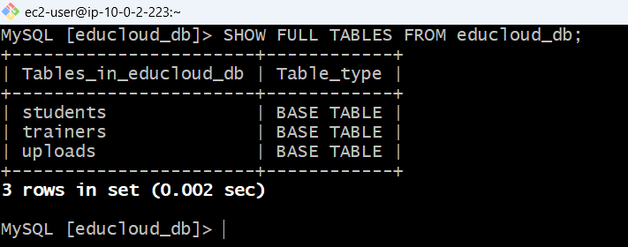

**Created indexing on email for the performance**

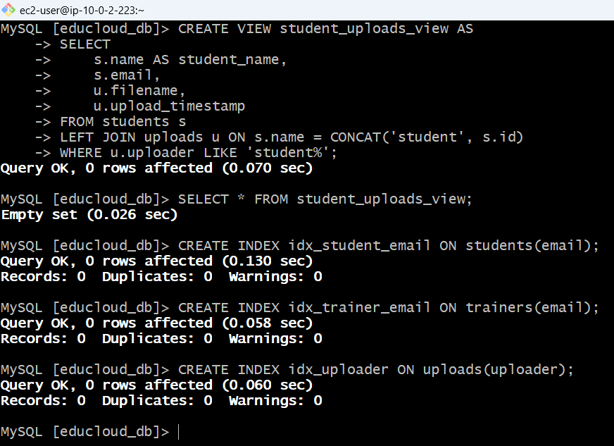

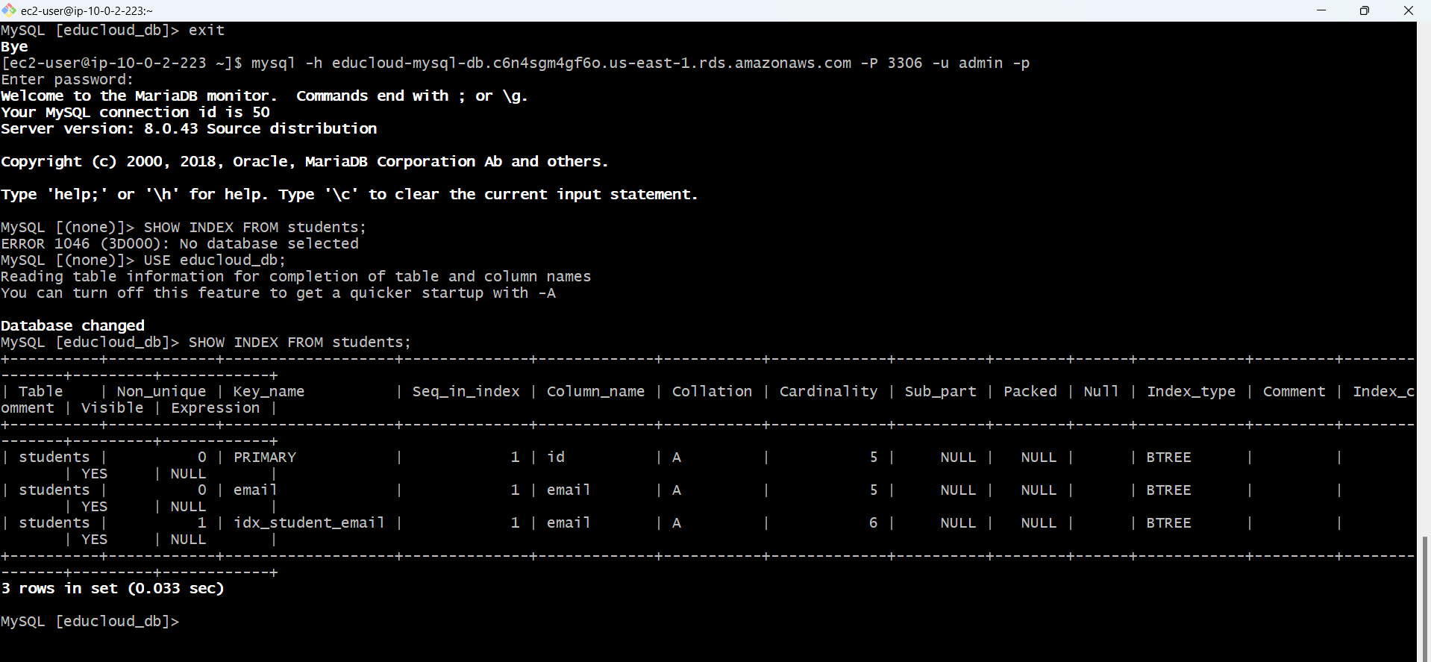

**NFS SERVER SETUP**

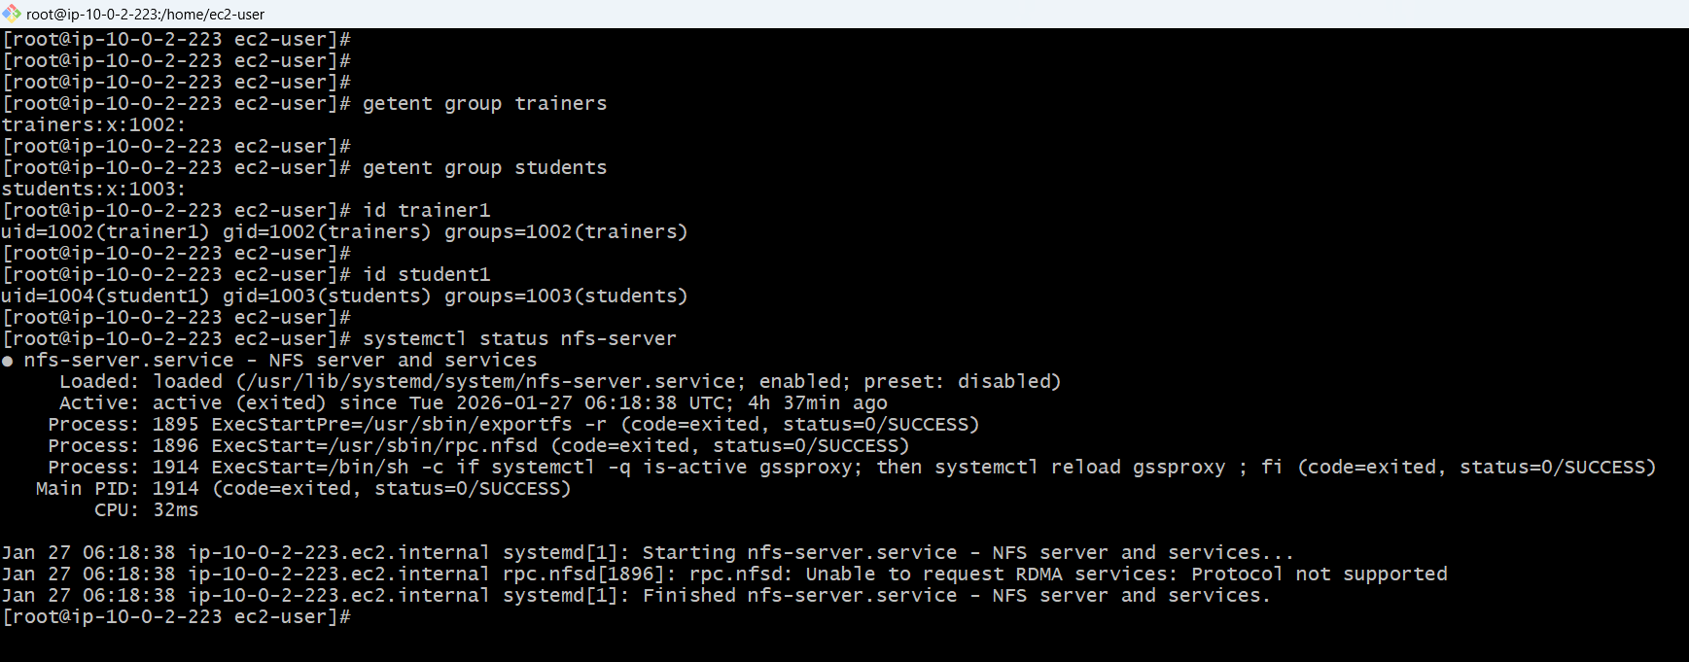

**Configure NFS Exports**

**Backup original exports file**

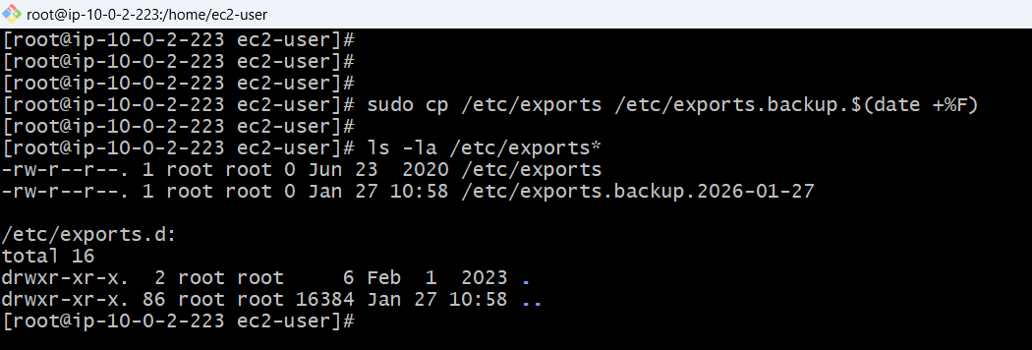

**Creating simple NFS export configuration**

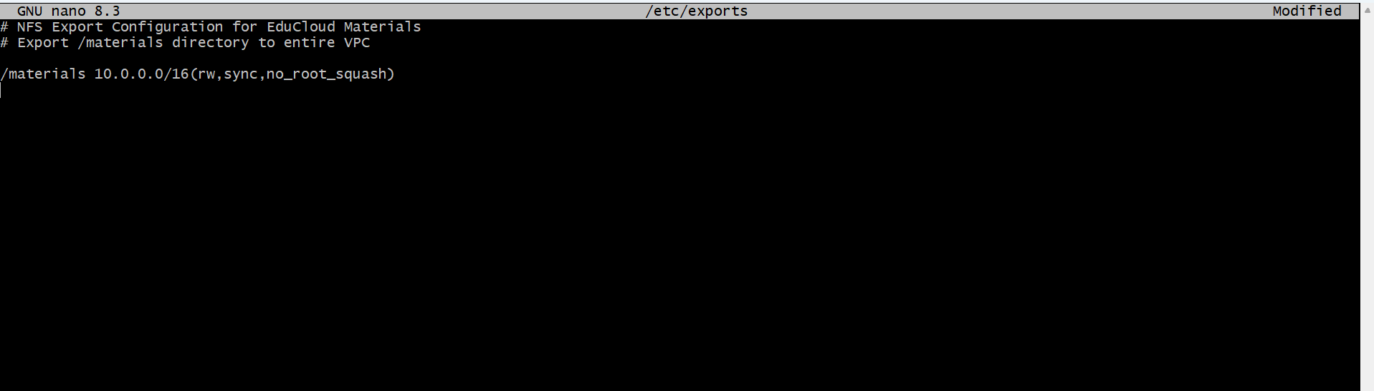

**proper permissions on /materials**

***# Set permissions: owner=rwx, group=rwx, others=no access***

***# This allows trainers to write, but we'll control read via file permissions***

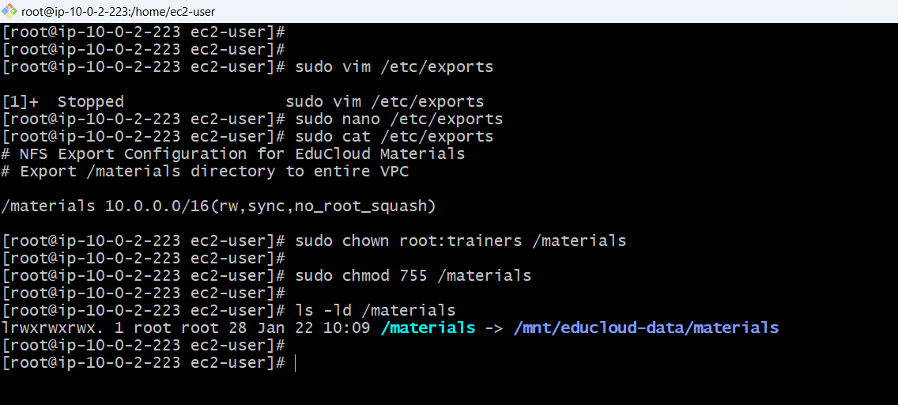

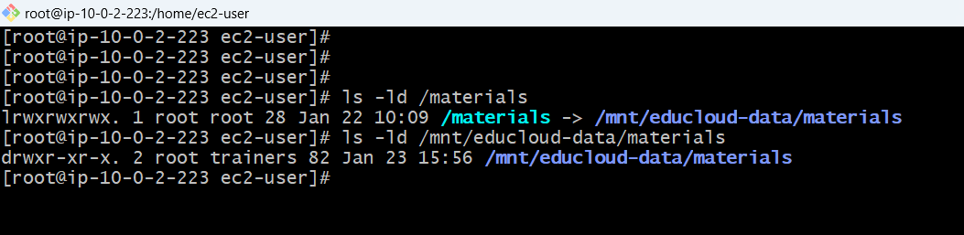

**Services running, exports are active**

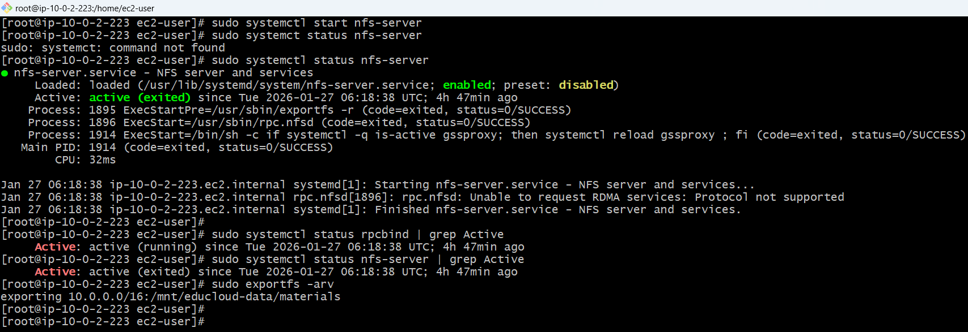

**Testing with local test mount point /mnt/nfs-local-test**

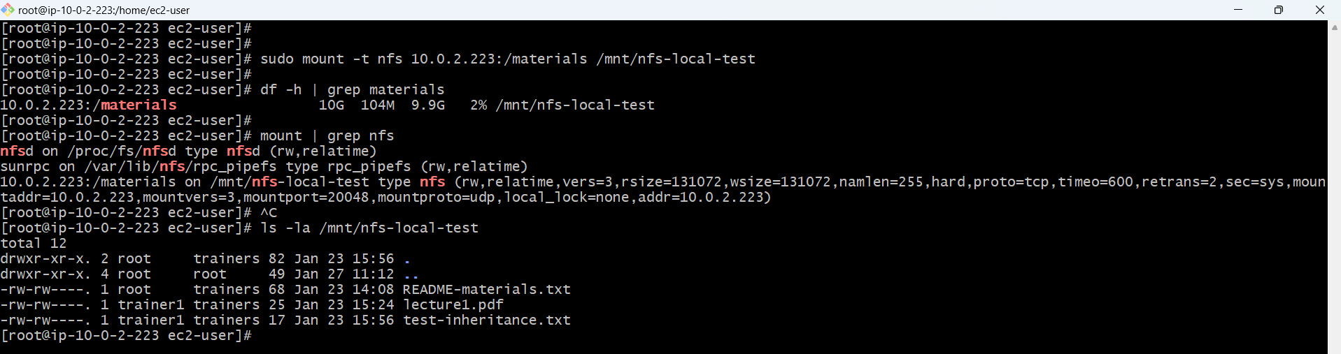

**Testing write access as trainer**

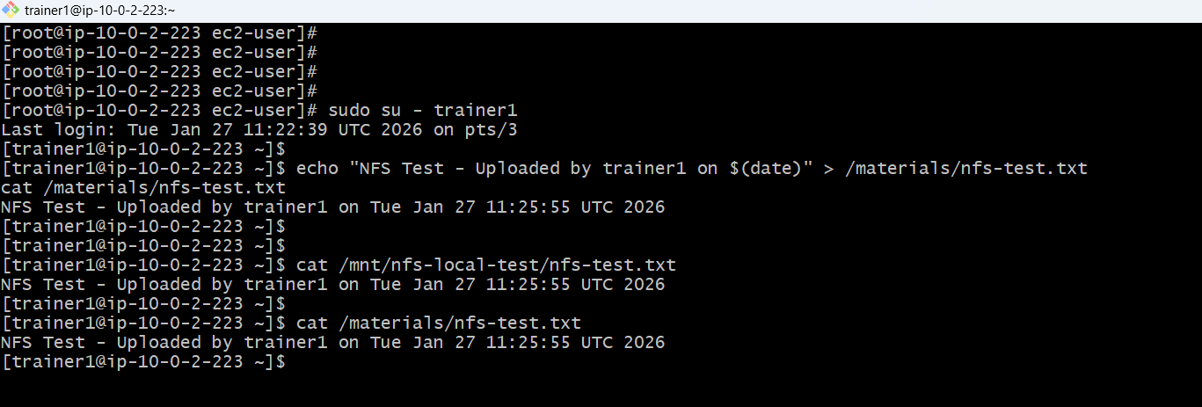

**Create Sample Training Materials**

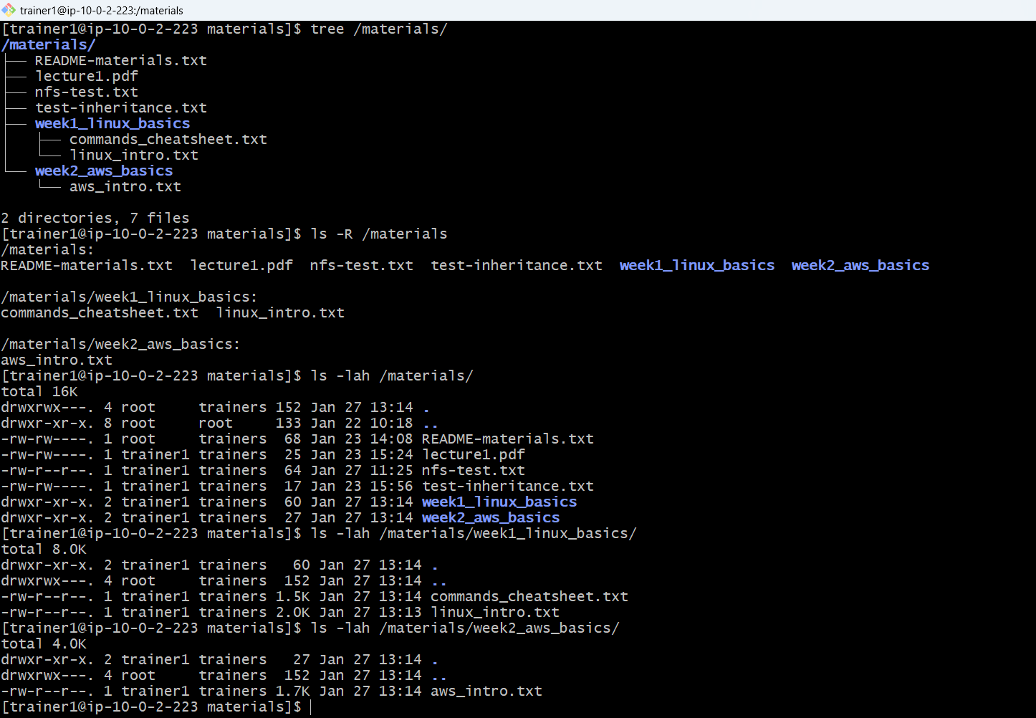

**Student read only enforced**

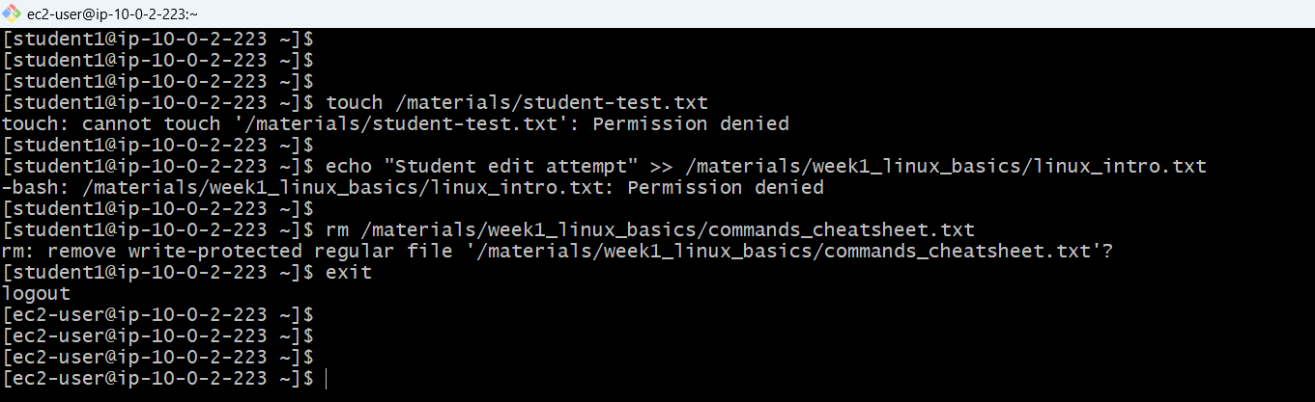

**NFS server configuration**

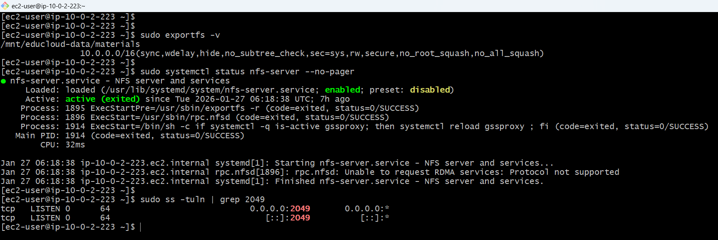

**Nfs-test-server**

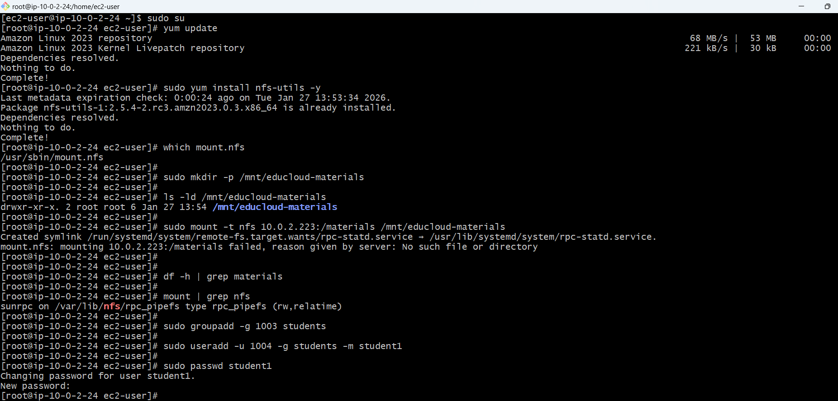

**Student1 pwd:Stud1@2026**

**Client-side nfs testing, file mounted successfully from client**

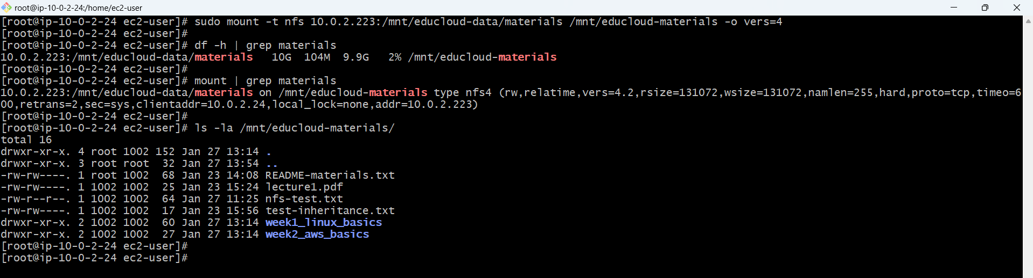

**Student login in client and accessing mounted file from server /mnt/educloud-data/materials/\***

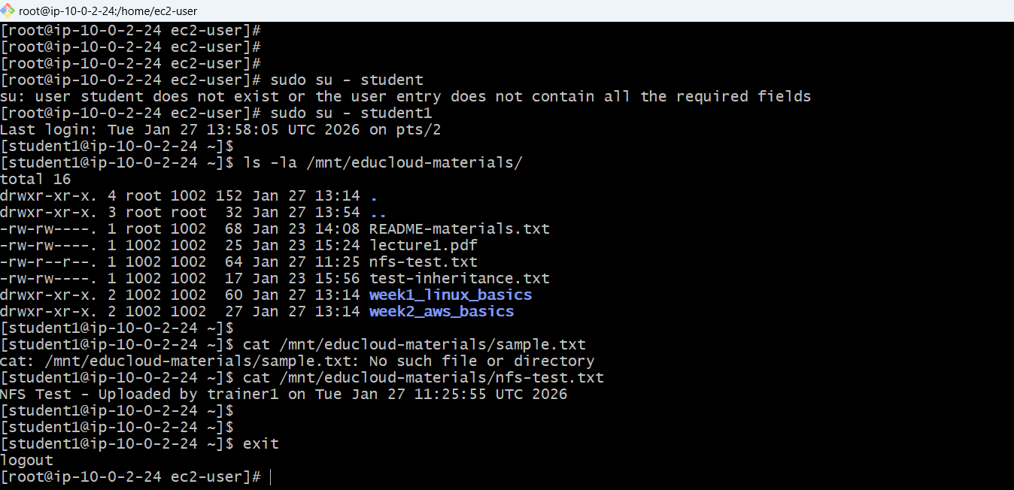

**Write for the student is permission denied**

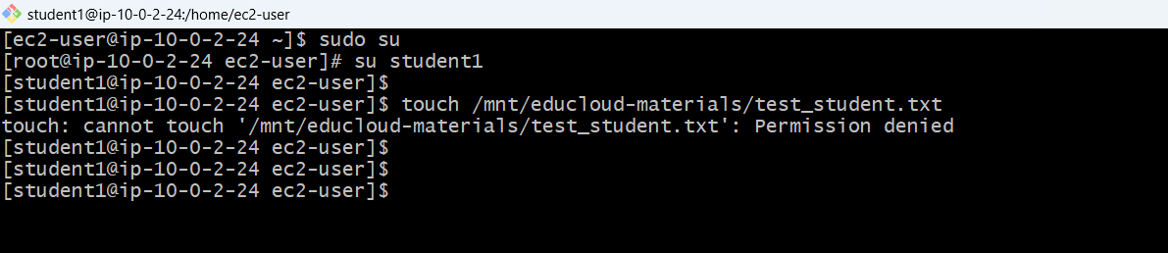

**train@2026**

**trainers write on mounted**

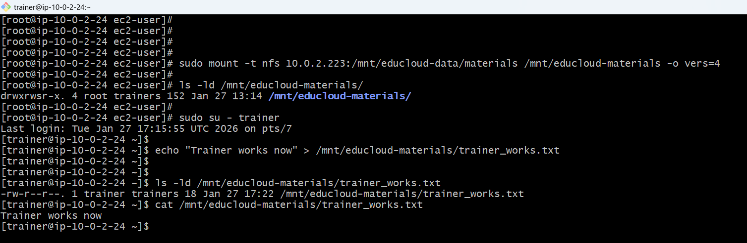

**Create mount point sudo mkdir -p /mnt/educloud-materials**

**sudo mount -t nfs 10.0.2.223:/mnt/educloud-data/materials /mnt/educloud-materials -o vers=4**

**df -h | grep materials**

**FTP Server Setup with vsftpd**

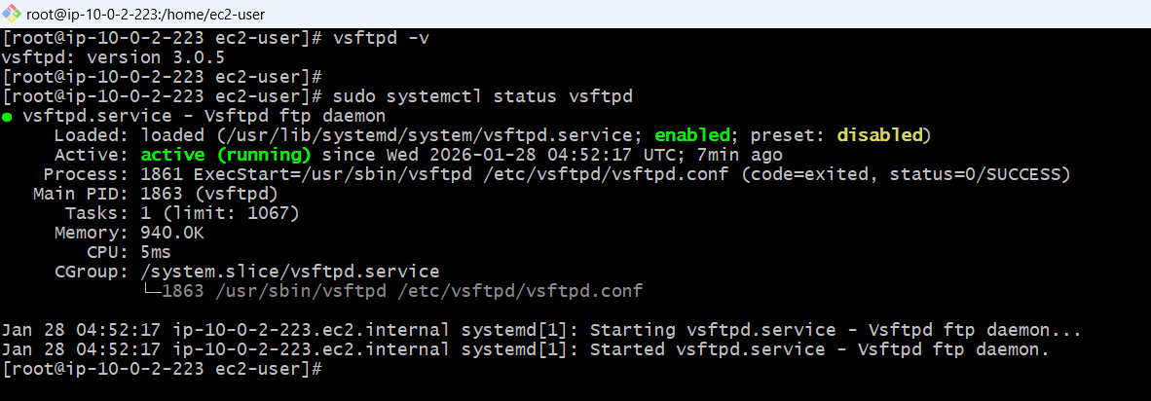

**These permission for chroot jail user restricting user from accessing each other**

**Each student will be locked to their own directory (chroot jail)**

**allows students to write files in their directory**

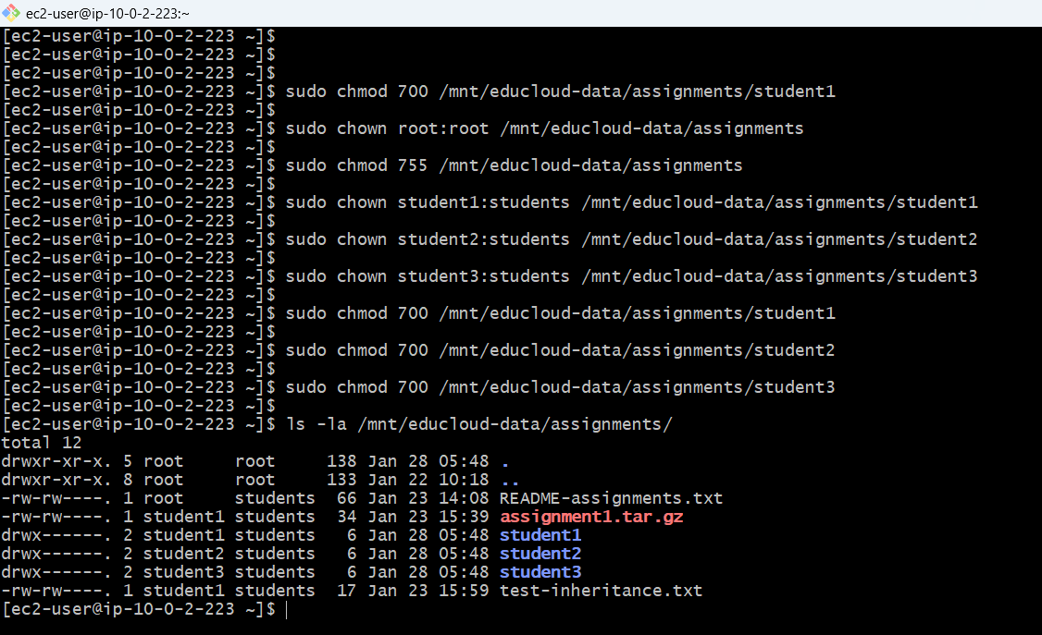

**Backing up of vsftpd.conf file befor changed**

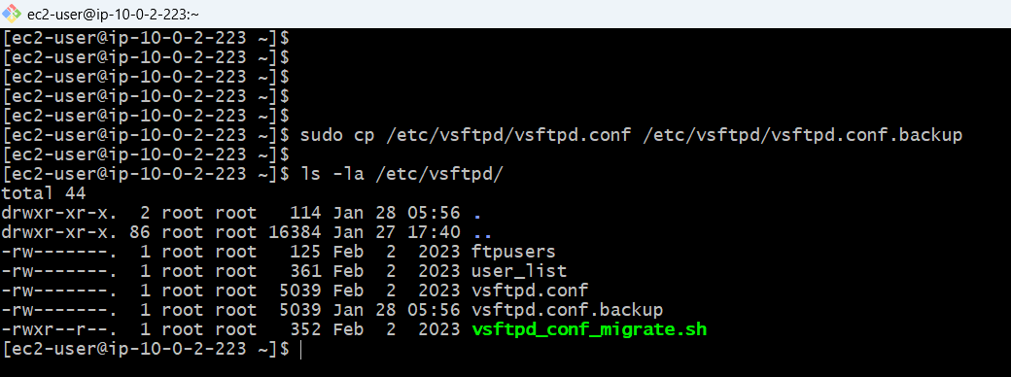

**SSL/TLS Certificate for Encryption**

**TLS enabled, uploads restricted to /assignments.**

**Generated a self signed certificate**

Generate self-signed SSL certificate valid for 365 days # -x509: Create self-signed certificate (not CA-signed) # -nodes: No password protection (for automated services) # -days 365: Valid for 1 year # -newkey rsa:2048: Generate 2048-bit RSA key pair # -keyout: Where to save private key # -out: Where to save public certificate # -subj: Certificate details (Country, State, City, Organization, Common Name)

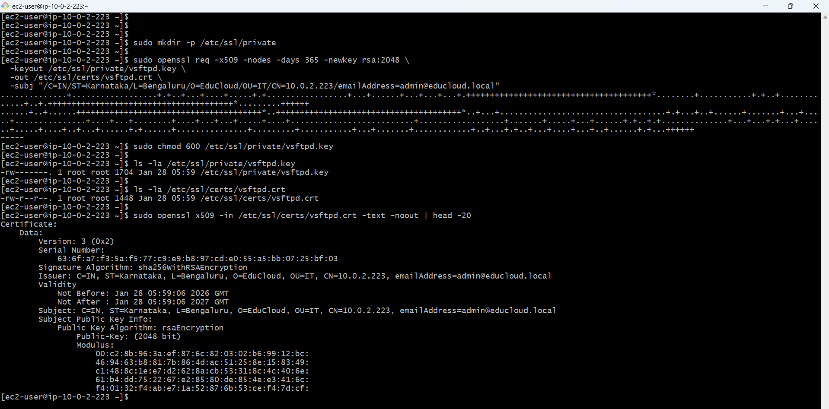

Changing student home directories to point to their assignment folders

This ensures they land in correct directory when they login via FTP

home directory for student1

Set home directory for student2

home directory for student3

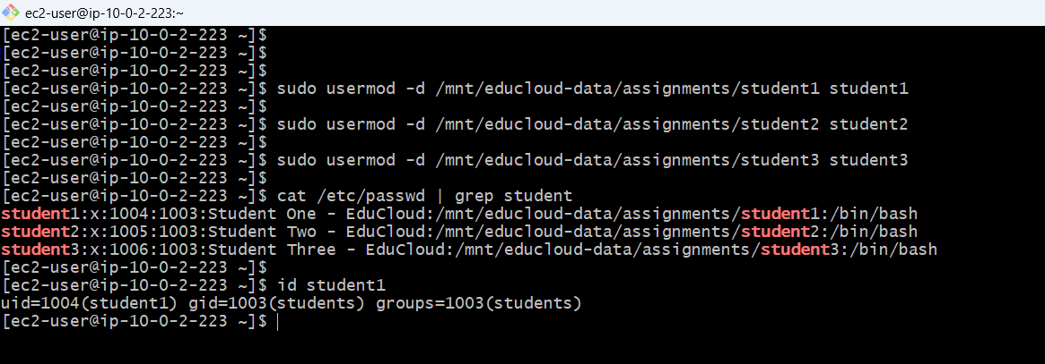

Clinet ftp student1 login

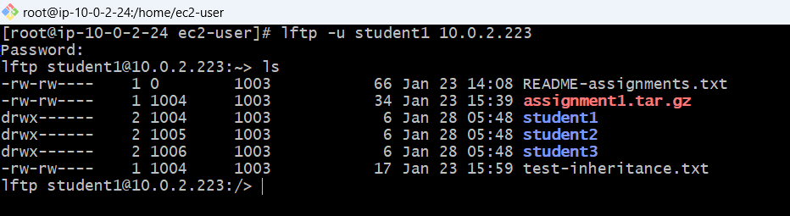

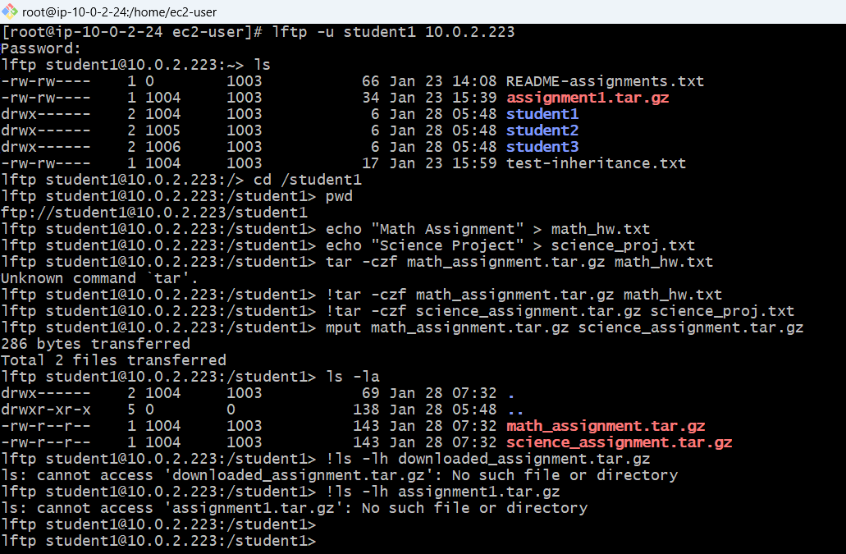

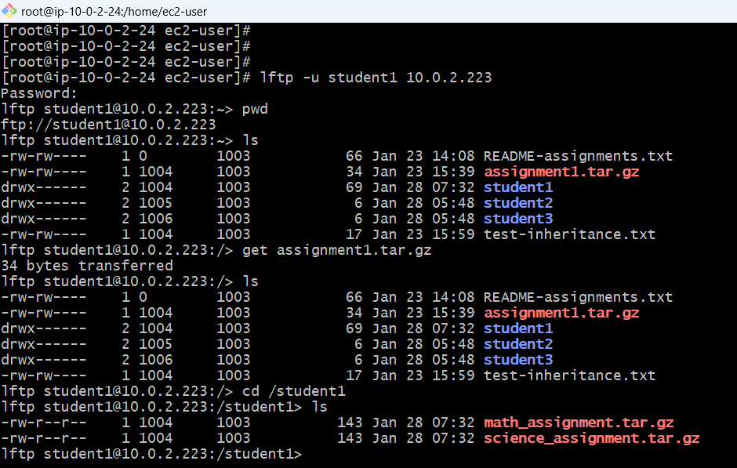

file uploads/downloads work, isolation is enforced, and the core EduCloud assignment system is functional

**final working**

**Client student**

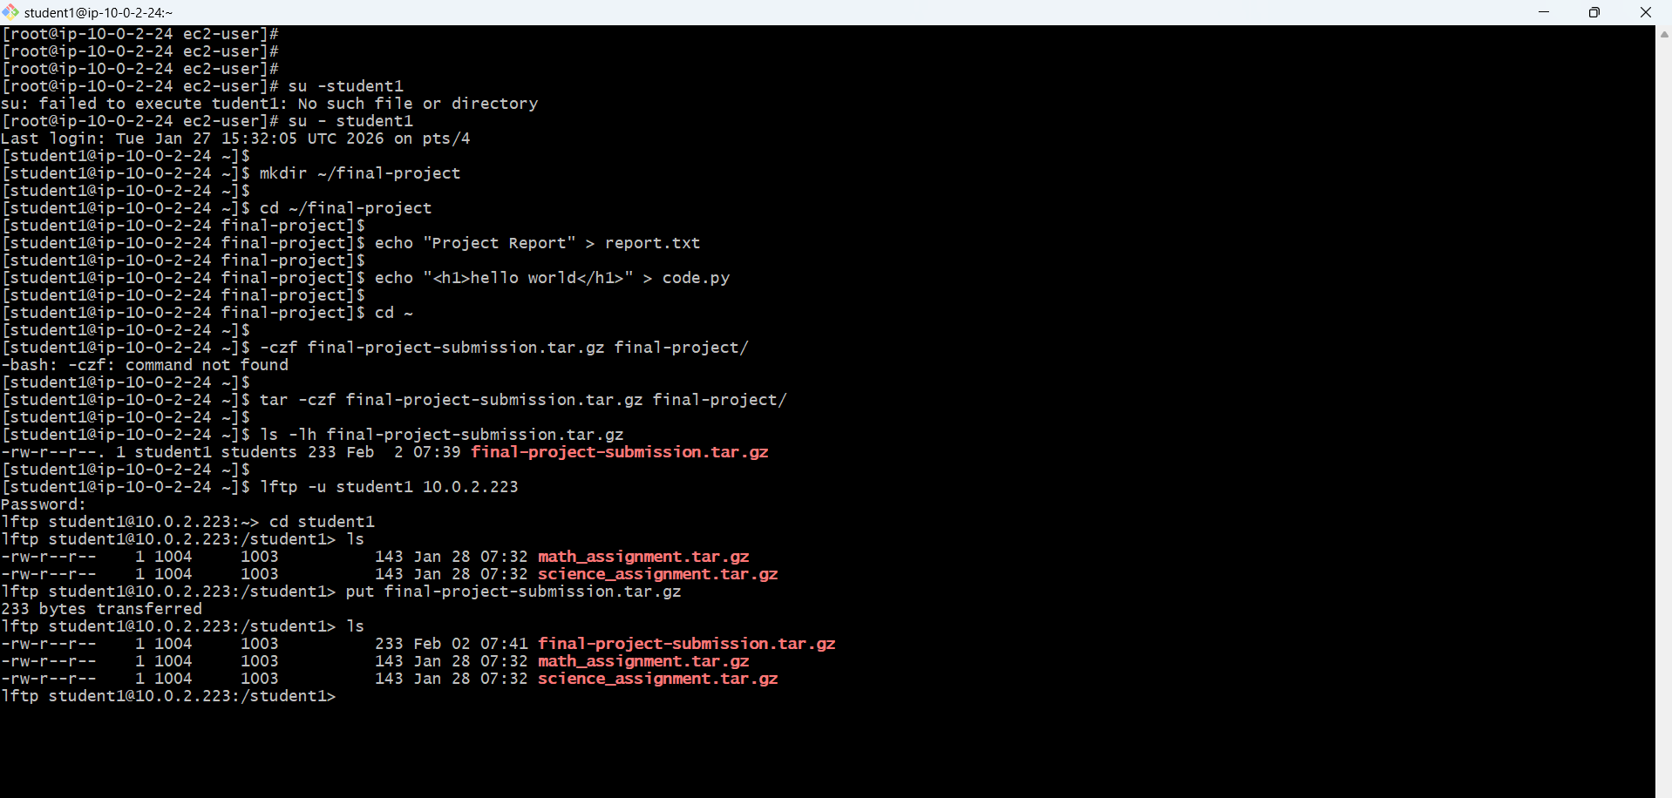

**Server**

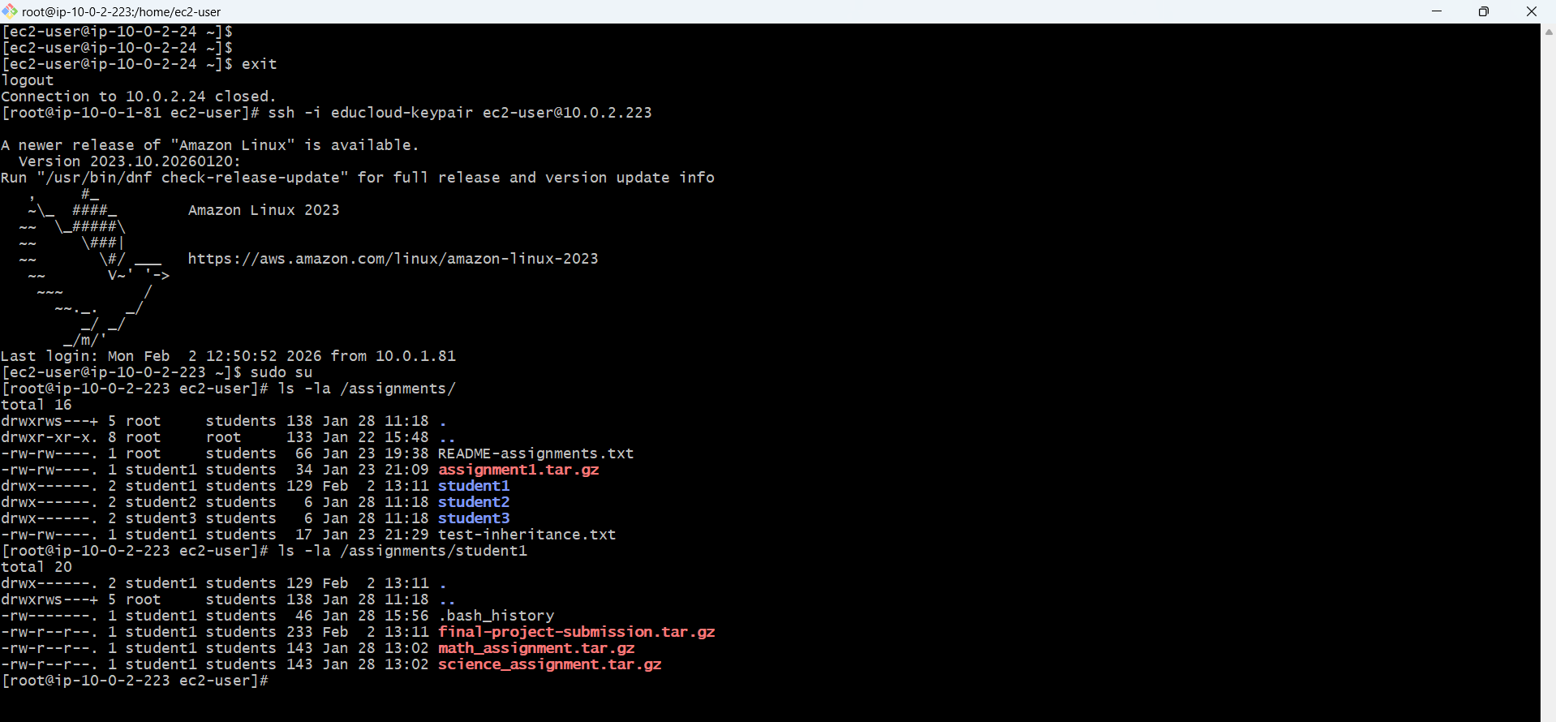

**AWS CLI - Test S3 Access from EC2**

**Listing bucket**

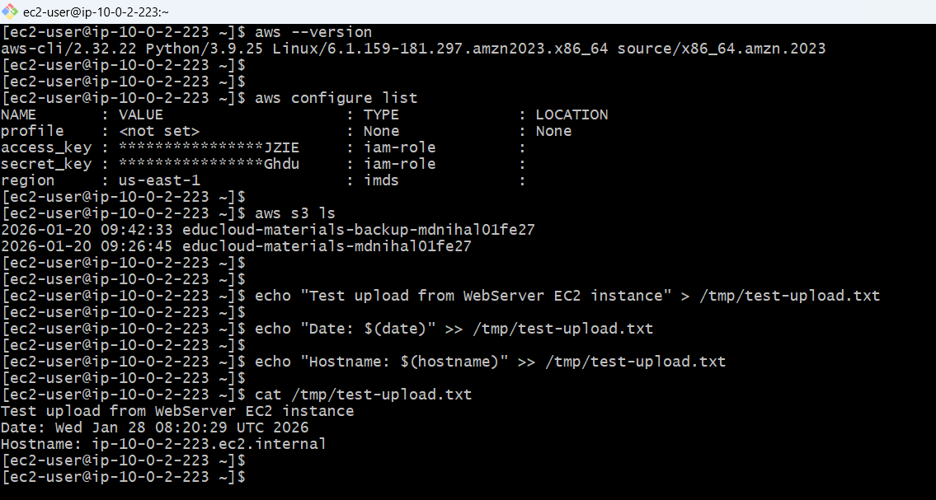

IAM Role attached to s3 access from ec2

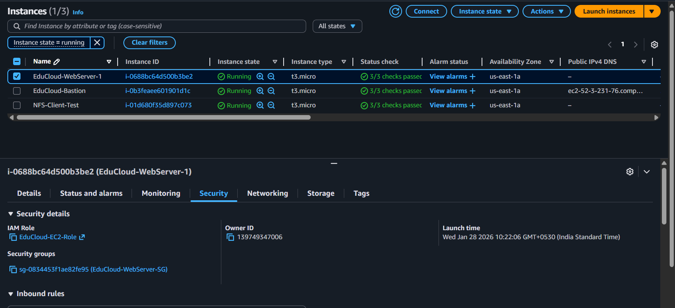

S3 upload from ec2 cli

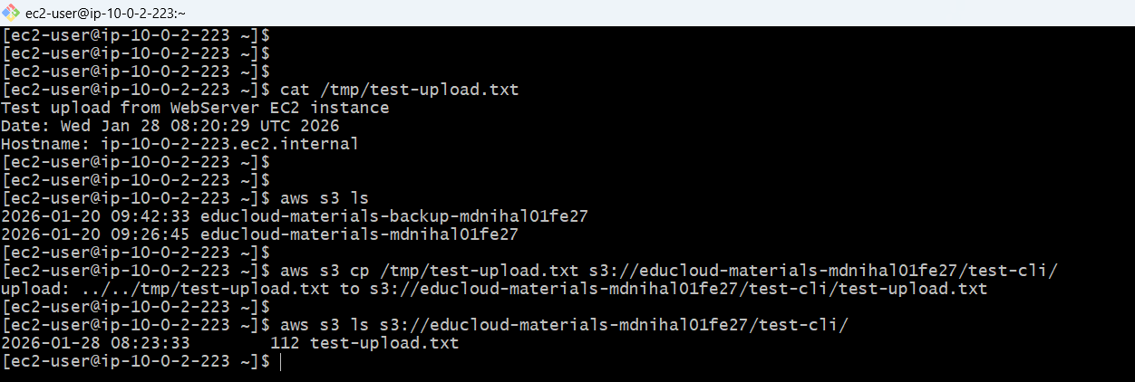

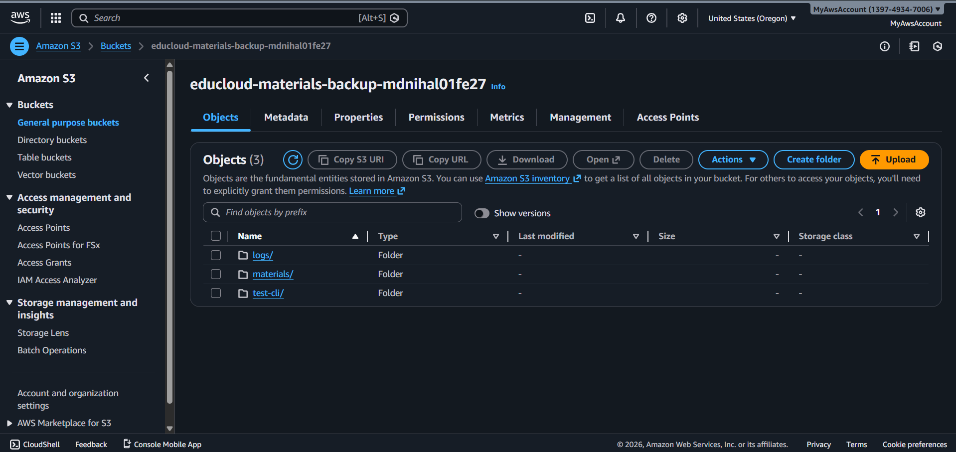

**S3 Download**

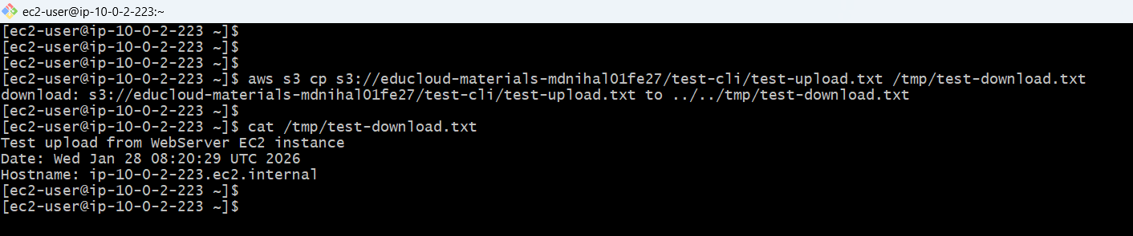

**Created 5 file and pushed across s3 at once for batch upload**

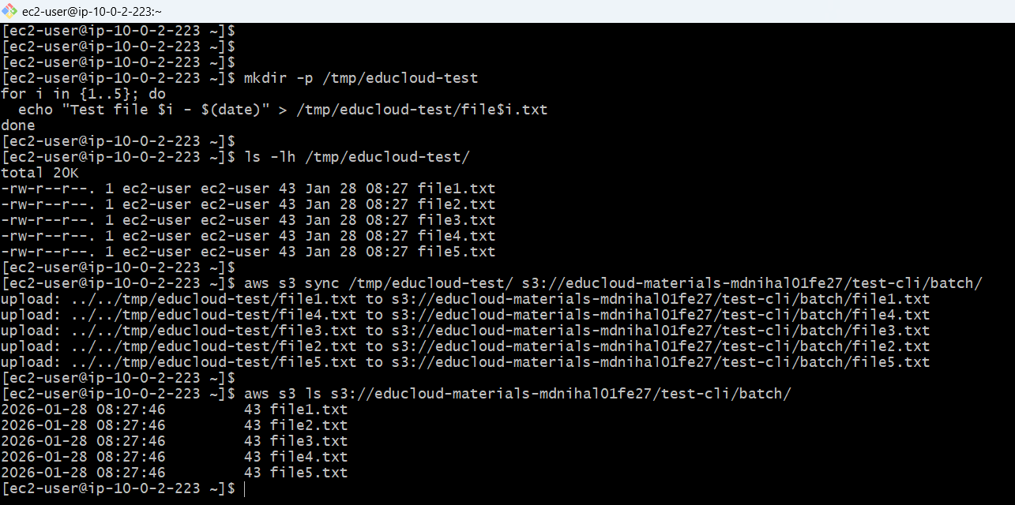

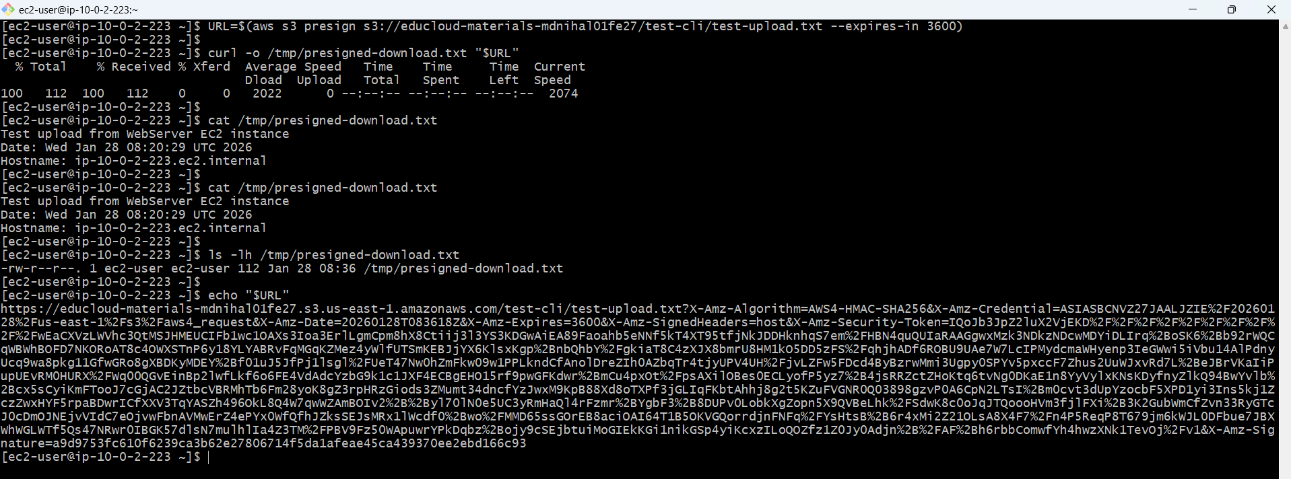

AWS CLI Installed (v2)

IAM Role Attached (EduCloud-EC2-Role)

S3 List Access Working

S3 Upload Working

S3 Download Working

S3 Sync Working

Presigned URLs Working

**Automation Scripts used later for the cron jobs**

**backup-materials.sh**

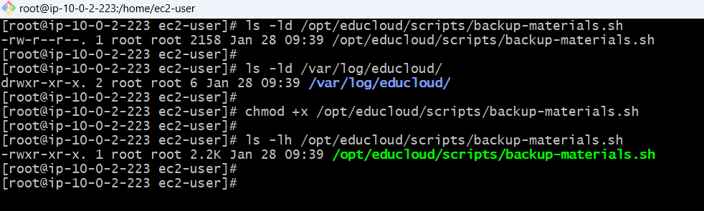

**upload-logs.sh Script**

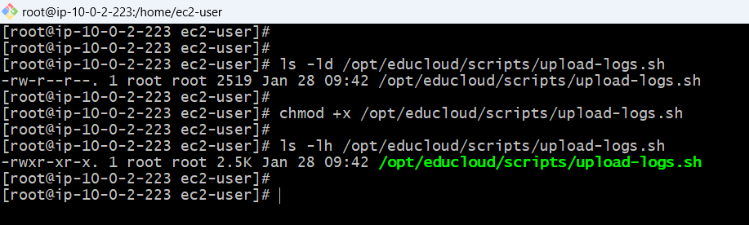

**archive-assignments.sh Script**

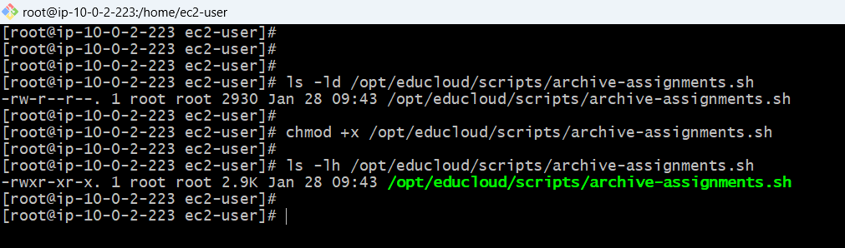

**Permissions**

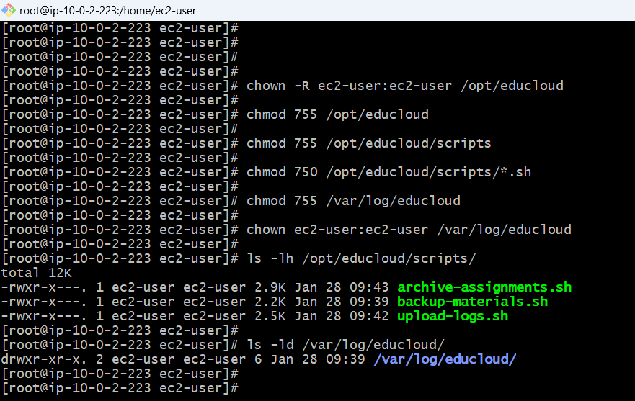

**Testing scripts (backup)**

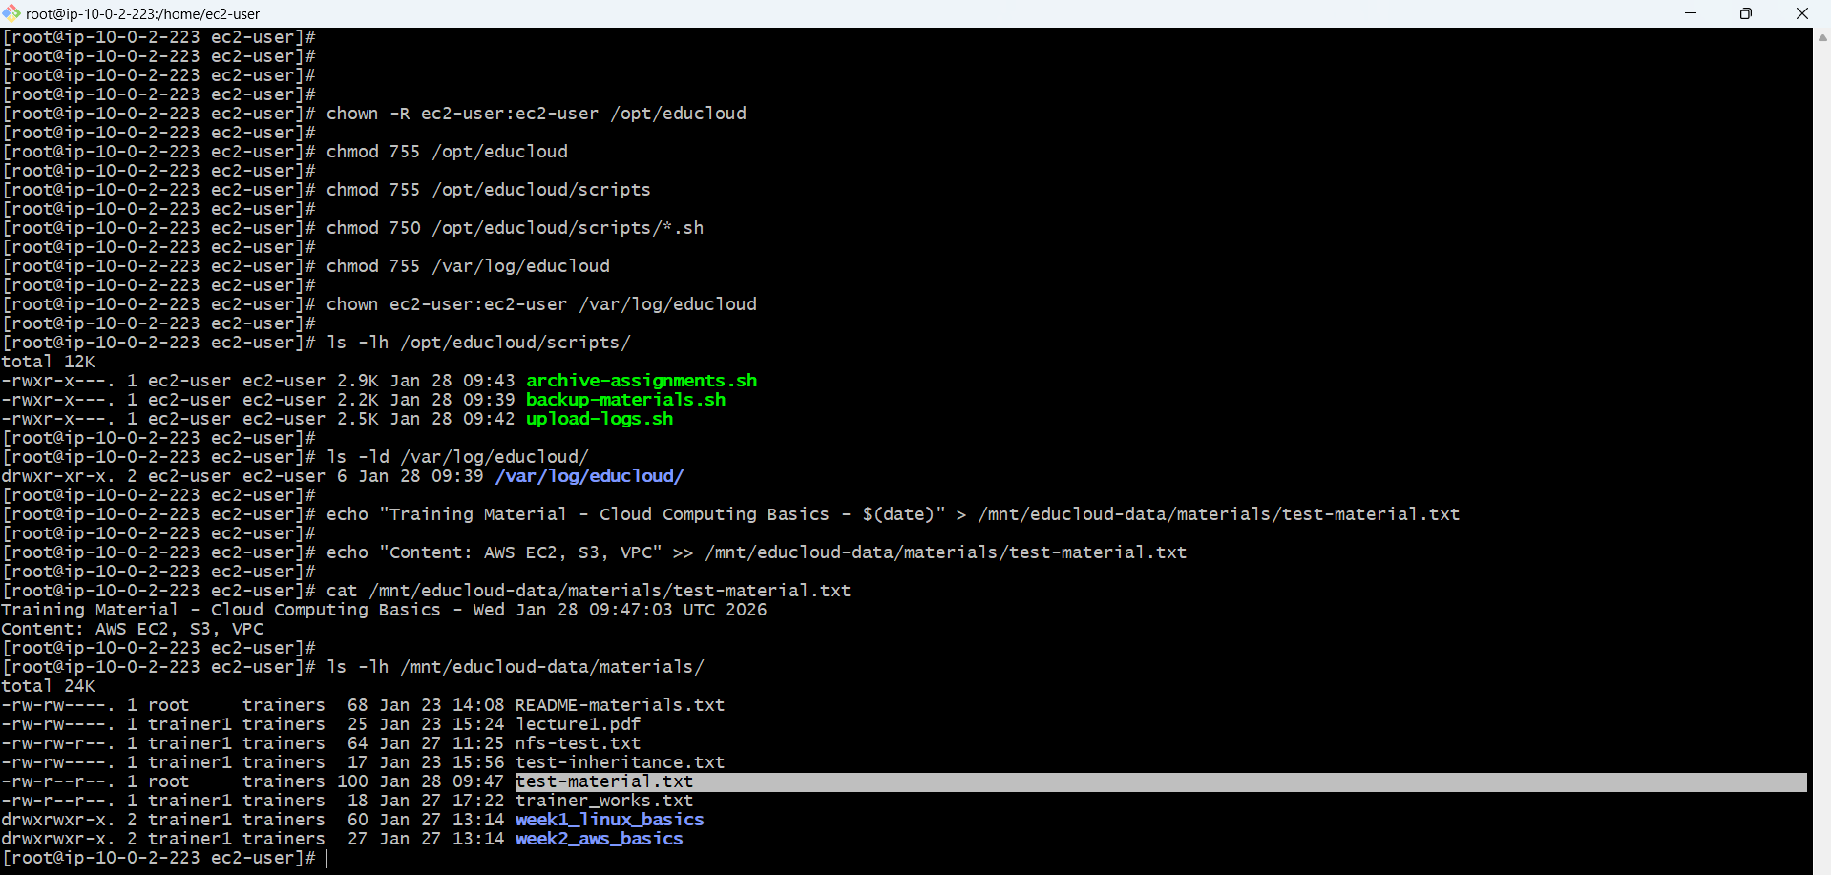

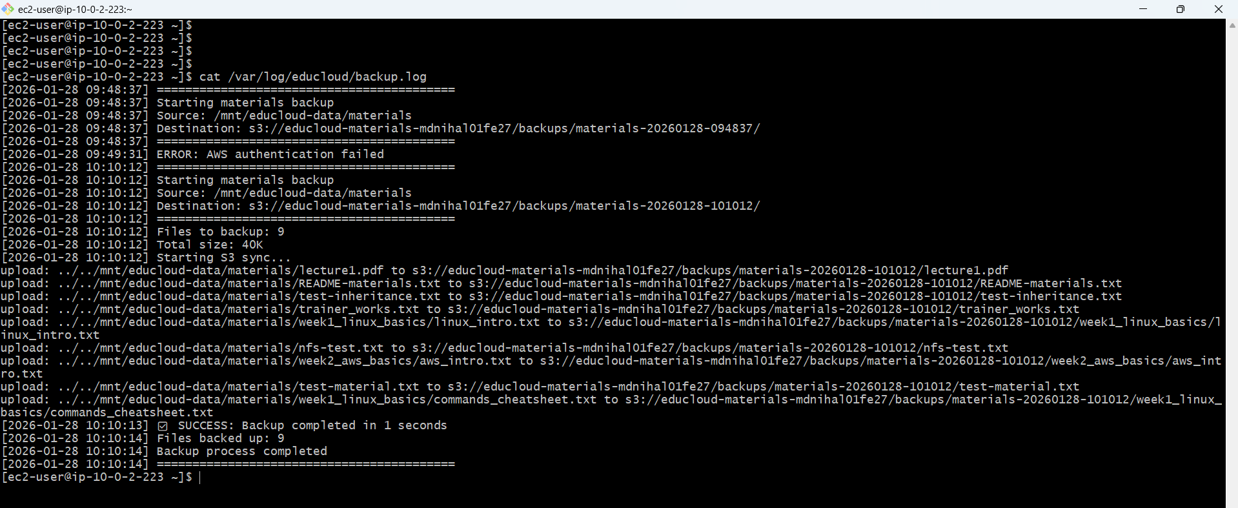

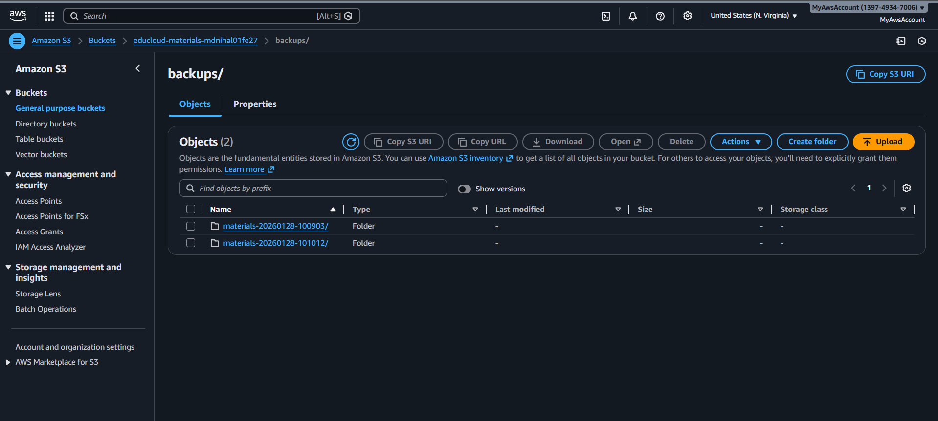

**Logs /var/log/educloud/backup.log**

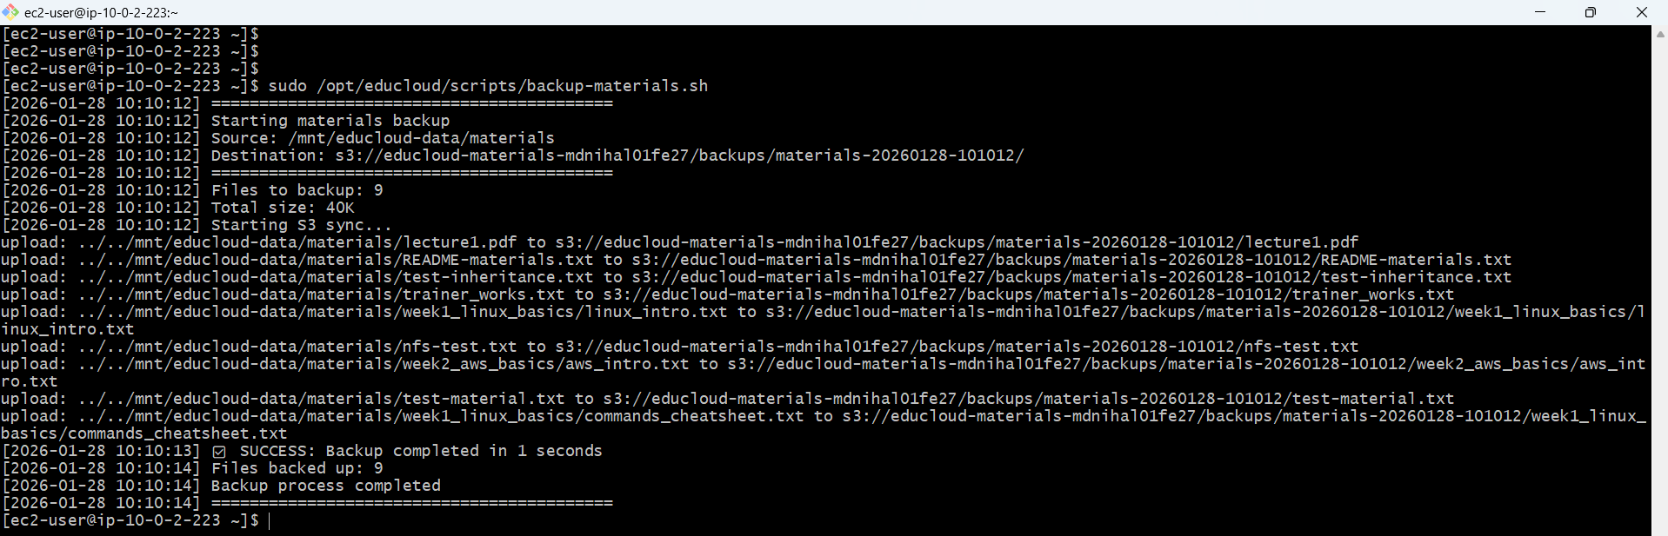

**Test archive-assignments.sh Script**

**Created old sample data by student**

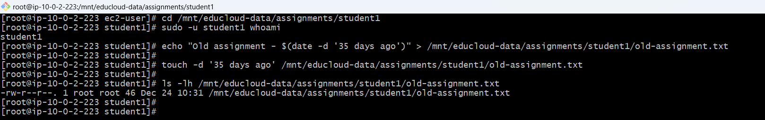

**File archived**

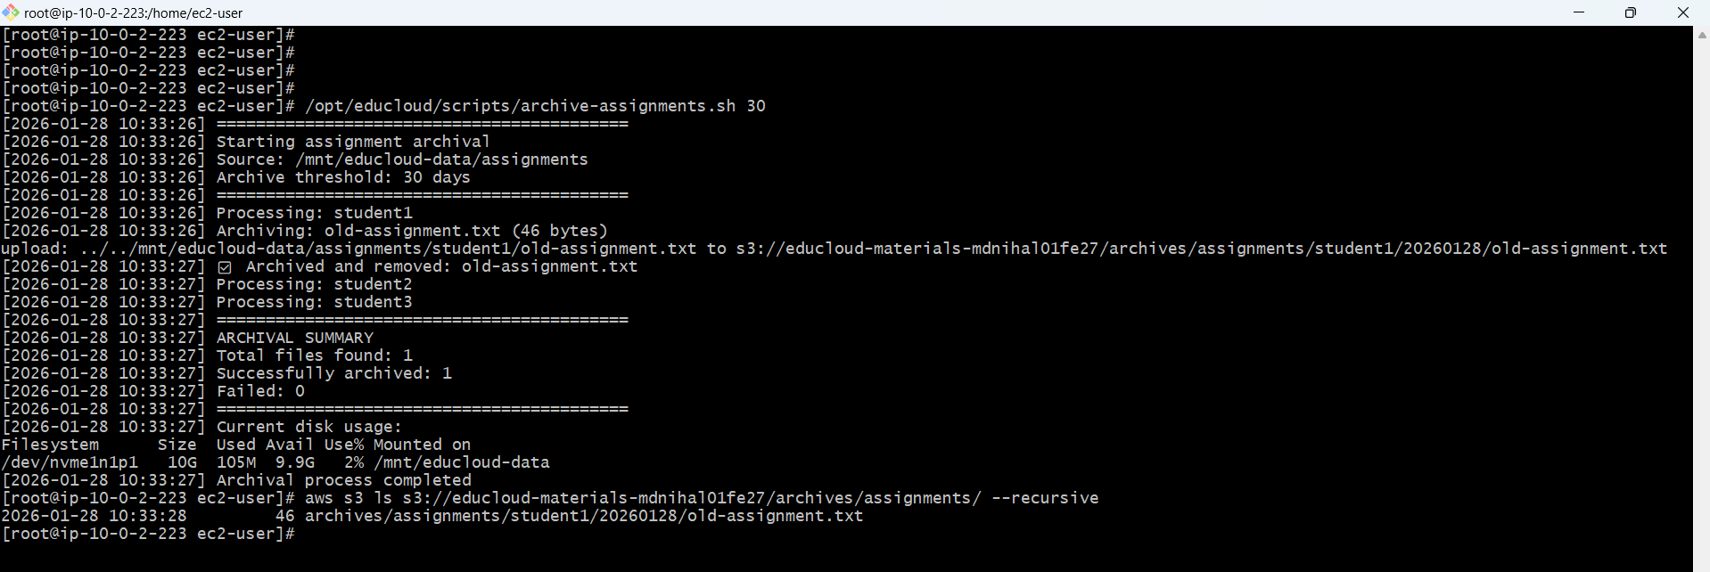

**Can be accessed via - s3://educloud-materials-mdnihal01fe27/archives/assignments/student1/20260128/old-assignment.txt**

**Stored in glacier deep archive**

**Created VPC endpoint gateway for the communication between ec2 s3 without nat**

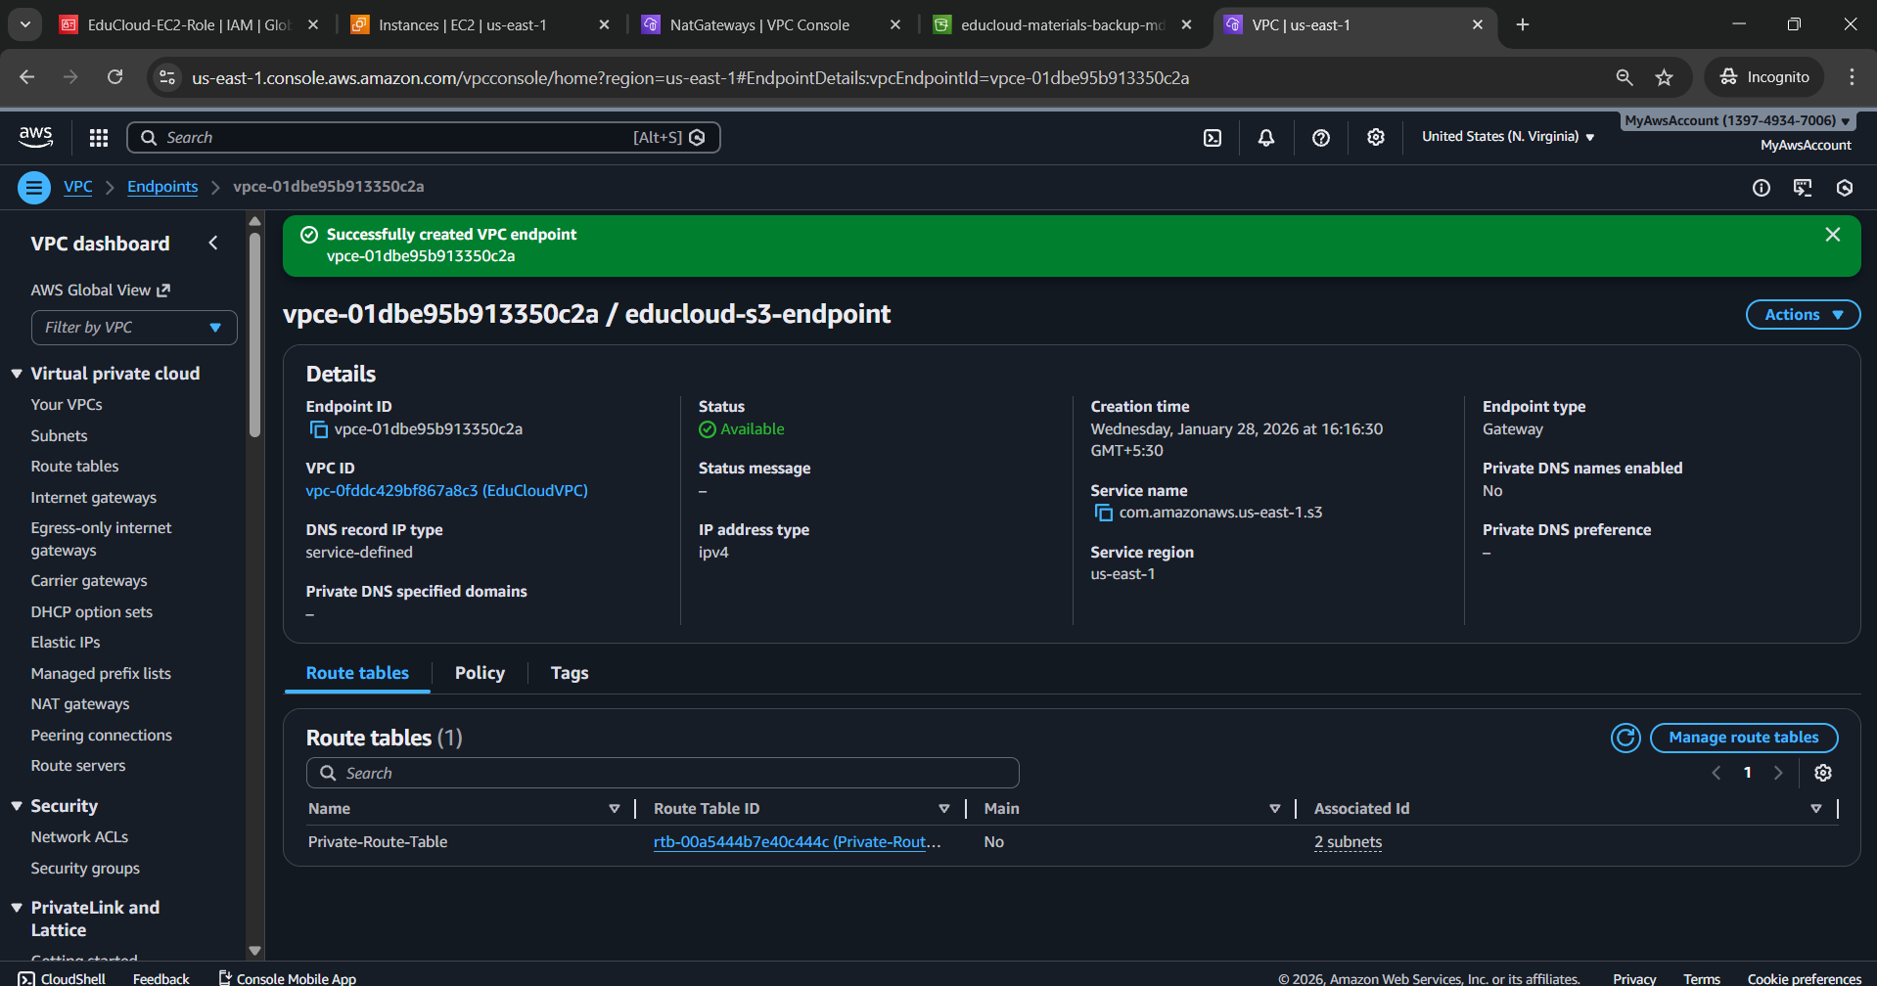

**Adding Cron Job Entries**

**Verify Scripts exist**

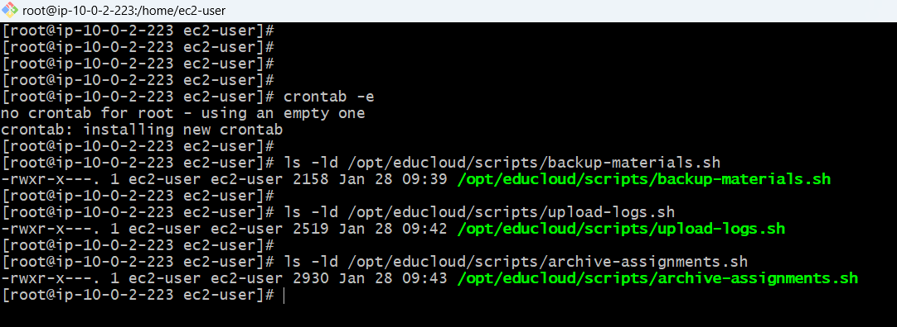

**Required Users Exist**

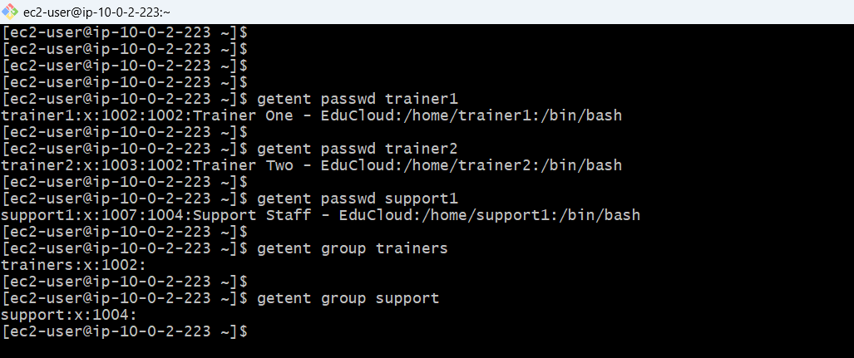

**Cron for trainer1 (Daily Backup at 11:00 PM)**

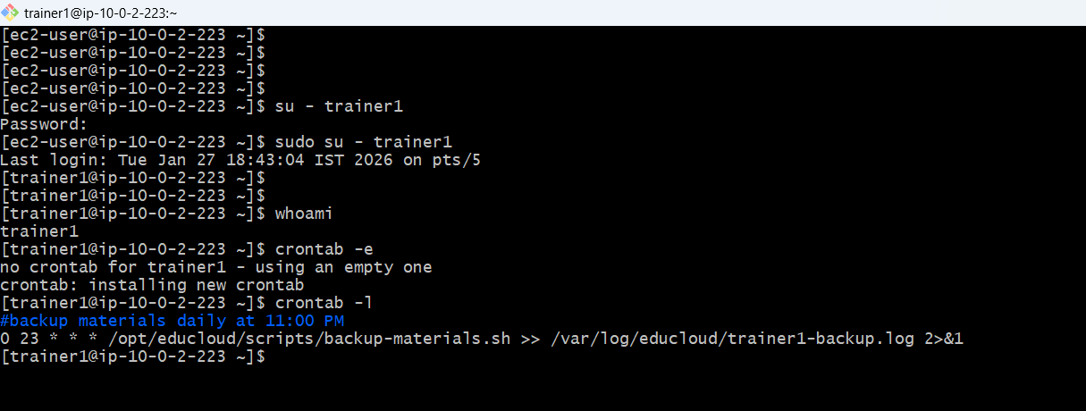

**Cron for support1 (Logs Every Sunday 6:00 PM)**

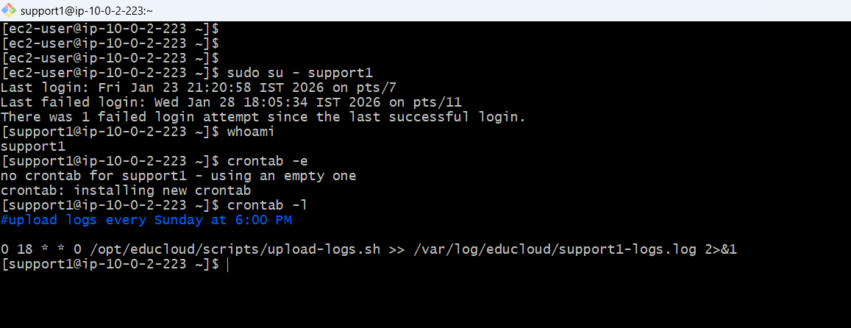

**Cron for trainer2 (Monthly Archive on 1st at 12:30 AM)**

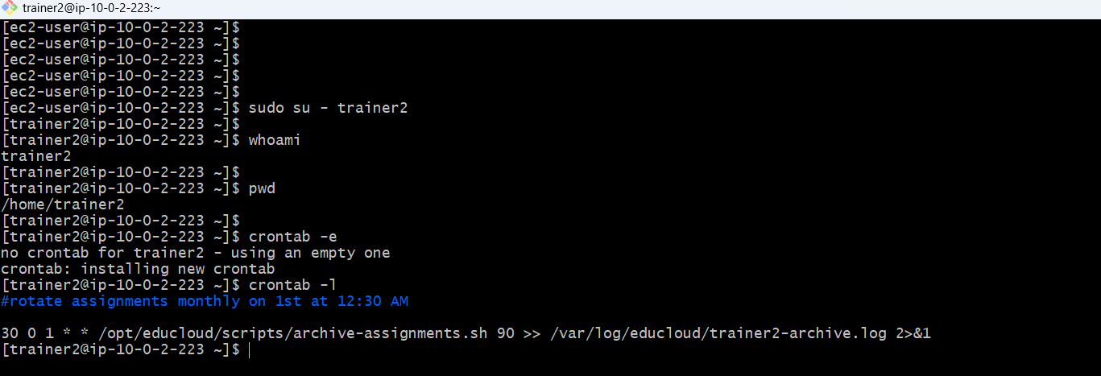

**Proper Script Execution Permissions to Users**

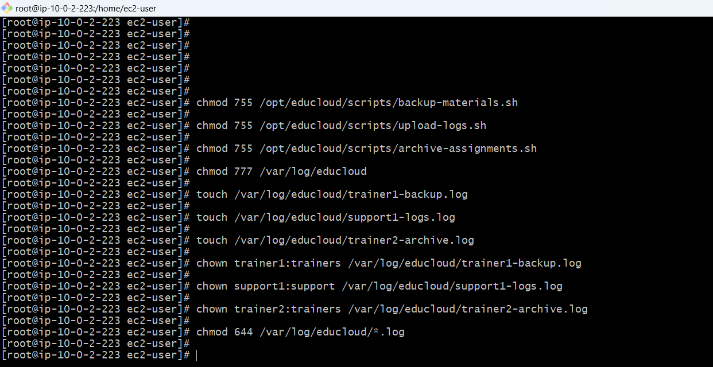

**Cron jobs log files**

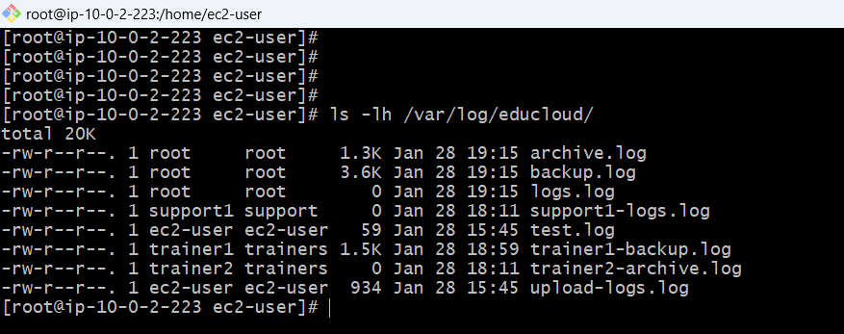

**All users crontab**

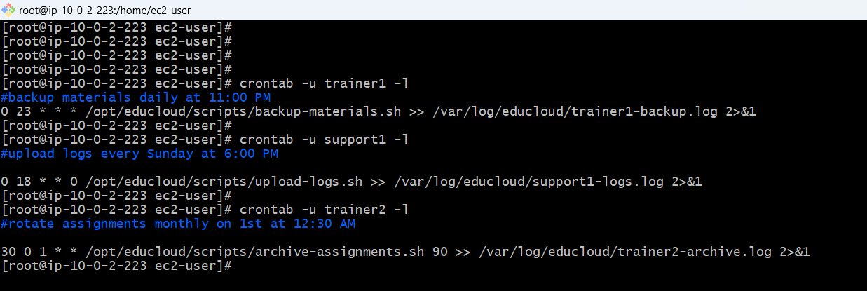

**Crontab root user**

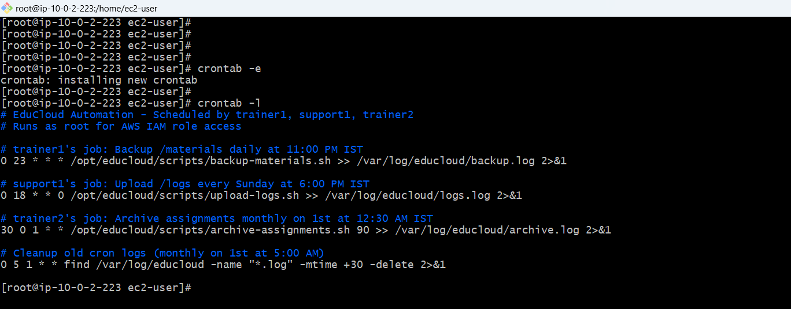

**Manual test after the crontab setup back ups working fine**

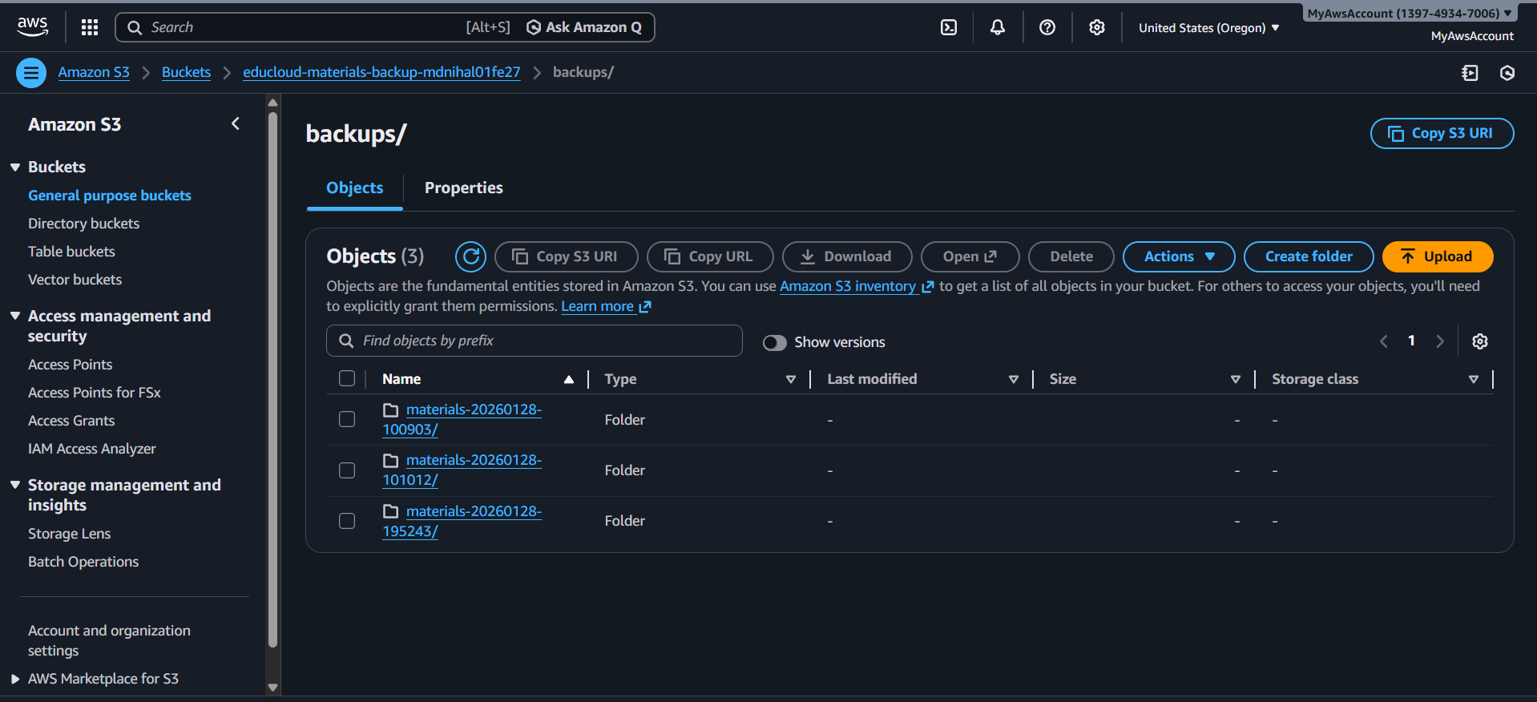

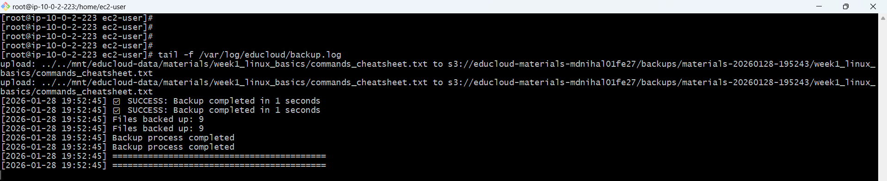

**Trainers archive old course materials into .tar.gz weekly**

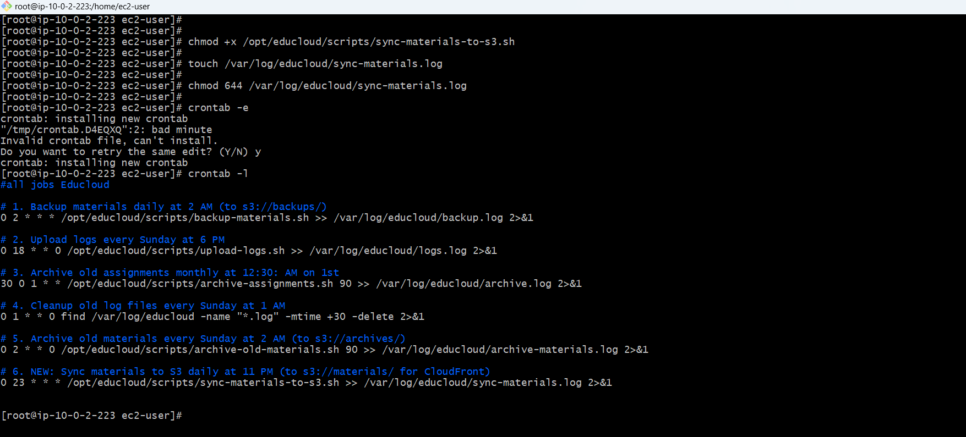

**Sync Materials to S3 Script**

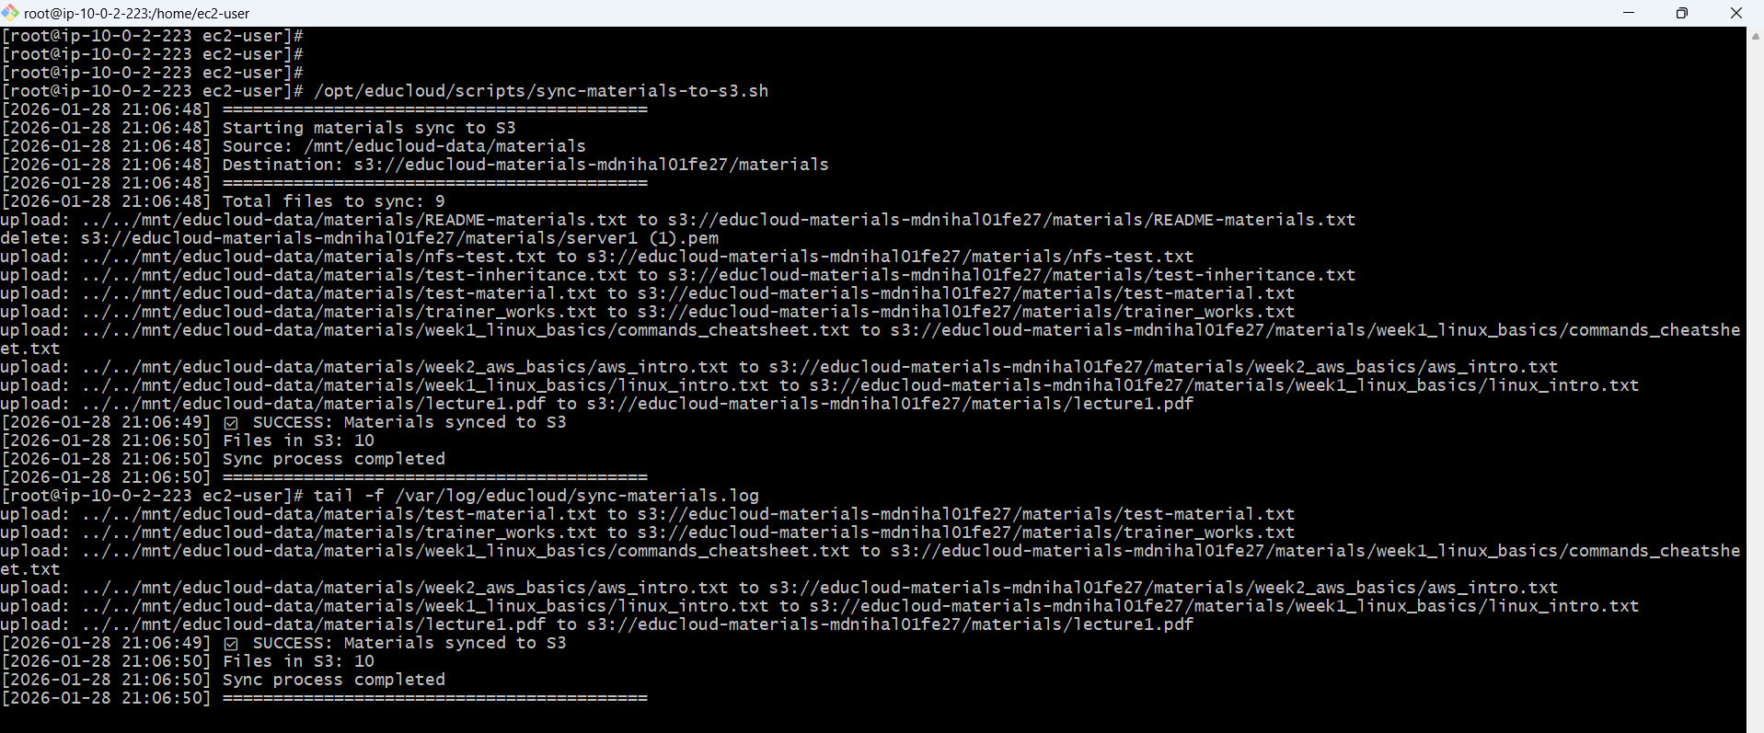

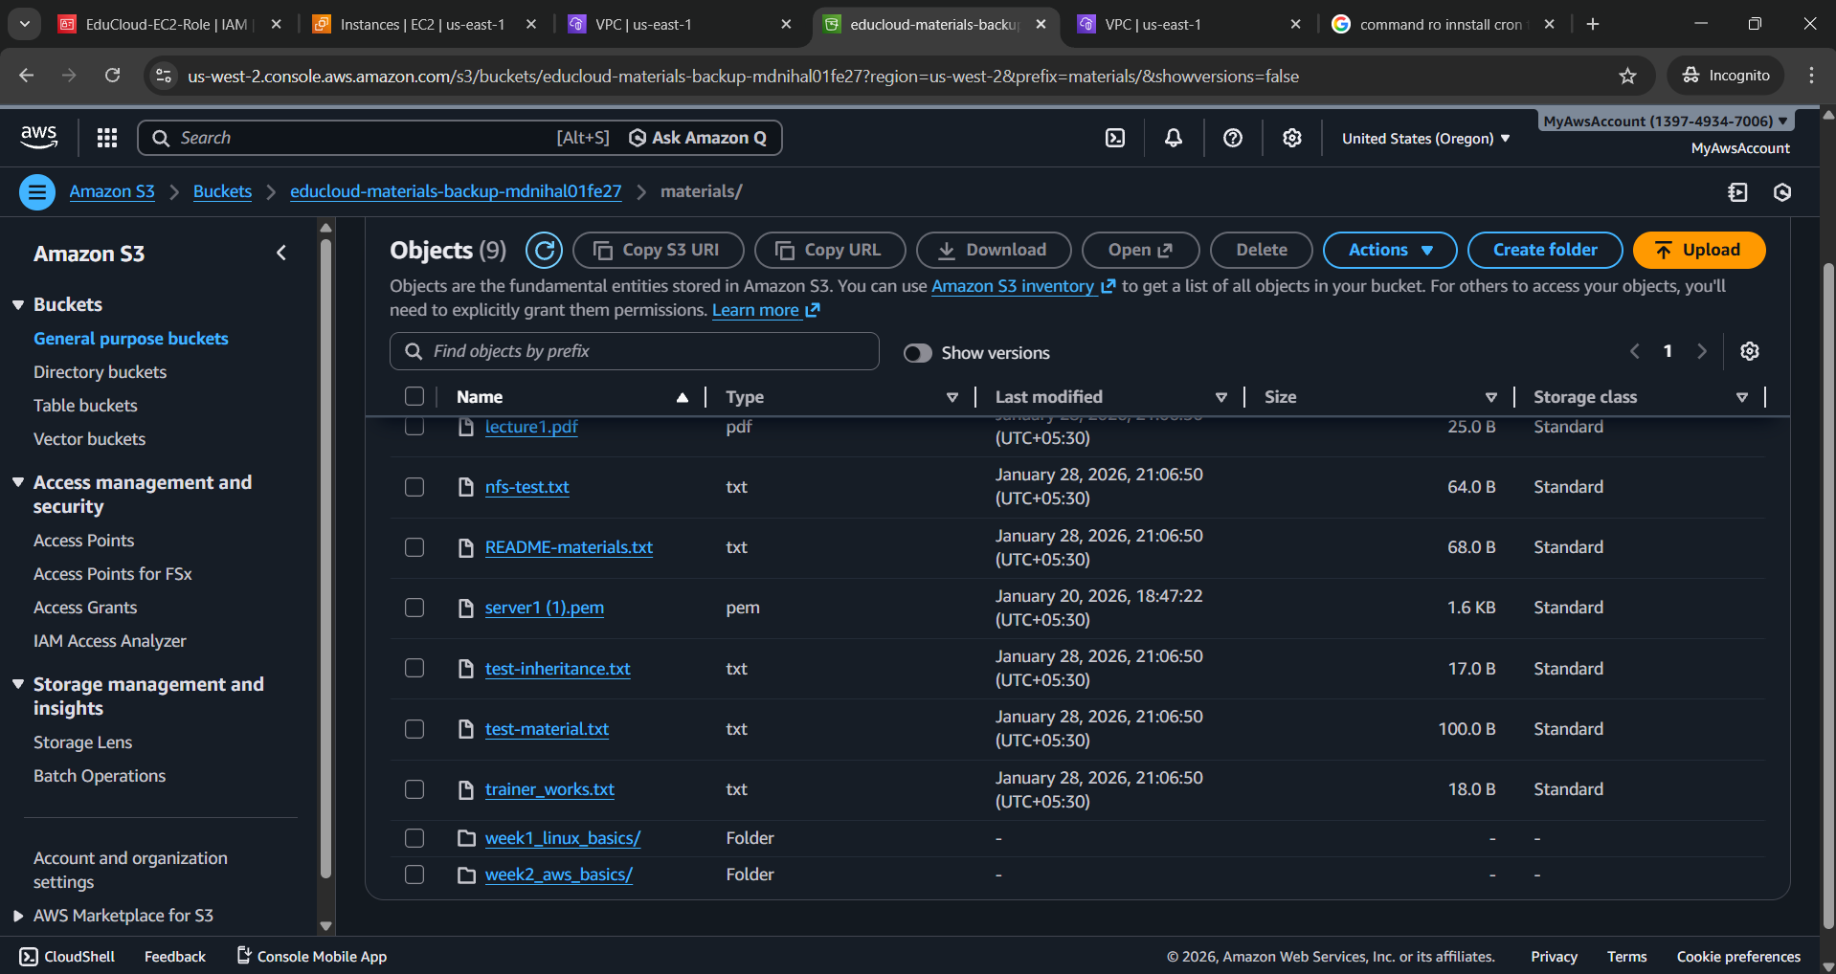

**Apache Configuration with your HTML pages**

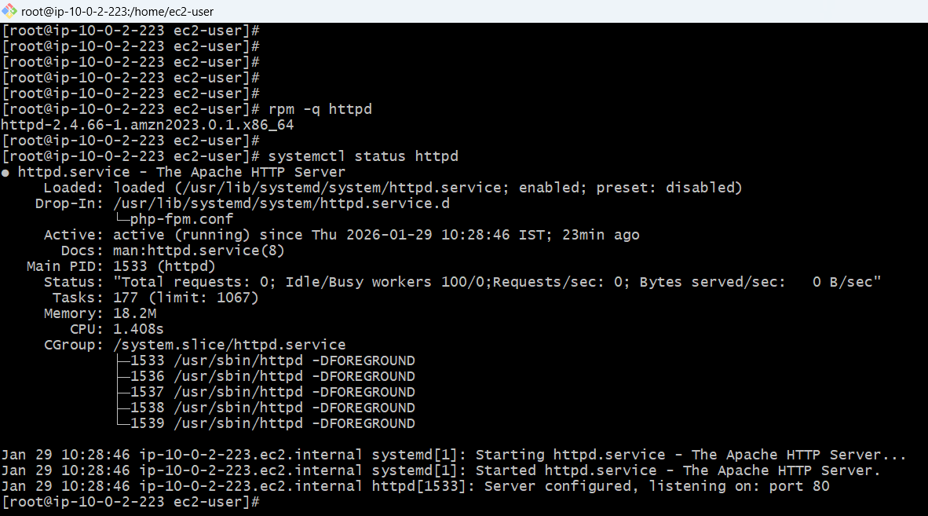

**Directory structure**

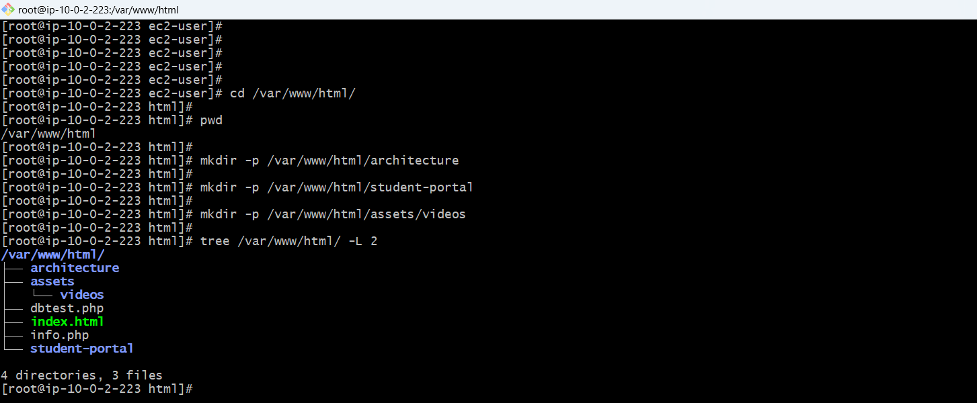

**Ami configured from the educloud-webserver-1**

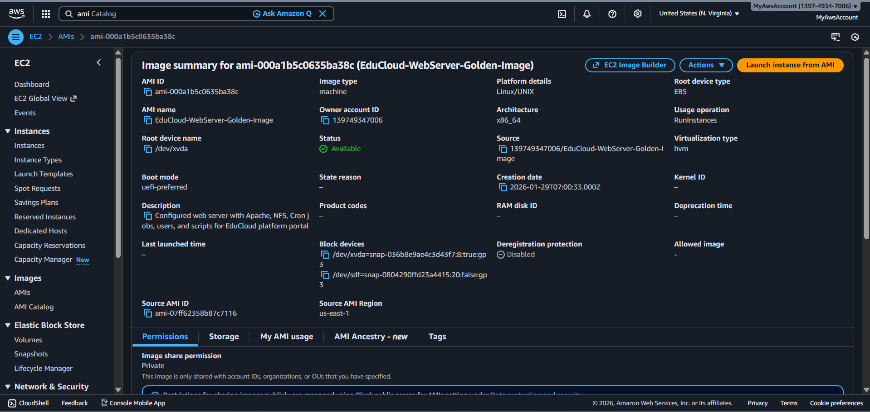

**Create Launch Template**

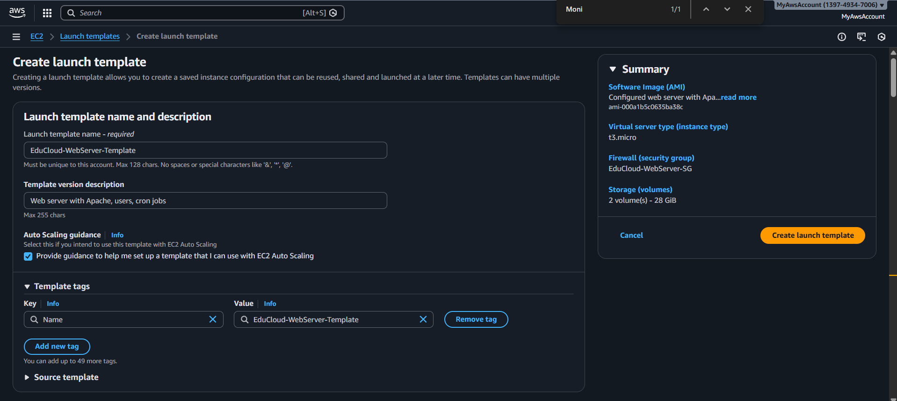

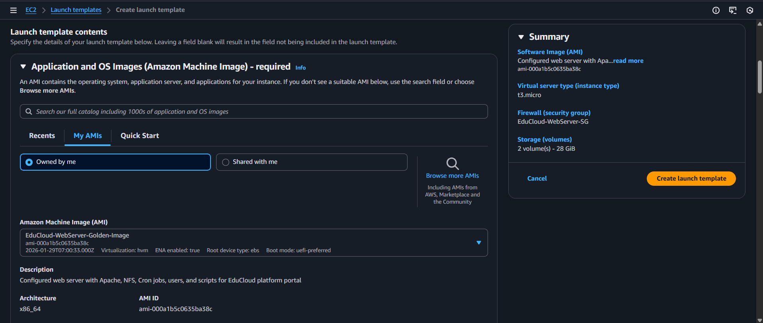

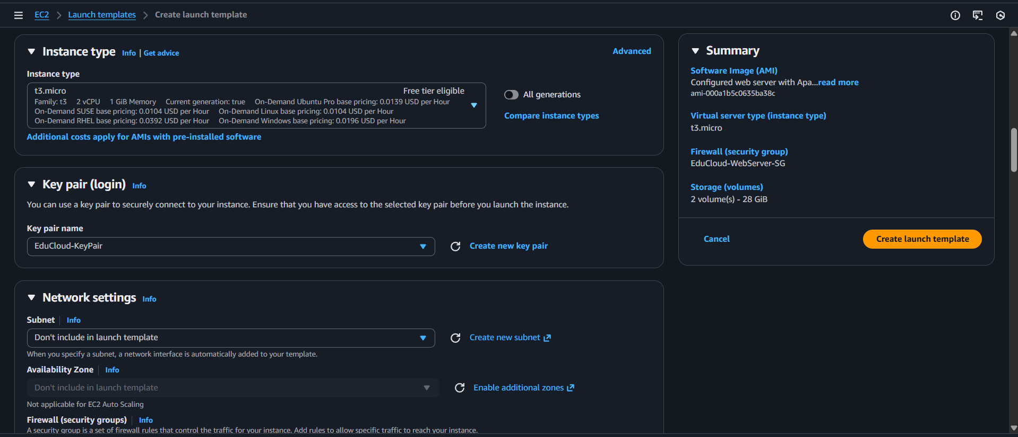

**Successfully created launch template which includes AMI of educloud-webserver-1**

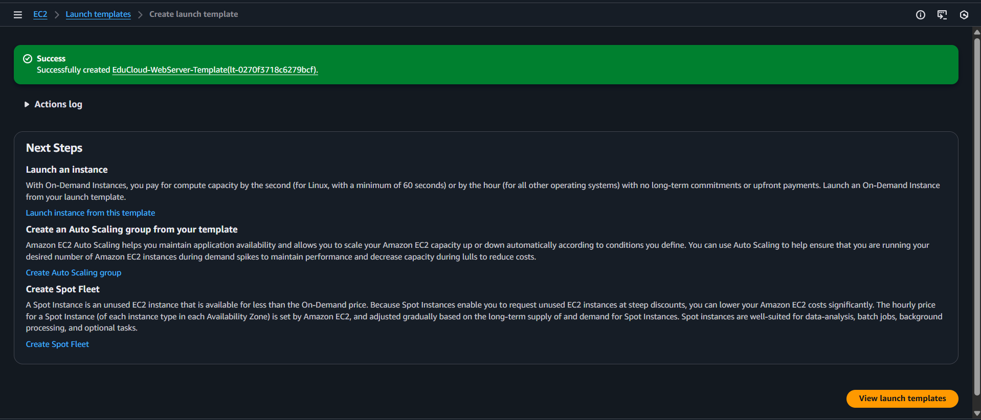

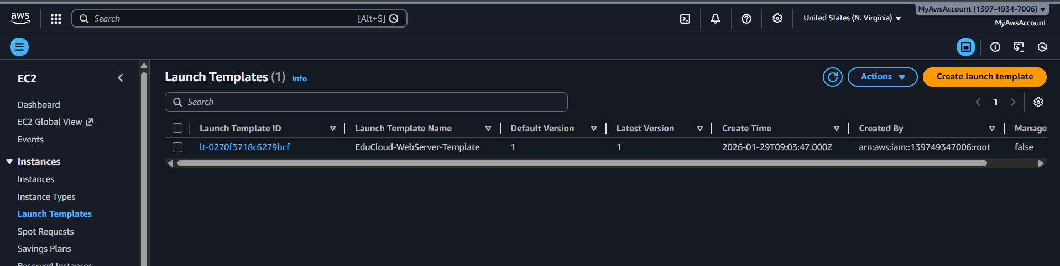

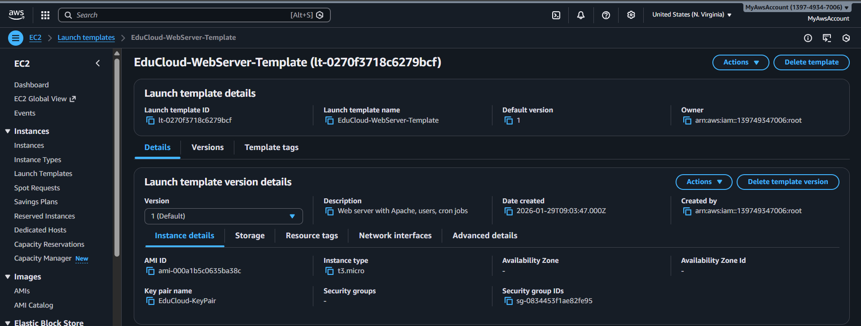

**Creating Target Group**

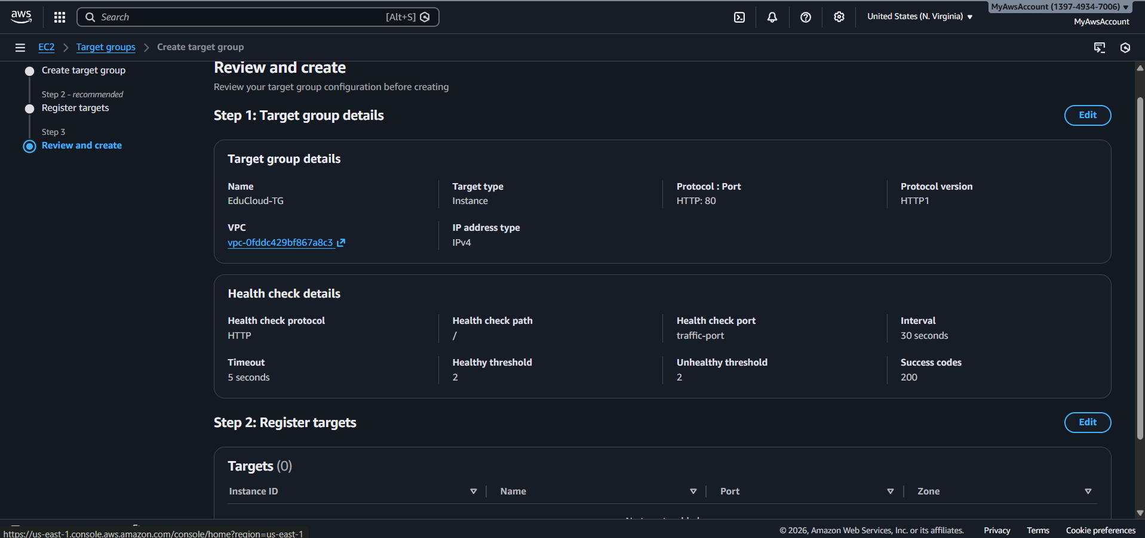

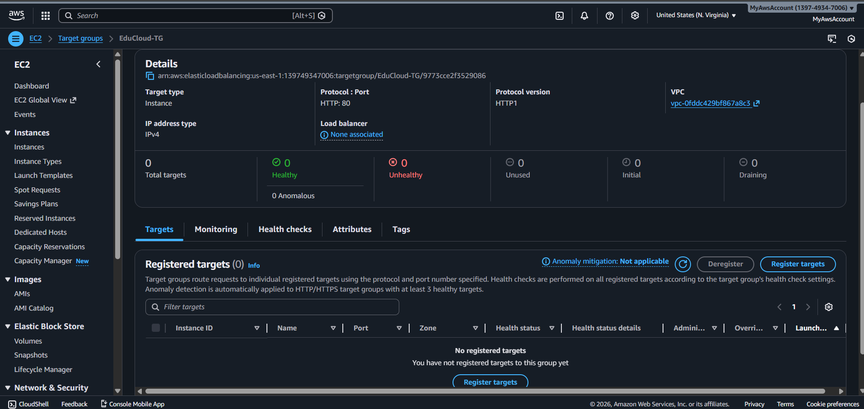

**Application Load Balancer (ALB)**

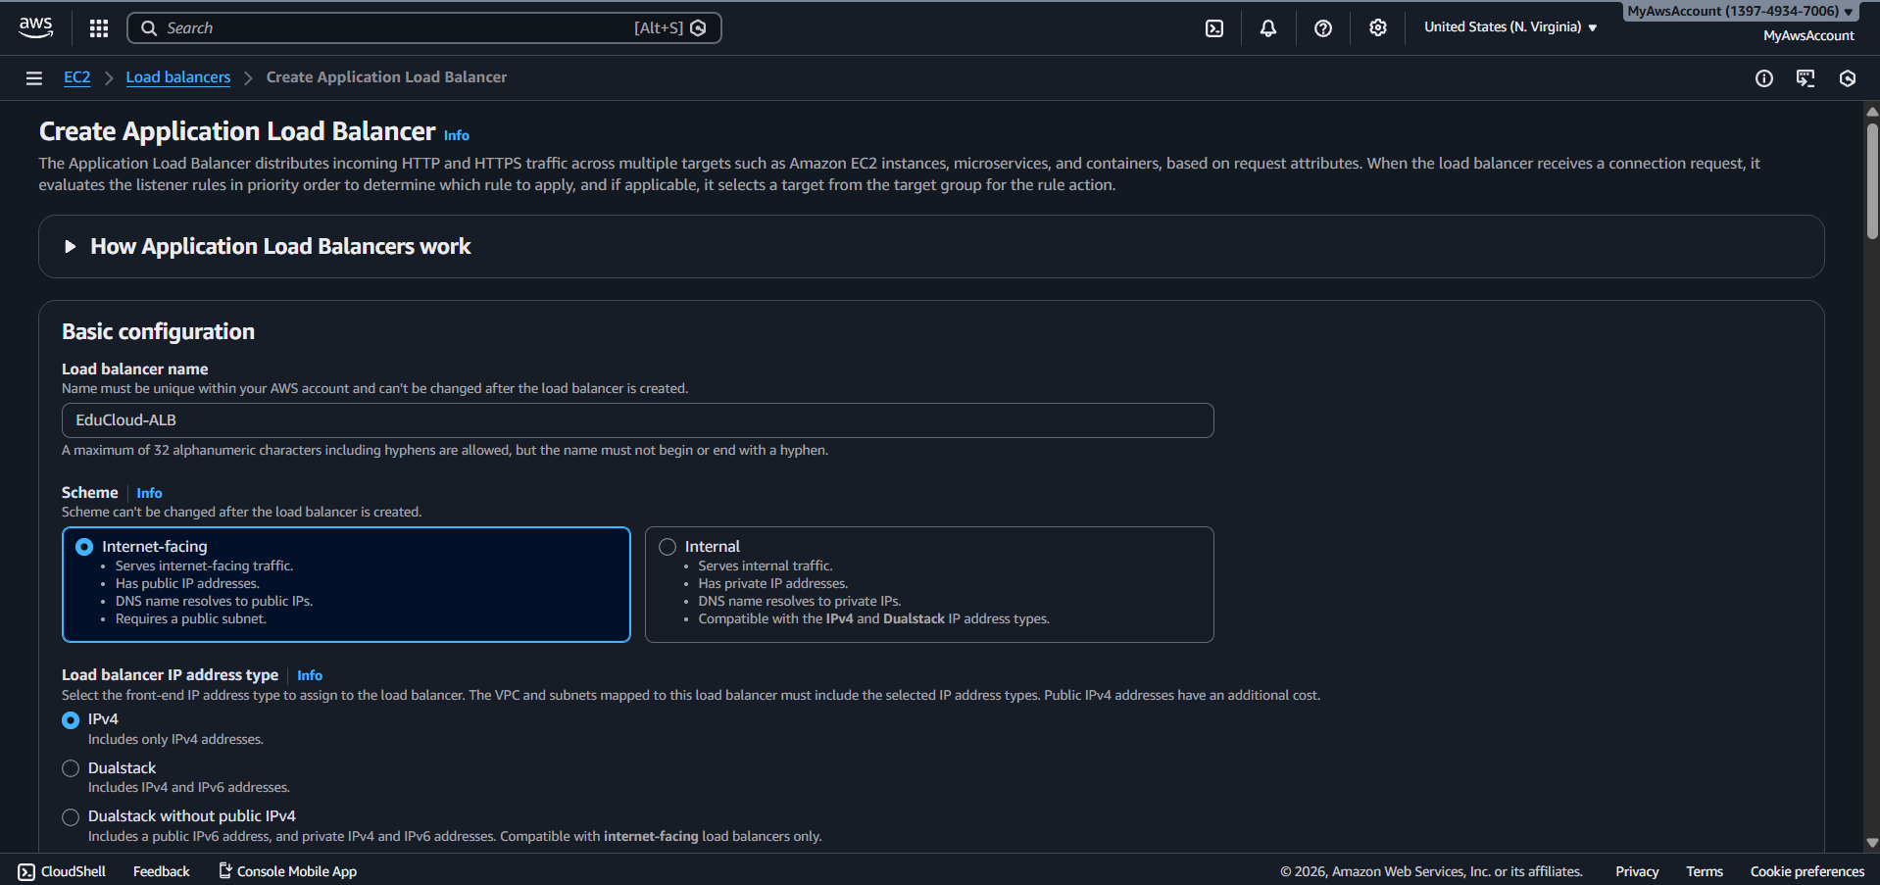

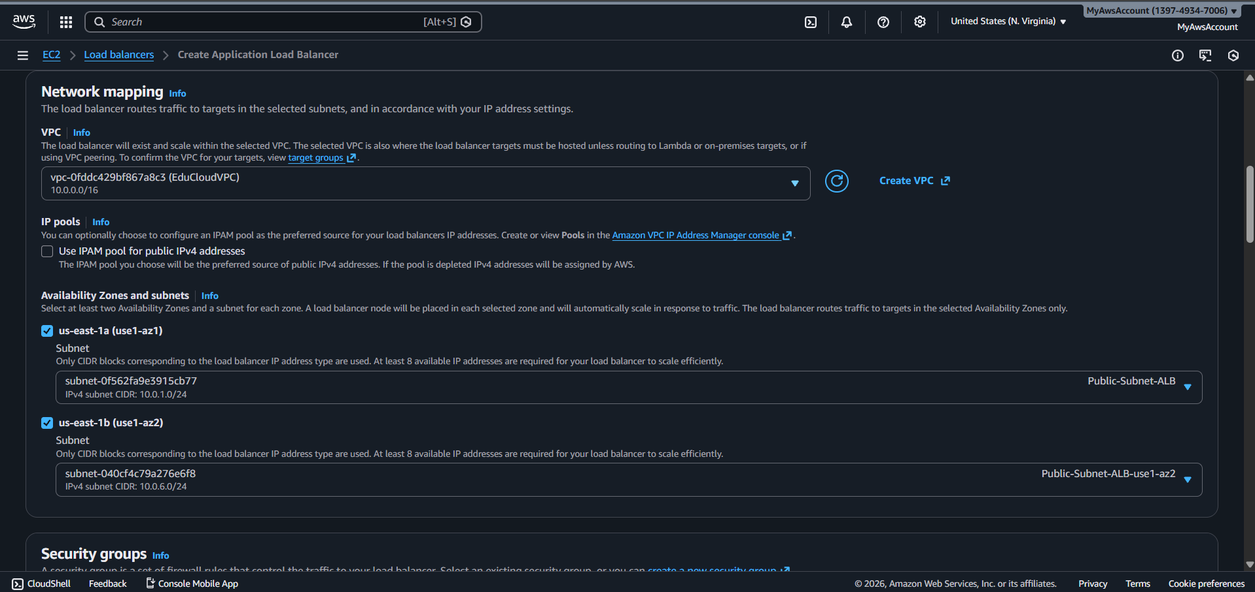

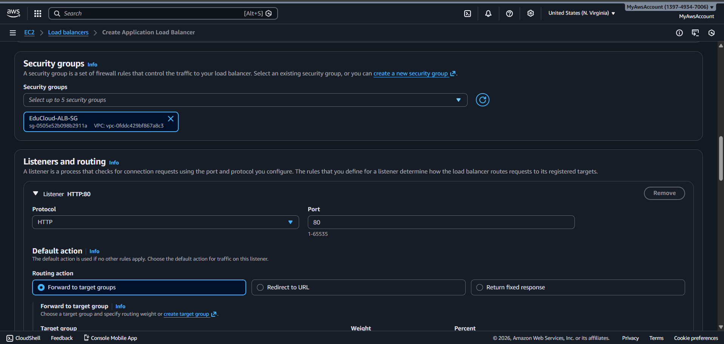

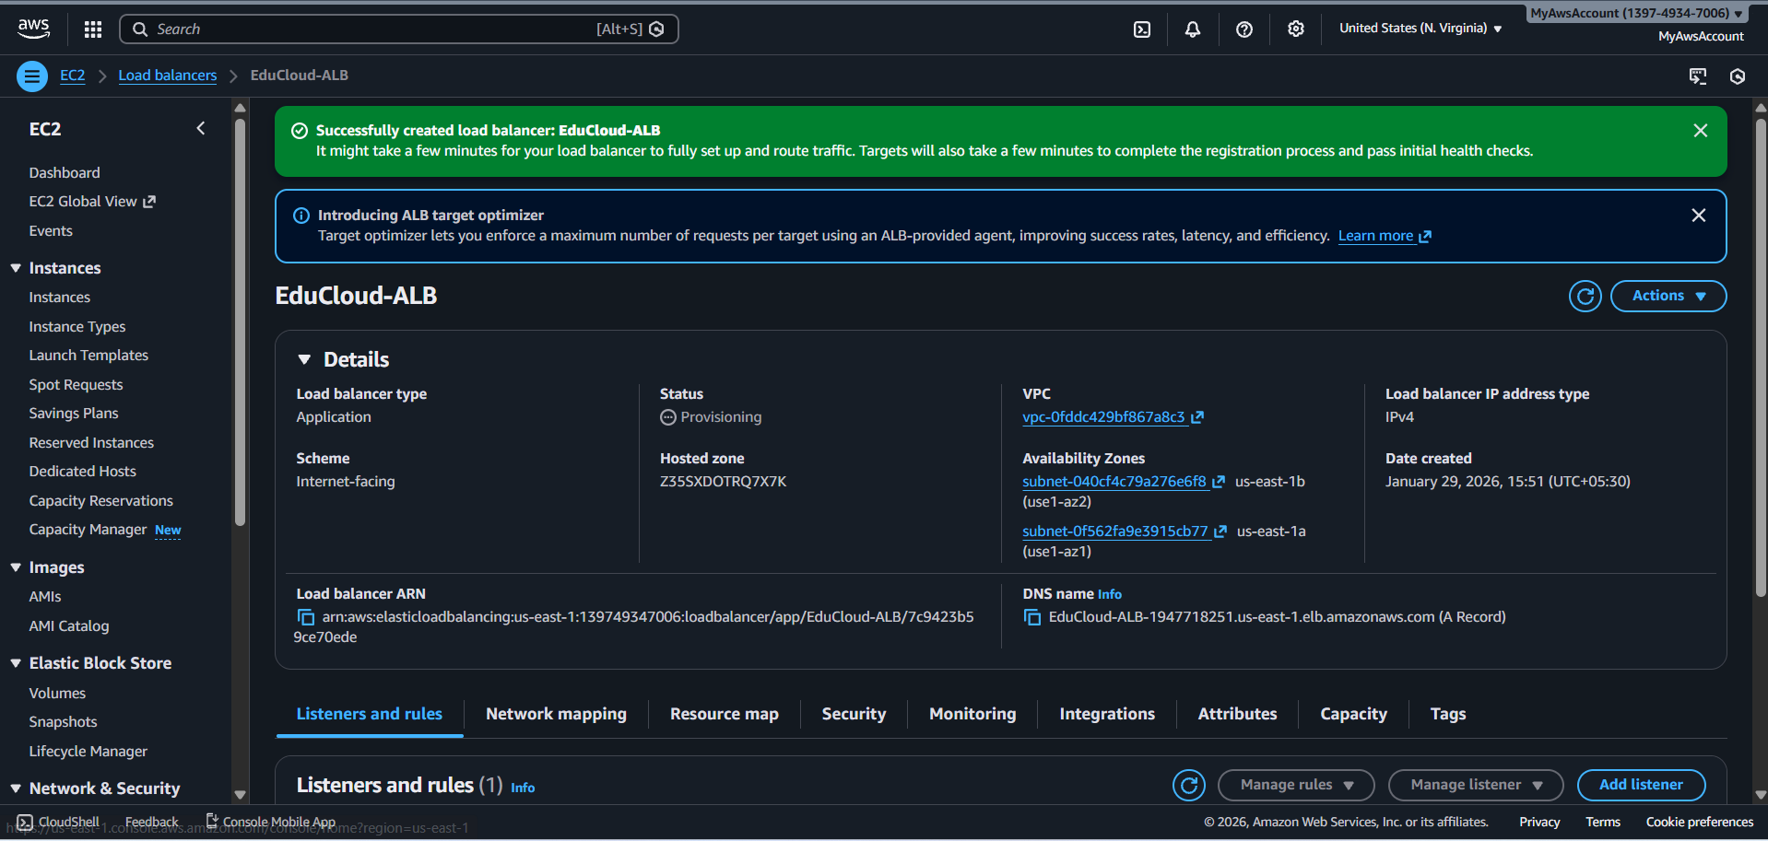

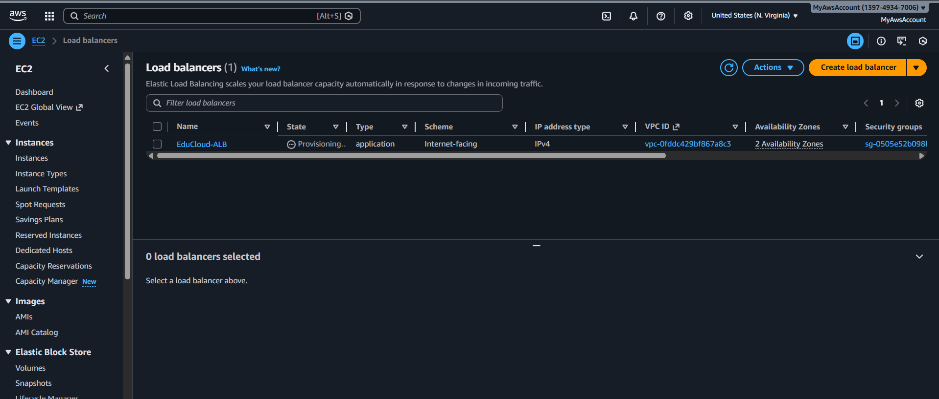

**Auto Scaling Group**

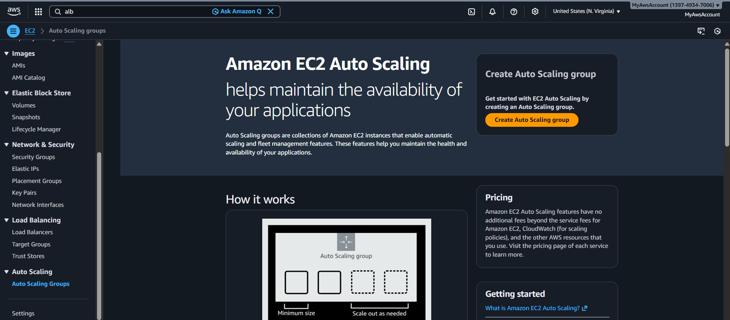

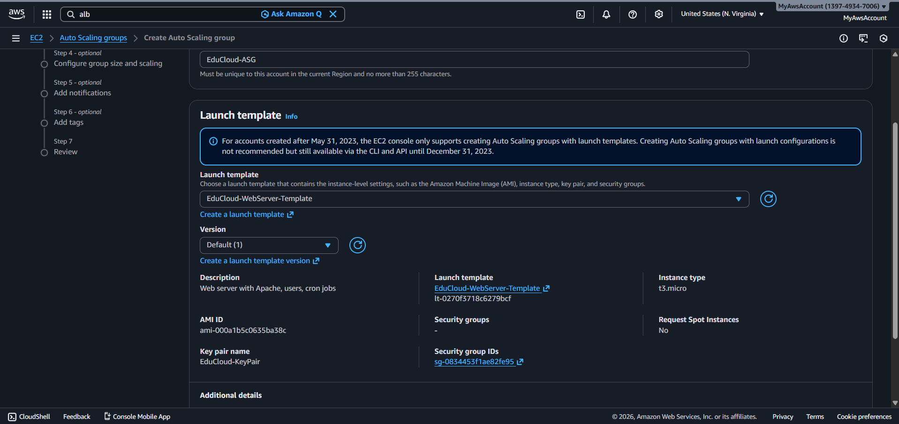

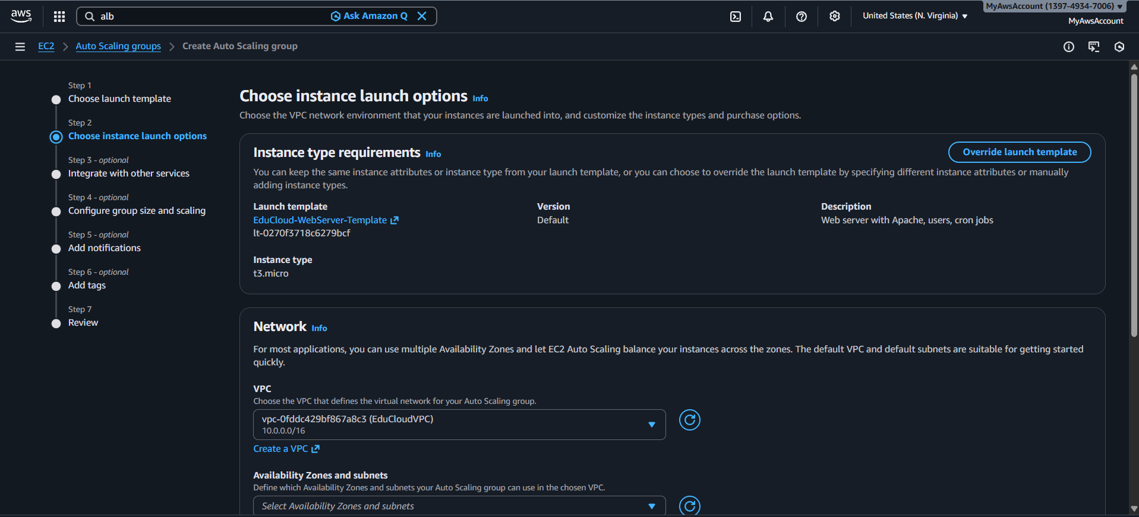

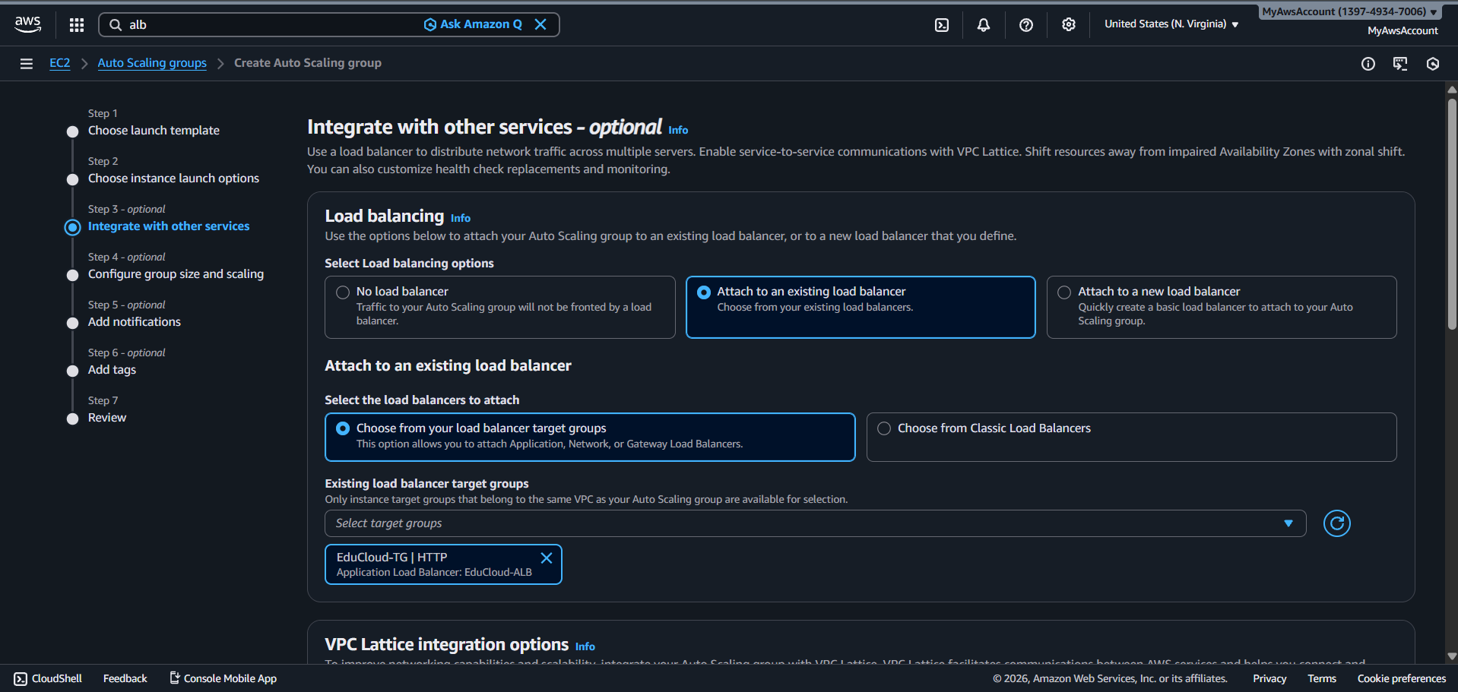

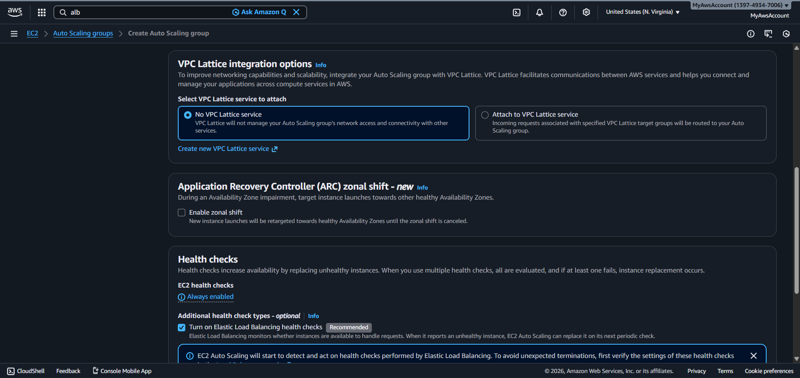

**Policy Configuration:**

**Scaling Policies**

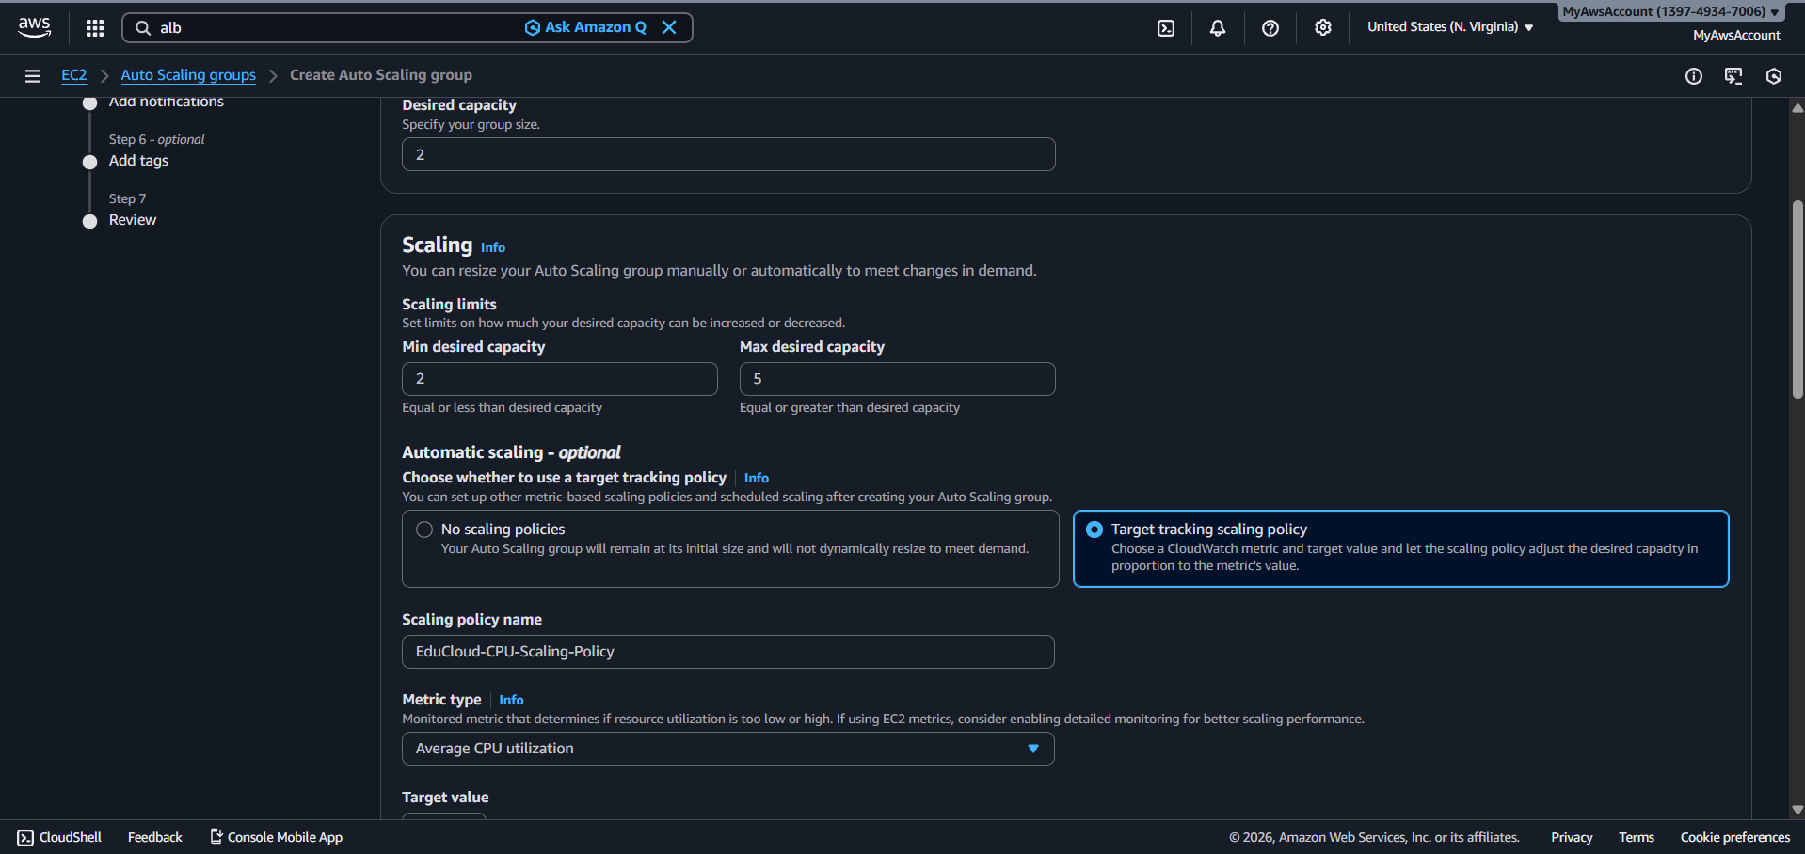

**ASG created**

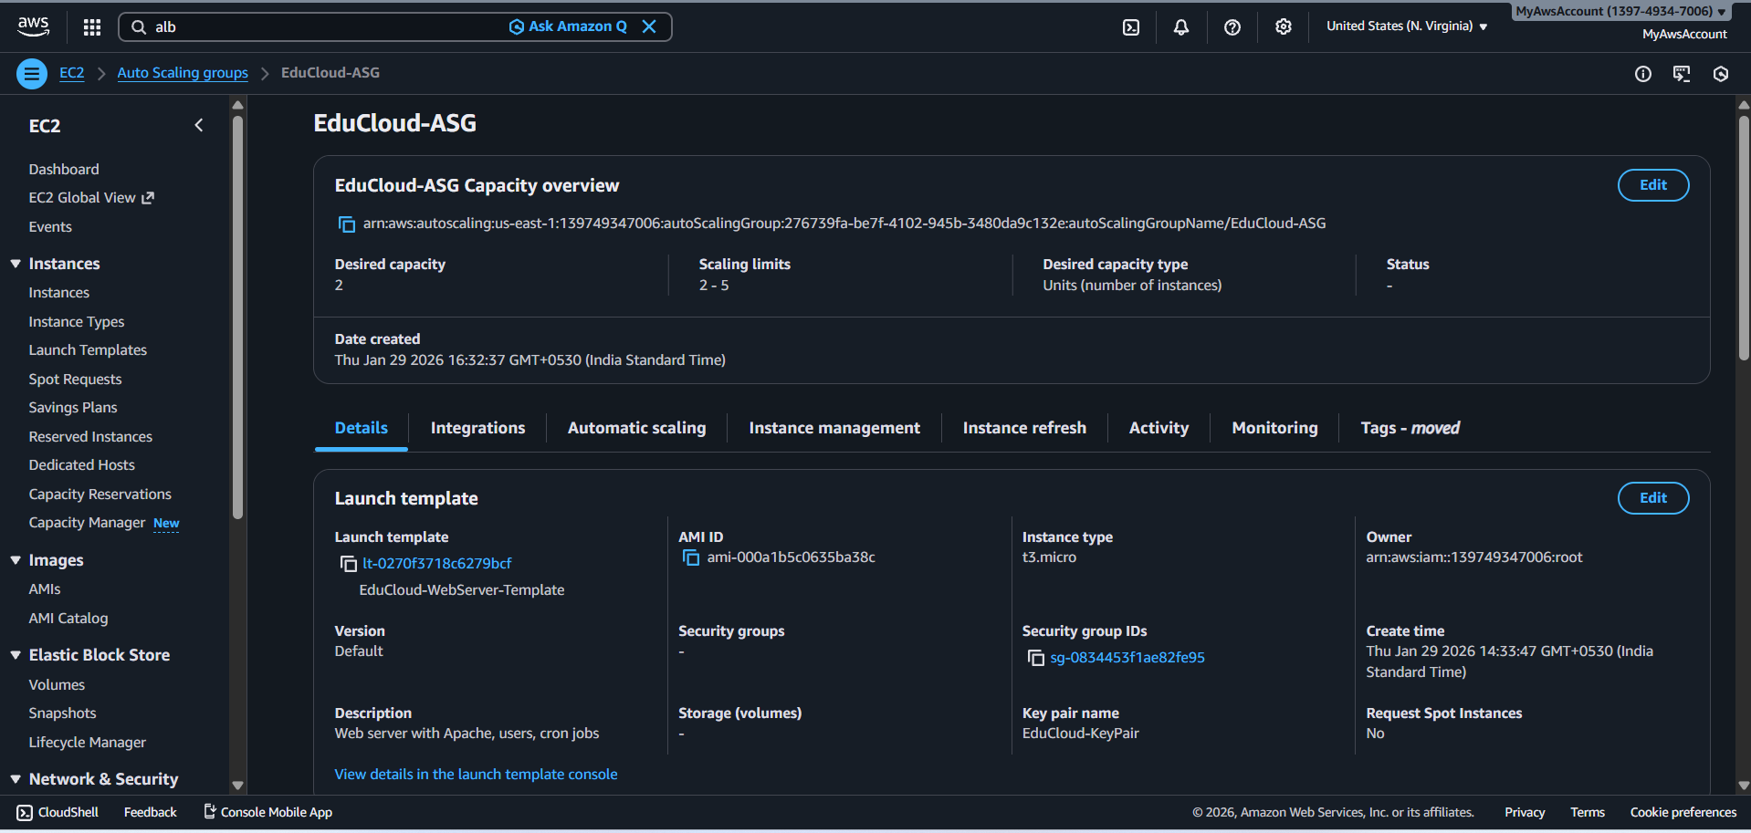

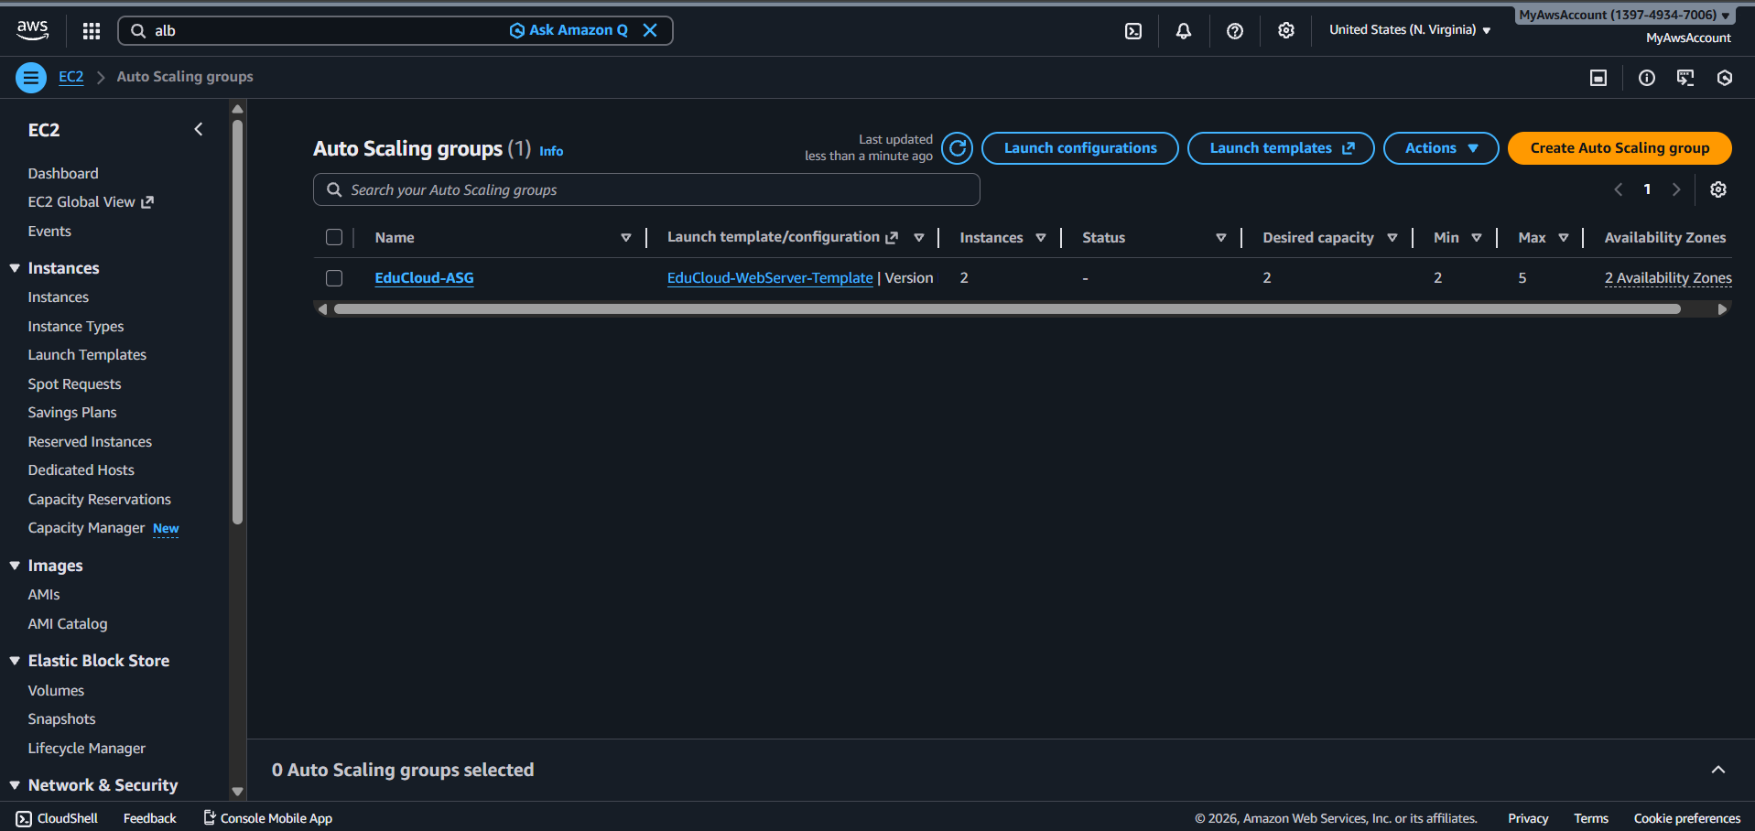

**Monitoring Instance Launch**

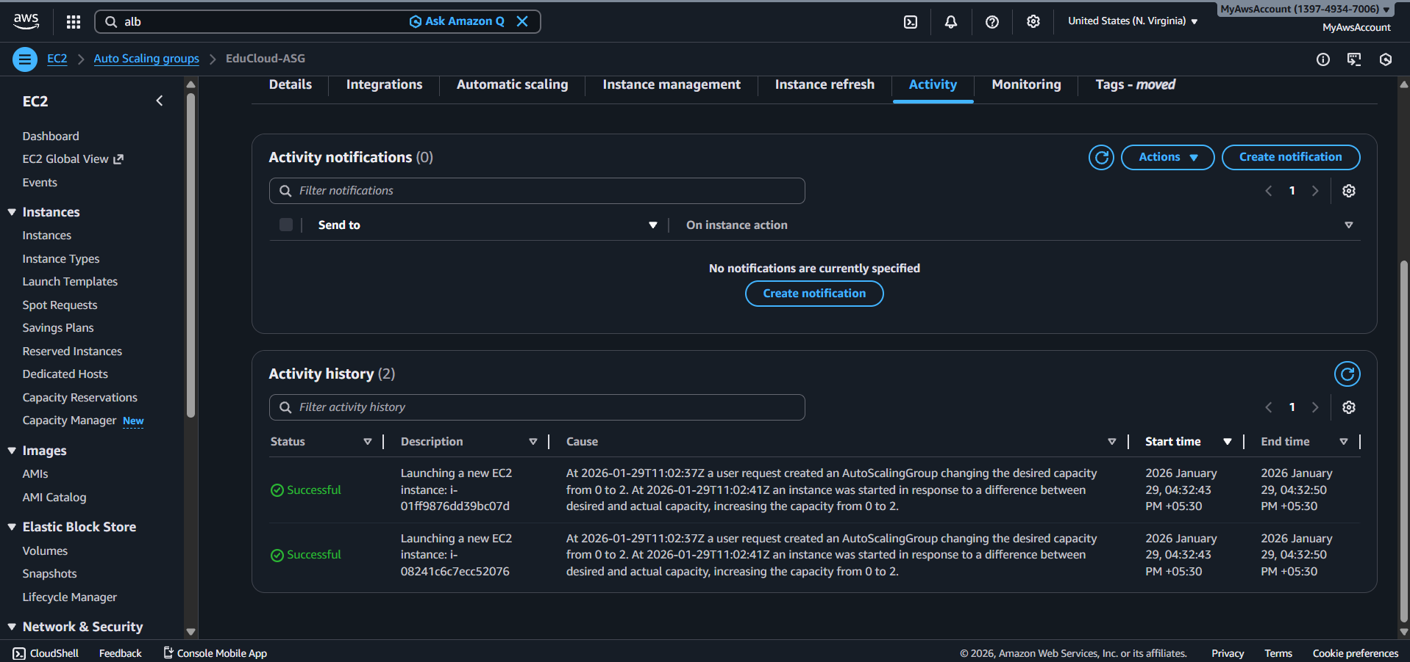

**Desired Capacity of 2**

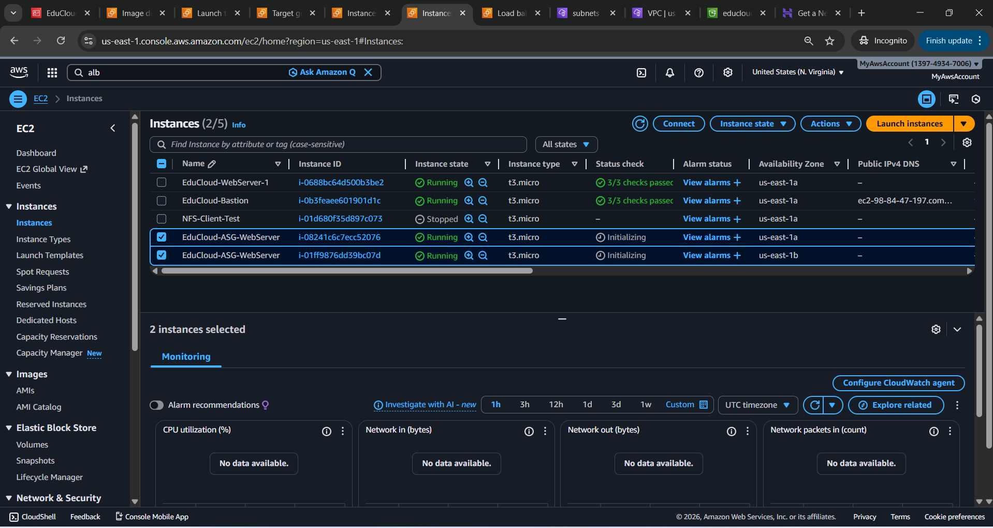

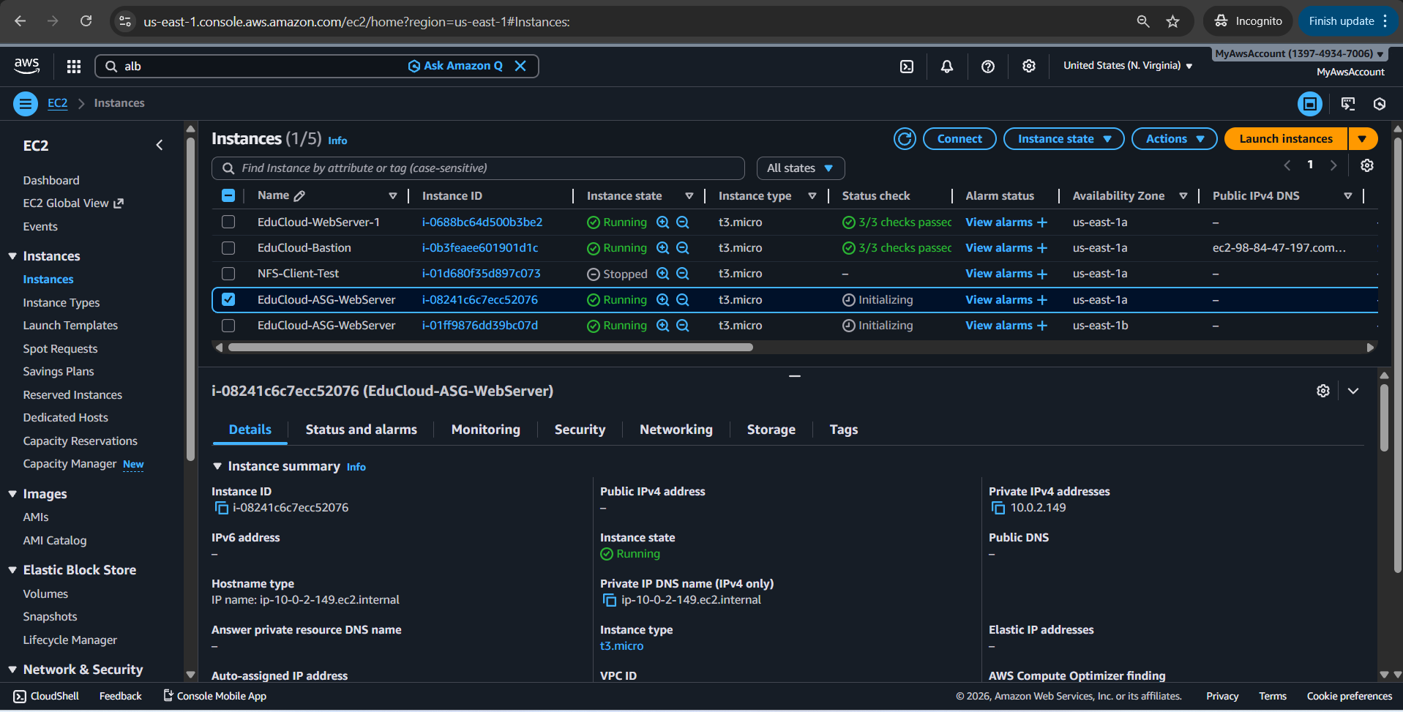

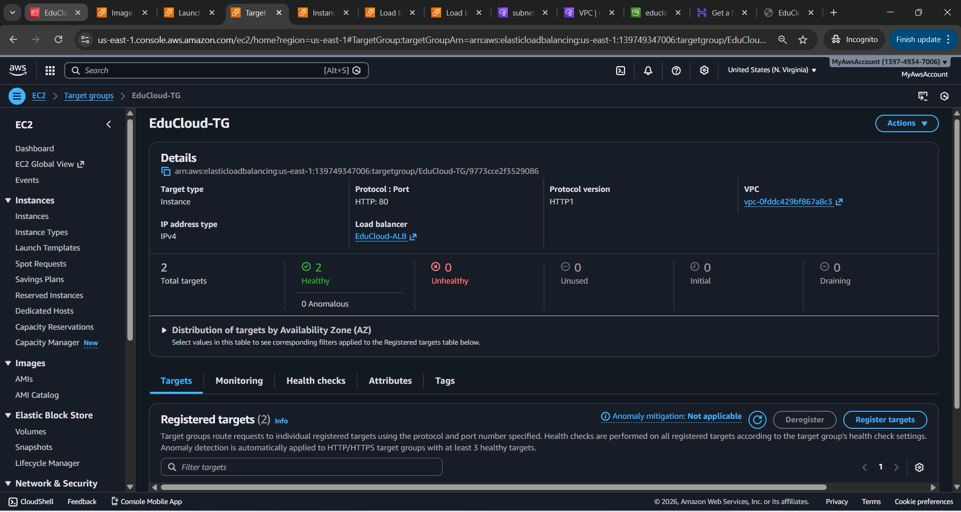

Educloud Trainer Portal live Created from the Golden image From Educloud-Websever-1

Inherited successfully, instances only allow traffic from ALB

**http://educloud-alb-1947718251.us-east-1.elb.amazonaws.com/**

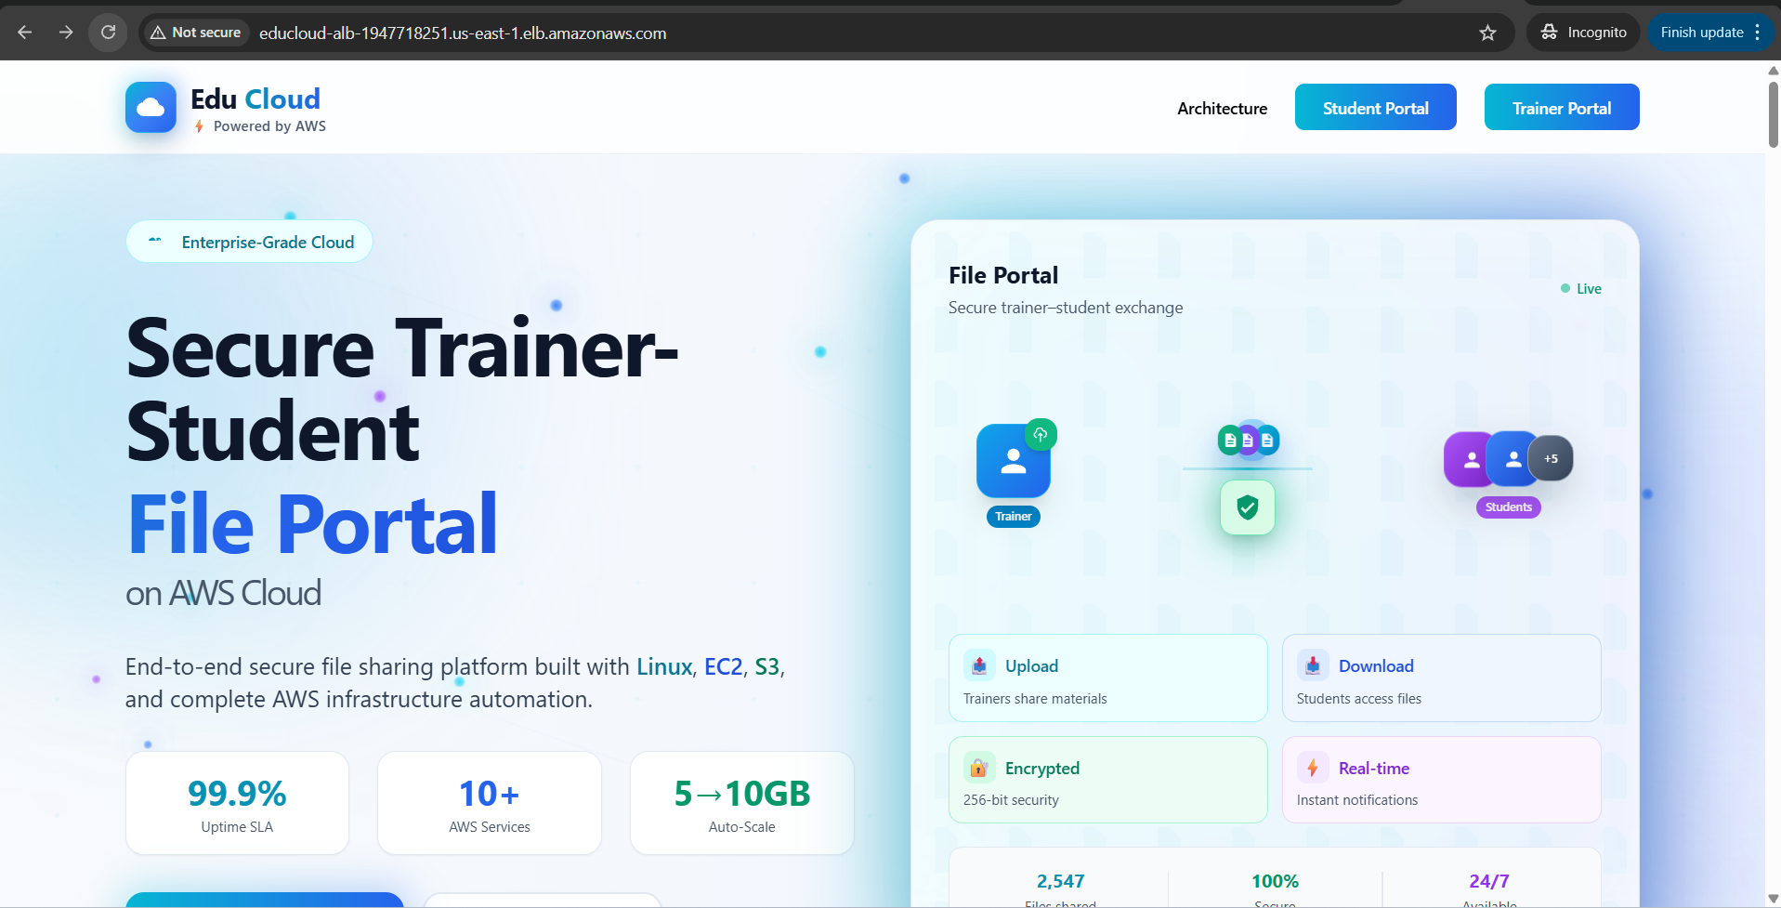

**Student Portal**

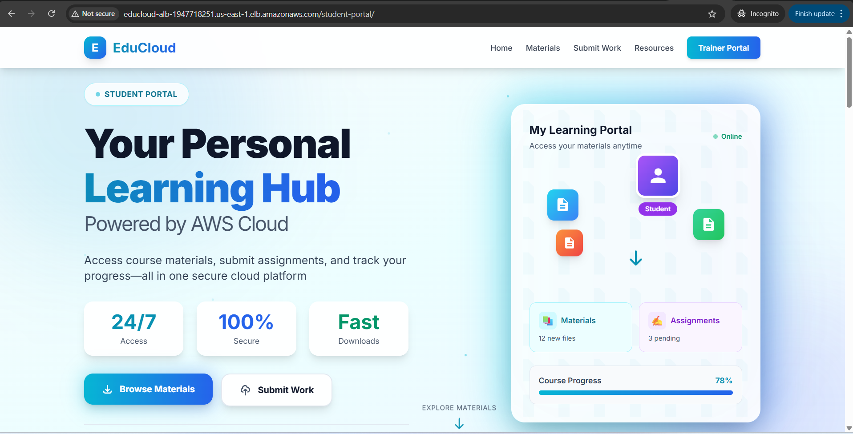

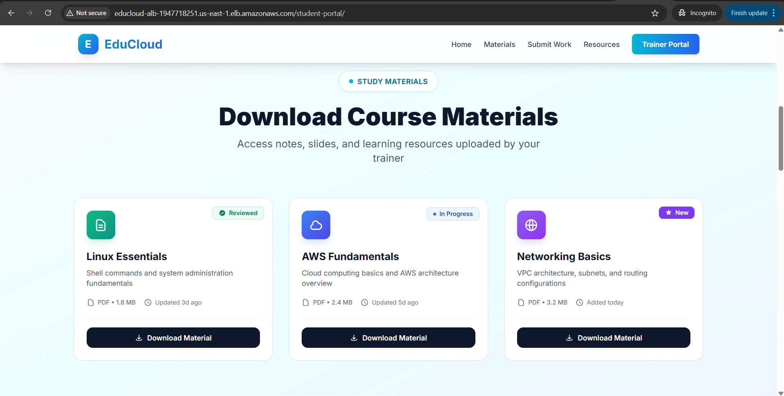

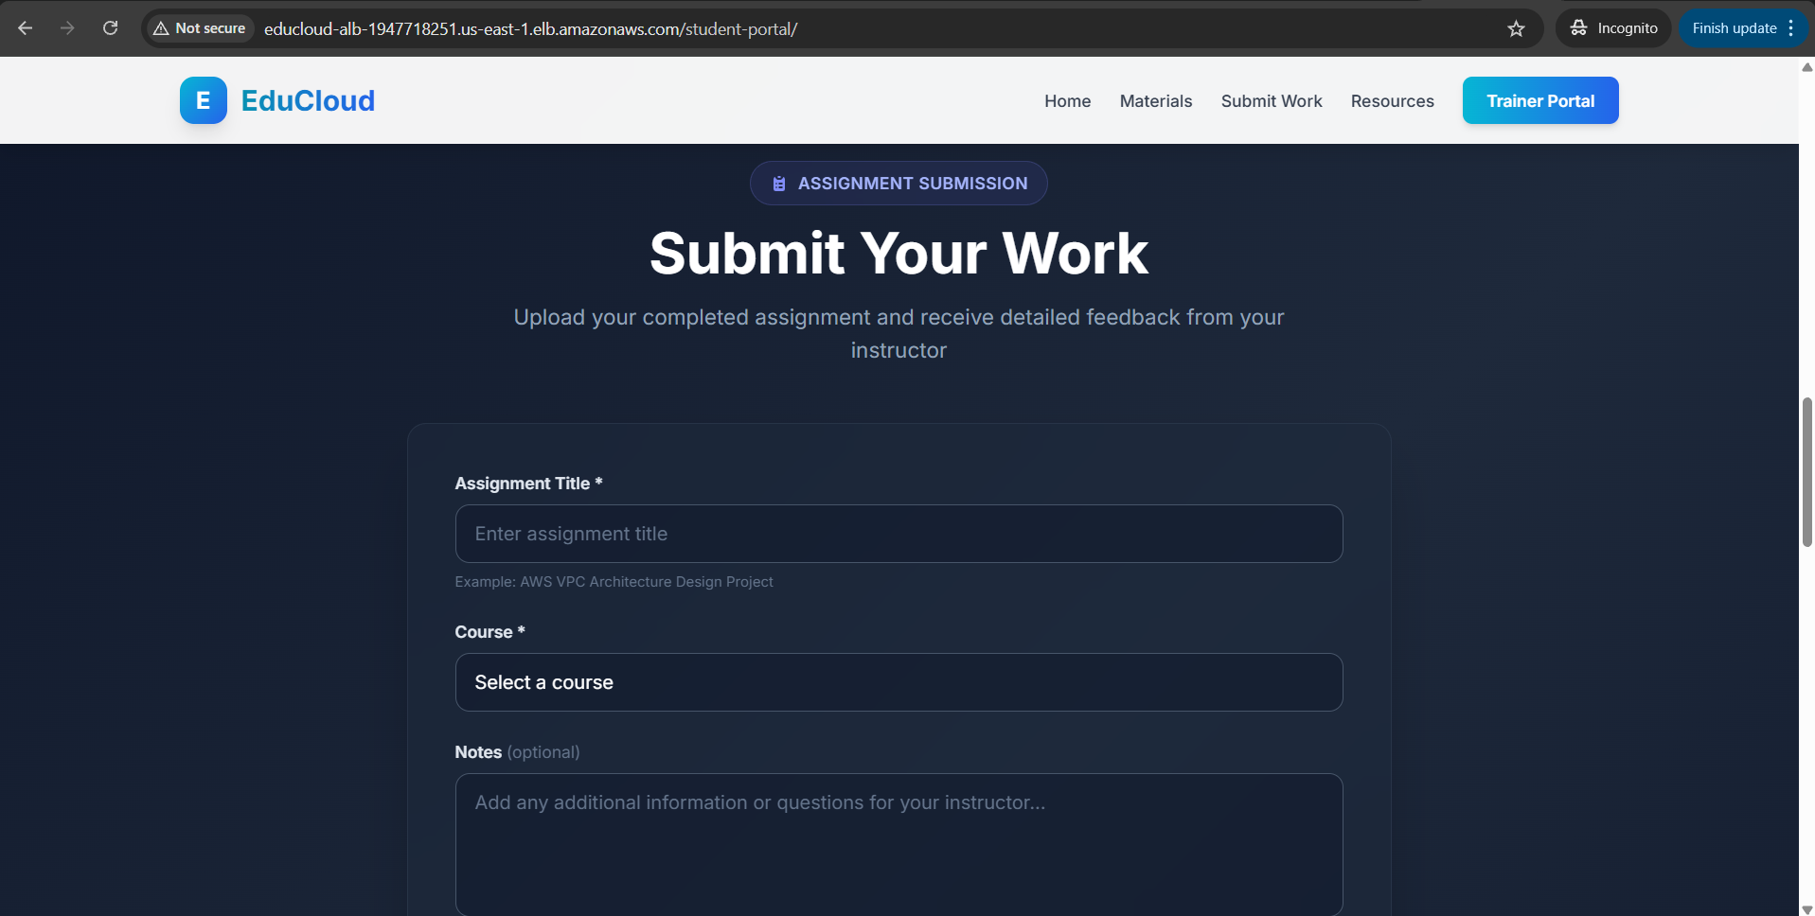

**Load Testing & Auto Scaling Verification desired capacity 2**

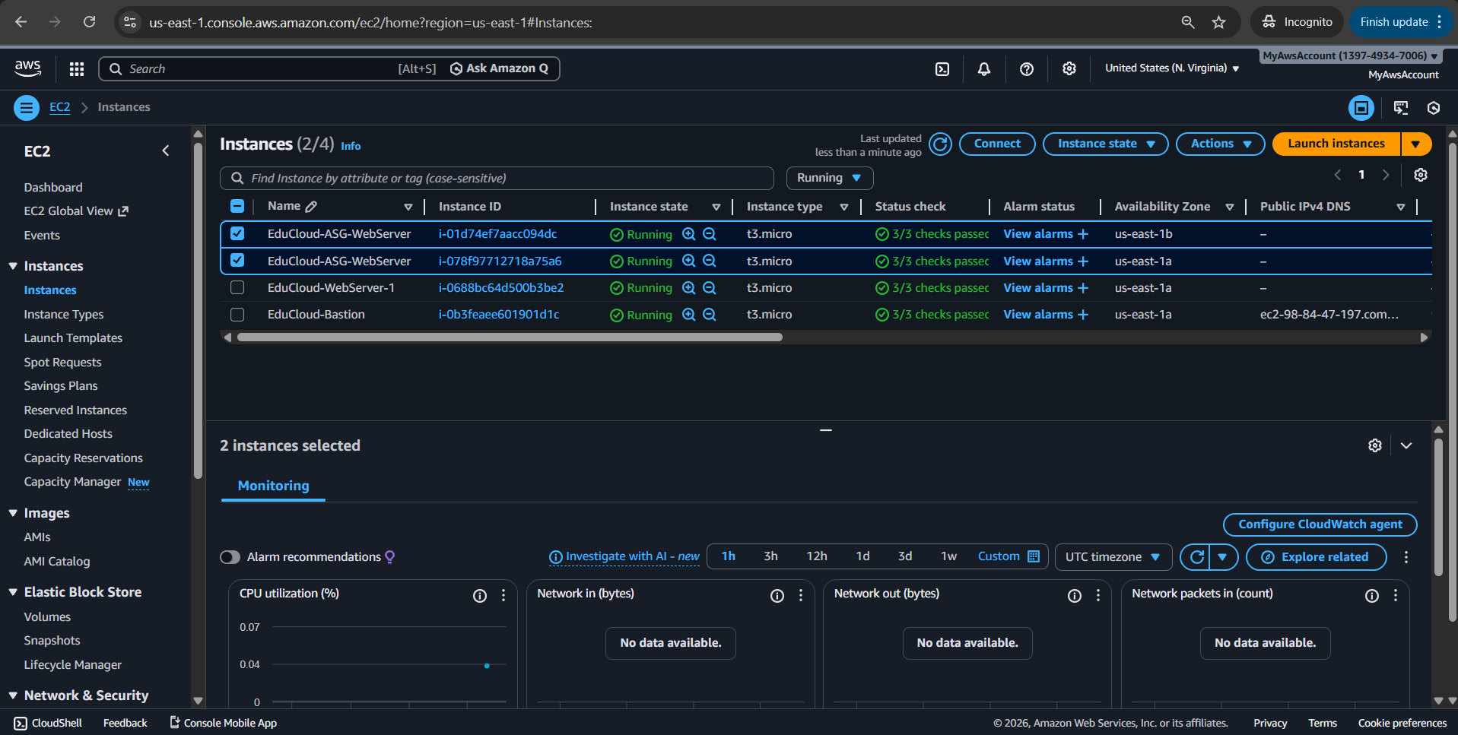

**http access logs**

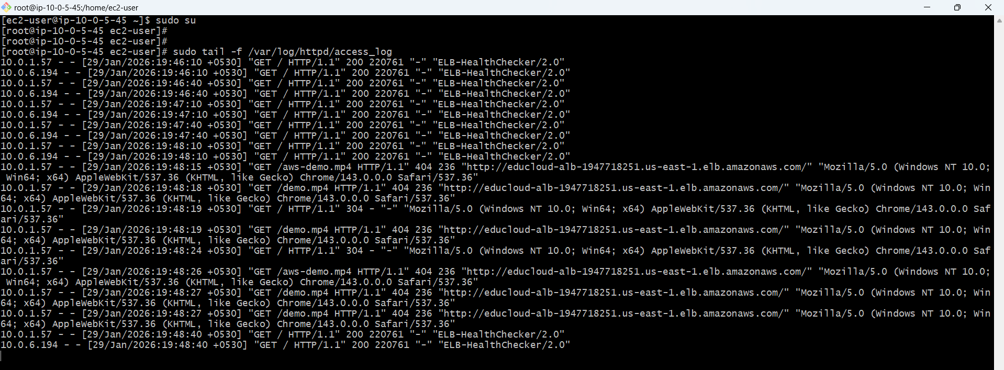

**Triggering Auto Scaling (Scale Out)**

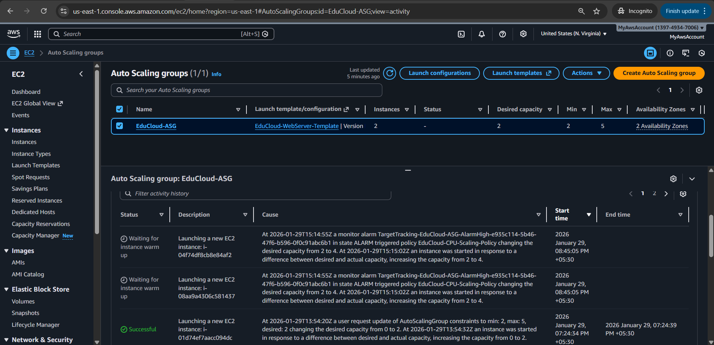

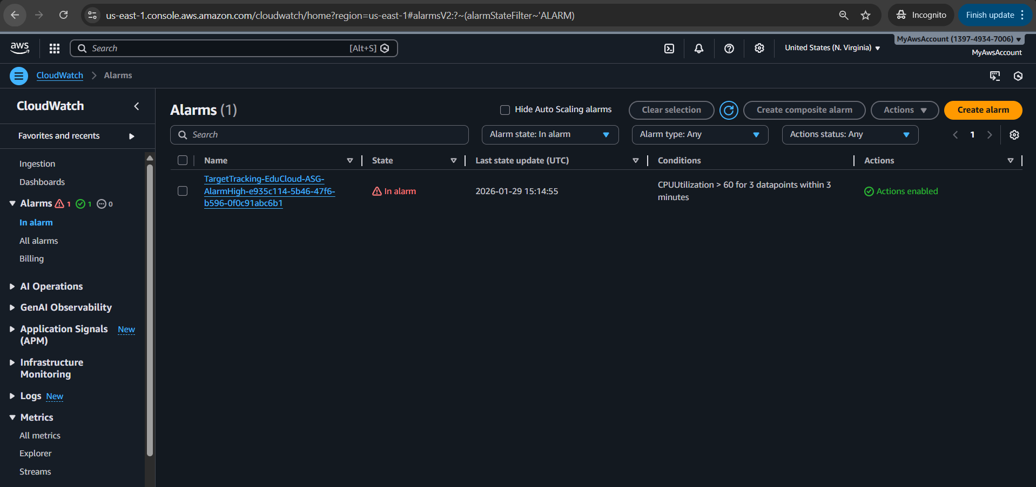

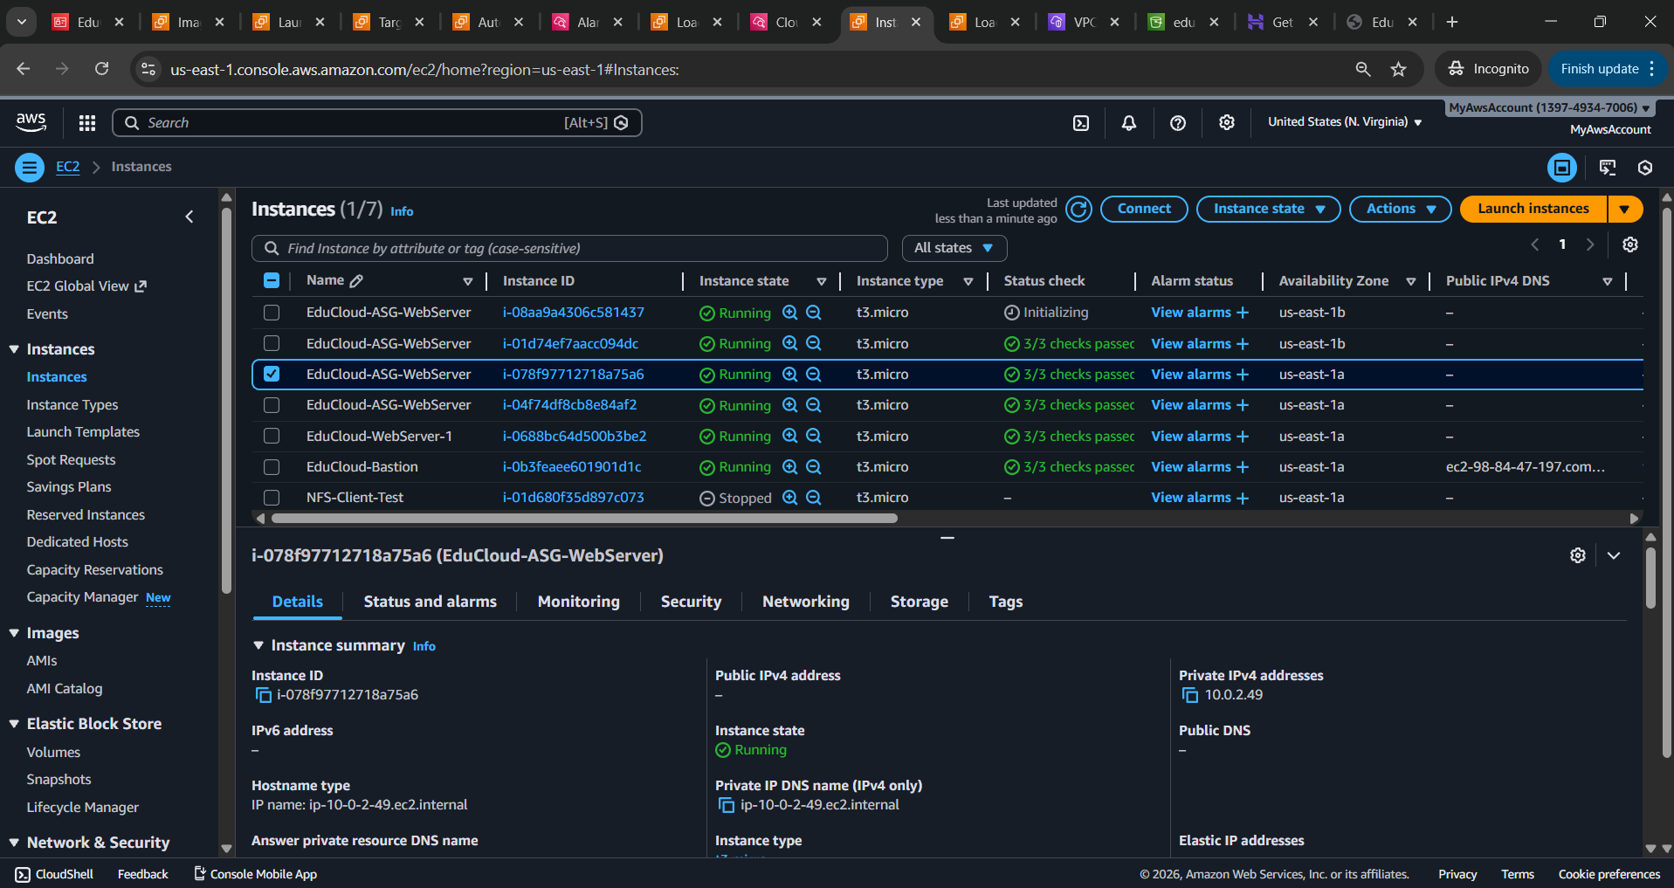

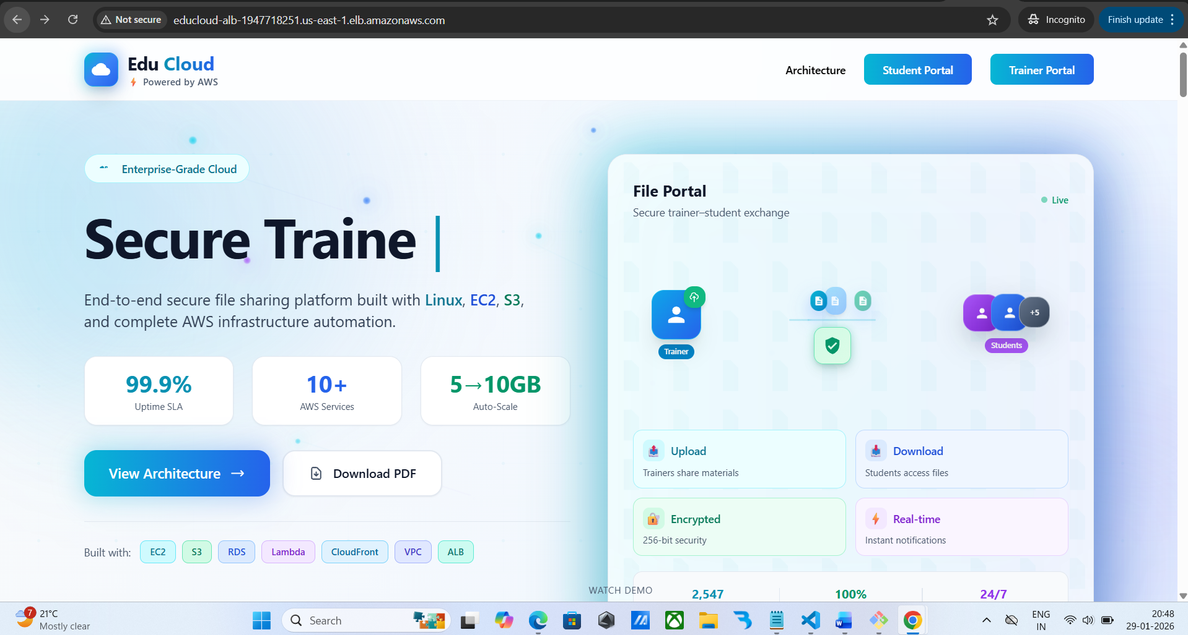

**Cloud watch monitoring**

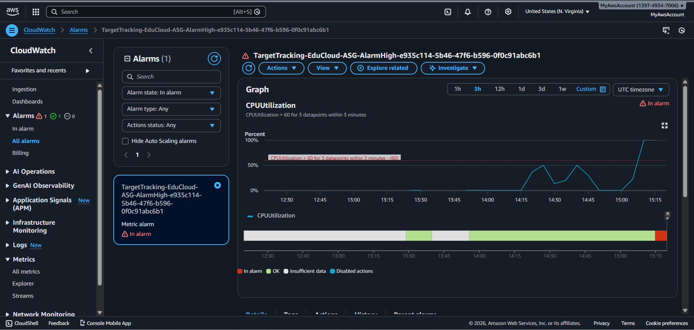

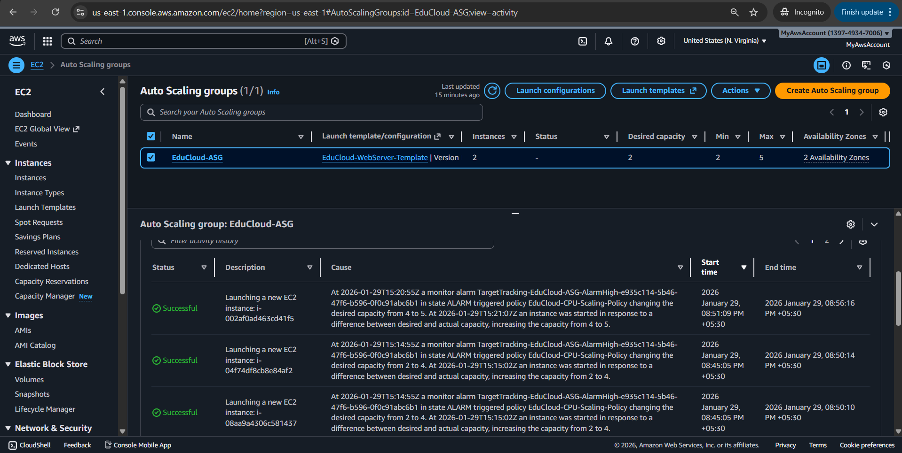

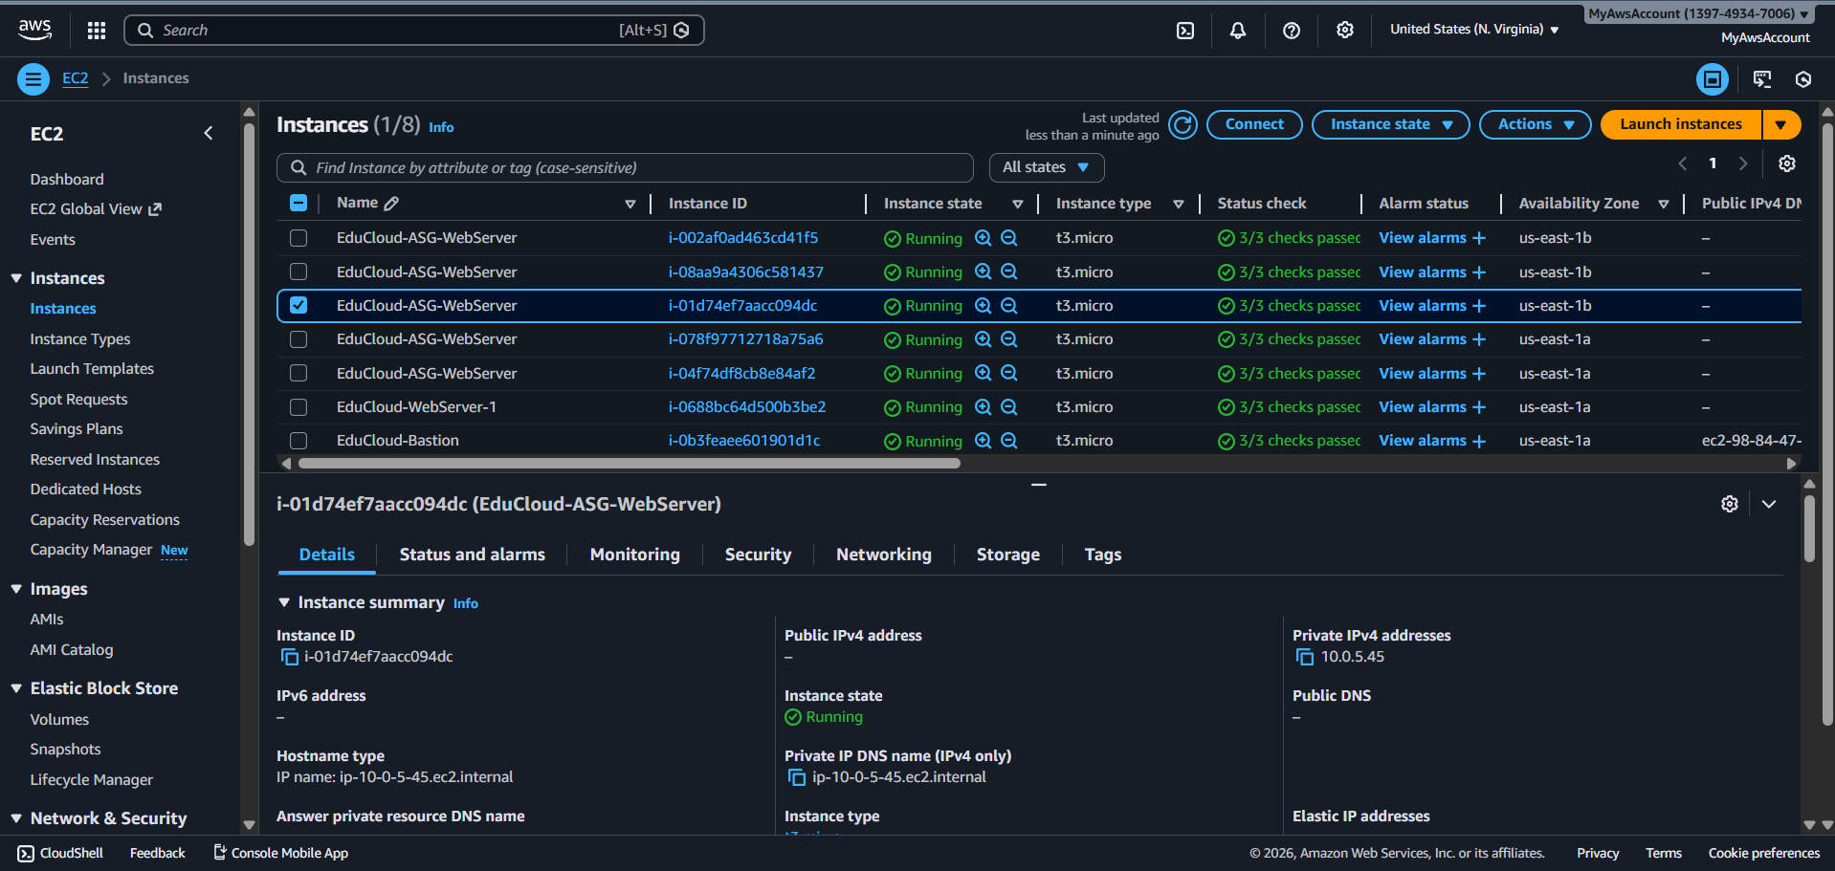

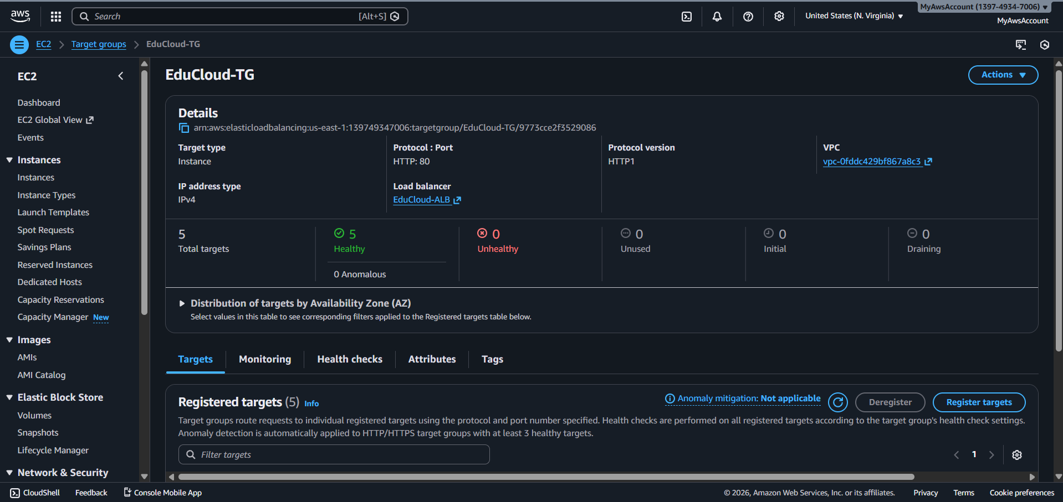

**Reducing (scale in)**

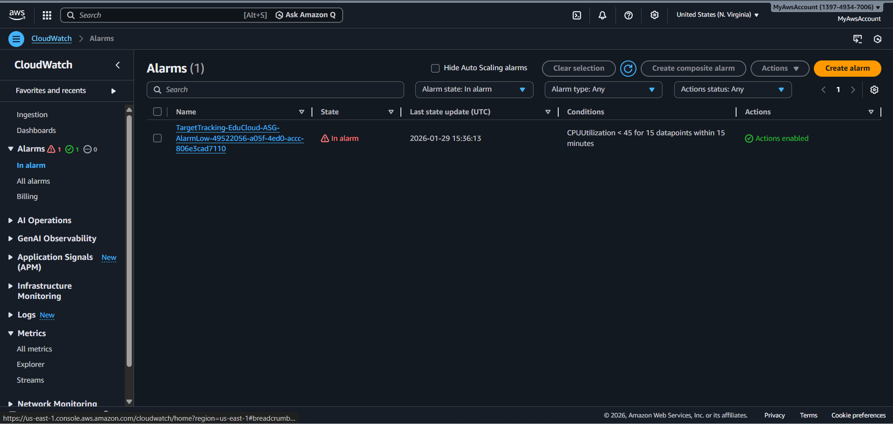

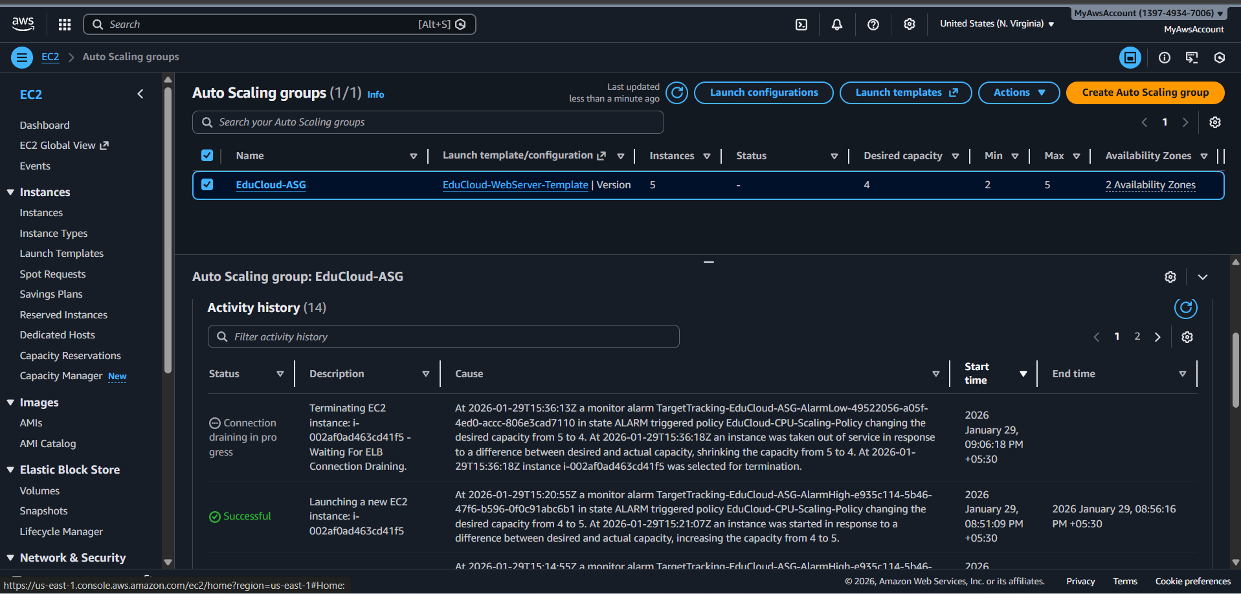

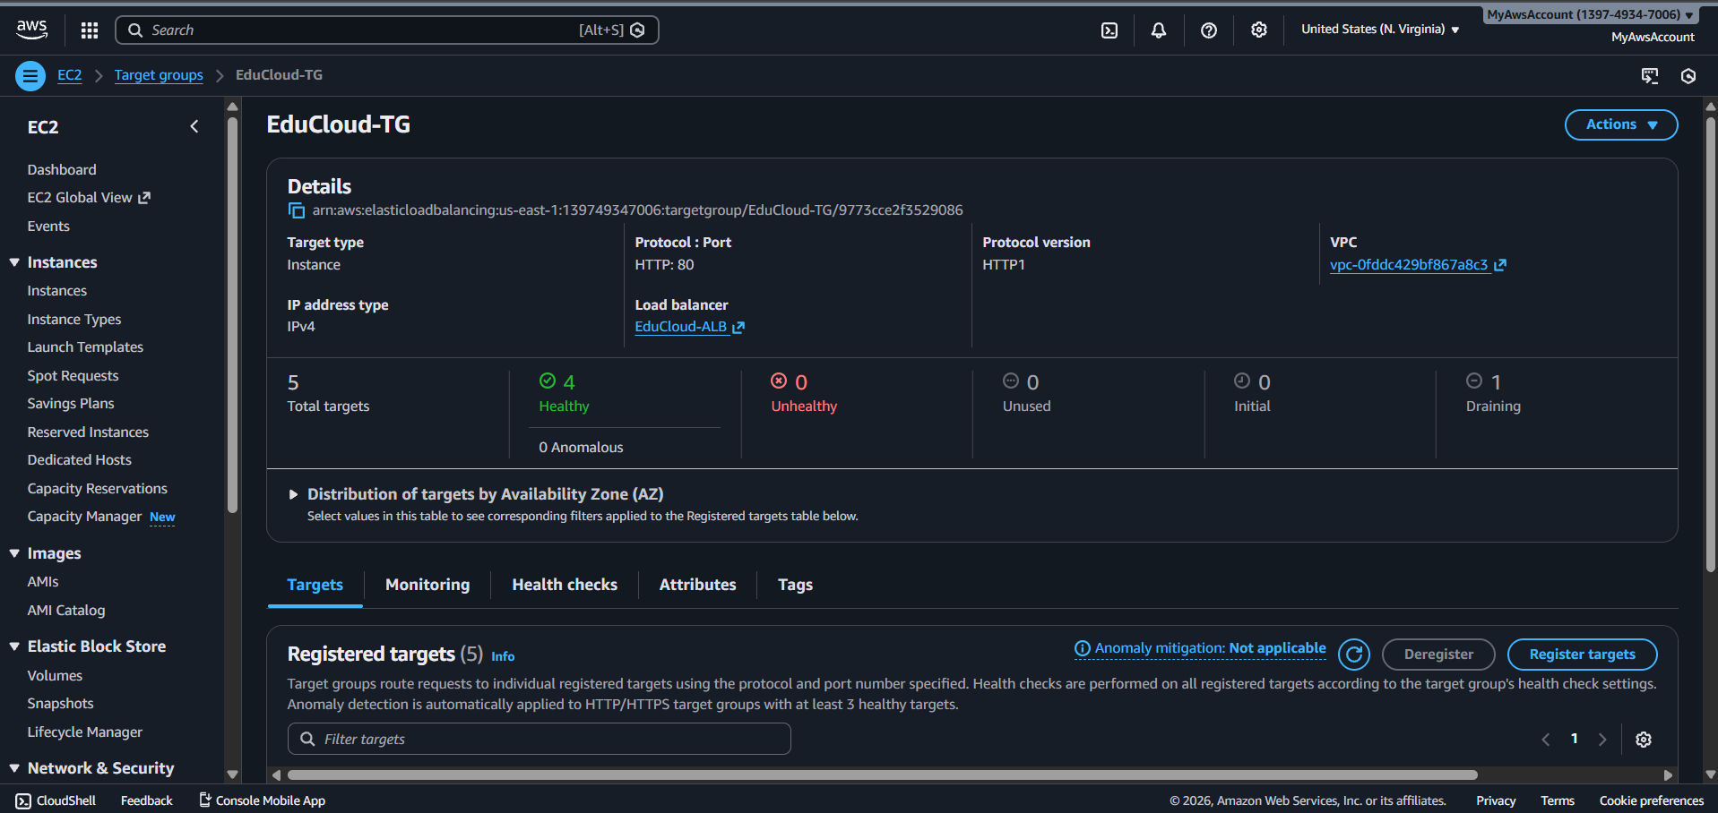

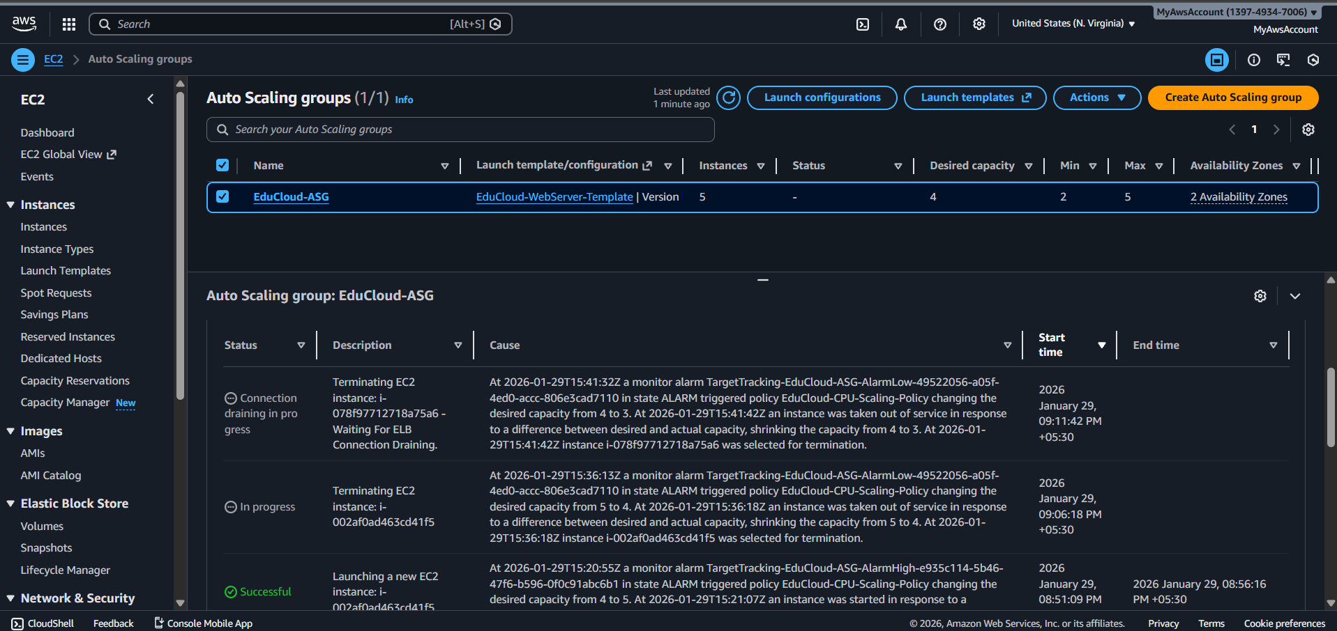

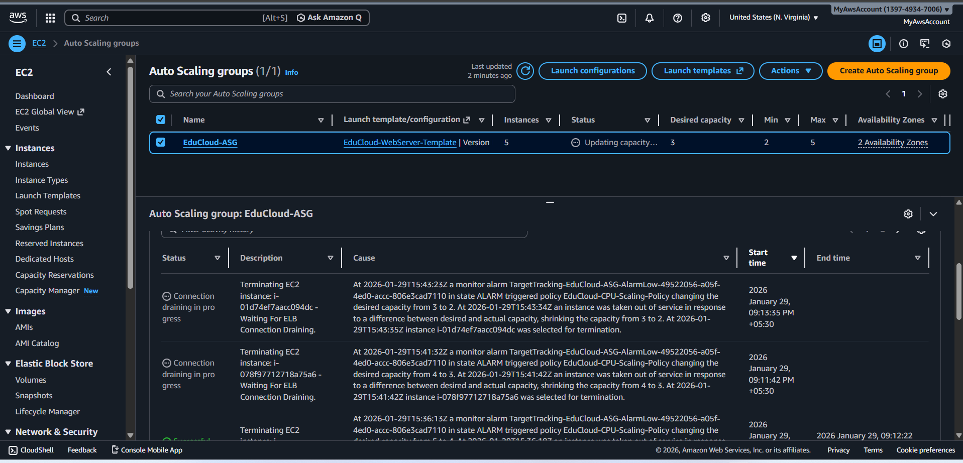

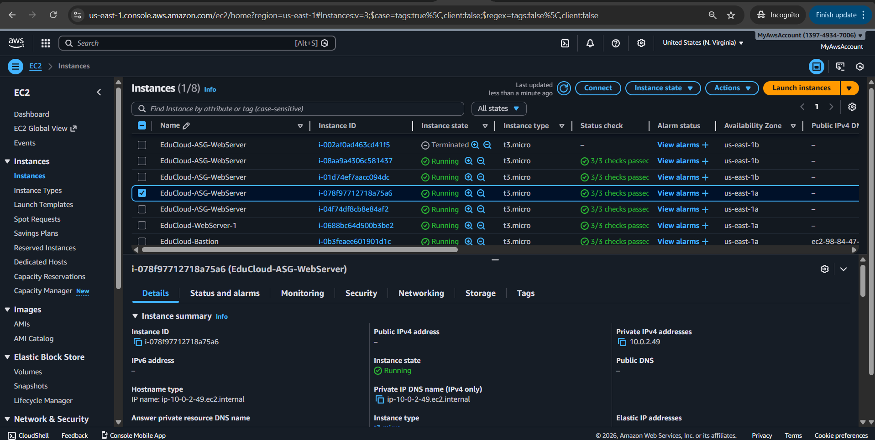

**Load balanced to 2 desired**

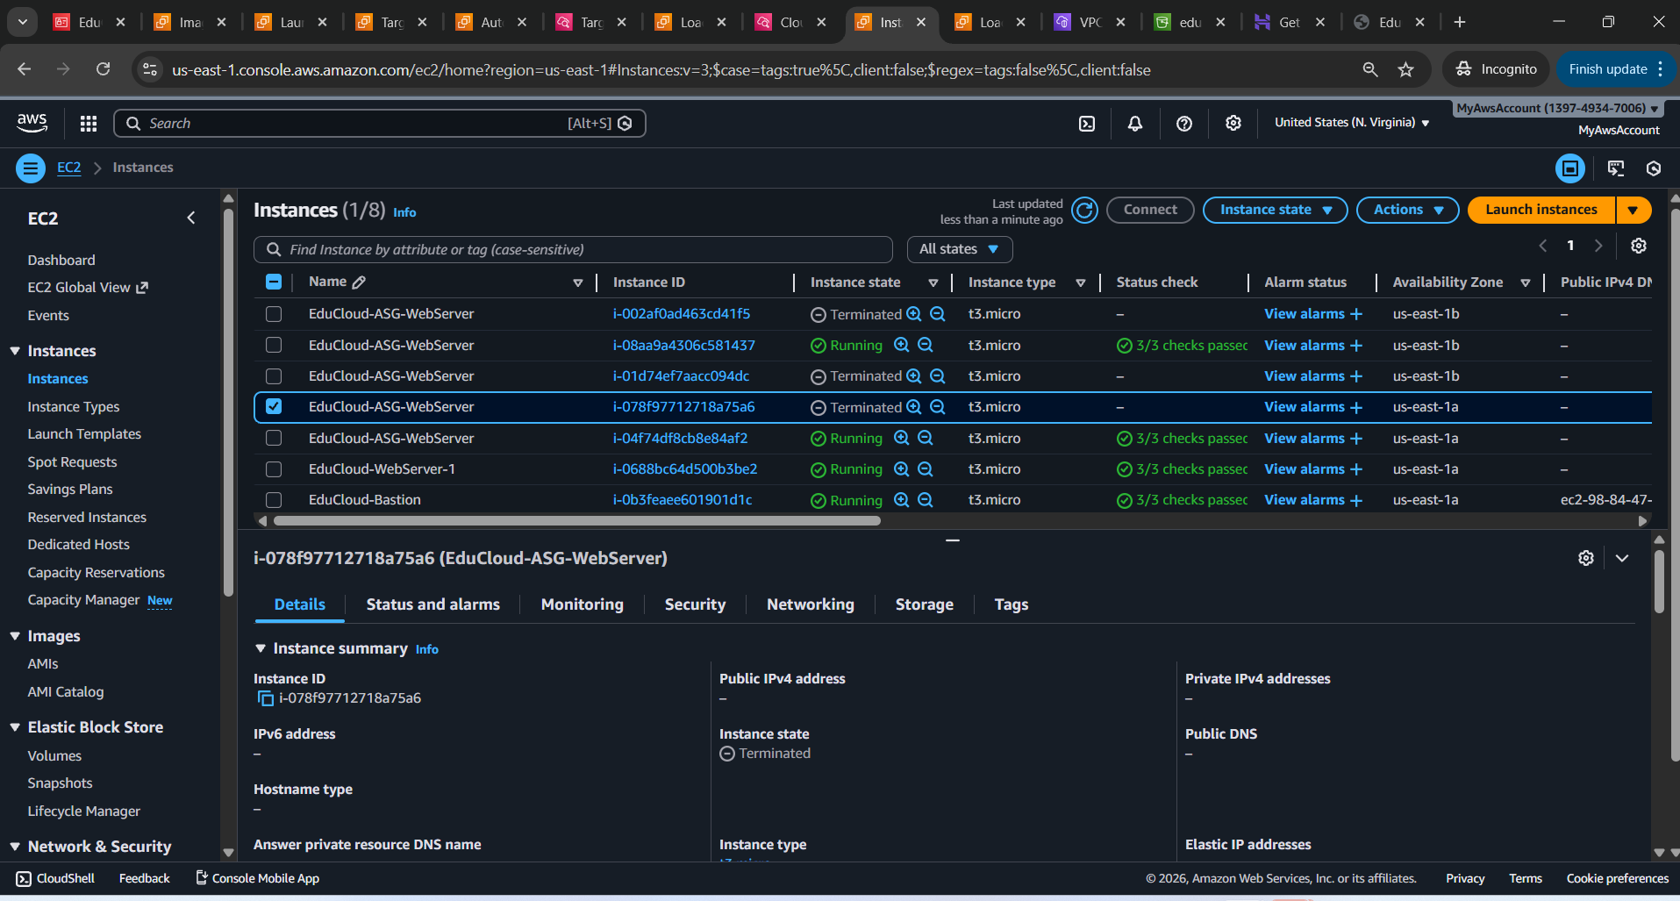

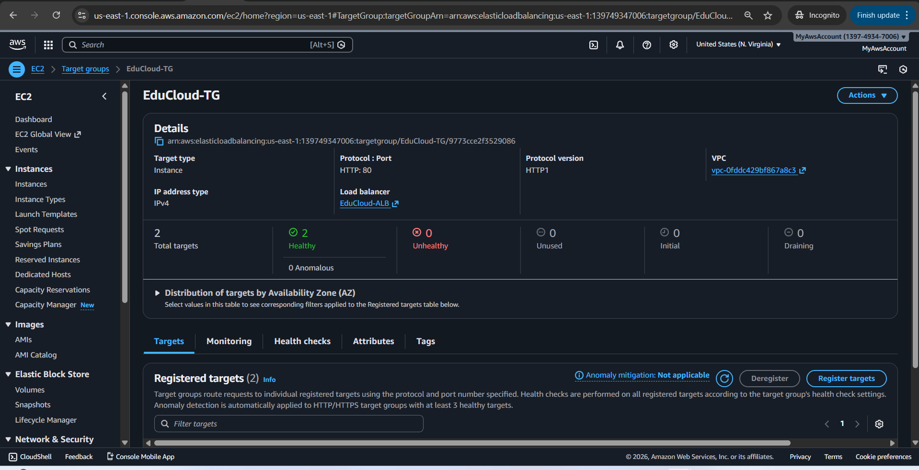

At 2026-01-29T15:43:23Z a monitor alarm TargetTracking-EduCloud-ASG-AlarmLow-49522056-a05f-4ed0-accc-806e3cad7110 in state ALARM triggered policy EduCloud-CPU-Scaling-Policy changing the desired capacity from 3 to 2. At 2026-01-29T15:43:34Z an instance was taken out of service in response to a difference between desired and actual capacity, shrinking the capacity from 3 to 2. At 2026-01-29T15:43:35Z instance i-01d74ef7aacc094dc was selected for termination.

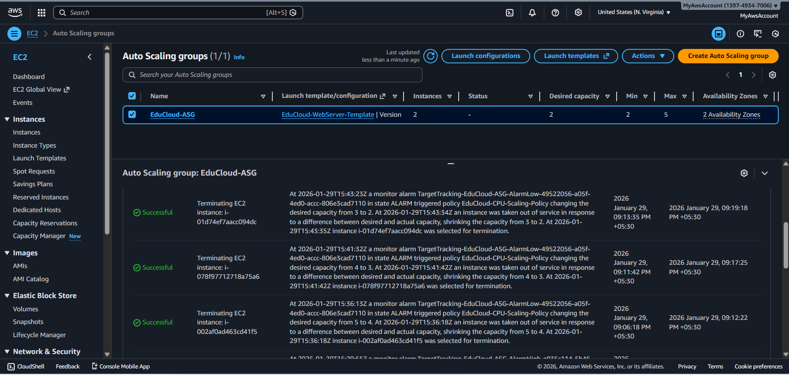

**CloudFront CDN Setup**

Created subfolder structure inside materials/

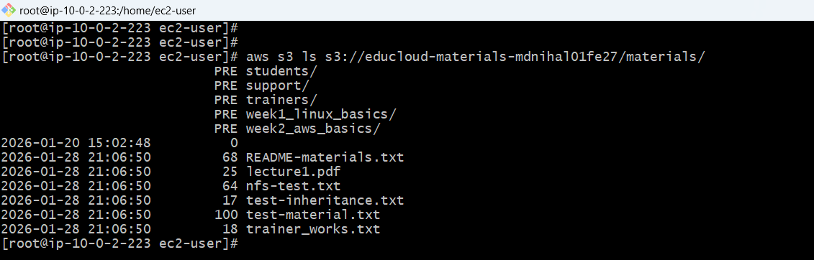

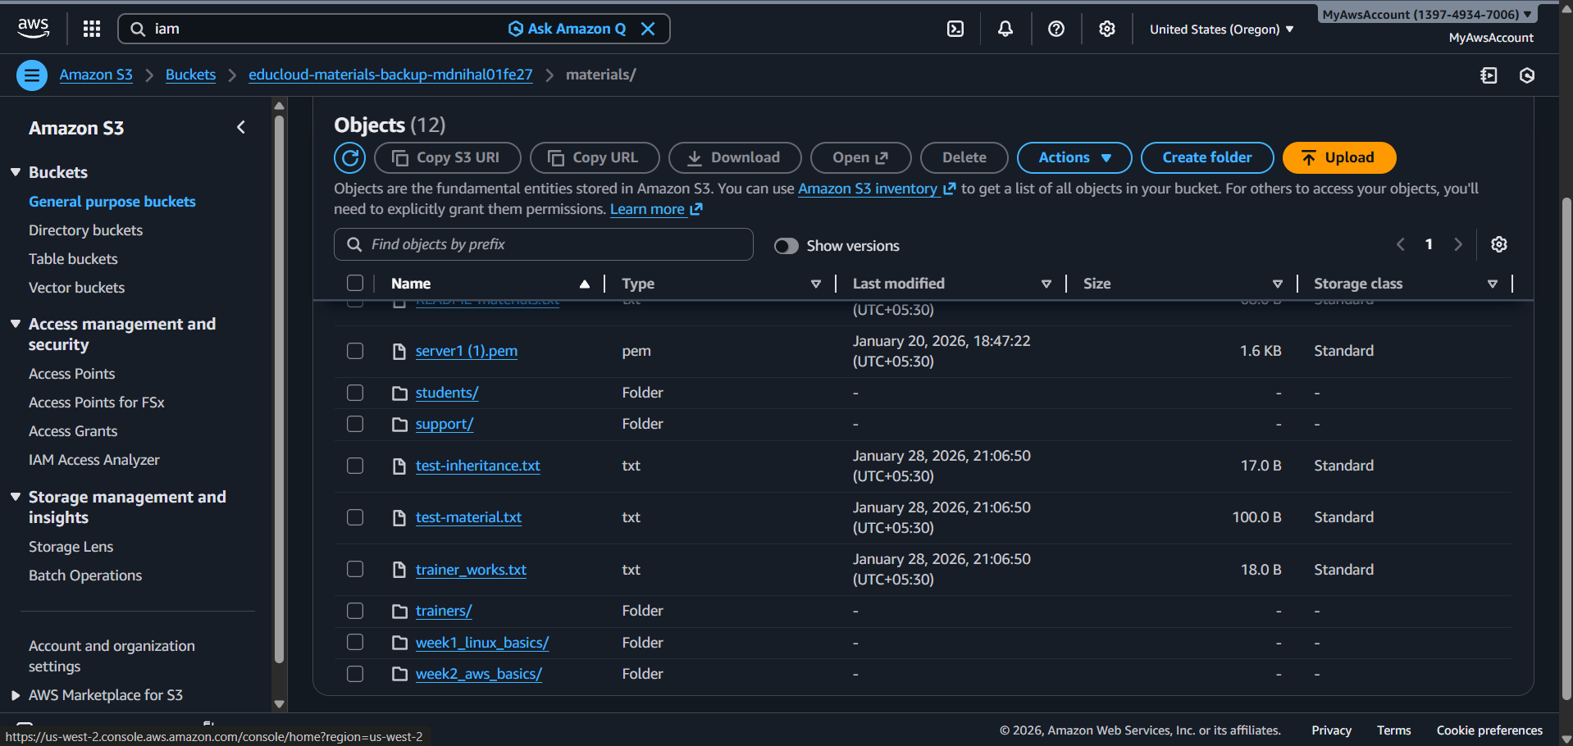

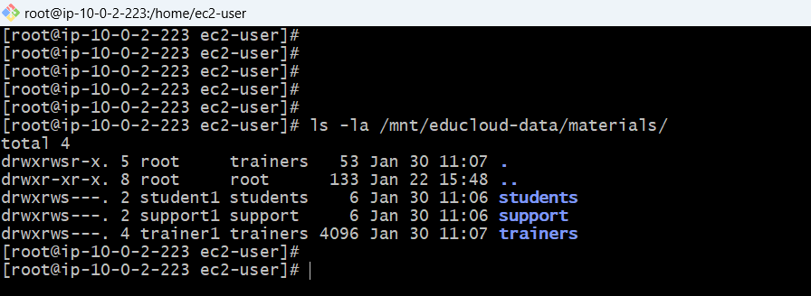

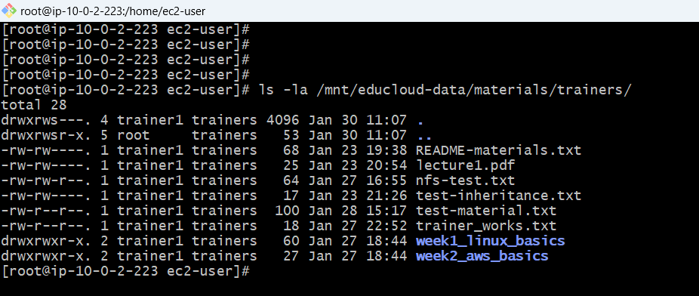

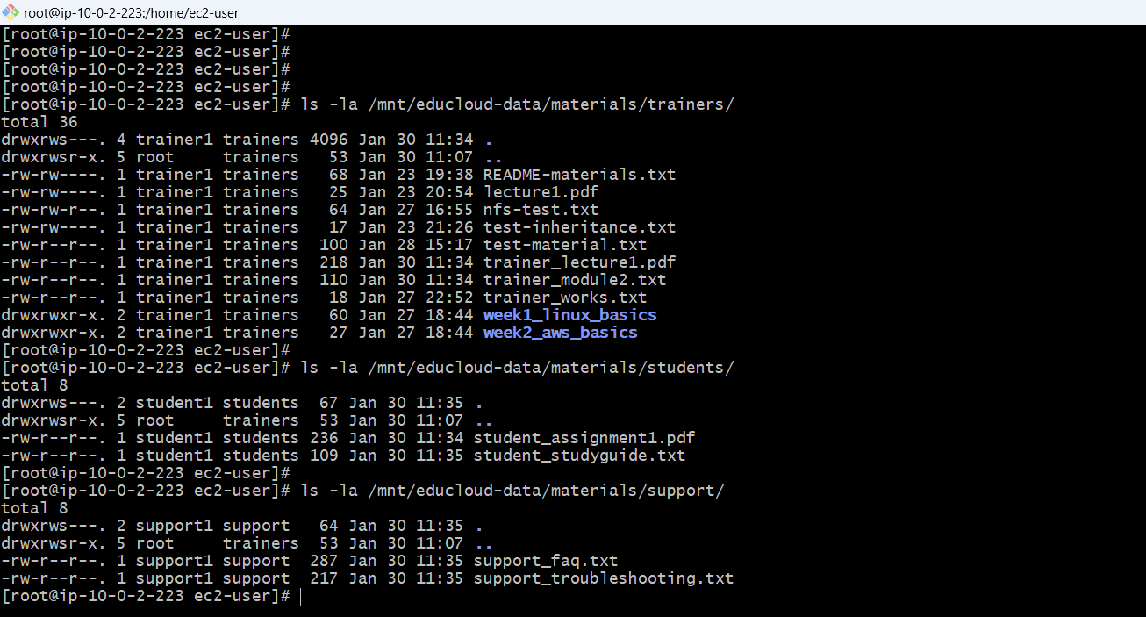

**Cron jobs to sync to s3 bucket /materials/\***

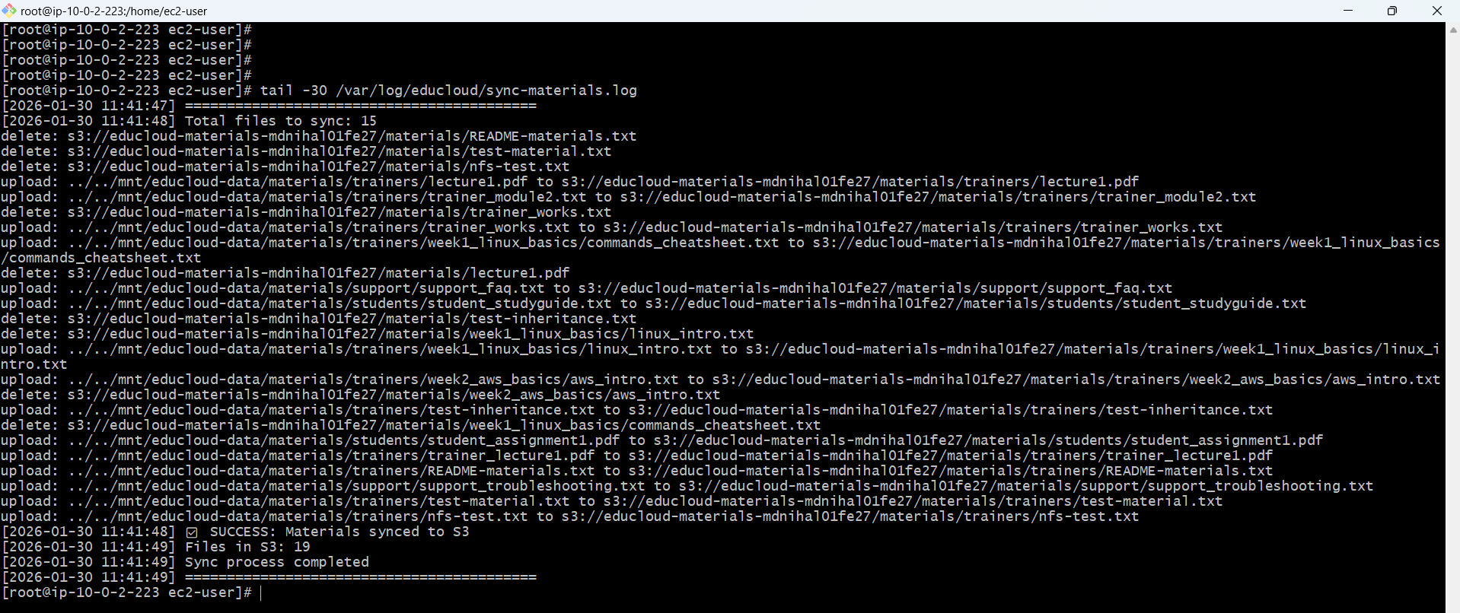

**/materials/support**

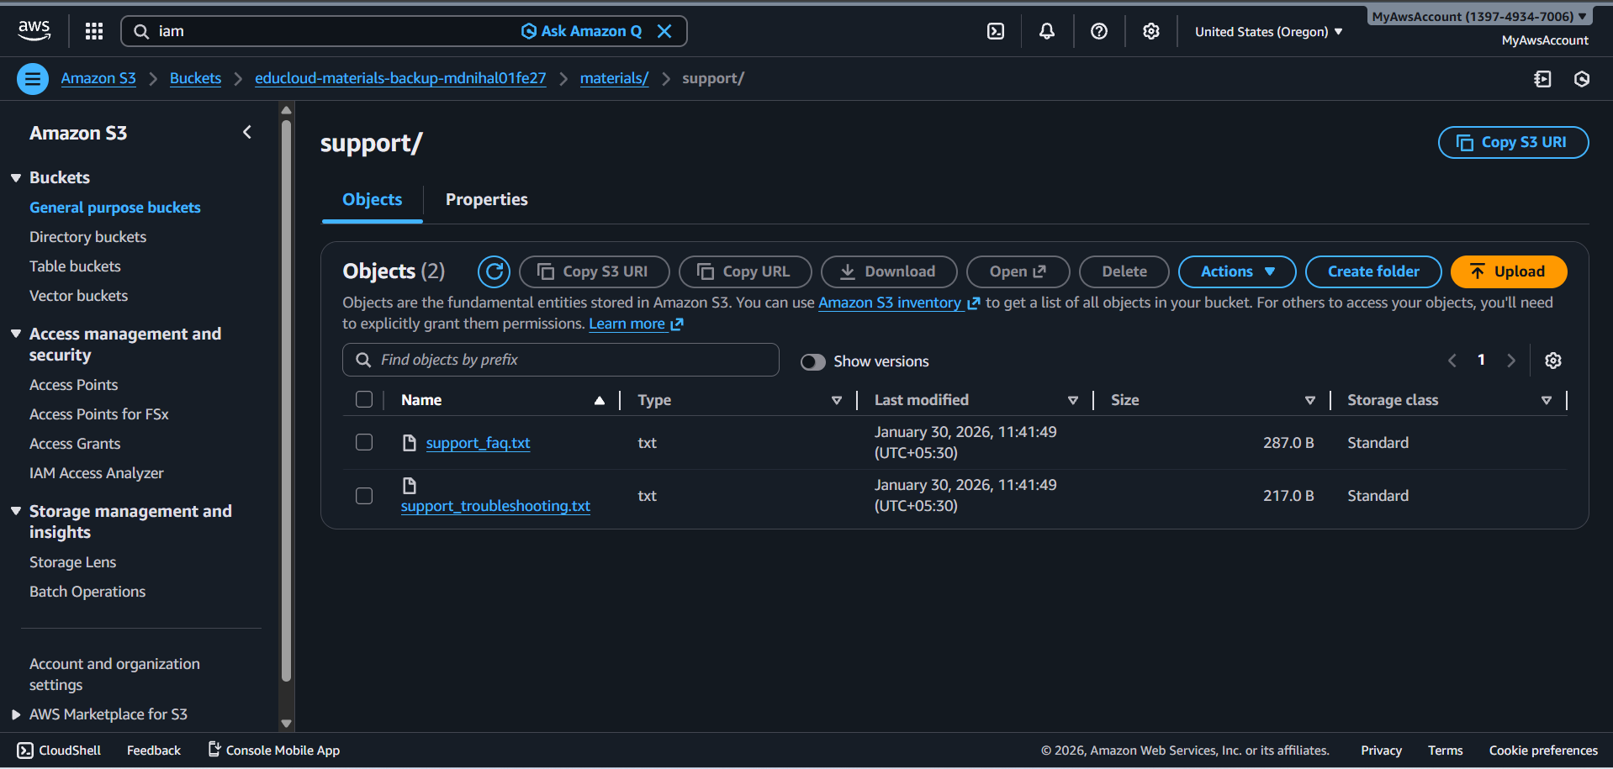

**/materials/sutednts**

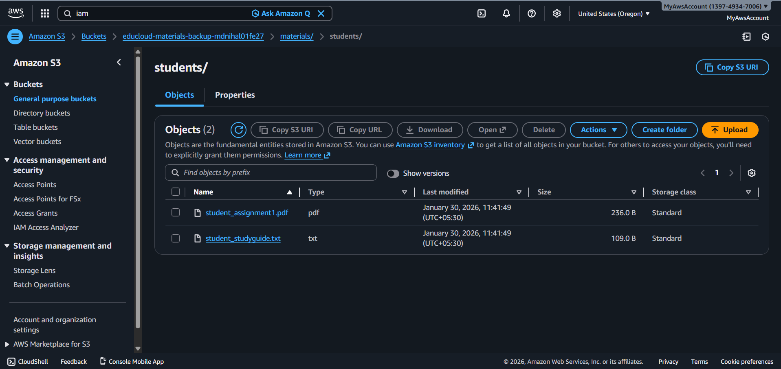

**/materials/trainers**

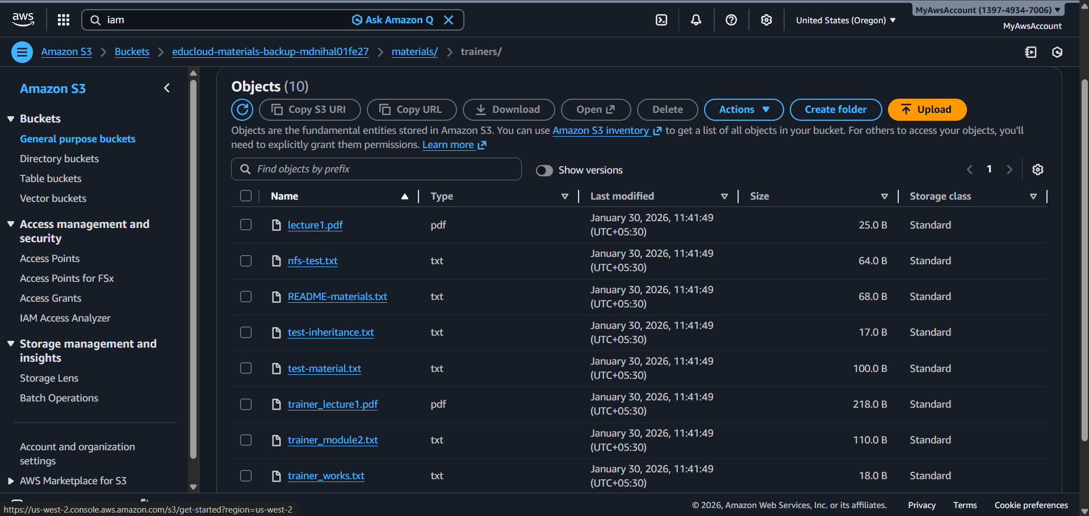

**CloudFront Distribution**

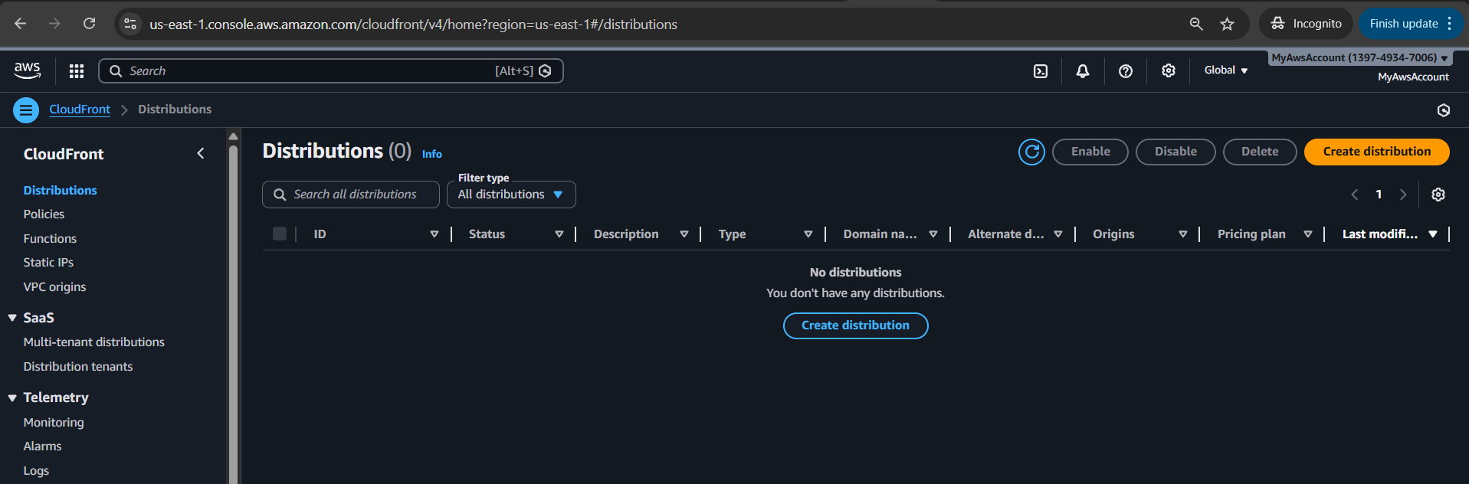

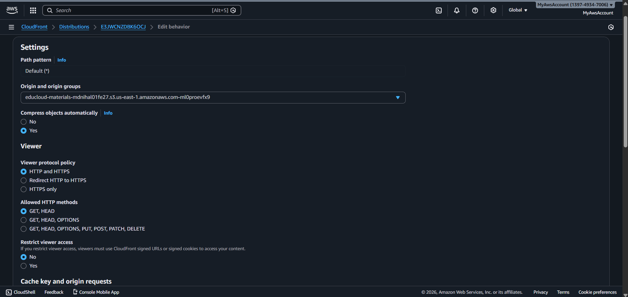

**Restrict other user should be selected yes and only be accessed by the signed url for that need keey groups for key groups need public key for public key need Generate 2048-bit RSA private key this and Generate public key from private key this need to be created**

**Steps**

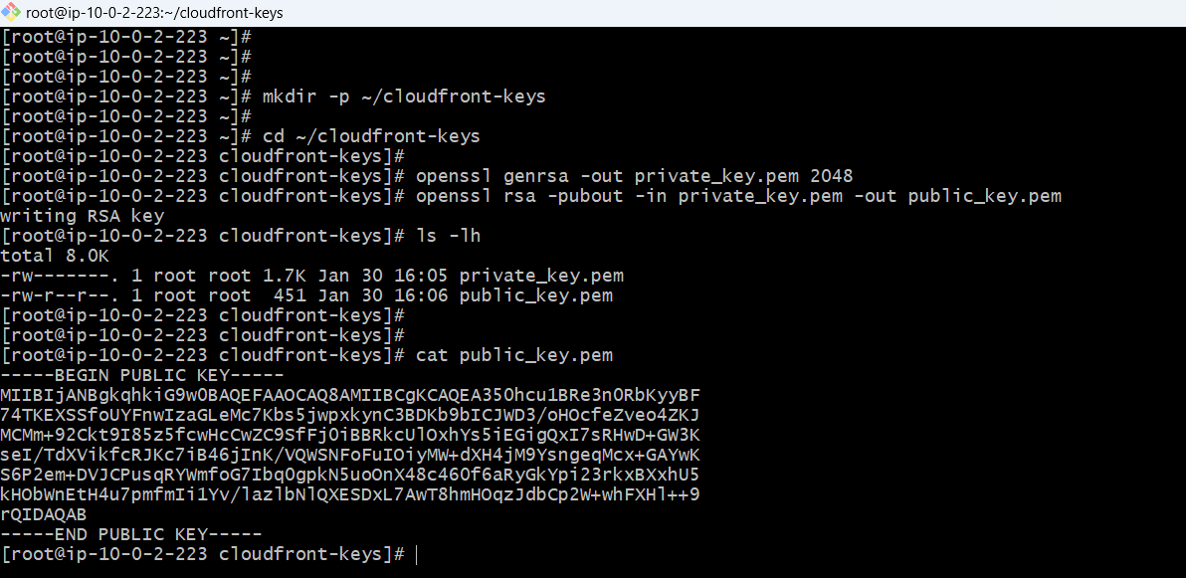

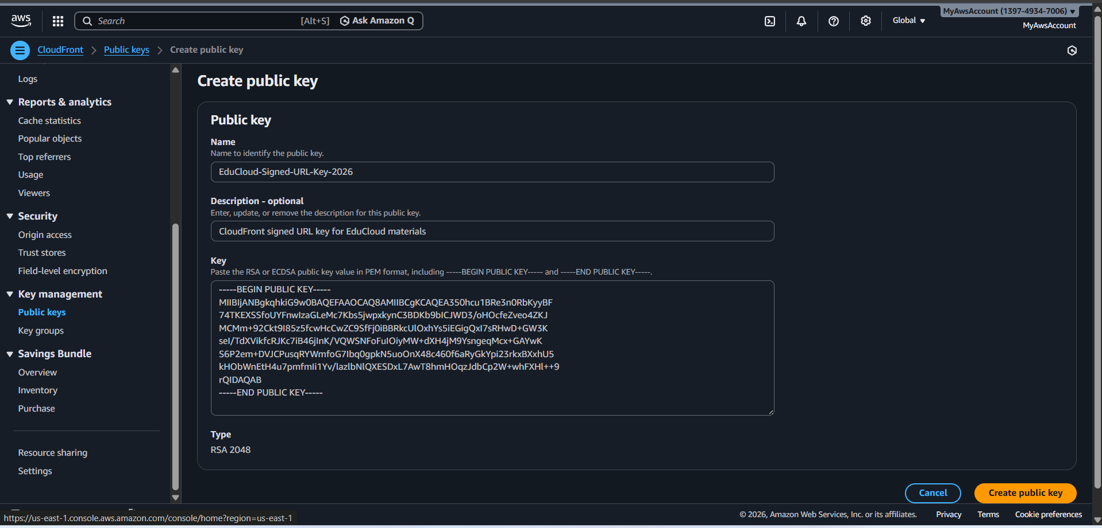

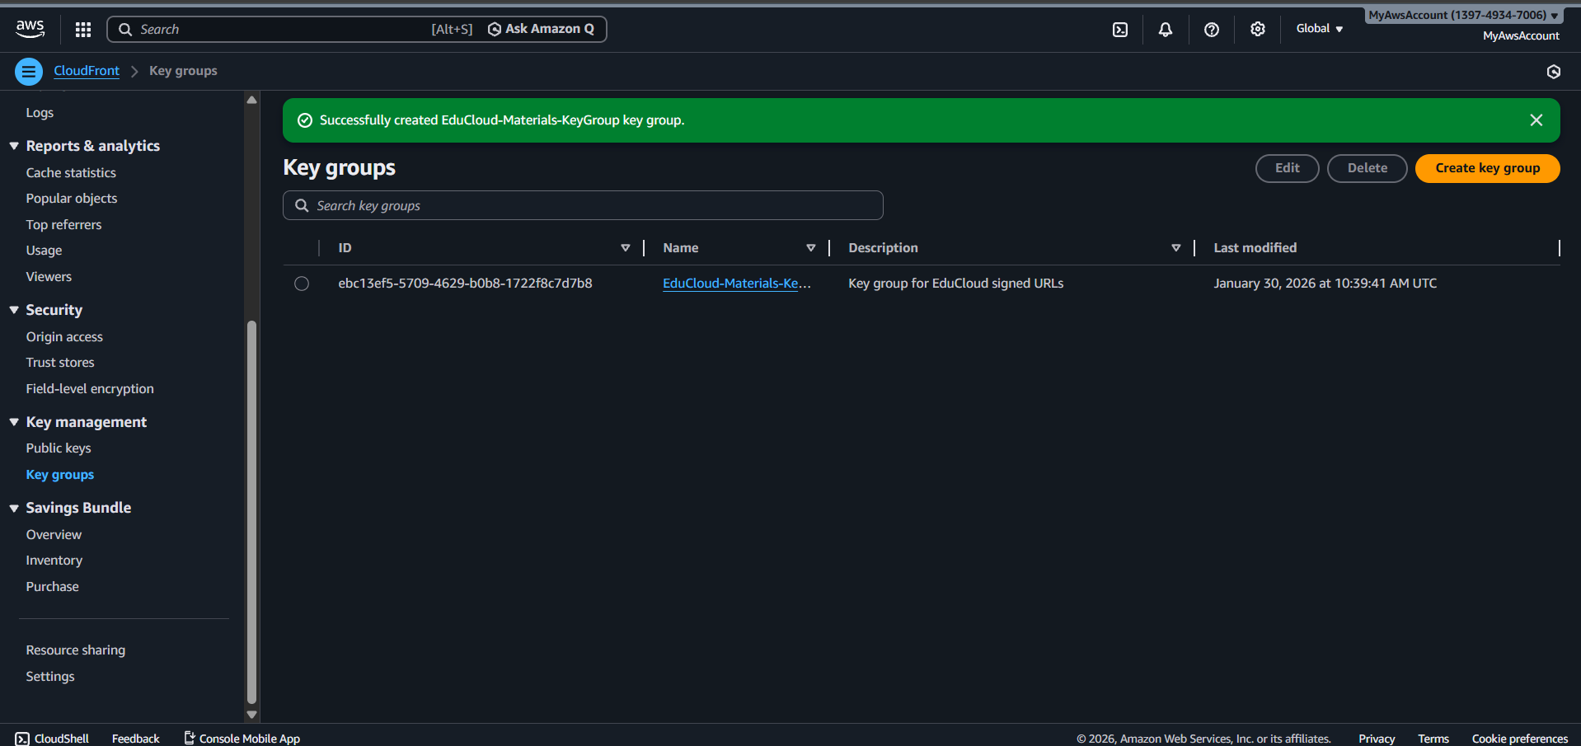

**To generate pre signed url**

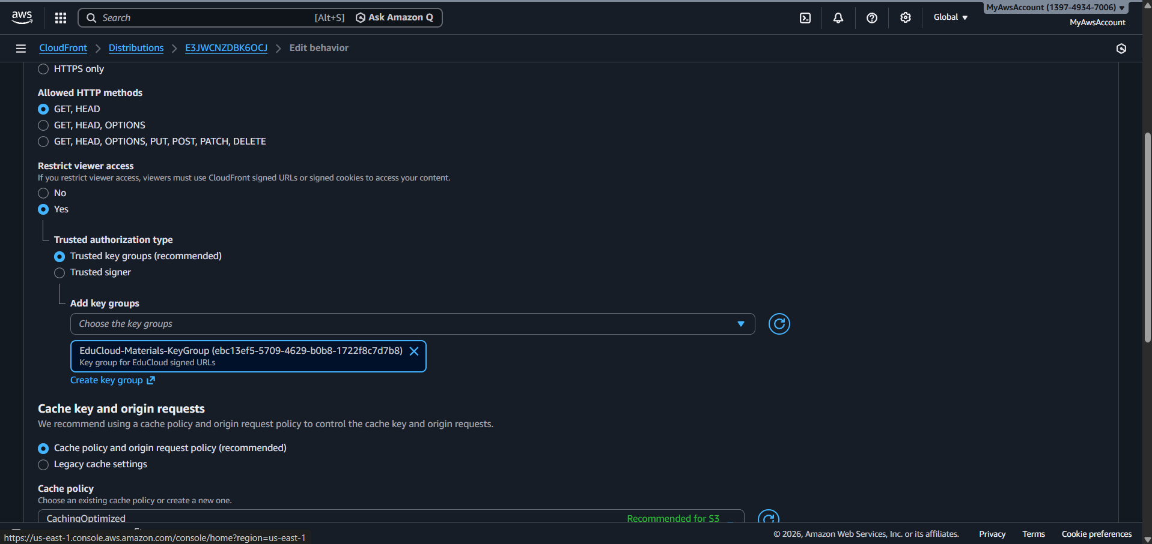

**Bucket policy for the distribution**

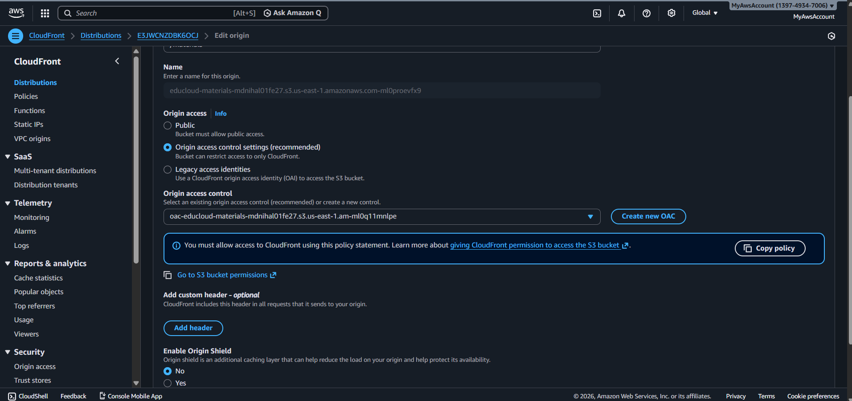

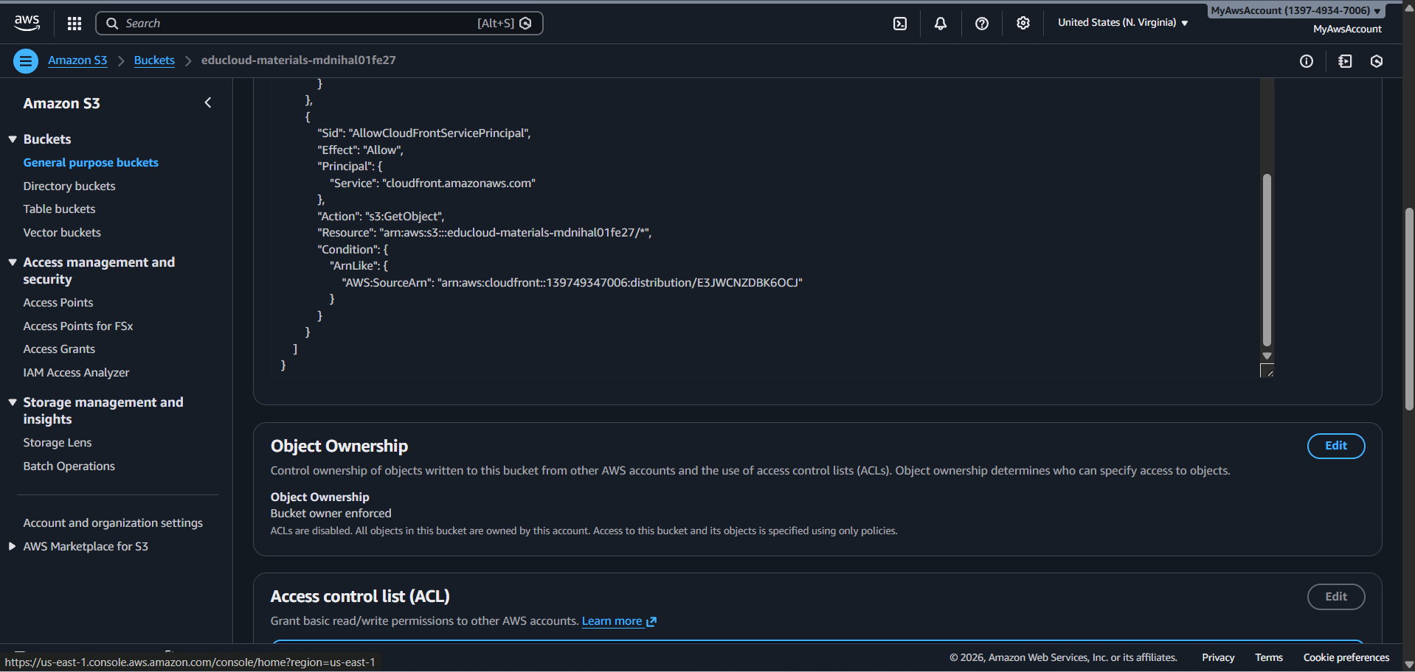

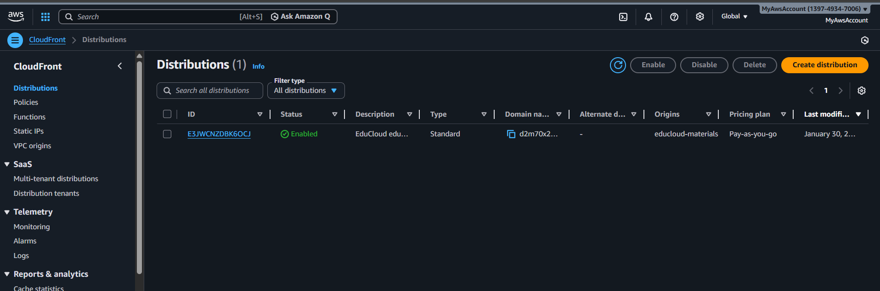

**Install Python Dependencies**

sudo yum install python3-pip -y

pip3 install cryptography botocore --user

**Created Signed URL Generator Script**

**Created the Python script**

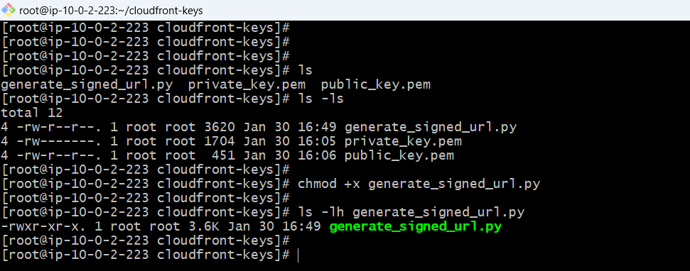

**Test Generating Signed URL for Trainer Material**

**SIGNED URL GENERATED SUCCESSFULLY**

**Used the domain name and key id from public key created in the key management tab in cloud front**

**Generate signed URL for trainer material**

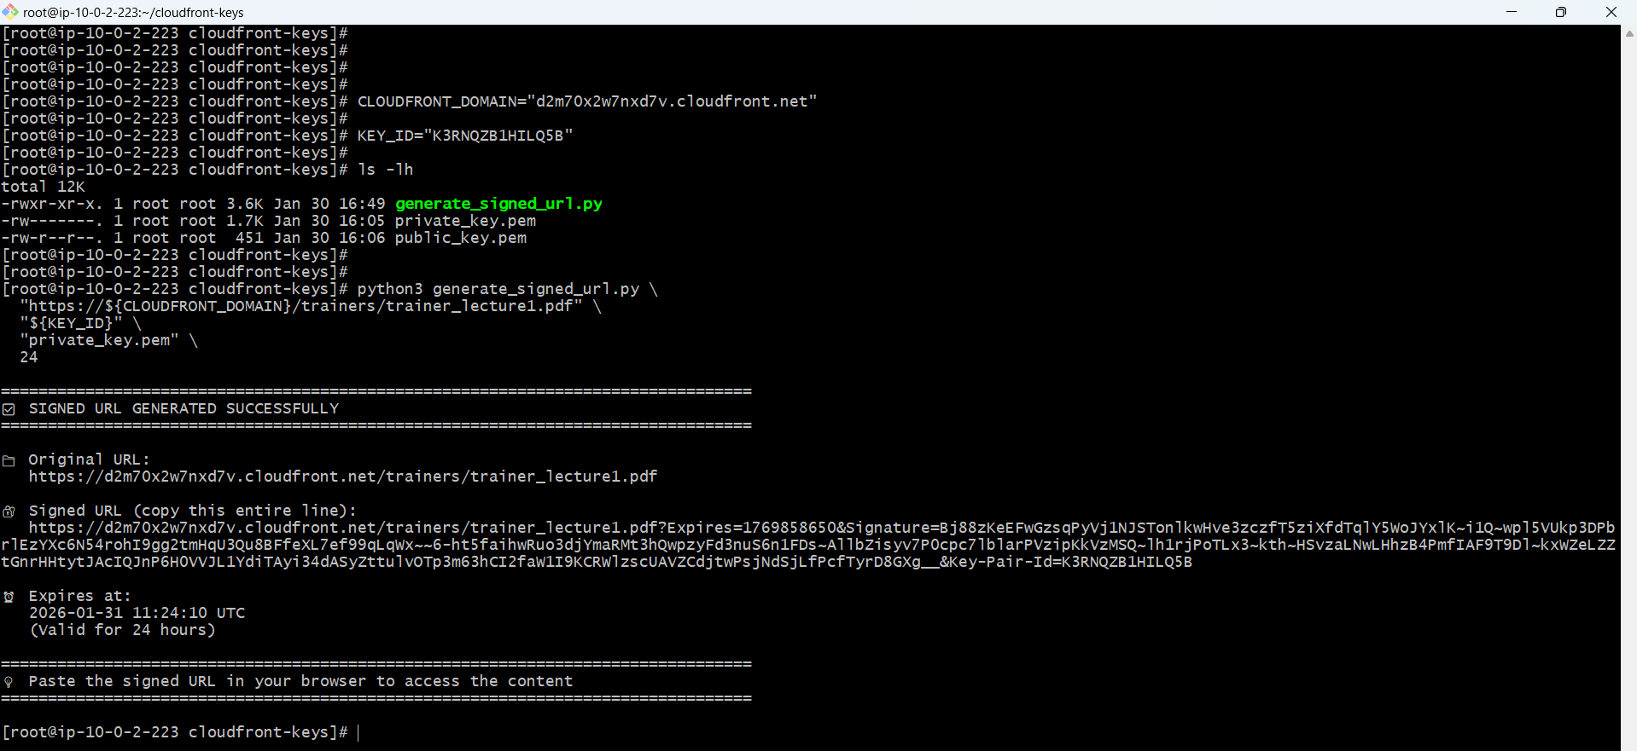

**There is no actual pdf**

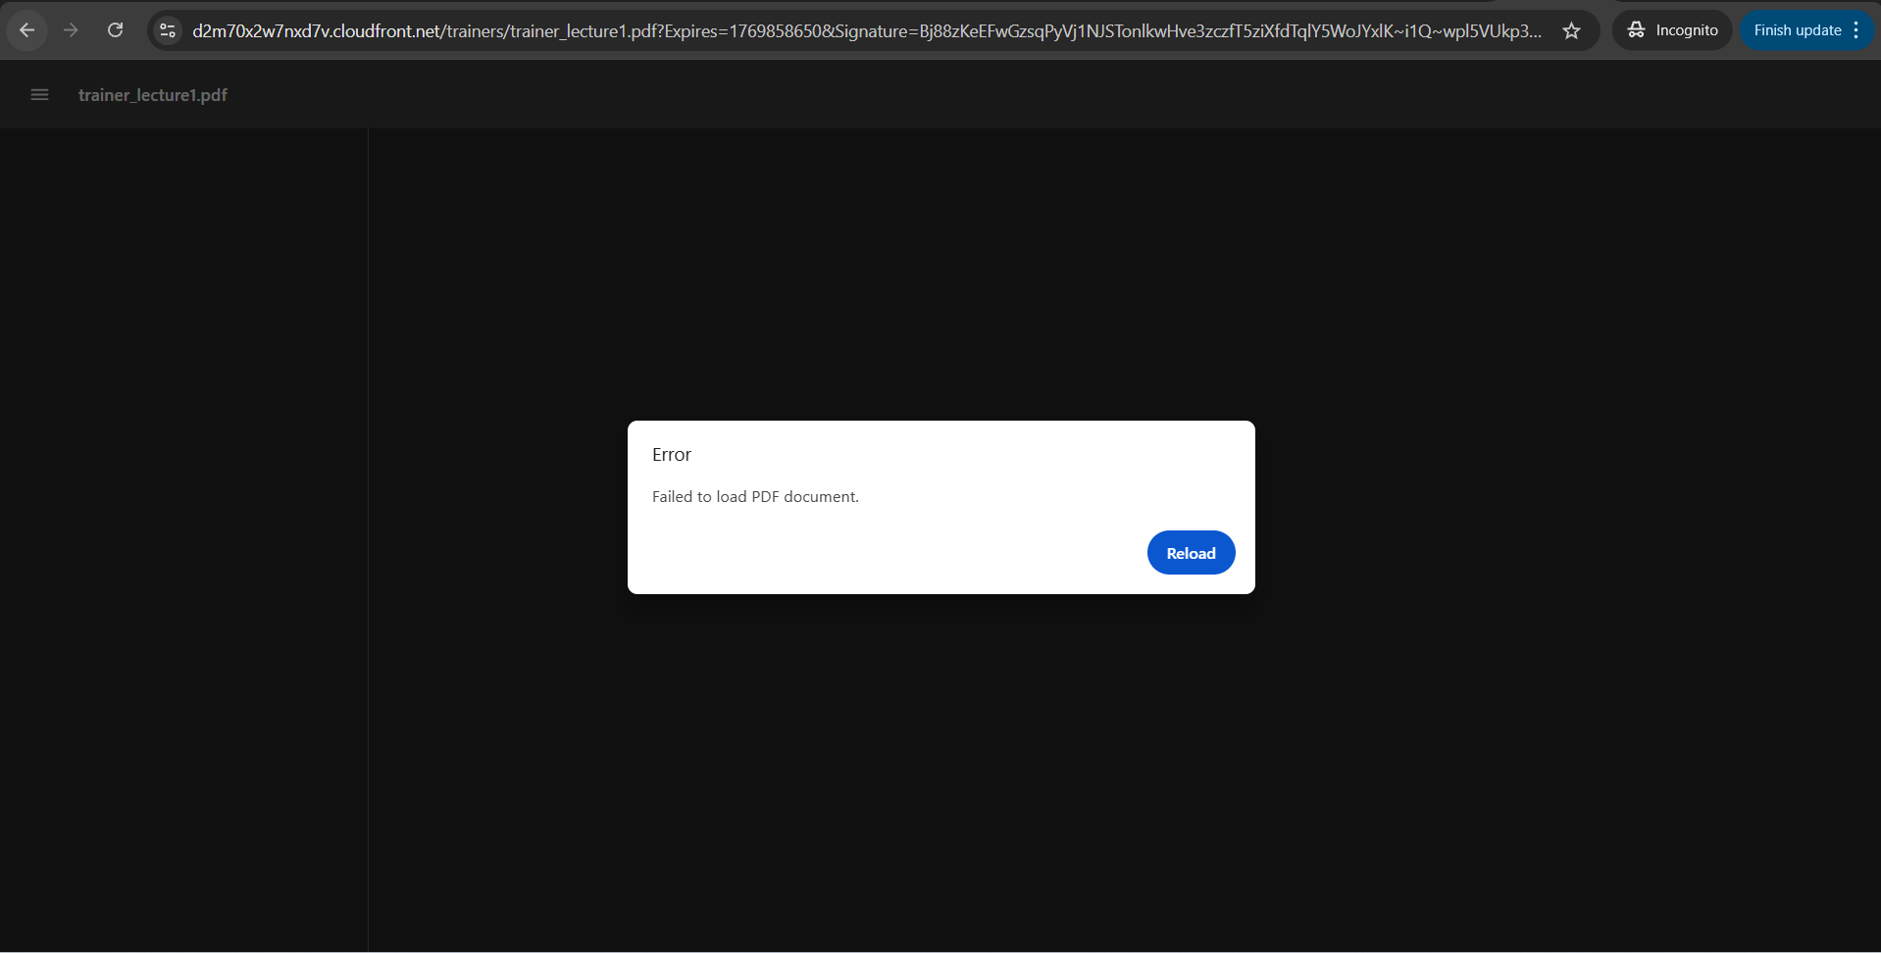

**Generate Signed URLs for All Materials different paths**

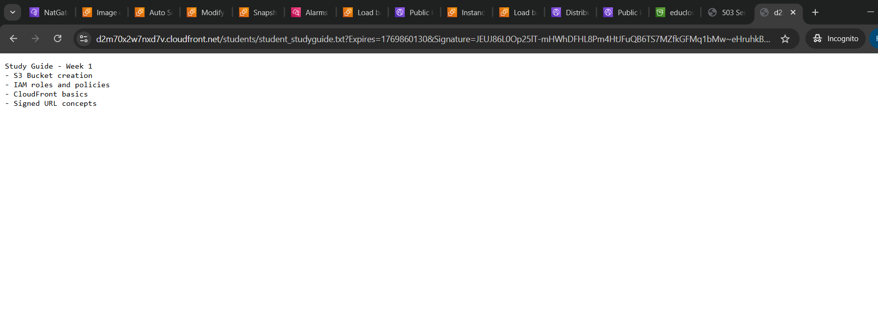

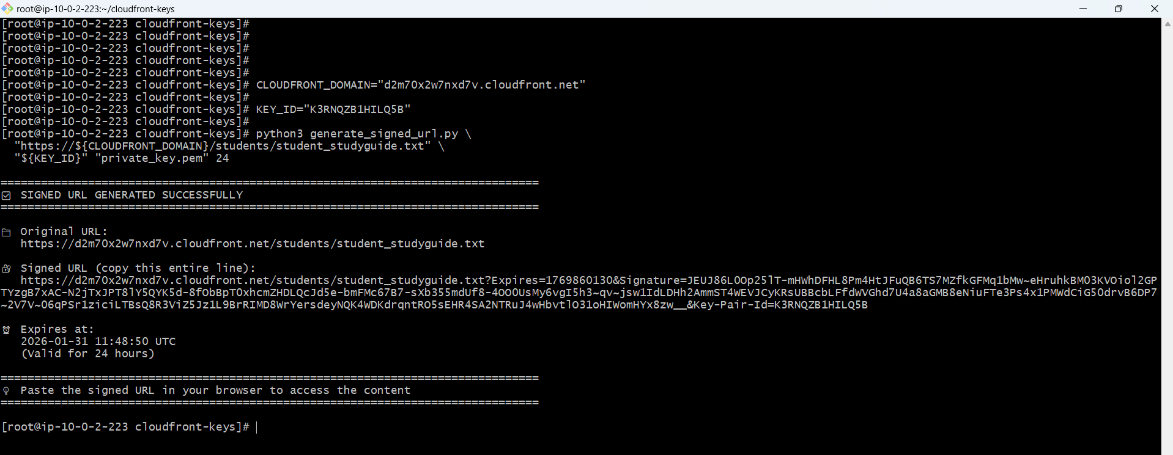

**Direct S3 Access Failed**

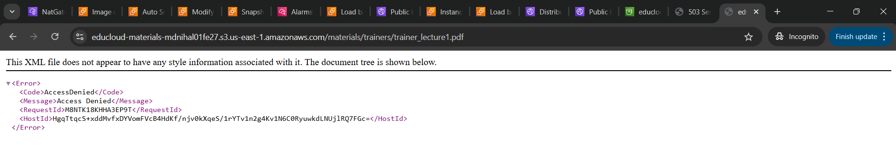

**CloudFront Without Signature**

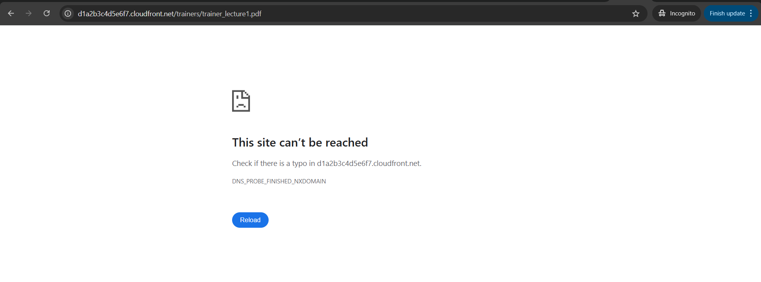

<https://d2m70x2w7nxd7v.cloudfront.net/materials/students/student_studyguide.txt?Expires=1769880811&Signature=GEzDHkU0waXITsT-kjPEZaCU0eEPlfczlblmcX4HygST02zbh76FInzSW-awdAQkig-GmSadVEcsMzVXD-HECyC1mSkPpCYq5qmCzVCgAVgGr0G2f1kr6VGk1z5CO92IfQI3EraXSC0~PiWtey71Dl0UTlQBjoEH-nAlT3kjvFBGUzIICe0L1JYMVUBFEnbm7Q44oHvvCa6OKAN8gY-VFEbqNKJ9rdGqduEPg8N7yaxERaJmFHFcTY1Yb4q~d7Ljr9xZX-wyWF2~wqY220sD1LKHcdQzhyC2w3wPuNLno1UF1BsJ4L8Q~LT~okEjNSiKguz~EeS6WJ6YPP6u4WcMMA__&Key-Pair-Id=K3RNQZB1HILQ5B>

**Through ALB accessing website prepopulating the file from the student table and click on download button generates pre signed url**

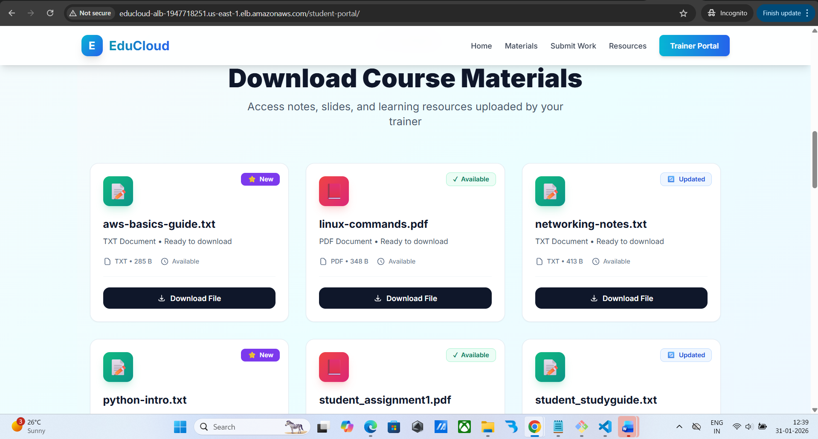

Downloads file

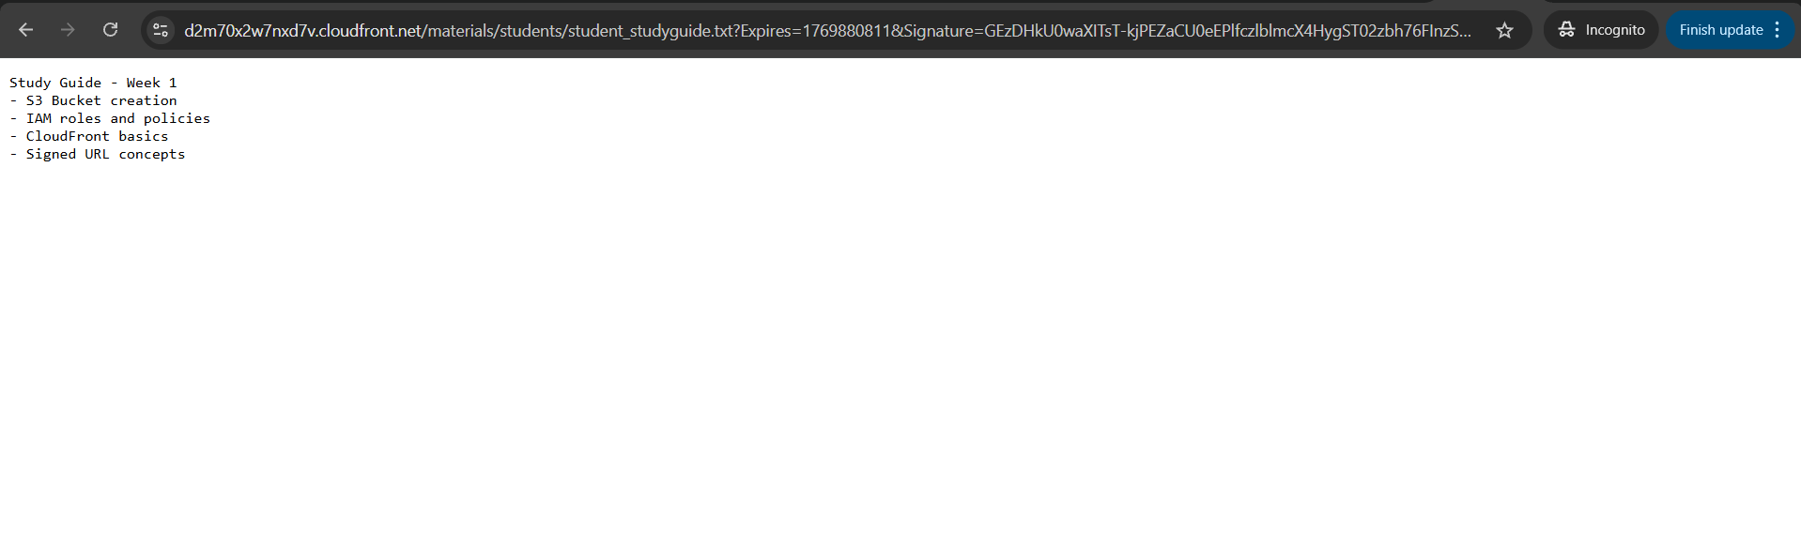

**new test file created for student and synced through script**

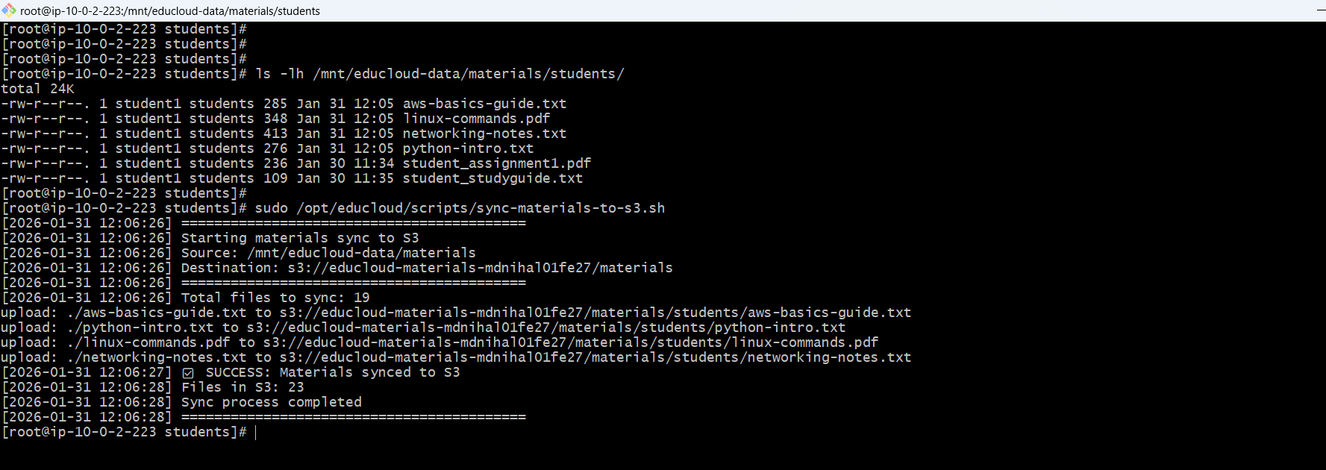

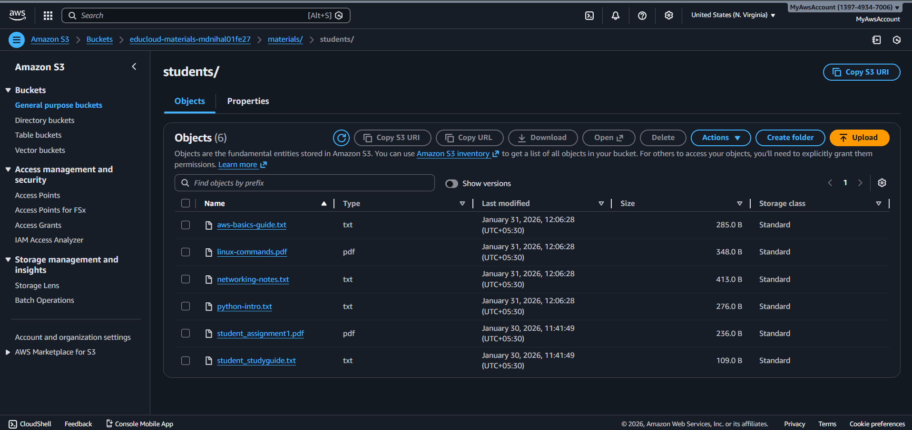

**File listing as cards fetch from the s3 bucket**

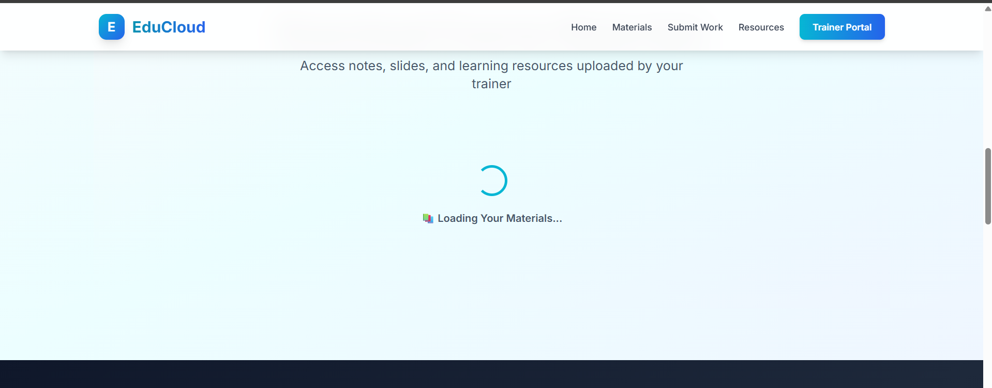



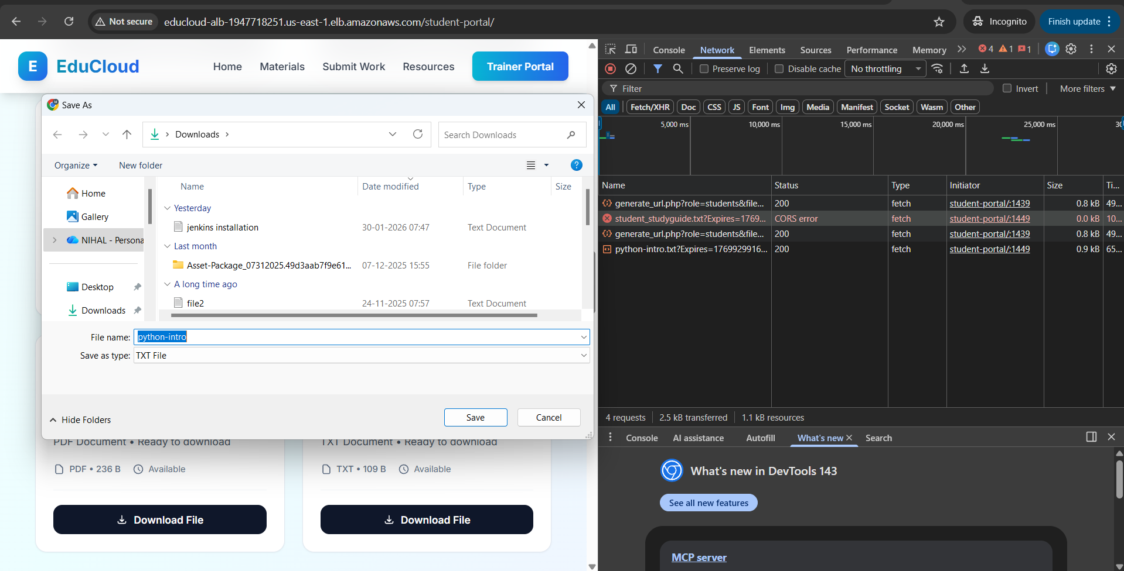

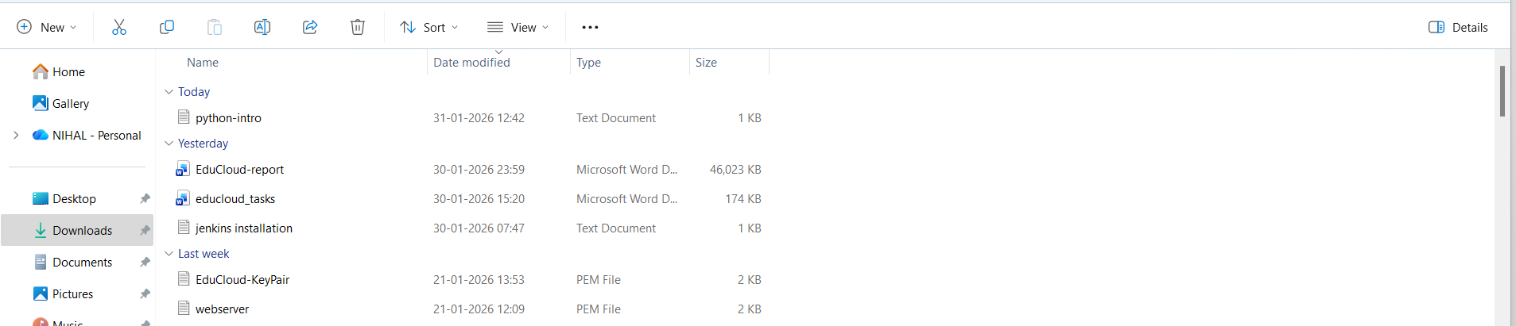

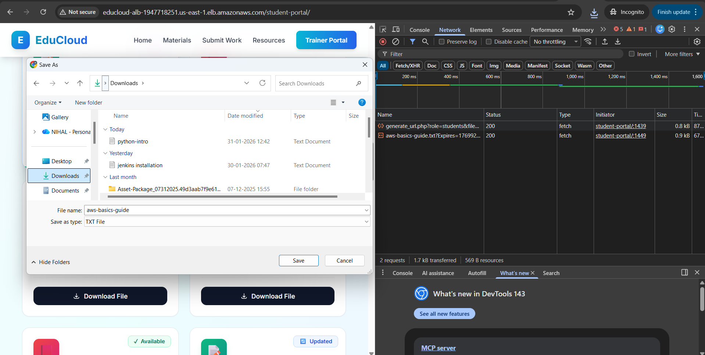

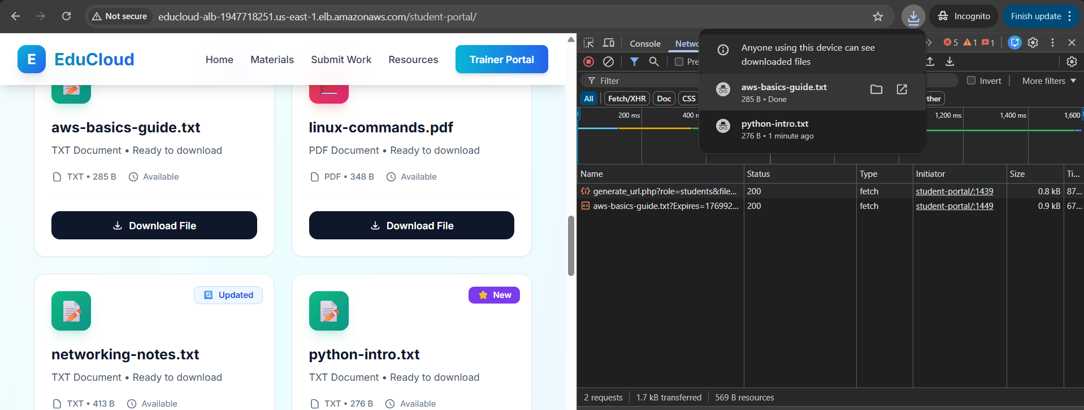

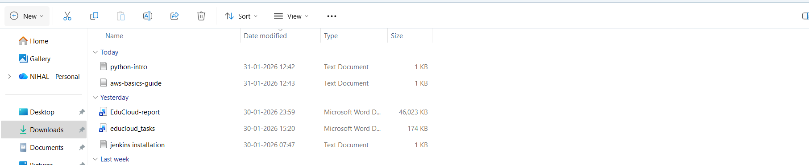

User clicks "Download File"

JavaScript sends request to /api/generate_url.php

PHP generates signed URL with private key

JSON response returns signed URL to browser

Browser fetches file from CloudFront signed URL

CloudFront validates signature

CloudFront serves cached file (or fetches from S3 if not cached)

File downloads as Blob in browser memory

createObjectURL generates blob:// URL

Invisible <a> link clicks automatically

Browser "Save As" dialog appears

File saved to user's Downloads folder

**SNS Email Notifications**

**Created topic for the sns**

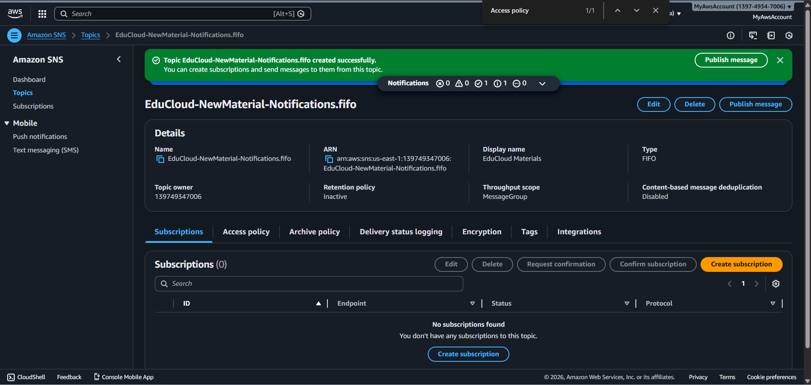

**Created and confirmed subscription**

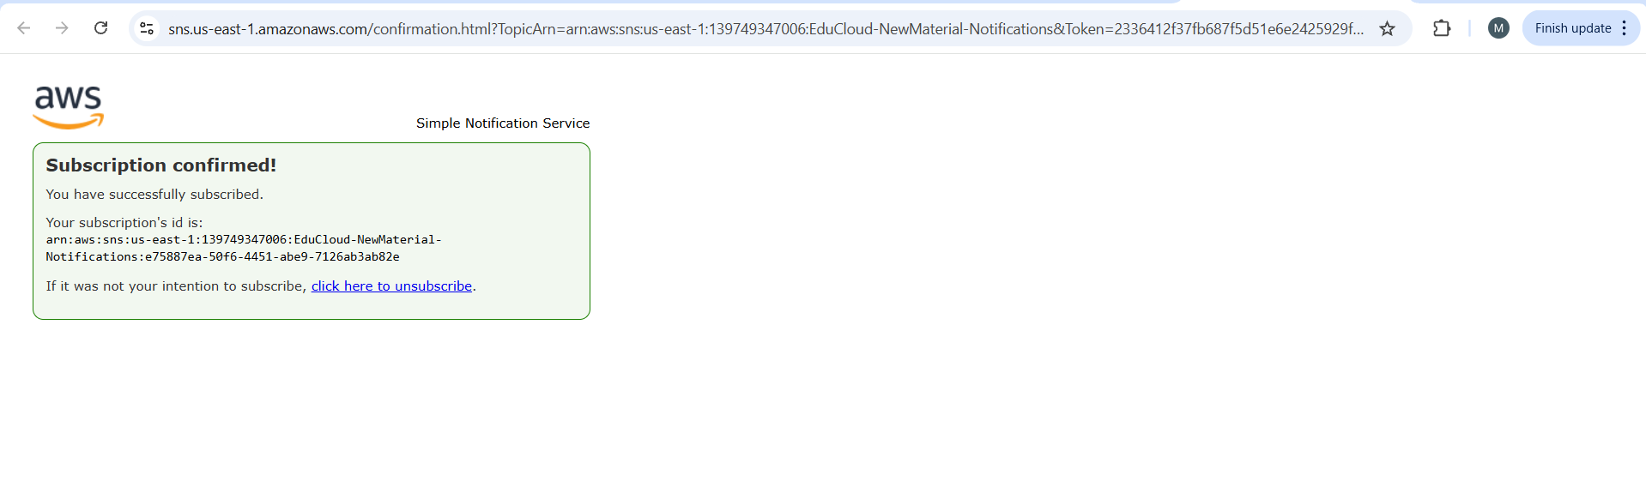

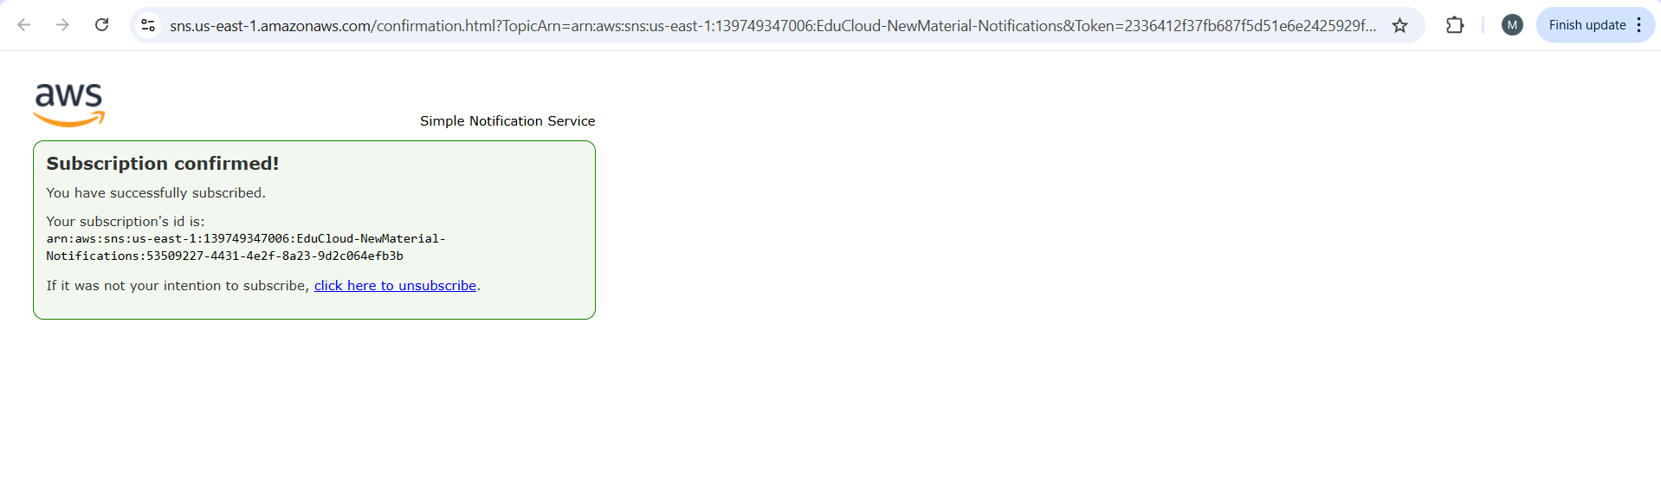

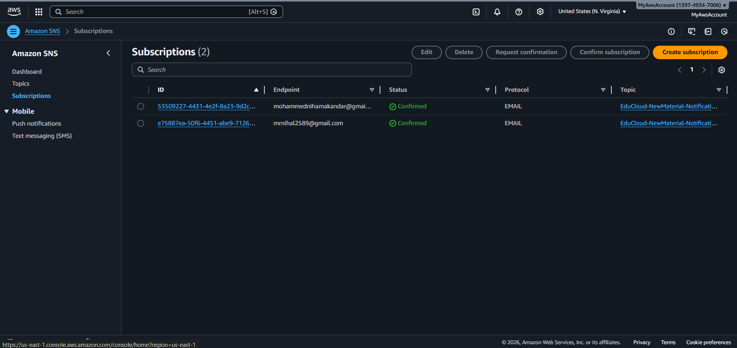

**Lambda Function for Notifications**

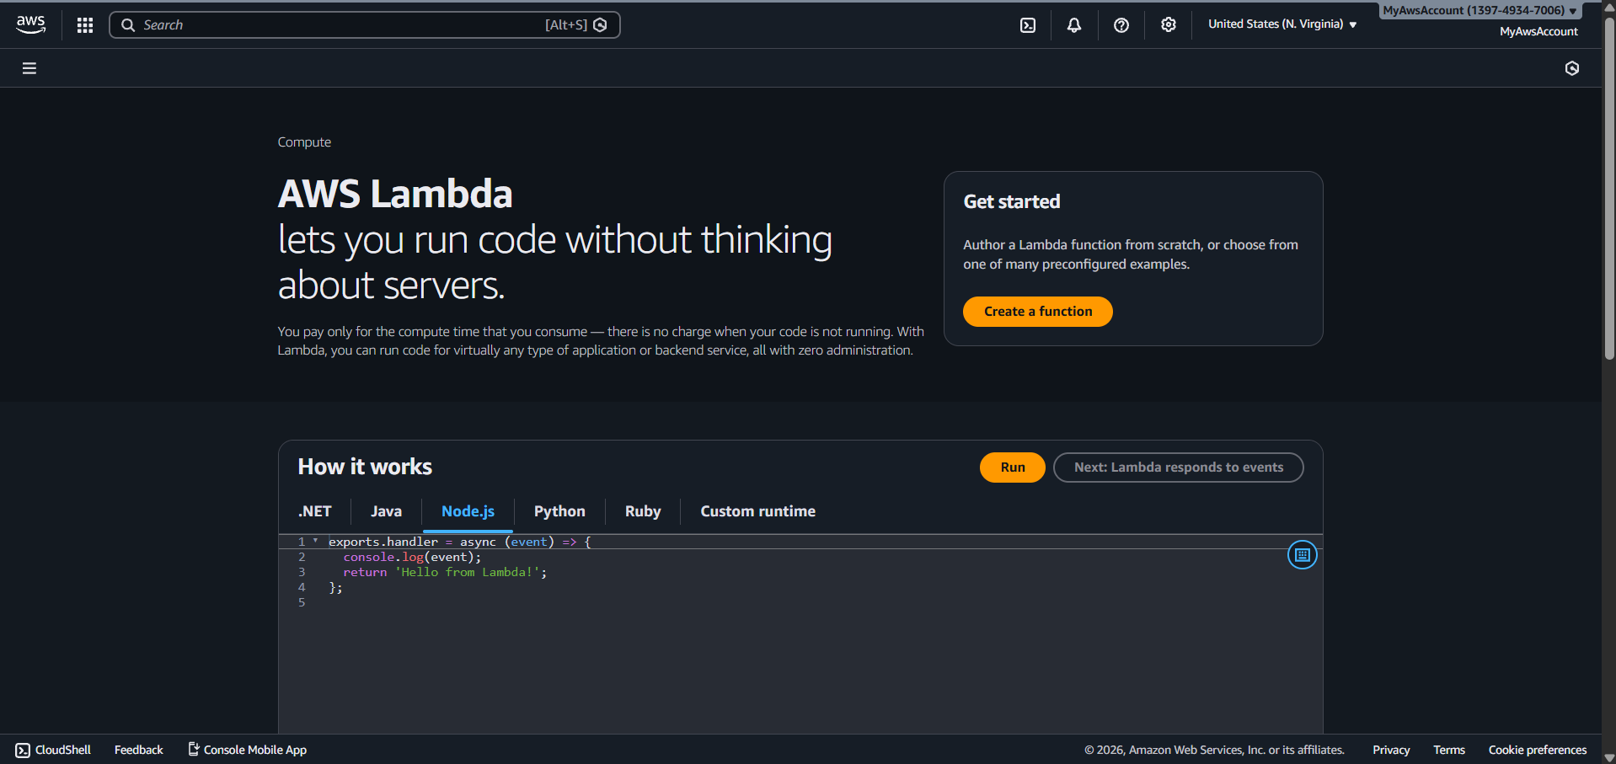

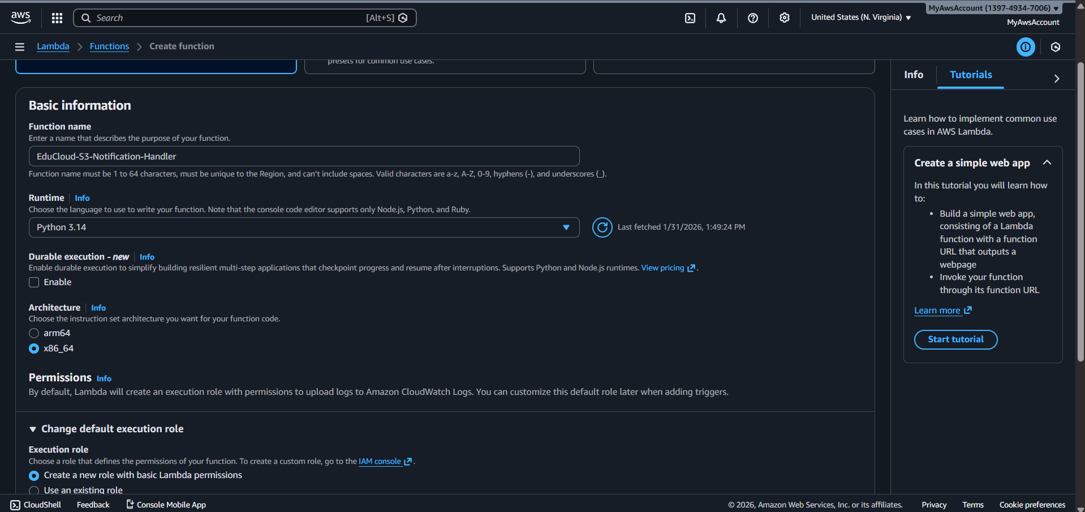

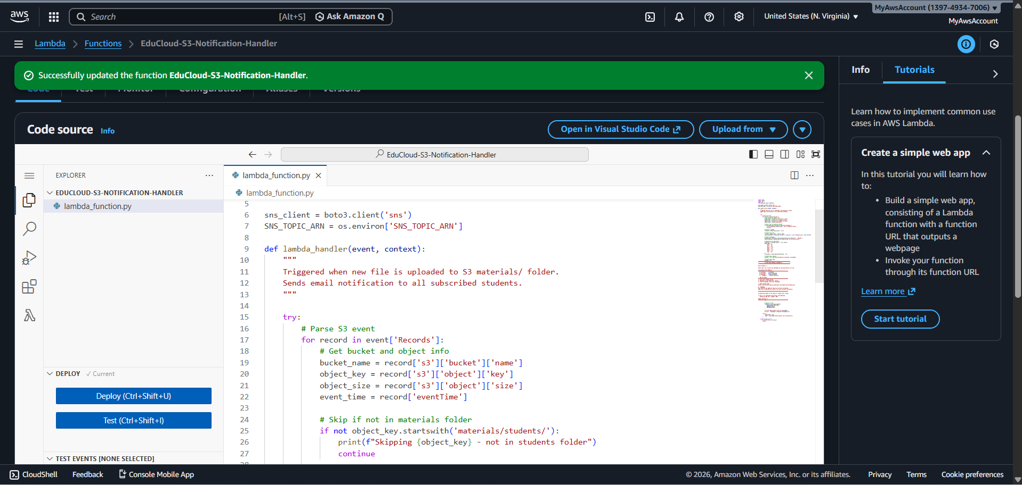

**Environment variable**

**SNS_TOPIC_ARN**

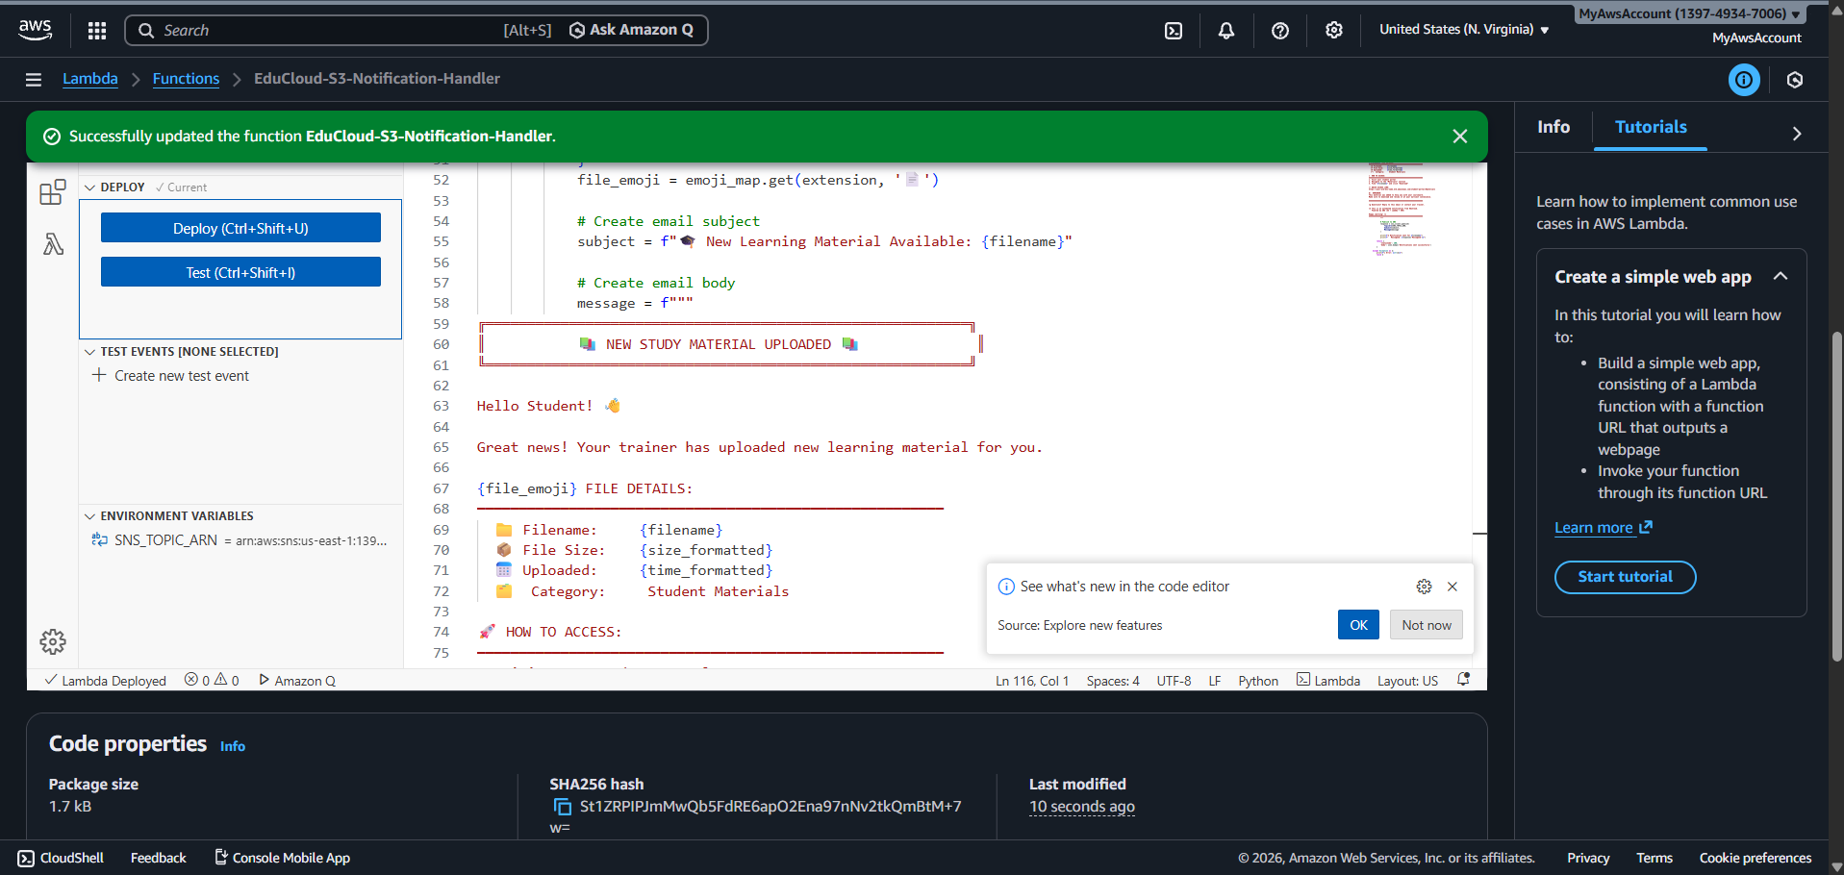

**SNS Permissions to Lambda**

**Inline policy for the sns to lambda**

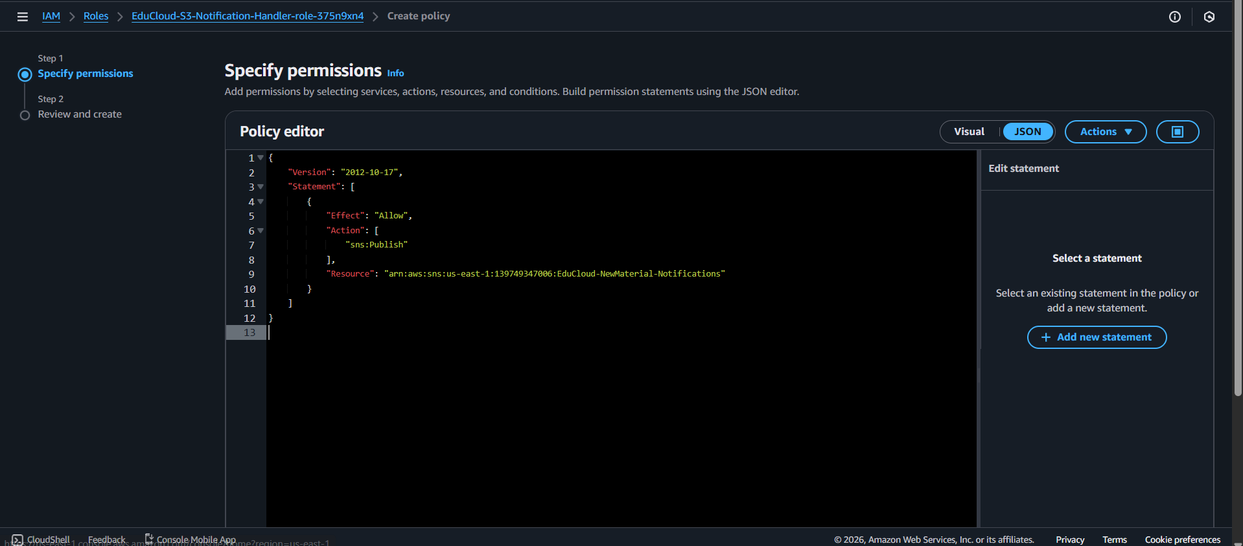

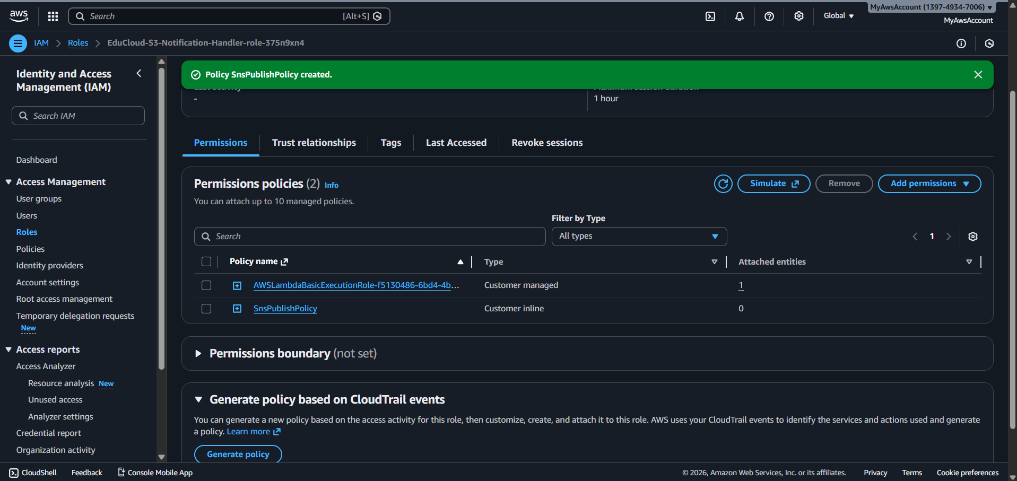

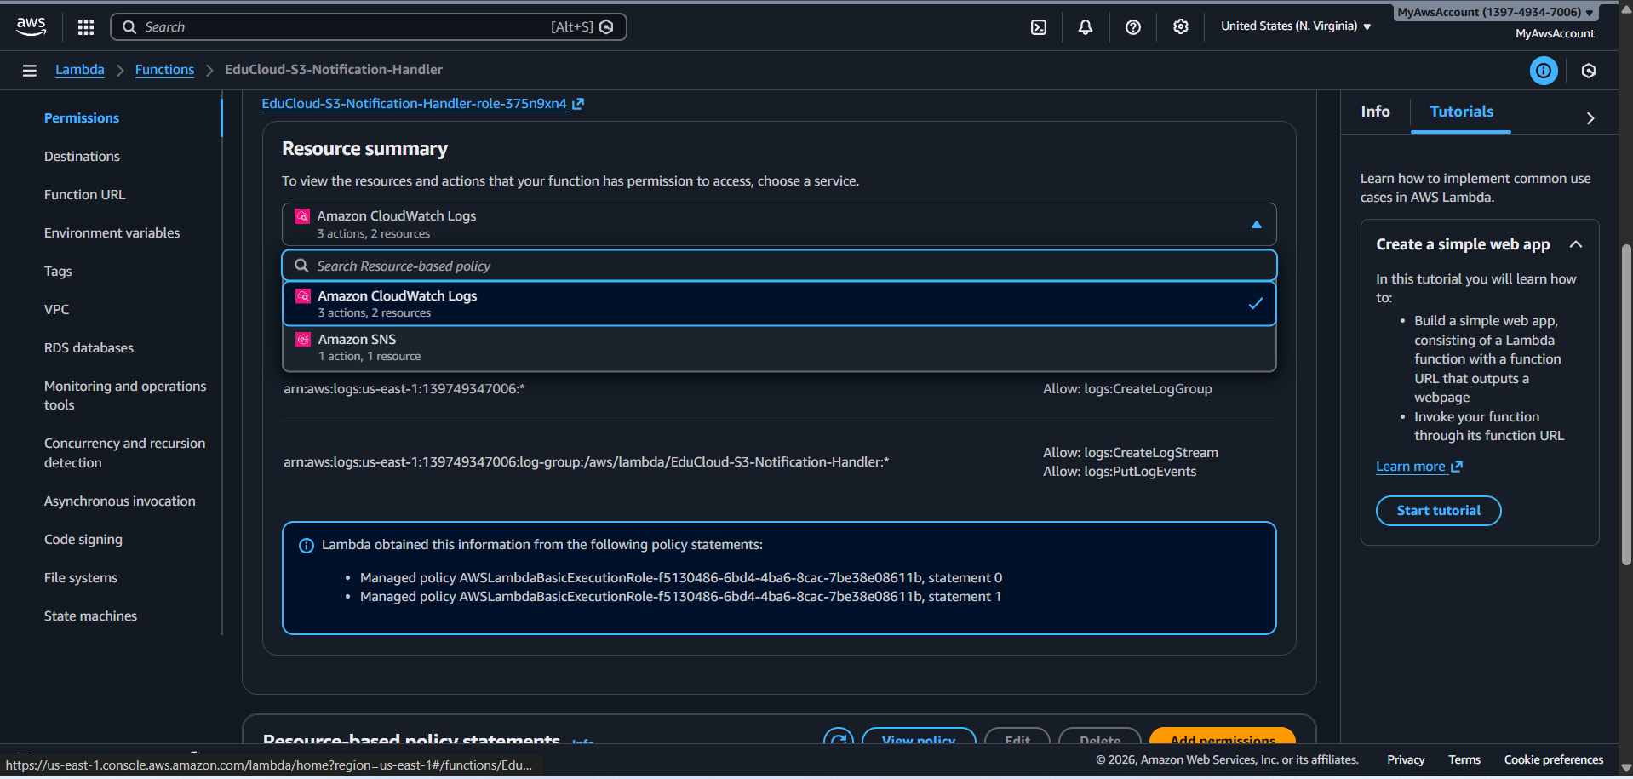

**Configuring S3 Event Notification**

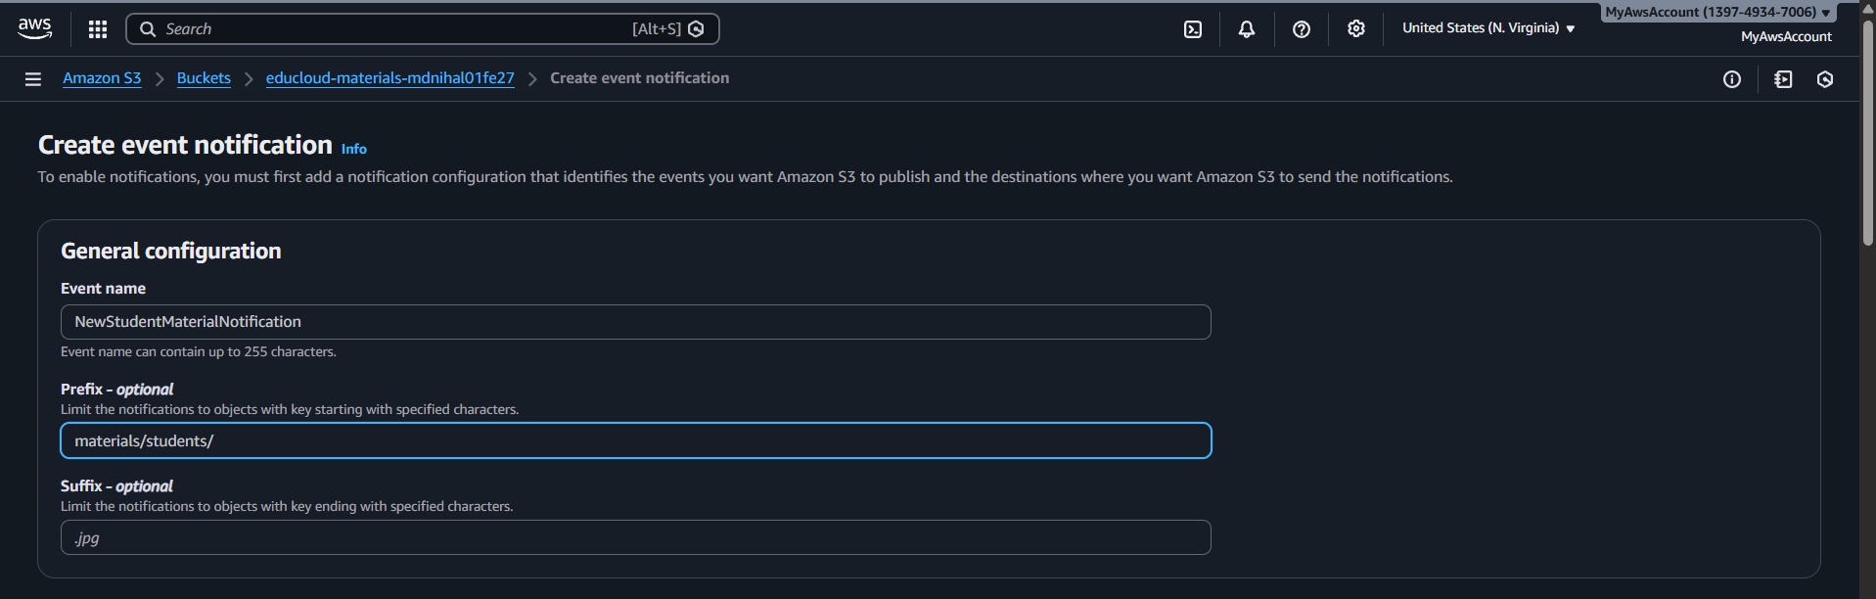

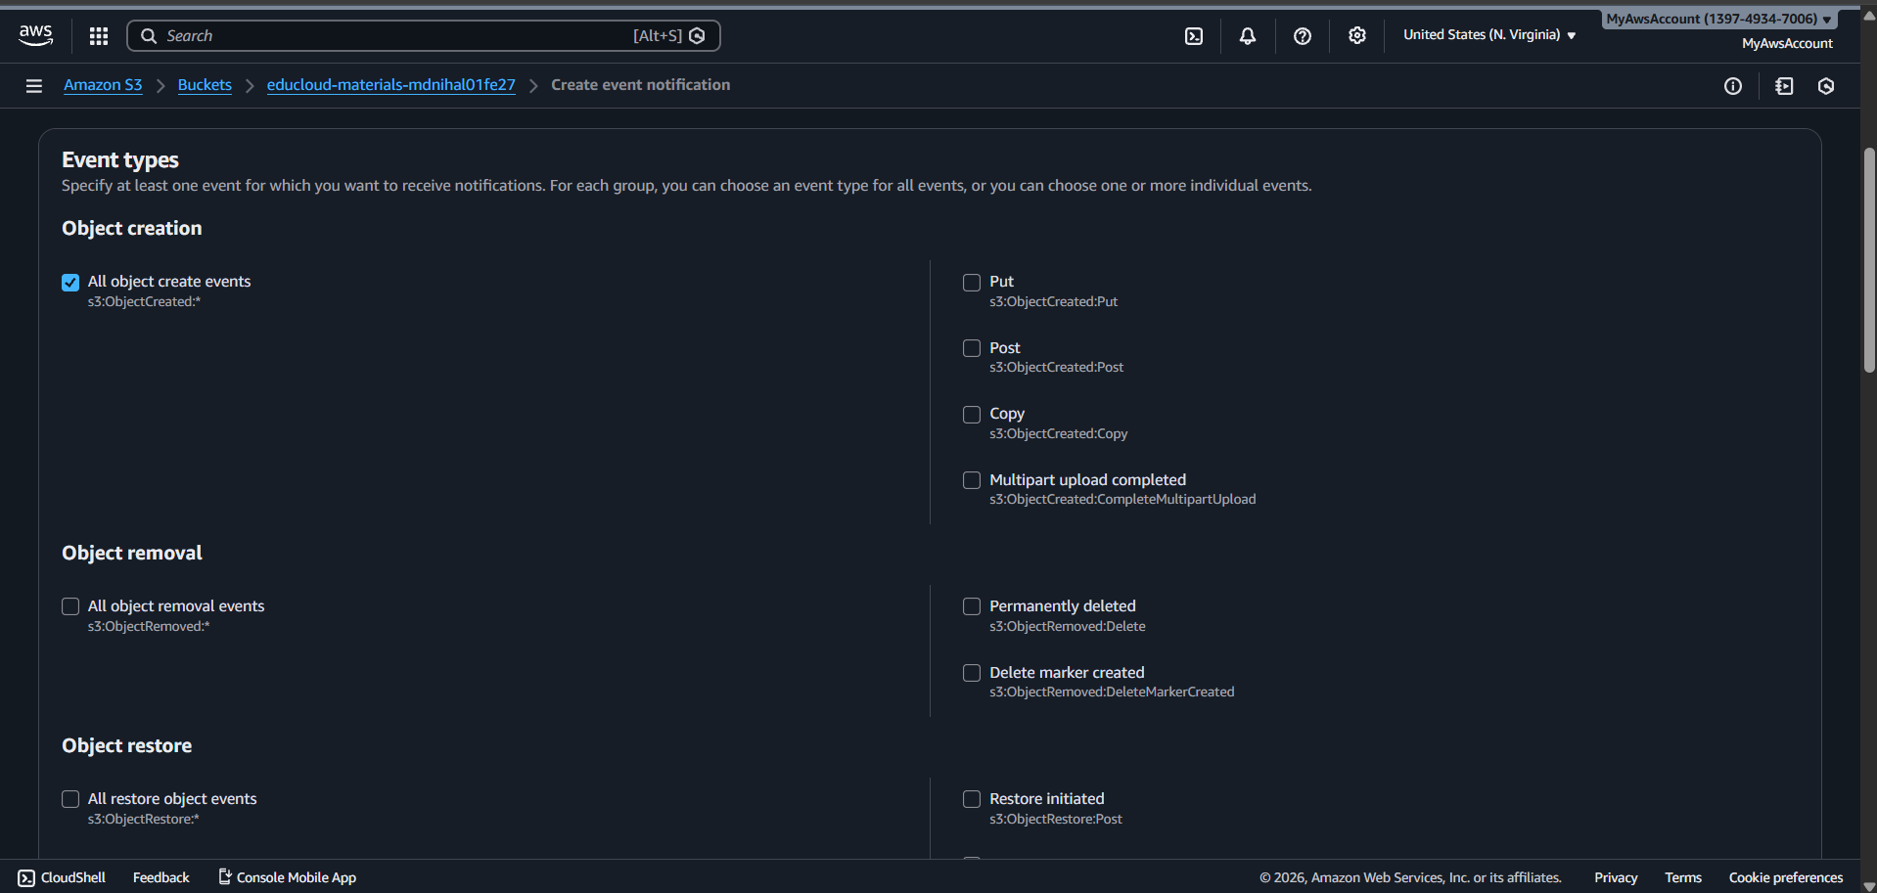

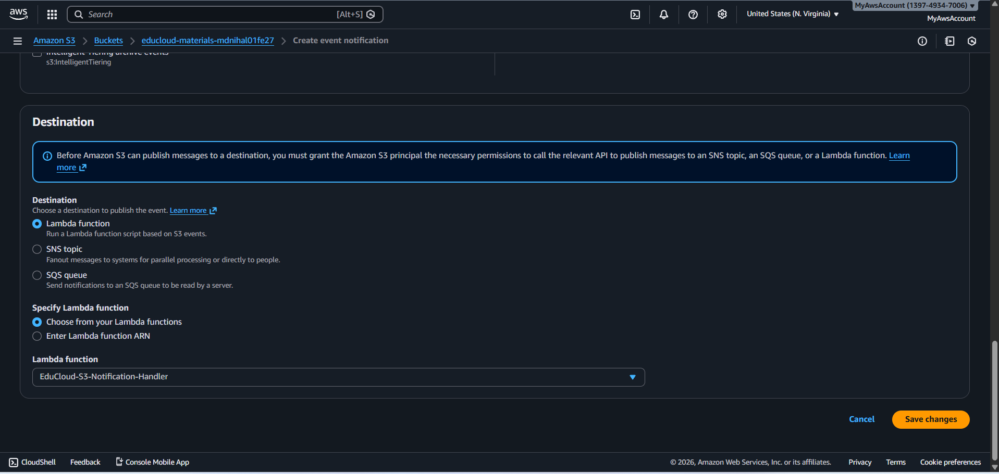

**Event Notification created in s3 bucket**

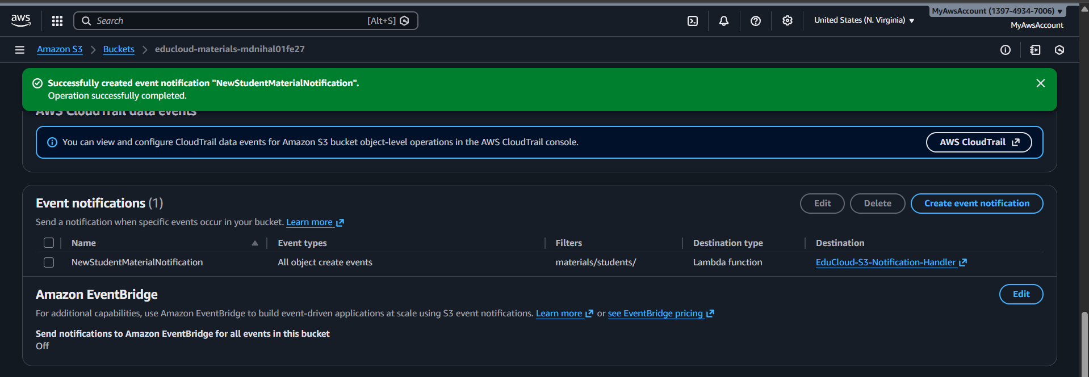

**Bothe the email recived the email (worked when it was in public network)**

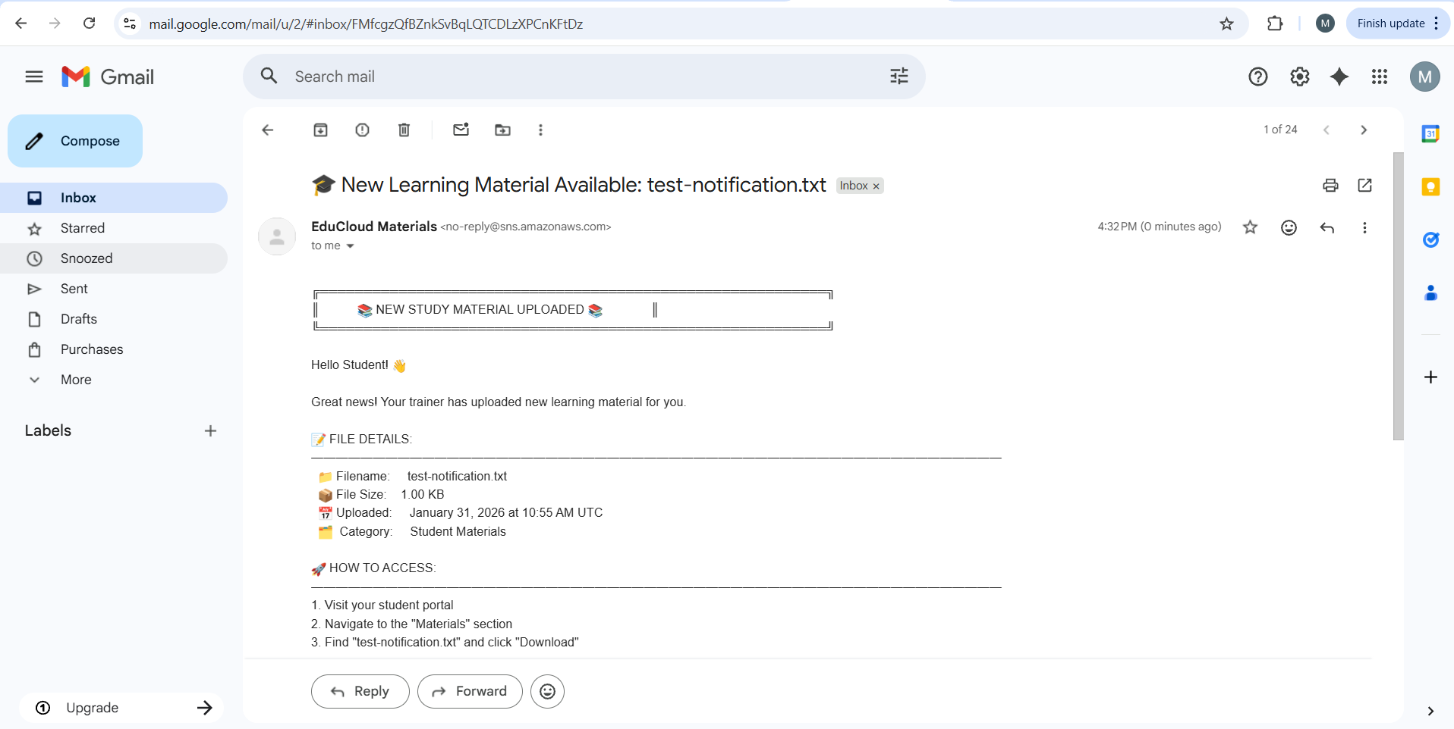

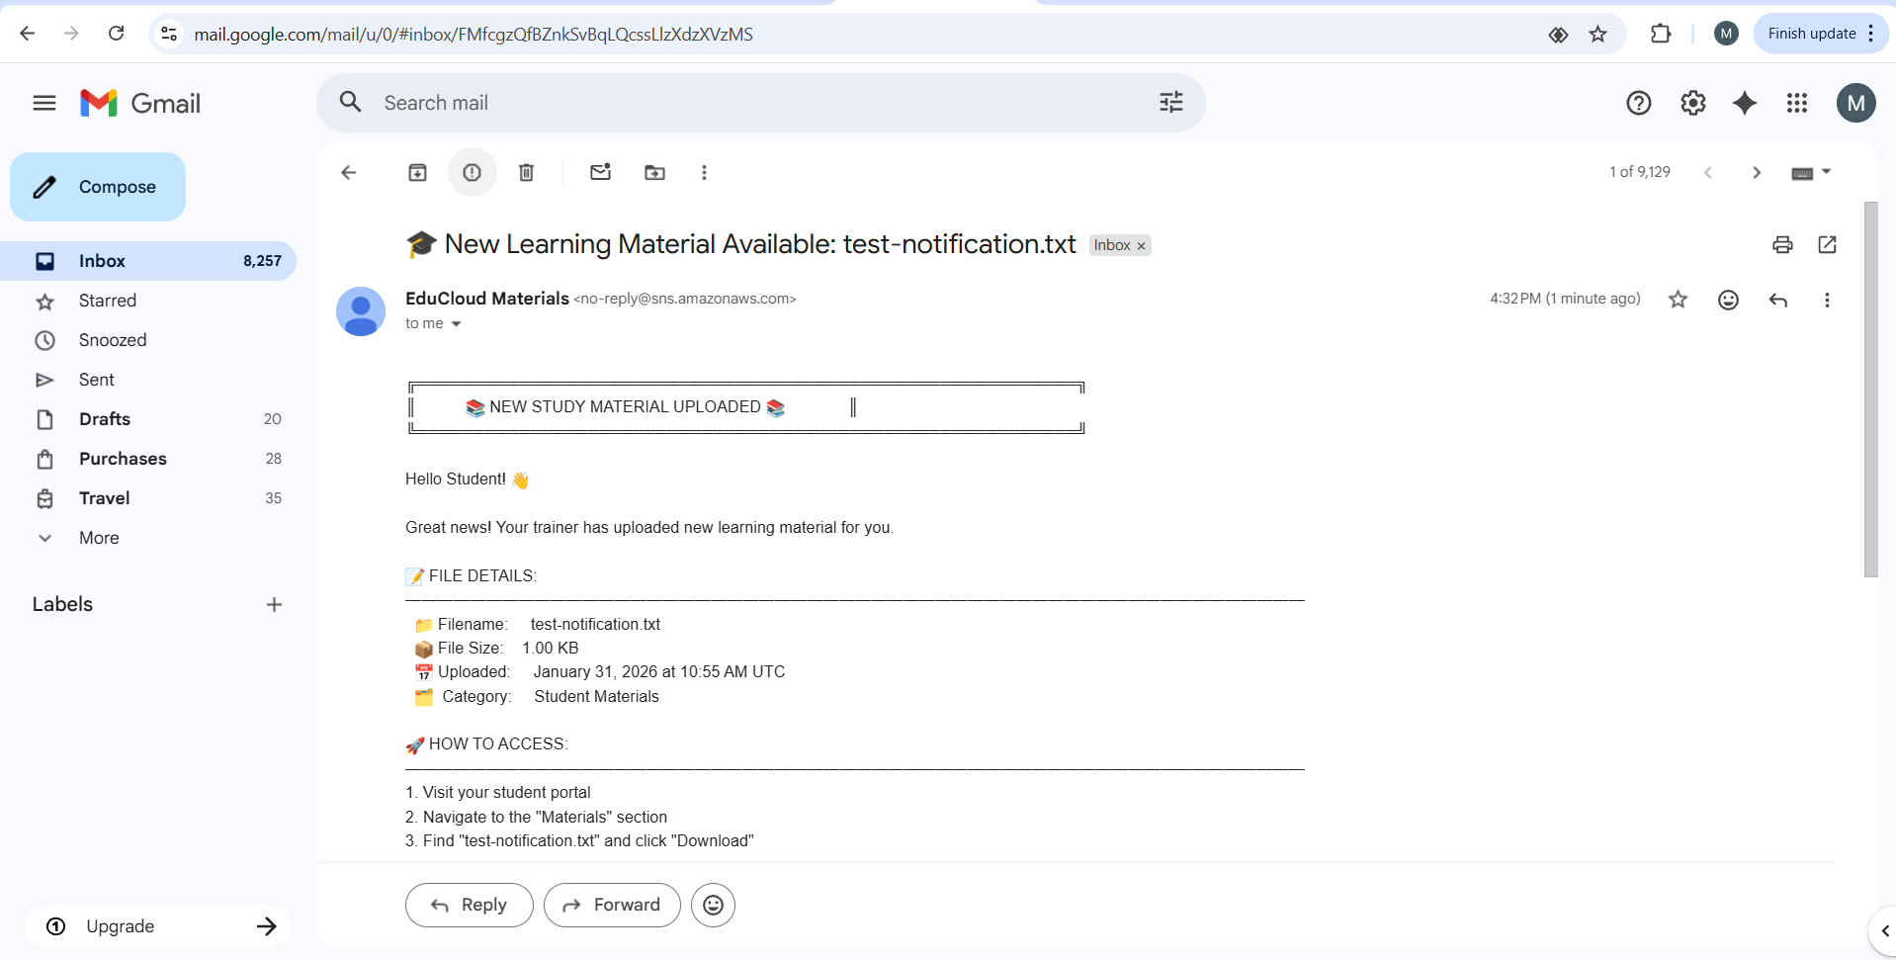

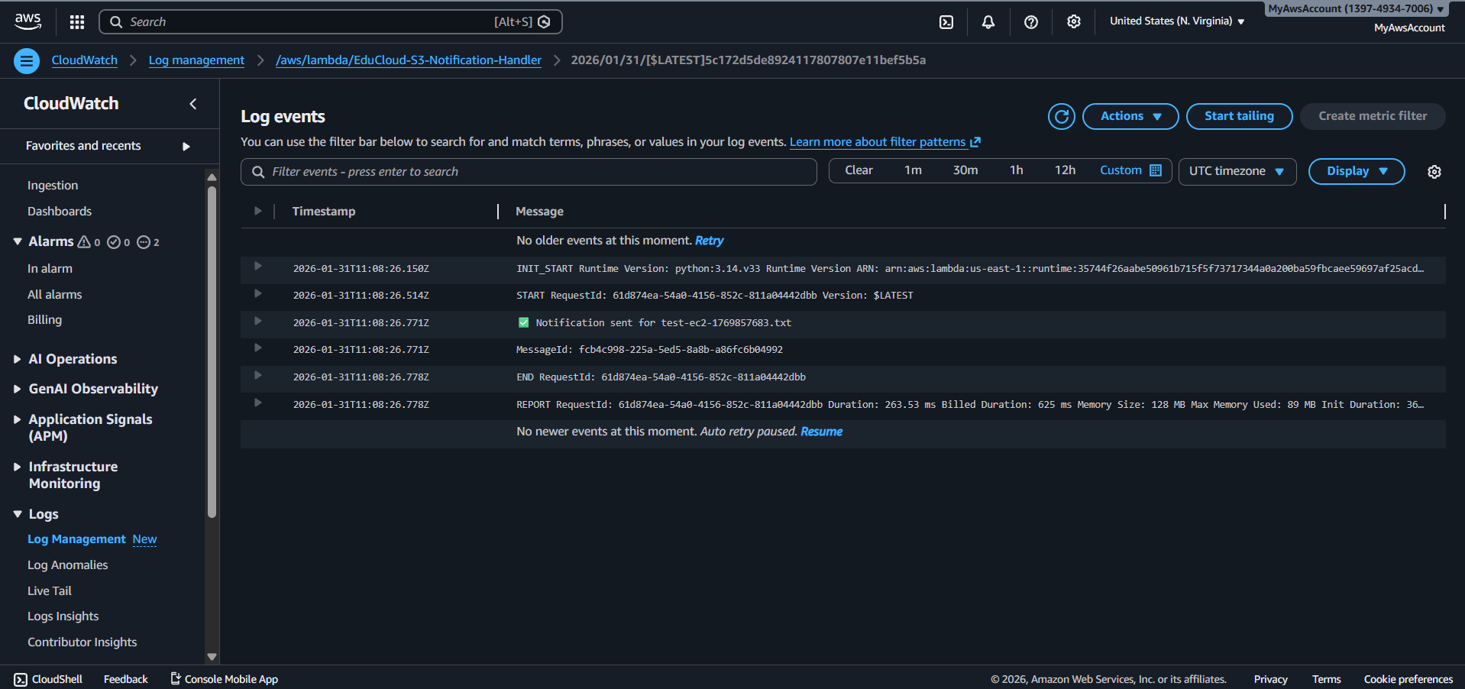

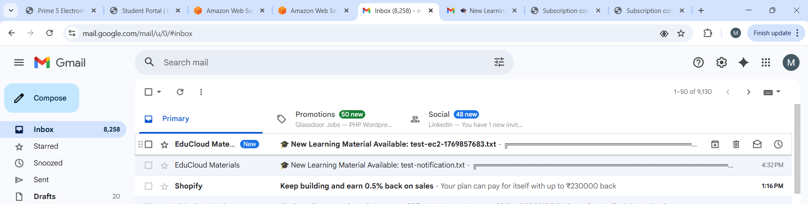

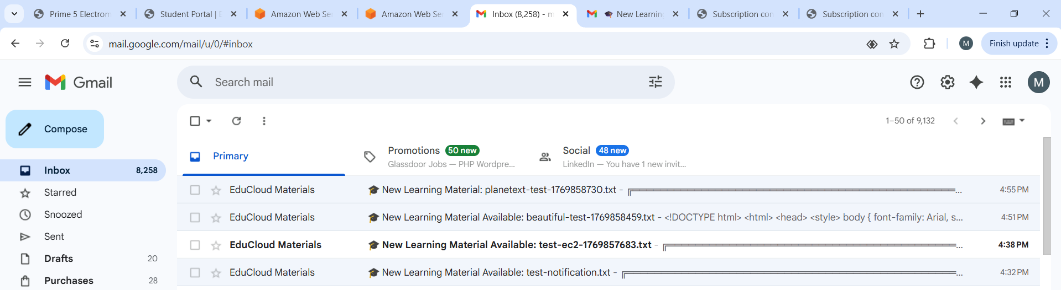

**Rds entry for upload via lambda trigger**

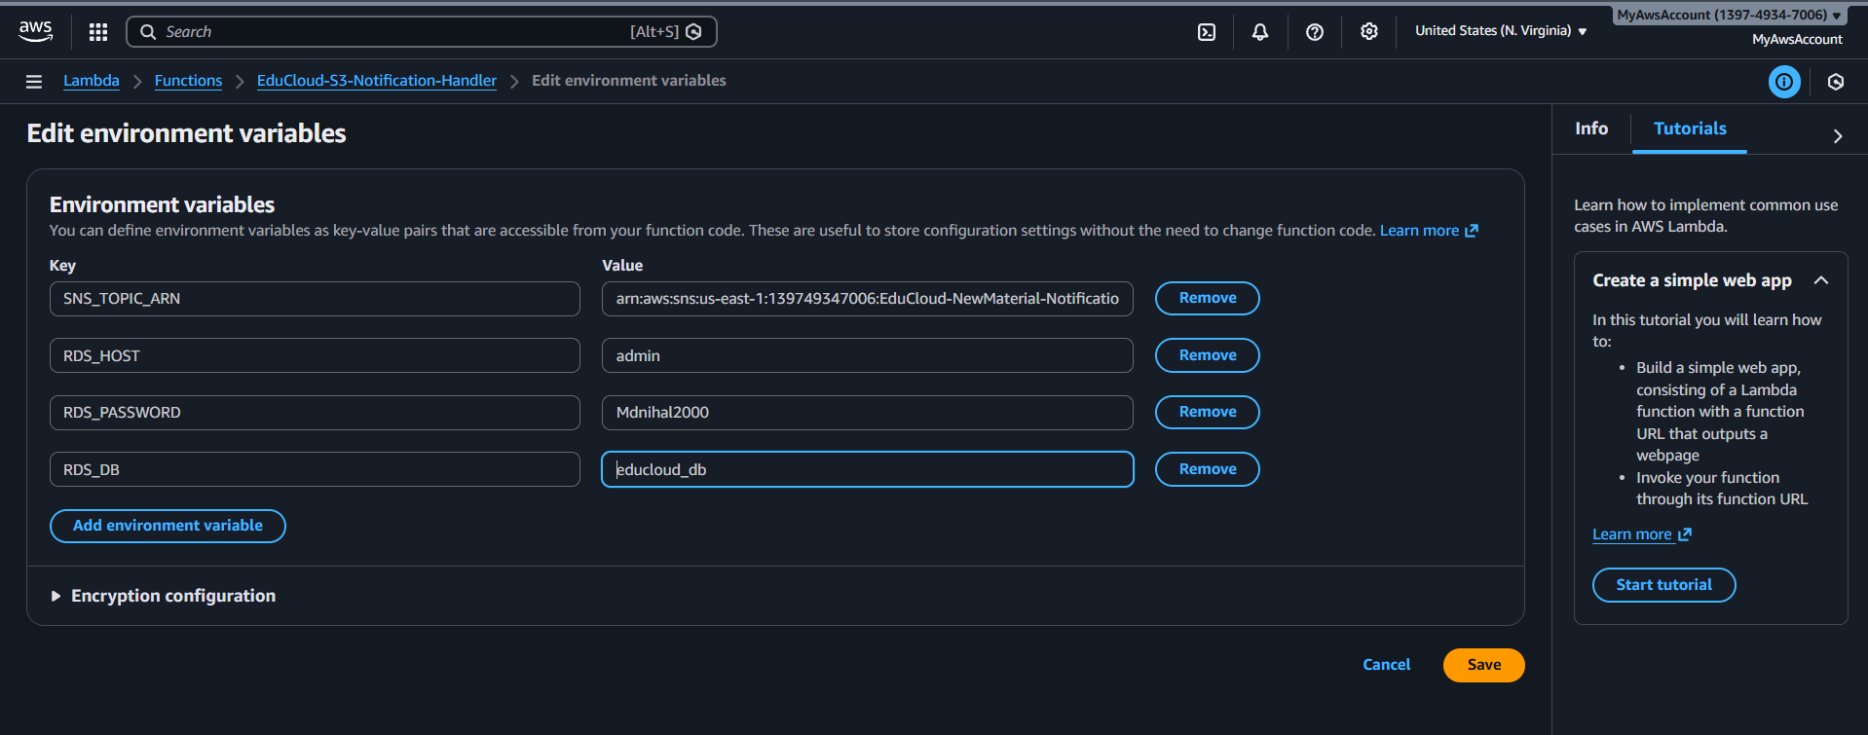

**Updated lambda for the rds entry on upload**

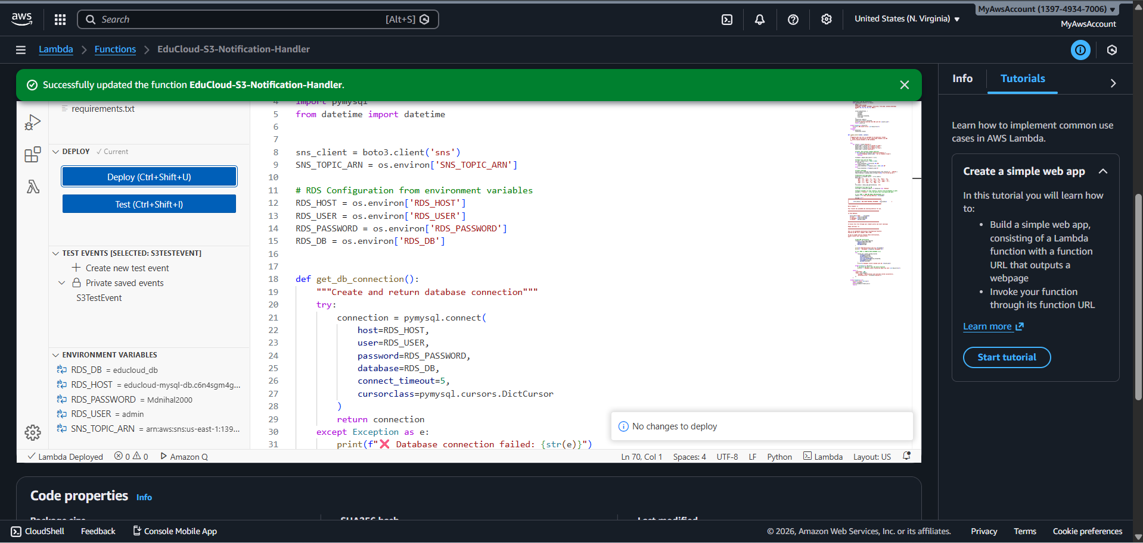**Permission for lambda to rds**

**RDS is in private subnet, Lambda must be in same subnet to connect**

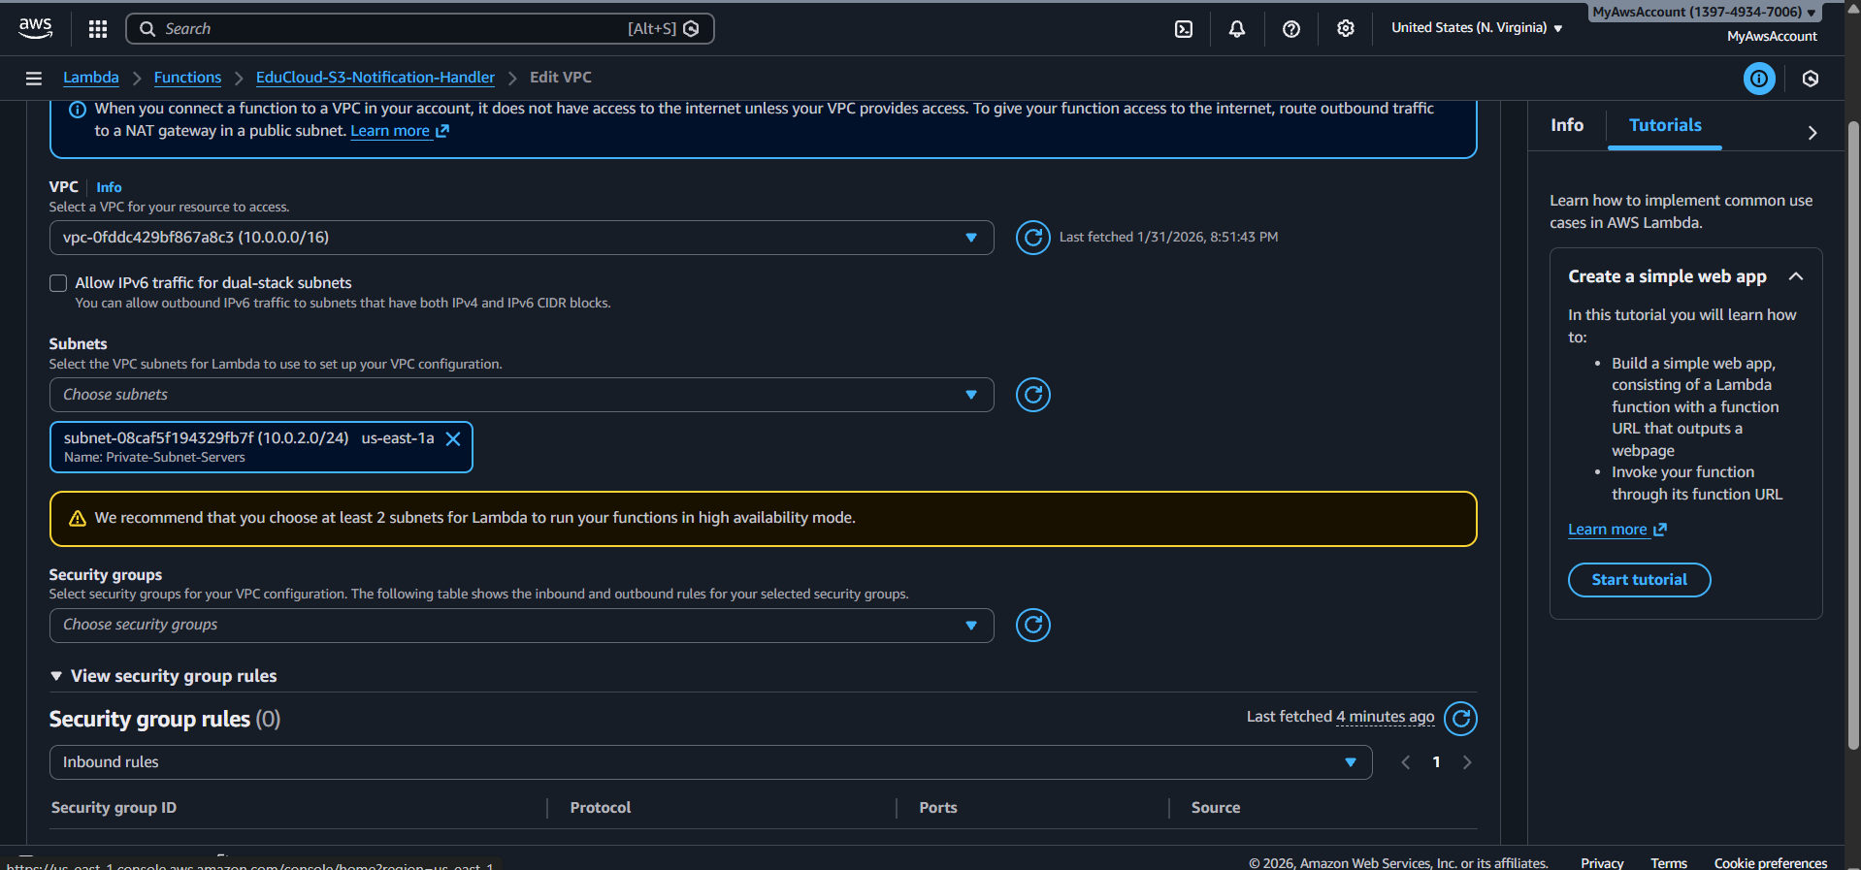

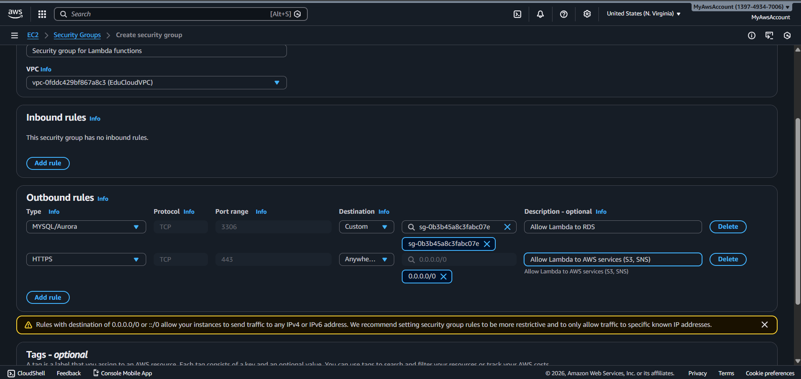

**Iam role for Lambda**

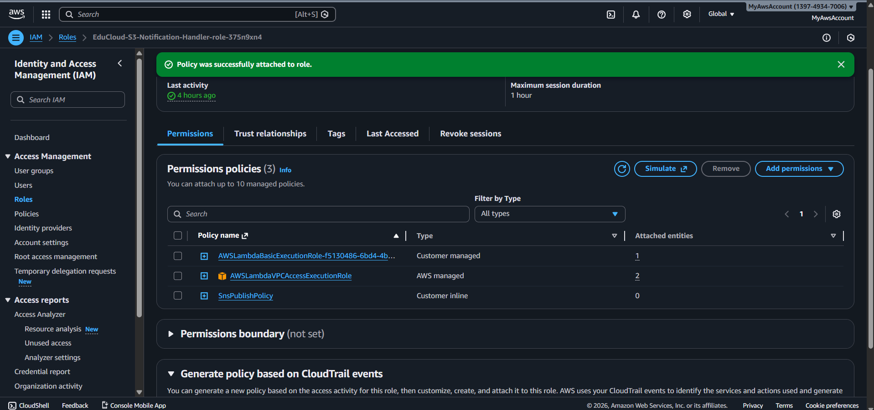

**After adding iam role add try this else get error**

**This vpc edit is required to run lambda in vpc**

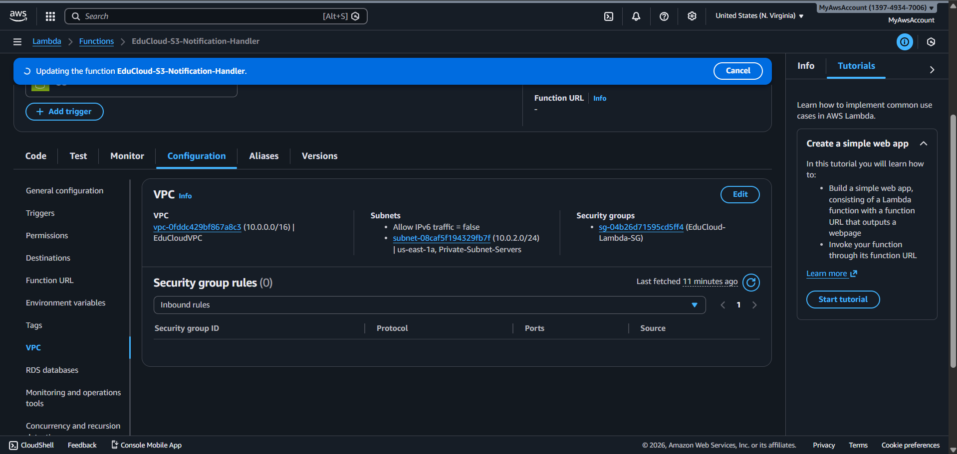

**After doing all these it will not work because we kept lambda in private so to communicate it need vpc end points to talk one service to other service**

**Created interface vpc endpoint to connect lambda with sns**

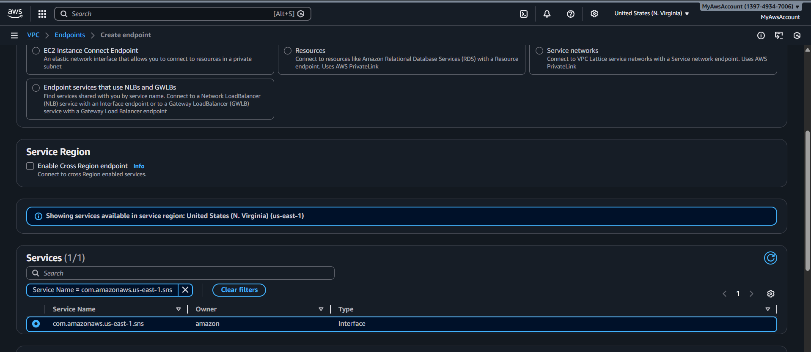

**Interface should allow network where lambda recides if no in bound from the lambda’s subnet allowed to the vpc end point sg it wont allow lambda connection**

**Same done over here allowed lambda’s sg**

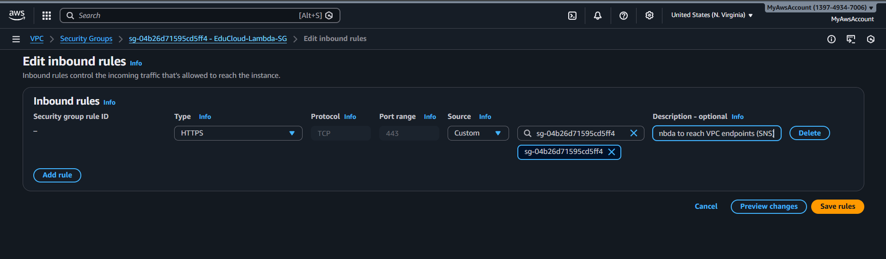

**Only after allowing trafiic from the sg of lambda oit worked befor we have done it in keeping lambda in public now it for private with vpc endpoints**

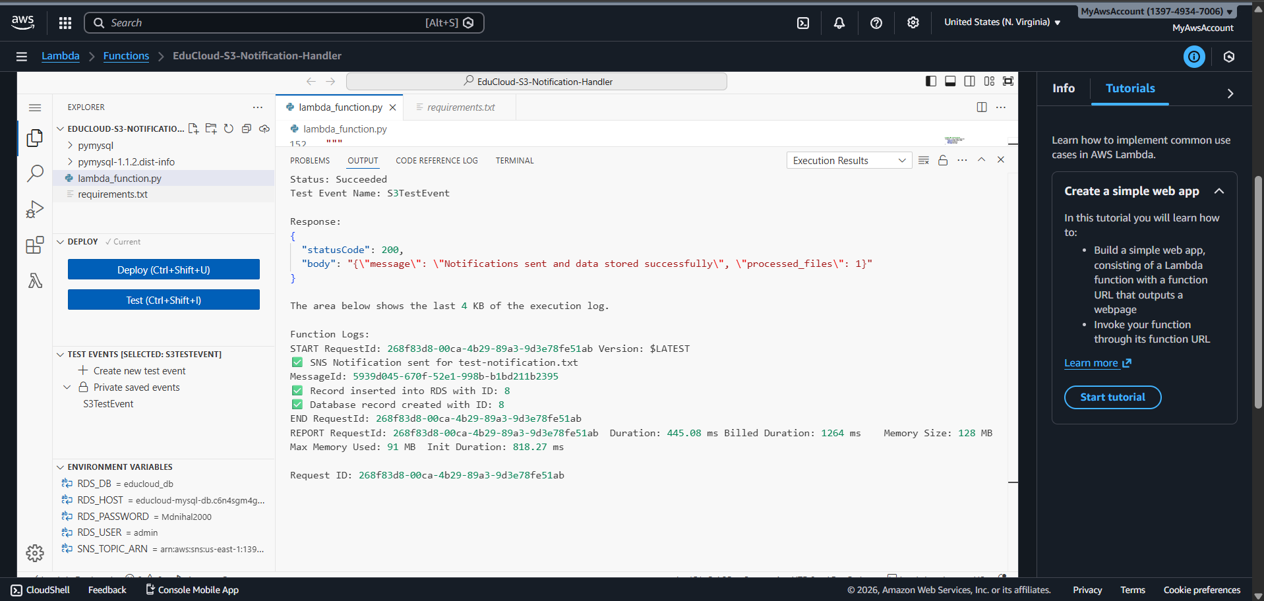

**worked when the lambda was in private subnet**

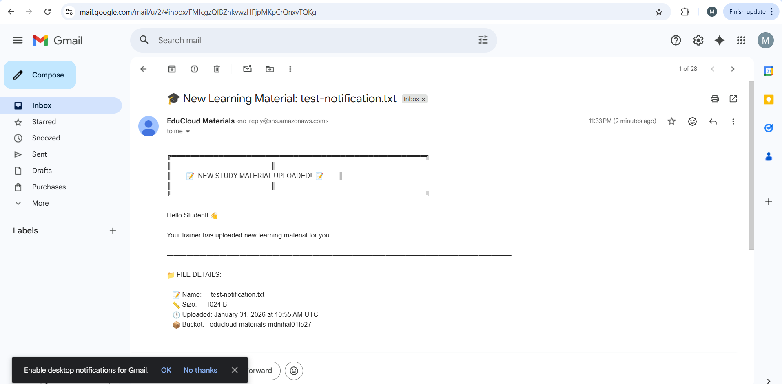

**Rds entry 8 the record**

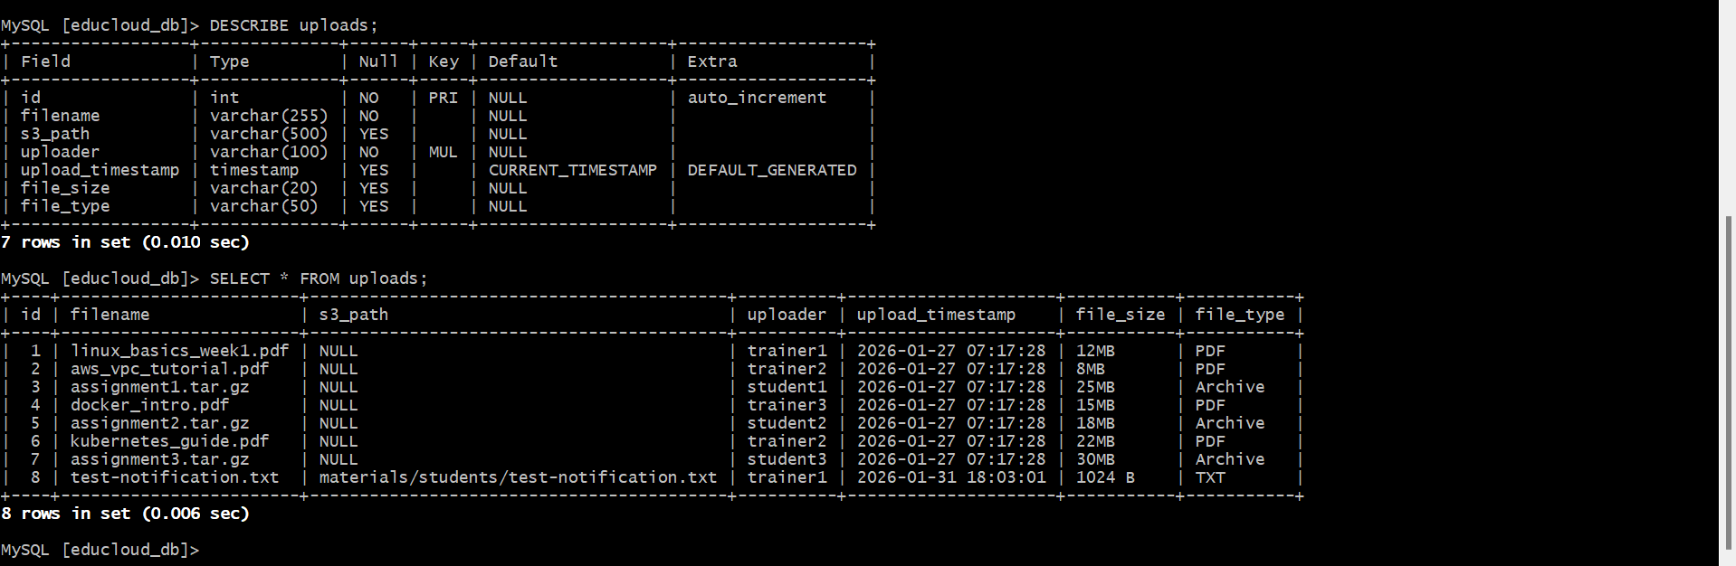

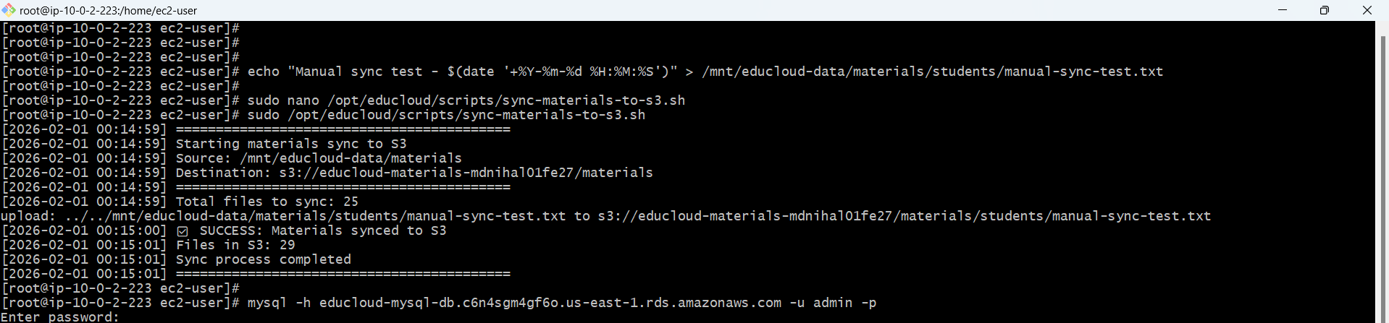

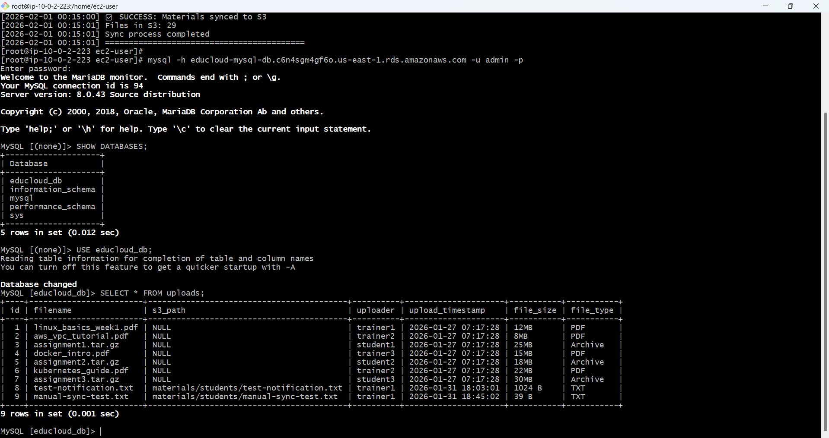

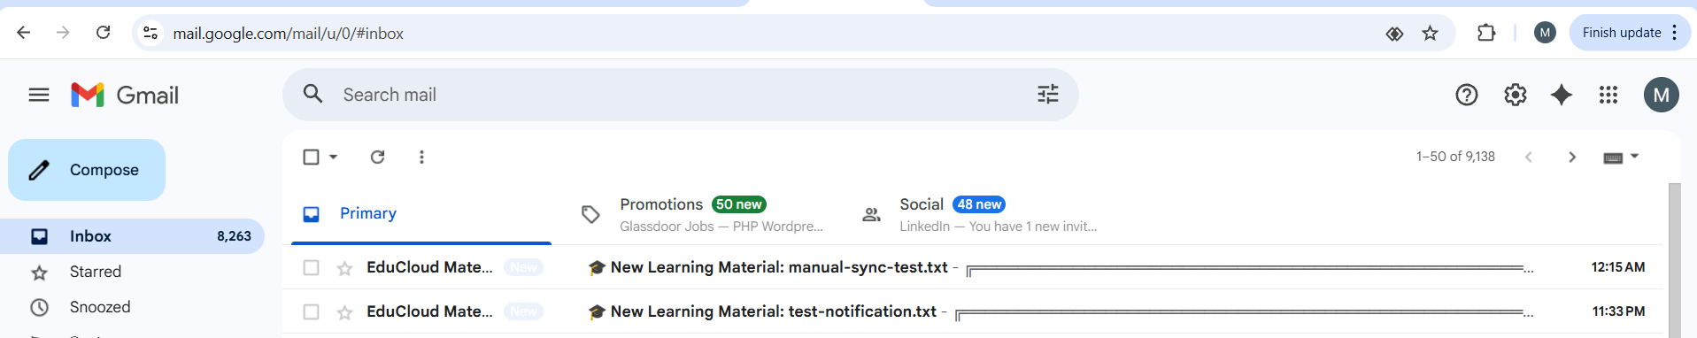

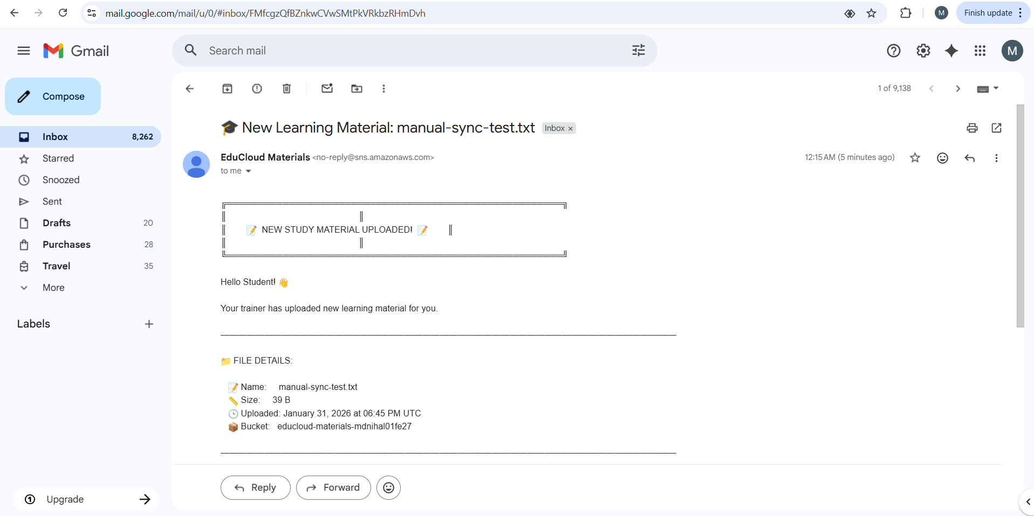

**Lambda kept in private subnet in vpc and can communicate with rds why because its in same vpc, lambda and rds are in same vpc they can communicate through security groups but as lambda is In private and sns, cloud watch se are out of vpc gloabal service they need to be comminicated via vpc end points after creating end points we we should allow vpc endpoint sg from lambda’s sg (inbounds) and vpc dns resolution enabled so that dns of its is resolved**

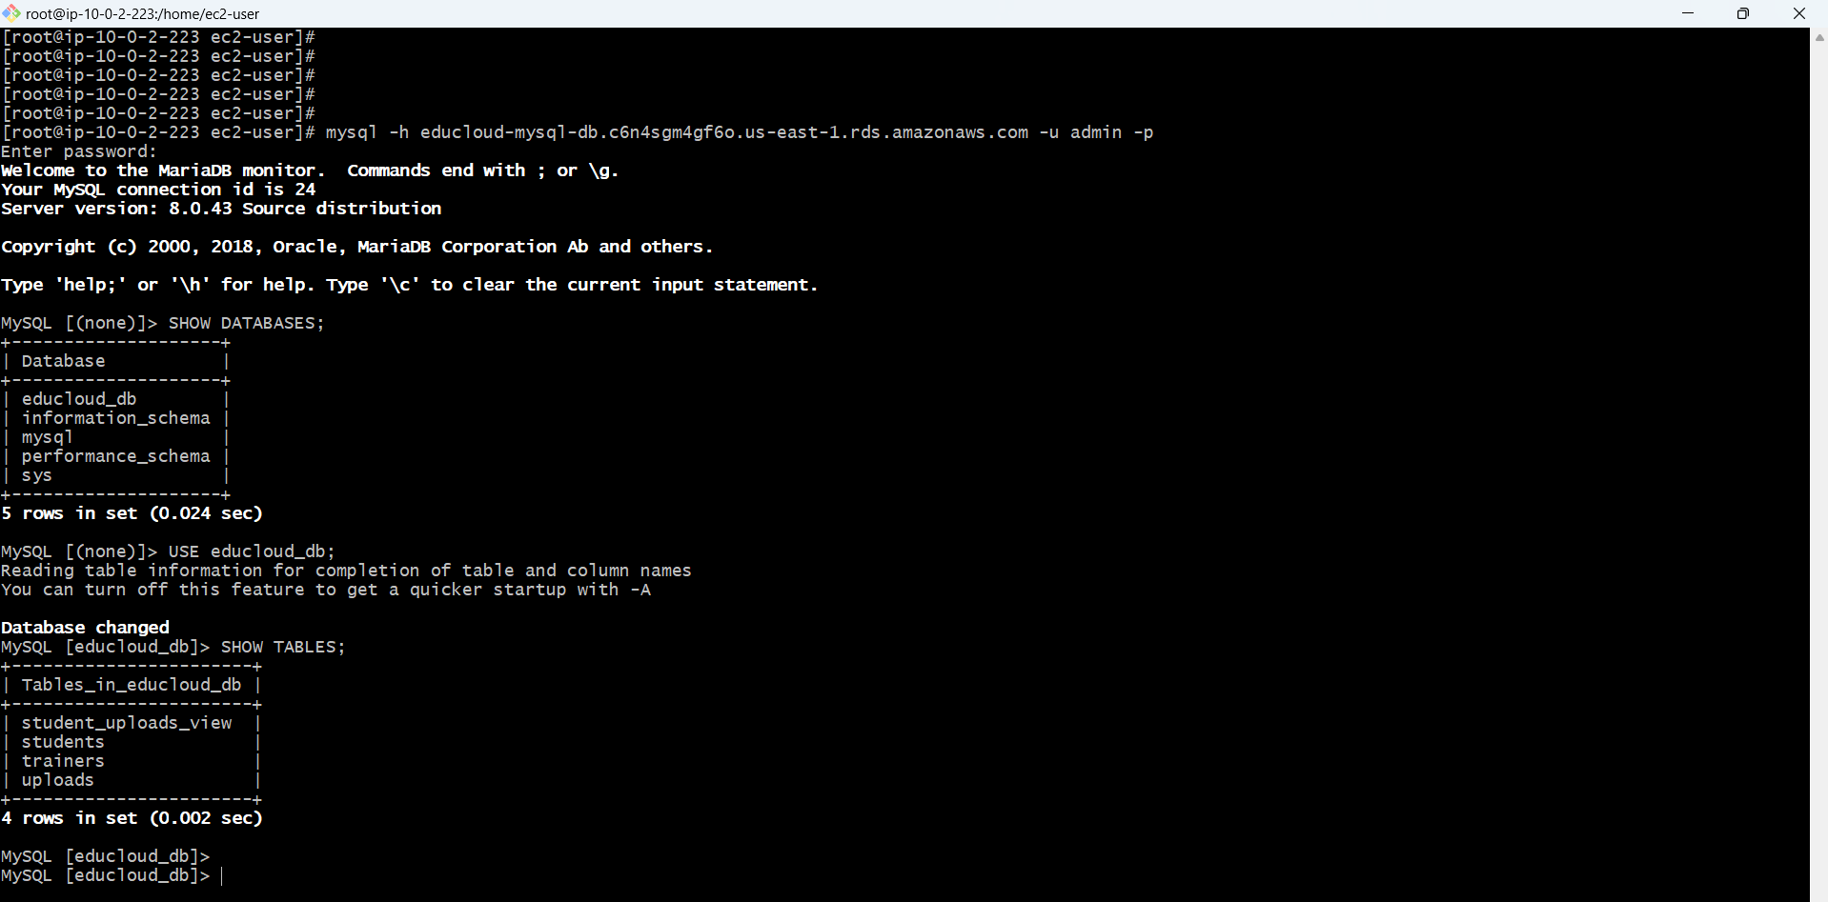

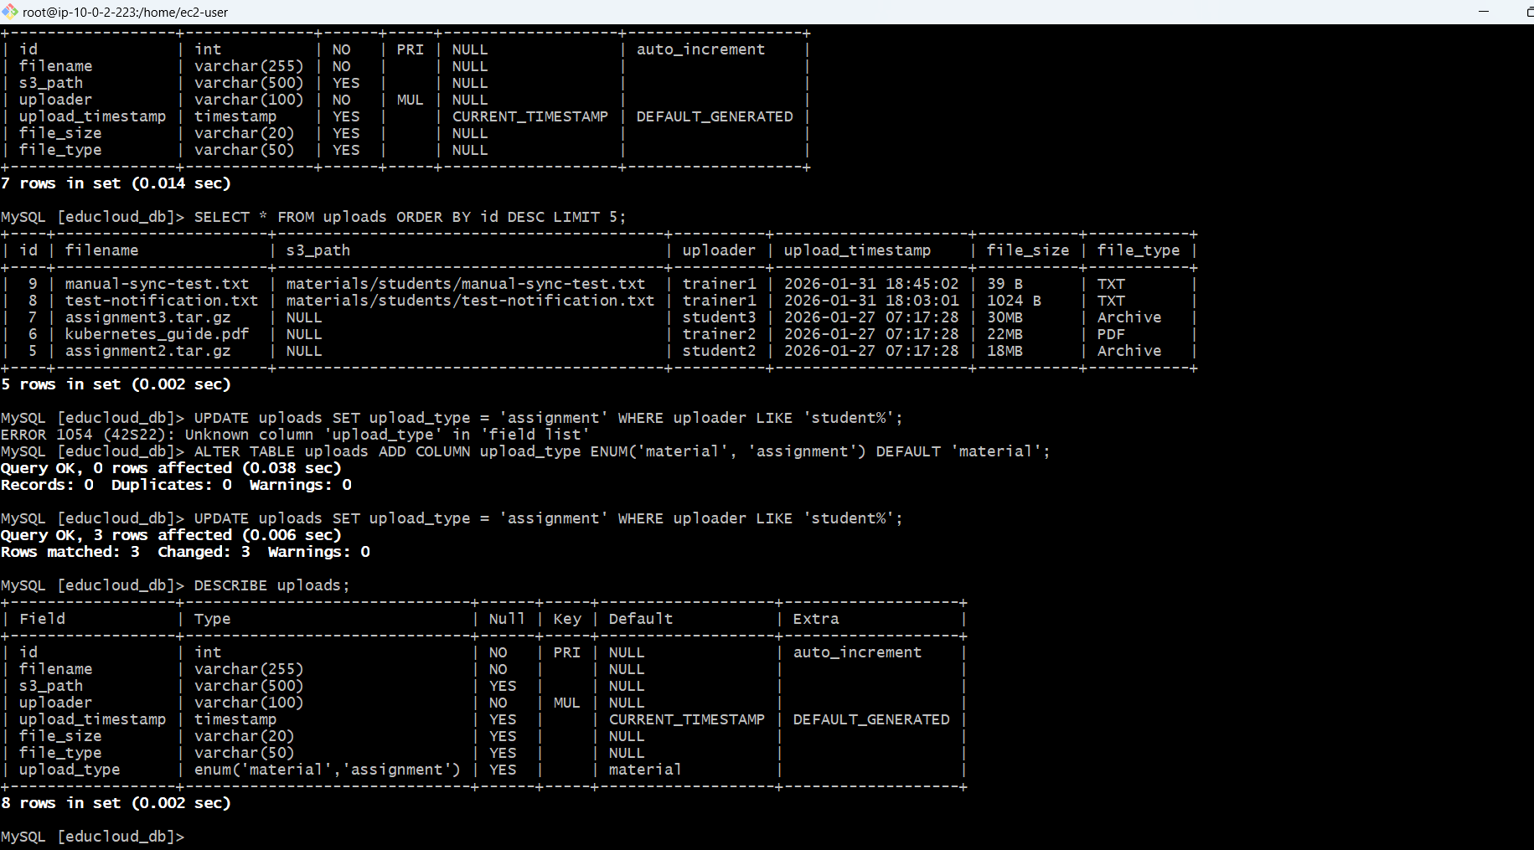

**Synced to s3**

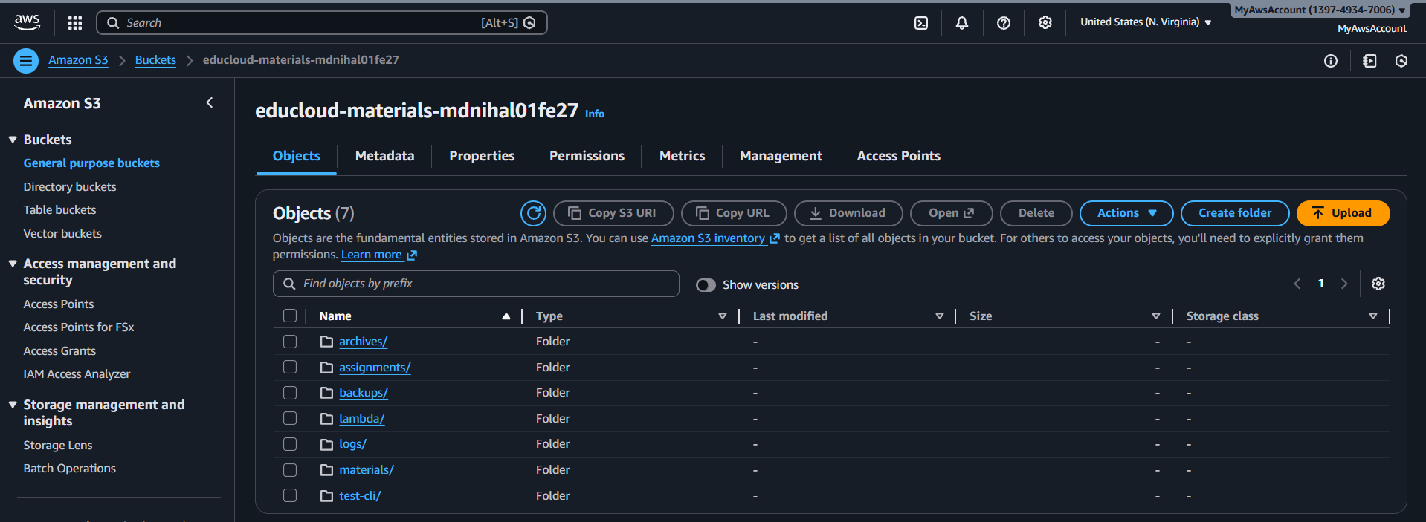

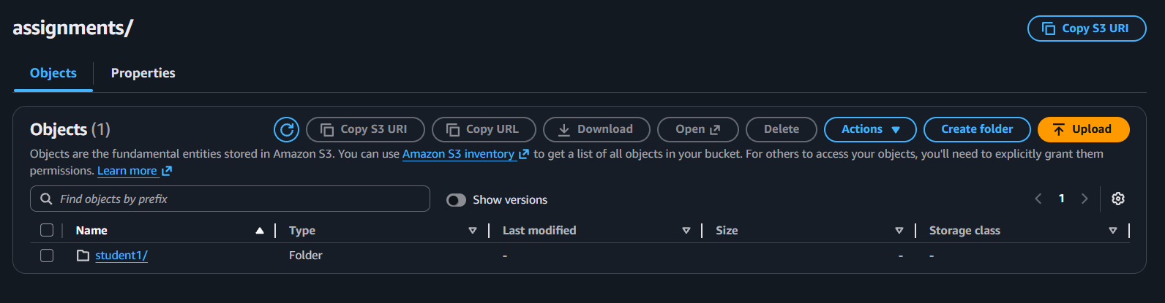

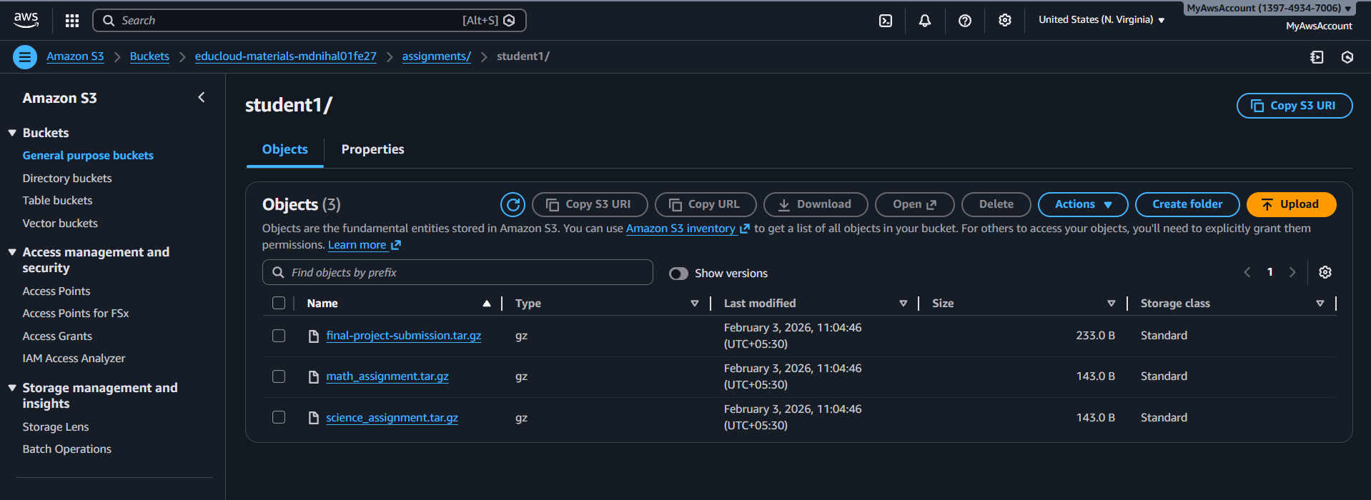

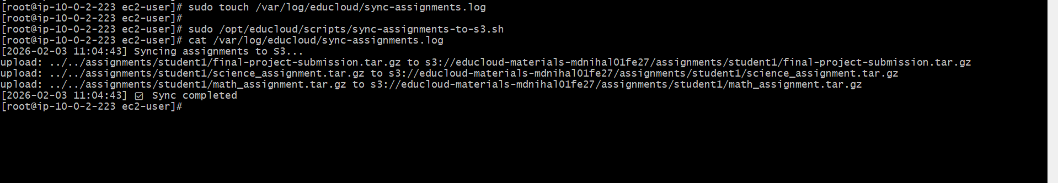

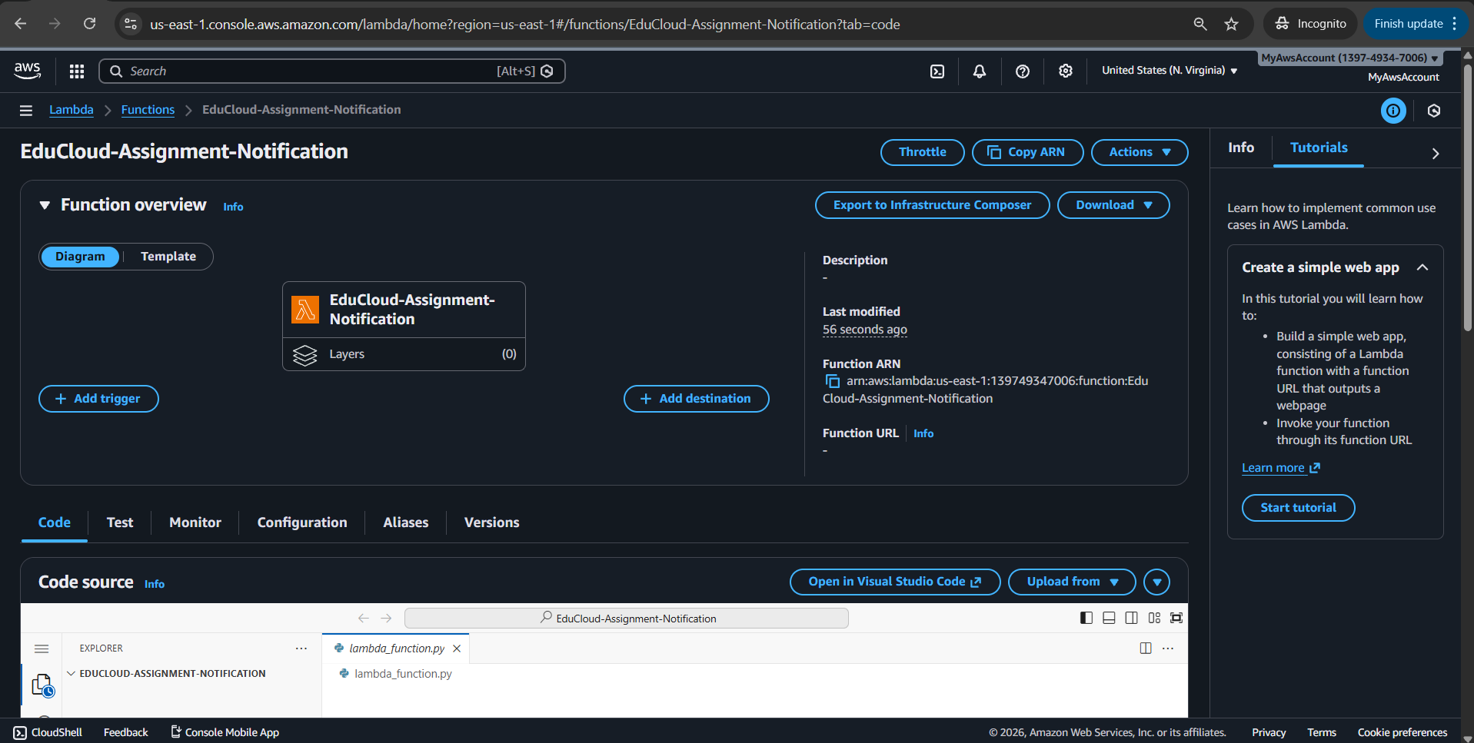

**Trainer recived email when student uploads assignements**

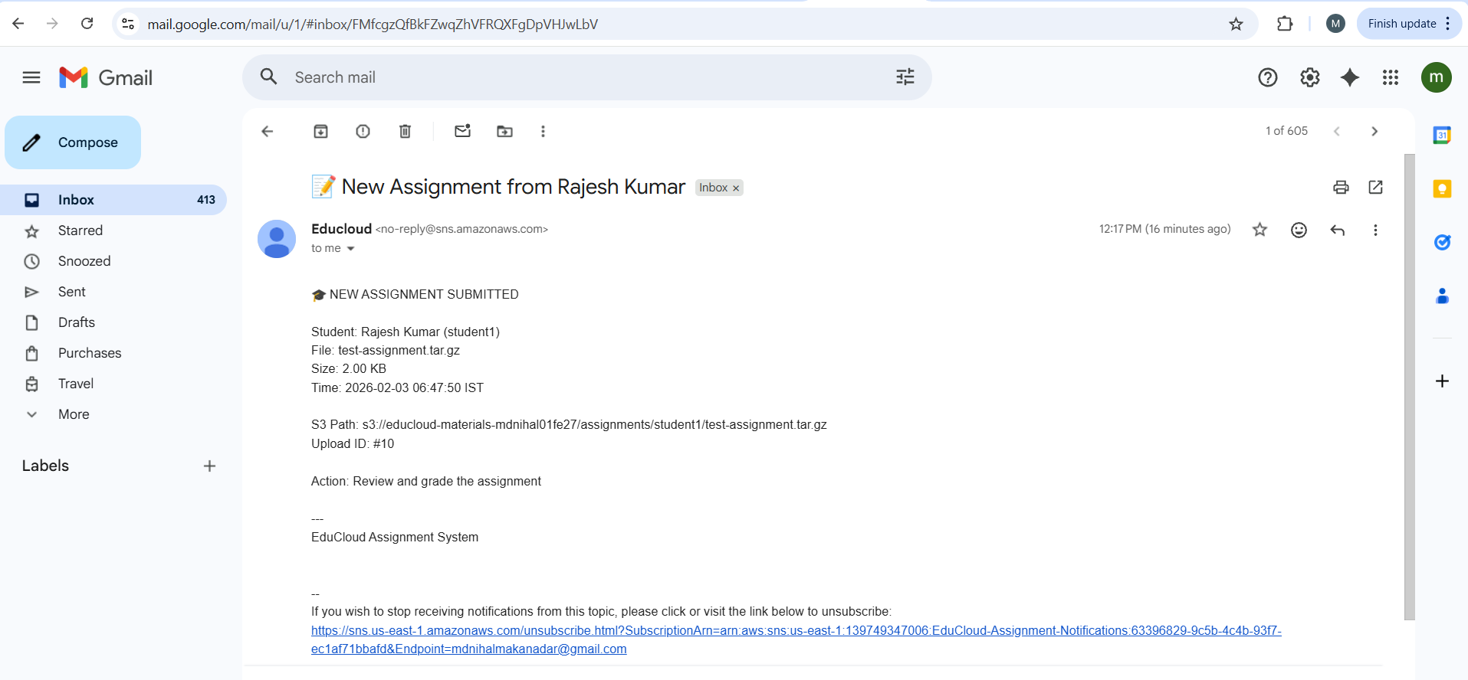

**Vpc configuration for the lambda**

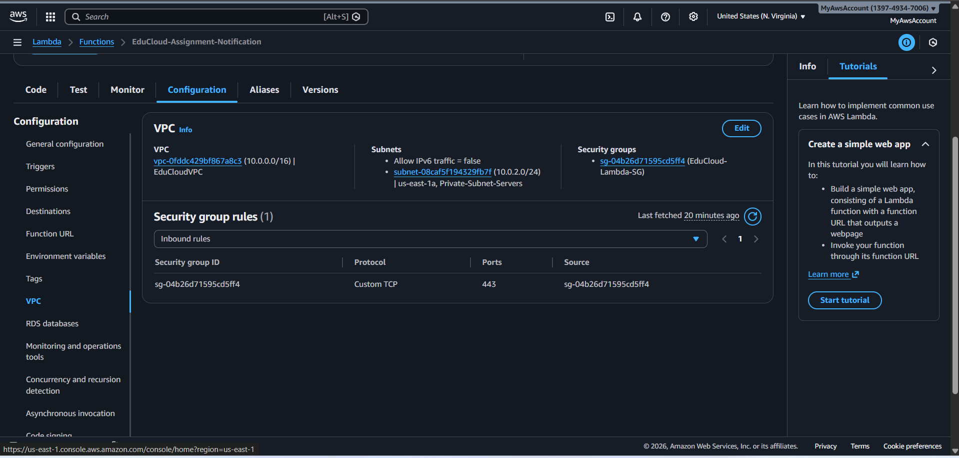

**DB entry by student1**

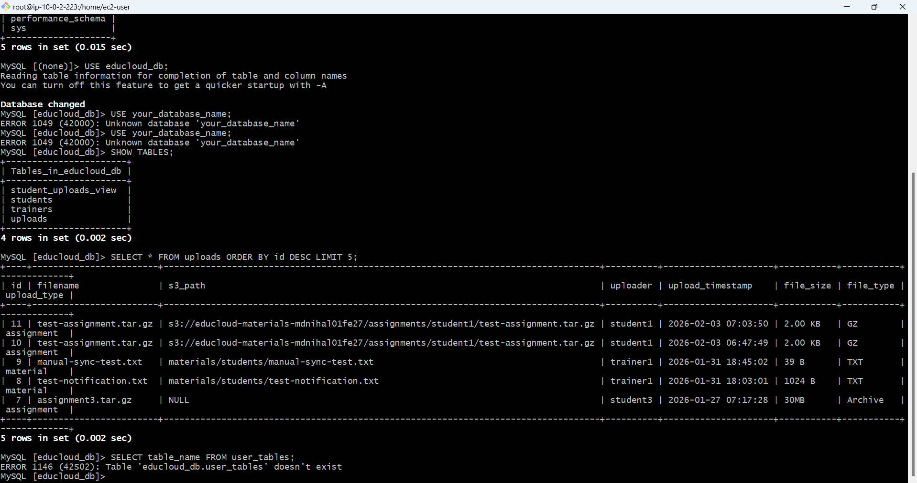

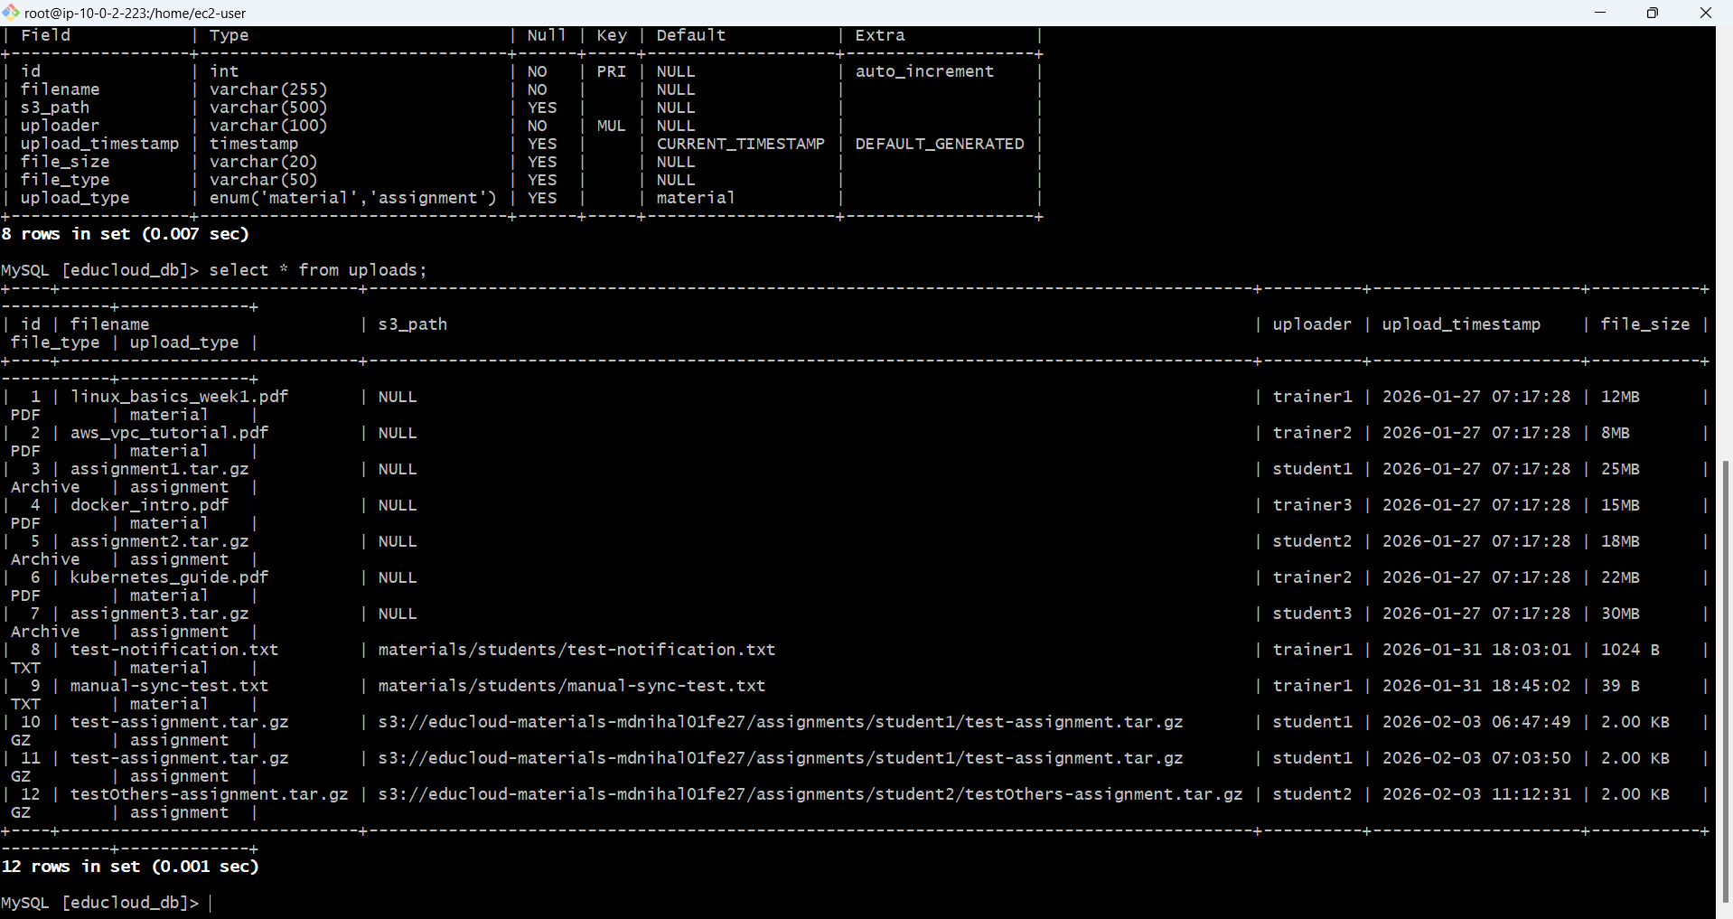

**Final student upload flow**

**client**

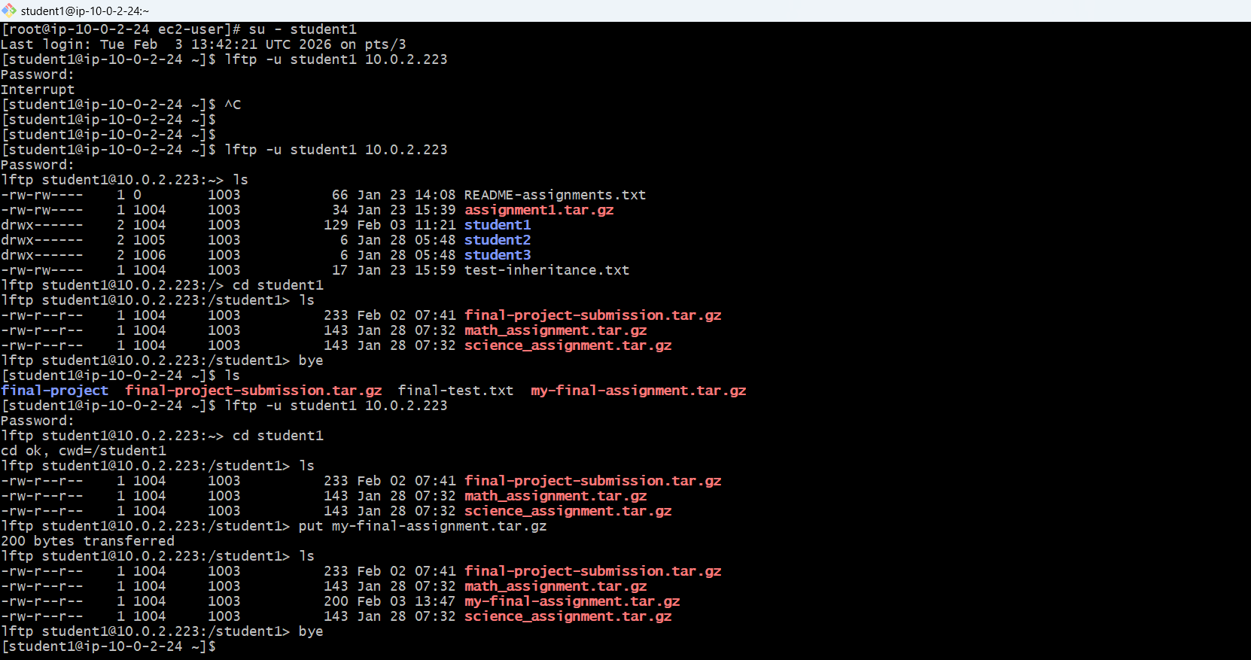

**Server**

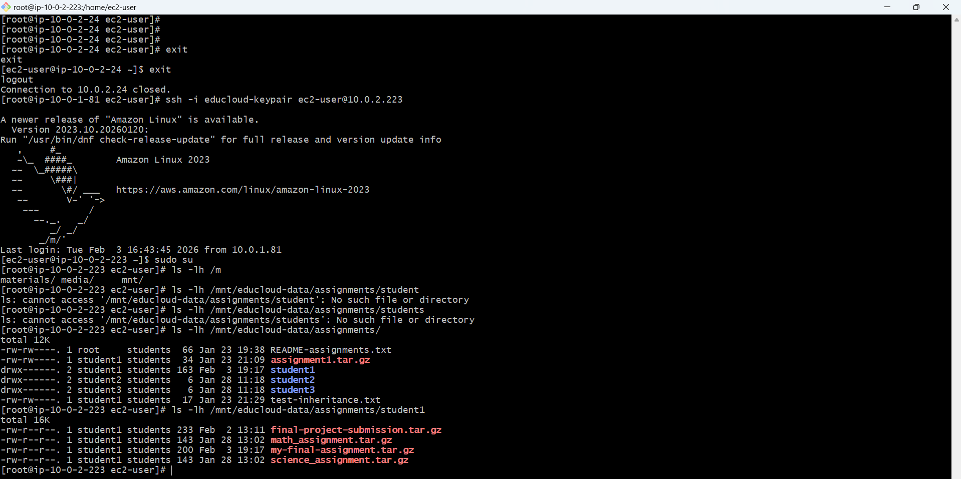

**Cron**

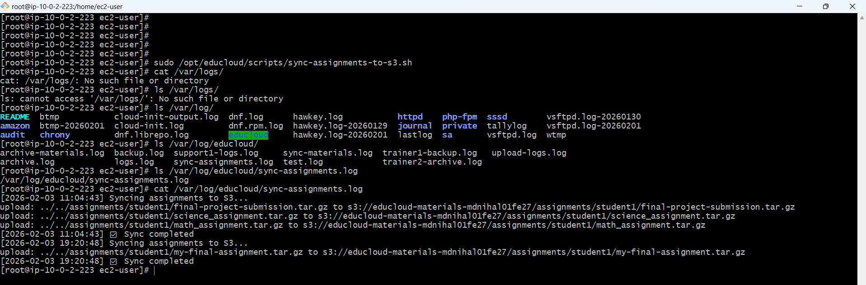

**Se bucket aws console**

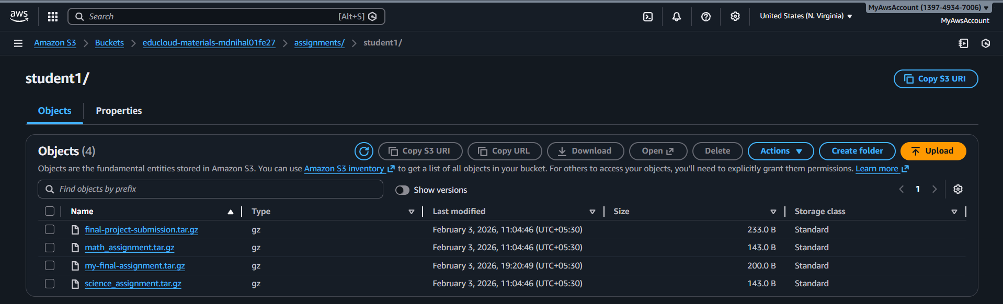

**Email sent for the trainer**

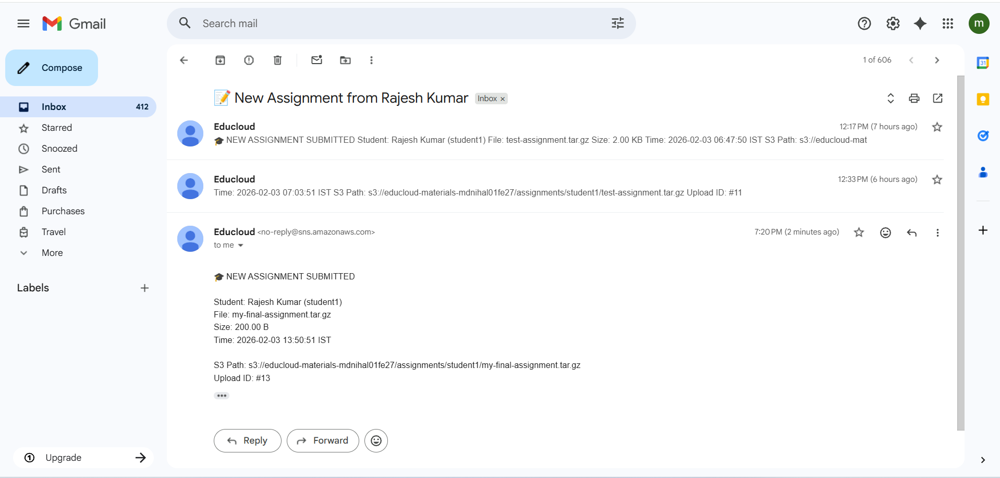

**Database entry**

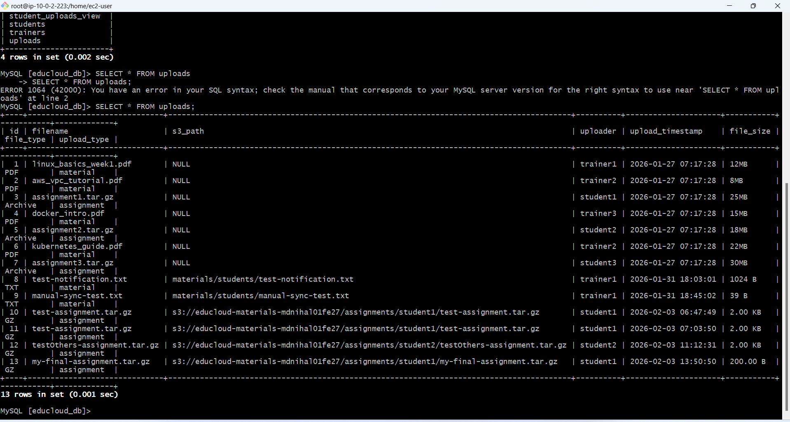

**Final work flow nfs (Client)**

**Trainer uploads from his pc**

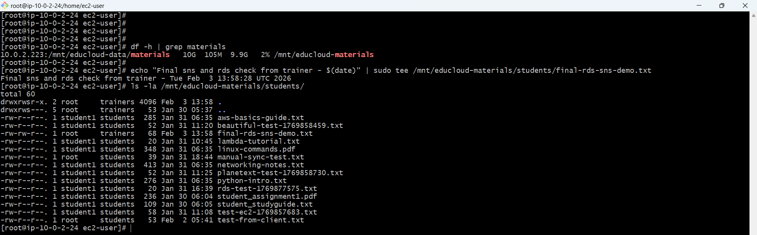

**(Server) file merriors in server**

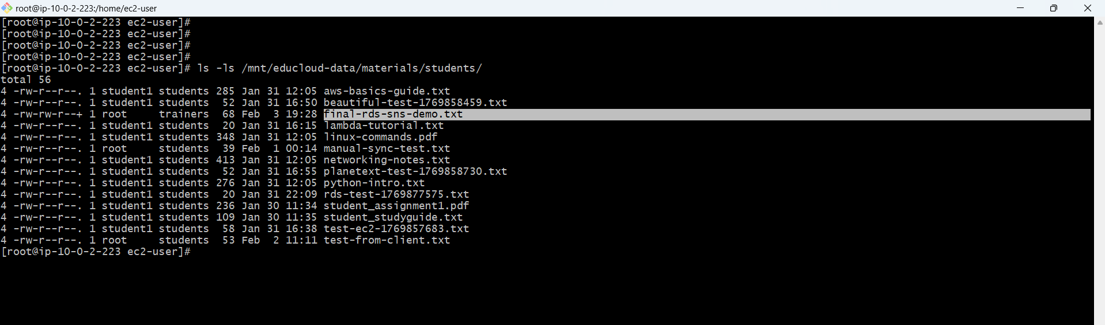

**Cron job to sync to s3**

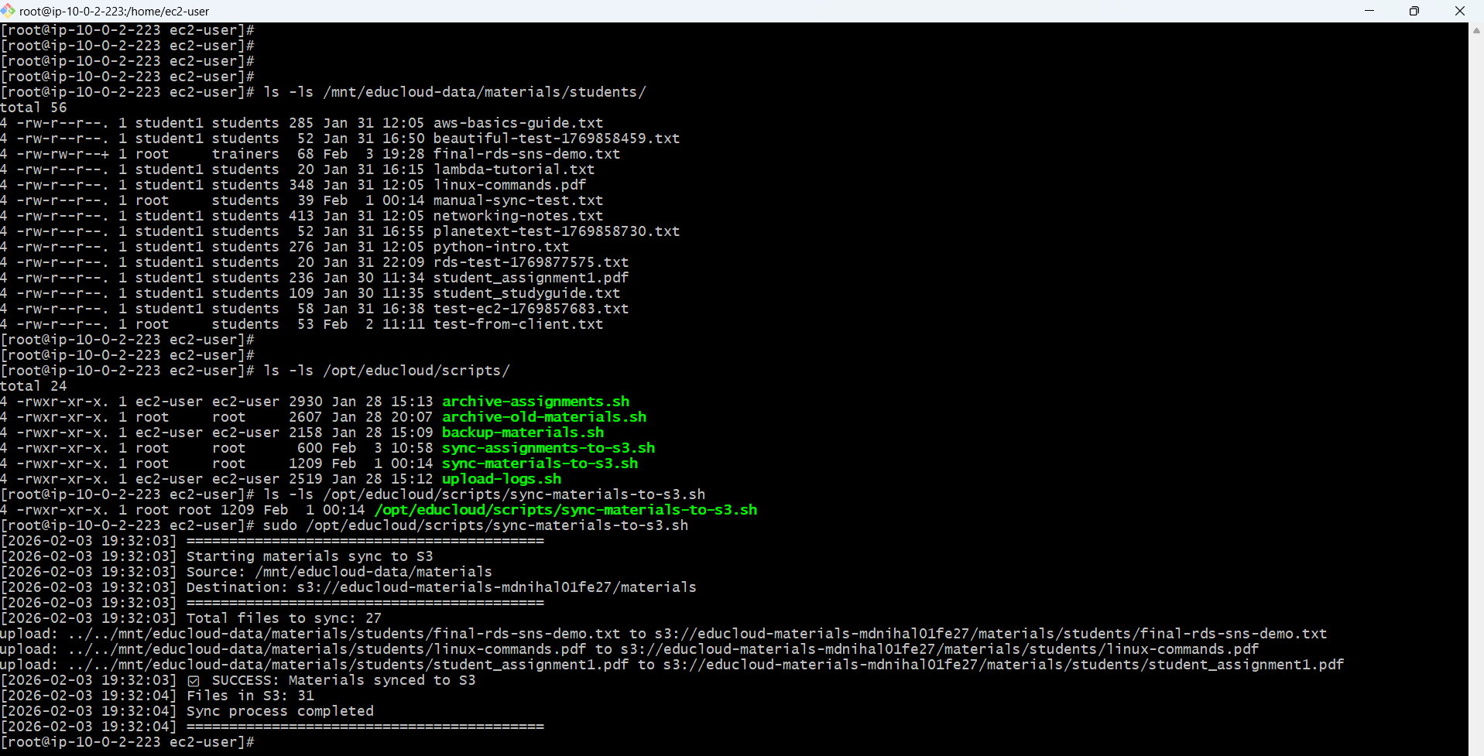

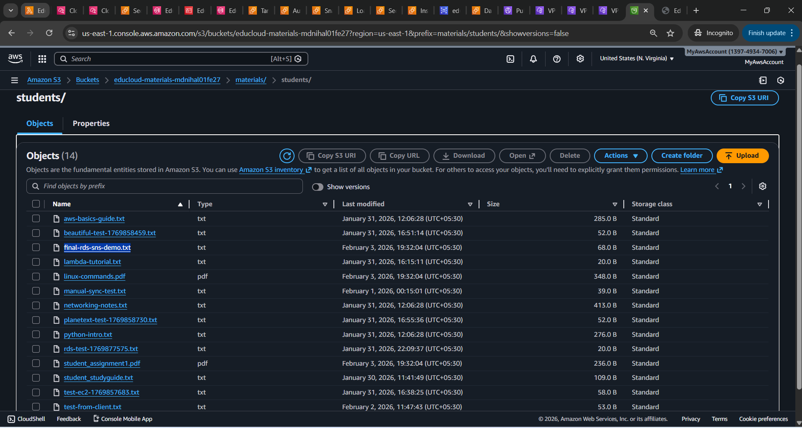

**Students reccives email**

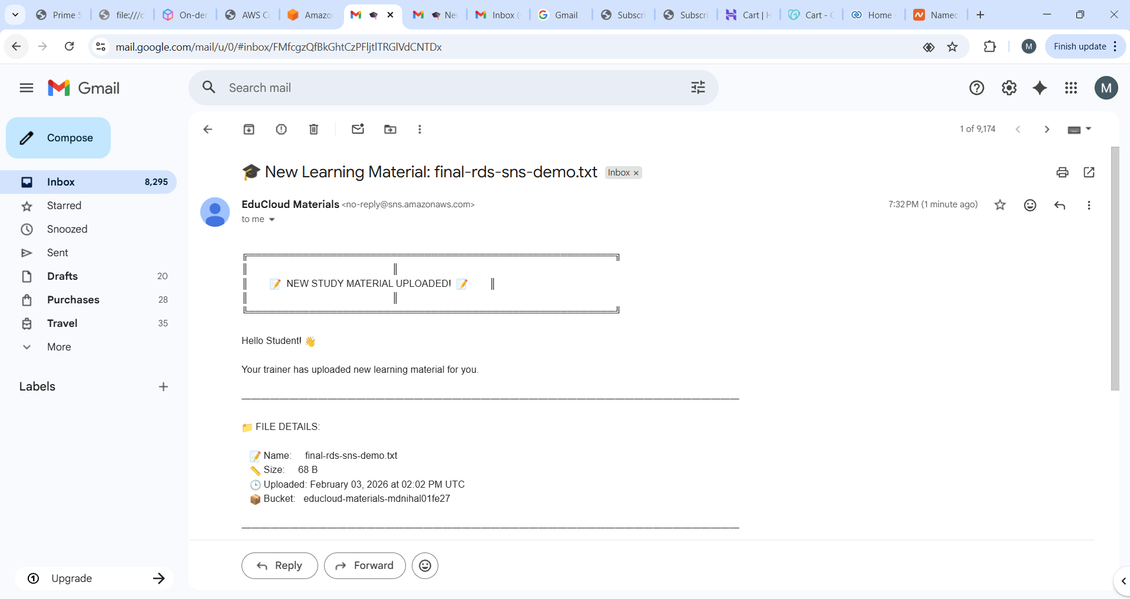

**Rds entry in uploads table by trainer**

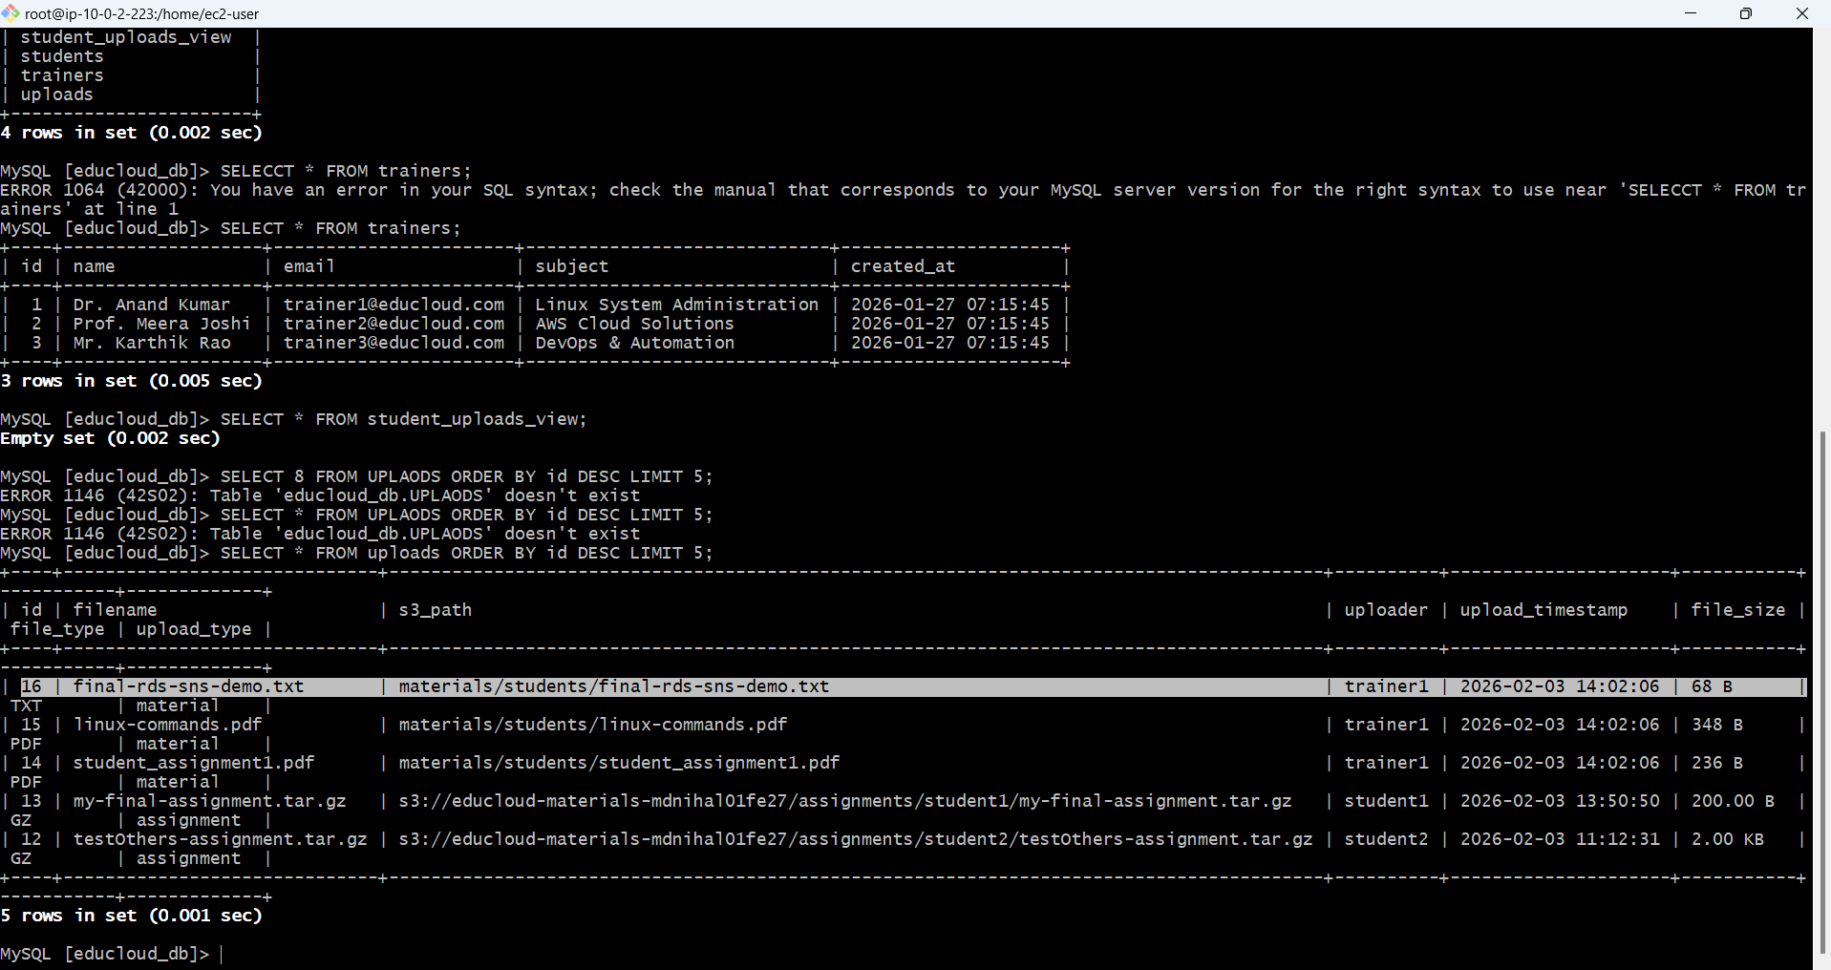

**Live website**

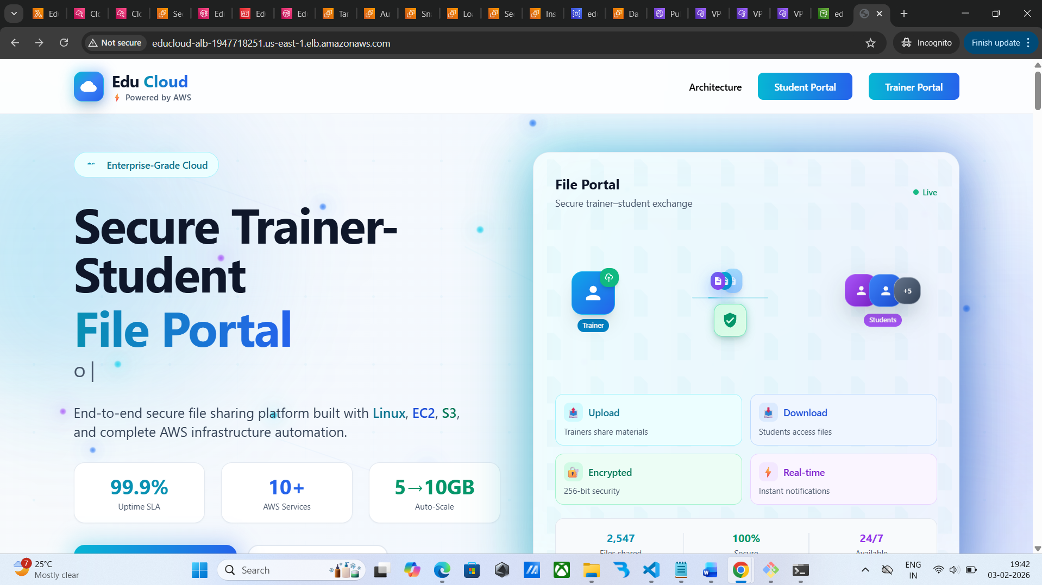

**Student portal**

